5.47 is closer to 5.5 than to 5.4. Look at the next digit: 5 or more rounds up, 4 or less rounds down:  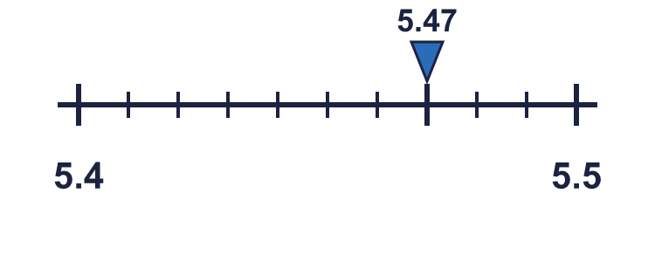 |  | 5.47 is closer to 5.5 than to 5.4. Look at the next digit: 5 or more rounds up, 4 or less rounds down:
  Year 6 · Decimals · Step 3  Rounding decimals | 
  Year 6 · Decimals · Step 3
  Rounding decimals
  1 | Write the two integers each decimal lies between.  Hint: The integer below is the whole number part. The integer above is one more.
    a) 1.6 is between |  | and
    b) 1.4 is between |  | and
  1 | Write the two integers each decimal lies between.  Hint: The integer below is the whole number part. The integer above is one more.
    a) 1.6 is between |  | and
    b) 1.4 is between |  | and
  2 | Write the two tenths each decimal lies between.  Hint: Look at the tenths digit. The next tenth is one more.
    a) 8.84 is between |  | and
    b) 7.89 is between |  | and
  2 | Write the two tenths each decimal lies between.  Hint: Look at the tenths digit. The next tenth is one more.
    a) 8.84 is between |  | and
    b) 7.89 is between |  | and
  3 | Write the two hundredths each decimal lies between.  Hint: Look at the hundredths digit. The next hundredth is one more.
    a) 5.585 is between |  | and
    b) 3.048 is between |  | and
  3 | Write the two hundredths each decimal lies between.  Hint: Look at the hundredths digit. The next hundredth is one more.
    a) 5.585 is between |  | and
    b) 3.048 is between |  | and
  4 | Round each number to the nearest integer.  Hint: Look at the tenths digit. 5 or more: round up. 4 or less: stay.
    a) 3.9 →
    b) 1.7 →
    c) 7.3 →
    d) 3.5 →
  4 | Round each number to the nearest integer.  Hint: Look at the tenths digit. 5 or more: round up. 4 or less: stay.
    a) 3.9 →
    b) 1.7 →
    c) 7.3 →
    d) 3.5 →
  5 | Round each number to the nearest tenth.  Hint: Look at the hundredths digit. 5 or more: round up. 4 or less: stay.
    a) 9.34 →
    b) 2.88 →
    c) 4.45 →
    d) 3.89 →
  5 | Round each number to the nearest tenth.  Hint: Look at the hundredths digit. 5 or more: round up. 4 or less: stay.
    a) 9.34 →
    b) 2.88 →
    c) 4.45 →
    d) 3.89 →
  6 | Round each number to the nearest hundredth.  Hint: Look at the thousandths digit. 5 or more: round up. 4 or less: stay.
    a) 0.536 →
    b) 0.189 →
    c) 4.125 →
    d) 7.814 →
  6 | Round each number to the nearest hundredth.  Hint: Look at the thousandths digit. 5 or more: round up. 4 or less: stay.
    a) 0.536 →
    b) 0.189 →
    c) 4.125 →
    d) 7.814 →
  7 | Round each number to the nearest integer, tenth and hundredth.  Hint: Integer: look at the tenths. Tenth: look at the hundredths. Hundredth: look at the thousandths.
    a) 28.542 →
    b) 7.694 →
    c) 7.143 →
  7 | Round each number to the nearest integer, tenth and hundredth.  Hint: Integer: look at the tenths. Tenth: look at the hundredths. Hundredth: look at the thousandths.
    a) 28.542 →
    b) 7.694 →
    c) 7.143 →
  8 | Round each number as shown.  Hint: Watch out when you round up a 9. It carries to the next column.
    a) 33.664 to the nearest tenth →
    b) 51.435 to the nearest integer →
    c) 0.591 to the nearest hundredth →
    d) 8.995 to the nearest hundredth →
  8 | Round each number as shown.  Hint: Watch out when you round up a 9. It carries to the next column.
    a) 33.664 to the nearest tenth →
    b) 51.435 to the nearest integer →
    c) 0.591 to the nearest hundredth →
    d) 8.995 to the nearest hundredth →

  9 | Is Mo correct? Circle yes or no.  Yes / No  Explain how you know.  Hint: Which digit decides? Is it 5 or more?
     | 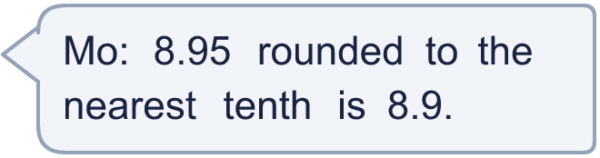
  9 | Is Mo correct? Circle yes or no.  Yes / No  Explain how you know.  Hint: Which digit decides? Is it 5 or more?
  10 | Which of these numbers round to 1.7 to the nearest tenth? Write the letters.  A: 1.64  B: 1.65  C: 1.74  D: 1.75  Hint: Round each number to the nearest tenth. Which ones match?
  10 | Which of these numbers round to 1.7 to the nearest tenth? Write the letters.  A: 1.64  B: 1.65  C: 1.74  D: 1.75  Hint: Round each number to the nearest tenth. Which ones match?
  11 | A number with two decimal places rounds to 6.7 to the nearest tenth.  Hint: Halfway below is 6.65. The number just before halfway above is 6.74.
    The smallest it could be:
    The largest it could be:
  11 | A number with two decimal places rounds to 6.7 to the nearest tenth.  Hint: Halfway below is 6.65. The number just before halfway above is 6.74.
    The smallest it could be:
    The largest it could be:
  12 | How many numbers with two decimal places round to 1.2 to the nearest tenth?  Hint: List them from 1.15 to 1.24.
  12 | How many numbers with two decimal places round to 1.2 to the nearest tenth?  Hint: List them from 1.15 to 1.24.
  13 | a) A snail travels 22.183 cm. Round this to the nearest tenth of a centimetre.  b) A runner takes 11.265 seconds. Round this to the nearest hundredth of a second.  Hint: Look at the digit after the place you are rounding to.
  13 | a) A snail travels 22.183 cm. Round this to the nearest tenth of a centimetre.  b) A runner takes 11.265 seconds. Round this to the nearest hundredth of a second.  Hint: Look at the digit after the place you are rounding to.
  14 | Challenge  A number with two decimal places rounds to 7.9 to the nearest tenth and to 8 to the nearest integer. Write a number it could be.  Hint: The number must be at least 7.85 and below 7.95.
  14 | Challenge  A number with two decimal places rounds to 7.9 to the nearest tenth and to 8 to the nearest integer. Write a number it could be.  Hint: The number must be at least 7.85 and below 7.95.

Year 6 · Decimals · Step 3
Rounding decimals
Answers (teacher copy)

5.47 is closer to 5.5 than to 5.4. Look at the next digit: 5 or more rounds up, 4 or less rounds down:
  1 | Write the two integers each decimal lies between.  a) 1.6 is between 1 and 2  b) 1.4 is between 1 and 2  Hint: The integer below is the whole number part. The integer above is one more.
  2 | Write the two tenths each decimal lies between.  a) 8.84 is between 8.8 and 8.9  b) 7.89 is between 7.8 and 7.9  Hint: Look at the tenths digit. The next tenth is one more.
  3 | Write the two hundredths each decimal lies between.  a) 5.585 is between 5.58 and 5.59  b) 3.048 is between 3.04 and 3.05  Hint: Look at the hundredths digit. The next hundredth is one more.
  4 | Round each number to the nearest integer.  a) 3.9 → 4  b) 1.7 → 2  c) 7.3 → 7  d) 3.5 → 4  Hint: Look at the tenths digit. 5 or more: round up. 4 or less: stay.
  5 | Round each number to the nearest tenth.  a) 9.34 → 9.3  b) 2.88 → 2.9  c) 4.45 → 4.5  d) 3.89 → 3.9  Hint: Look at the hundredths digit. 5 or more: round up. 4 or less: stay.
  6 | Round each number to the nearest hundredth.  a) 0.536 → 0.54  b) 0.189 → 0.19  c) 4.125 → 4.13  d) 7.814 → 7.81  Hint: Look at the thousandths digit. 5 or more: round up. 4 or less: stay.
  7 | Round each number to the nearest integer, tenth and hundredth.  a) 28.542 → 29 28.5 28.54  b) 7.694 → 8 7.7 7.69  c) 7.143 → 7 7.1 7.14  Hint: Integer: look at the tenths. Tenth: look at the hundredths. Hundredth: look at the thousandths.
  8 | Round each number as shown.  a) 33.664 to the nearest tenth → 33.7  b) 51.435 to the nearest integer → 51  c) 0.591 to the nearest hundredth → 0.59  d) 8.995 to the nearest hundredth → 9  Hint: Watch out when you round up a 9. It carries to the next column.
  9 | Is Mo correct? Circle yes or no.  Yes / No  Explain how you know.  No. The hundredths digit of 8.95 is 5, so it rounds to 9.  Hint: Which digit decides? Is it 5 or more?
  10 | Which of these numbers round to 1.7 to the nearest tenth? Write the letters.  A: 1.64  B: 1.65  C: 1.74  D: 1.75  B, C  Hint: Round each number to the nearest tenth. Which ones match?
  11 | A number with two decimal places rounds to 6.7 to the nearest tenth.  The smallest it could be: 6.65 The largest it could be: 6.74  Hint: Halfway below is 6.65. The number just before halfway above is 6.74.
  12 | How many numbers with two decimal places round to 1.2 to the nearest tenth?  10  Hint: List them from 1.15 to 1.24.
  13 | a) A snail travels 22.183 cm. Round this to the nearest tenth of a centimetre.  22.2 cm  b) A runner takes 11.265 seconds. Round this to the nearest hundredth of a second.  11.27 seconds  Hint: Look at the digit after the place you are rounding to.
  14 | Challenge  A number with two decimal places rounds to 7.9 to the nearest tenth and to 8 to the nearest integer. Write a number it could be.  7.92  Hint: The number must be at least 7.85 and below 7.95.

