To change a fraction to a decimal, make the bottom number 100 or 1,000. 28/50 = 56/100 = 0.56:  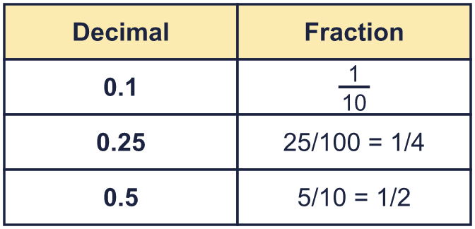 |  | To change a fraction to a decimal, make the bottom number 100 or 1,000. 28/50 = 56/100 = 0.56:
  Year 6 · Fractions, decimals and percentages · Step 1  Decimal and fraction equivalents | 
  Year 6 · Fractions, decimals and percentages · Step 1
  Decimal and fraction equivalents
  1 | The bar is a whole. Complete the sentences.  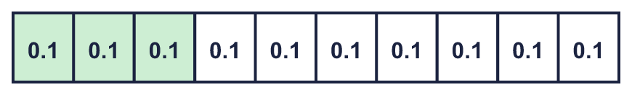  Hint: Count the parts. Each part is one tenth. The fraction is the shaded parts over all the parts.
    The whole has been divided into
    equal parts. Each part is worth
    . 3 parts are shaded. This is equivalent to
  1 | The bar is a whole. Complete the sentences.  Hint: Count the parts. Each part is one tenth. The fraction is the shaded parts over all the parts.
    The whole has been divided into
    equal parts. Each part is worth
    . 3 parts are shaded. This is equivalent to
  2 | Each hundred square is a whole. Write the fraction and the decimal for the shaded part.  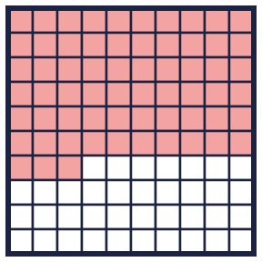  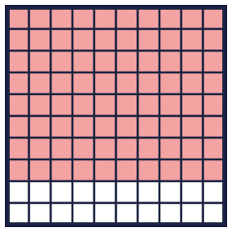  Hint: Count the shaded squares. There are 100 squares altogether.
    a) Fraction:
    b) Fraction (simplest form):
  2 | Each hundred square is a whole. Write the fraction and the decimal for the shaded part.  Hint: Count the shaded squares. There are 100 squares altogether.
    a) Fraction:
    b) Fraction (simplest form):
  3 | Write each decimal as a fraction in its simplest form.  Hint: Write the decimal over 10 or 100. Then divide the top and bottom by the same number.
    a) 0.7 =
    b) 0.05 =
    c) 0.35 =
    d) 0.25 =
  3 | Write each decimal as a fraction in its simplest form.  Hint: Write the decimal over 10 or 100. Then divide the top and bottom by the same number.
    a) 0.7 =
    b) 0.05 =
    c) 0.35 =
    d) 0.25 =
  4 | Make the bottom number 100. Then write the decimal.  Hint: Multiply the top and bottom by the same number to make the bottom 100.
    a) ²¹⁄₂₅ = |  | / 100 =
    b) ¹⁷⁄₂₀ = |  | / 100 =
    c) ⁴⁄₅ = |  | / 100 =
    d) ¹³⁄₂₅ = |  | / 100 =
  4 | Make the bottom number 100. Then write the decimal.  Hint: Multiply the top and bottom by the same number to make the bottom 100.
    a) ²¹⁄₂₅ = |  | / 100 =
    b) ¹⁷⁄₂₀ = |  | / 100 =
    c) ⁴⁄₅ = |  | / 100 =
    d) ¹³⁄₂₅ = |  | / 100 =
  5 | Make the bottom number 1,000. Then write the decimal.  Hint: Find what to multiply the bottom number by to make 1,000.
    a) ⁵⁹⁄₂₀₀ = |  | / 1,000 =
    b) ⁹³⁄₅₀₀ = |  | / 1,000 =
    c) ⁷⁄₄₀ = |  | / 1,000 =
    d) ²⁄₁₂₅ = |  | / 1,000 =
  5 | Make the bottom number 1,000. Then write the decimal.  Hint: Find what to multiply the bottom number by to make 1,000.
    a) ⁵⁹⁄₂₀₀ = |  | / 1,000 =
    b) ⁹³⁄₅₀₀ = |  | / 1,000 =
    c) ⁷⁄₄₀ = |  | / 1,000 =
    d) ²⁄₁₂₅ = |  | / 1,000 =
  6 | Write each decimal as a fraction in its simplest form.  Hint: Write the decimal over 100 or 1,000. Simplify.
    a) 0.625 =
    b) 0.36 =
    c) 0.875 =
    d) 0.15 =
  6 | Write each decimal as a fraction in its simplest form.  Hint: Write the decimal over 100 or 1,000. Simplify.
    a) 0.625 =
    b) 0.36 =
    c) 0.875 =
    d) 0.15 =
  7 | Write each fraction as a decimal.  Hint: Make the bottom number 10, 100 or 1,000.
    a) ³⁄₂₀ =
    b) ¹³⁄₂₀ =
    c) ¹⁄₂₀ =
    d) ³⁄₈ =
  7 | Write each fraction as a decimal.  Hint: Make the bottom number 10, 100 or 1,000.
    a) ³⁄₂₀ =
    b) ¹³⁄₂₀ =
    c) ¹⁄₂₀ =
    d) ³⁄₈ =
  8 | Write each decimal as a mixed number.  Hint: The whole number part stays the same. Write the decimal part as a fraction.
    a) 2.5 =
    b) 3.25 =
  8 | Write each decimal as a mixed number.  Hint: The whole number part stays the same. Write the decimal part as a fraction.
    a) 2.5 =
    b) 3.25 =

  9 | Tommy and Alex are finding the decimal equivalent of ¹³⁰⁄₂₀₀.  Who is correct? Write Tommy, Alex or Both.  Explain how you know.  Hint: Can you multiply the bottom number by a whole number to get 100? And 1,000?
     | 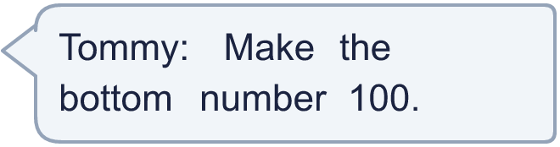
     | 
  9 | Tommy and Alex are finding the decimal equivalent of ¹³⁰⁄₂₀₀.  Who is correct? Write Tommy, Alex or Both.  Explain how you know.  Hint: Can you multiply the bottom number by a whole number to get 100? And 1,000?
  10 | Which of these are equal to 0.2? Write the letters.  A: ²⁄₁₀  B: 0.02  C: ¹⁄₅  D: 2%  Hint: Change each one to a decimal.
  10 | Which of these are equal to 0.2? Write the letters.  A: ²⁄₁₀  B: 0.02  C: ¹⁄₅  D: 2%  Hint: Change each one to a decimal.
  11 | Eva writes 0.35 as ³⁵⁄₁₀₀₀.  Is Boba correct? Circle yes or no.  Yes / No  Explain the mistake. Then write the correct fraction in its simplest form.  Hint: The last digit shows the column: tenths, hundredths …
    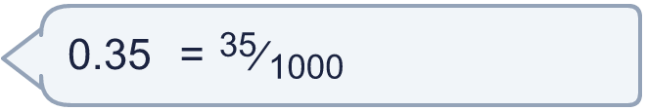
  11 | Eva writes 0.35 as ³⁵⁄₁₀₀₀.  Is Boba correct? Circle yes or no.  Yes / No  Explain the mistake. Then write the correct fraction in its simplest form.  Hint: The last digit shows the column: tenths, hundredths …
  12 | Write 0.875 as a fraction in its simplest form.  Hint: Write it over 1,000. Then divide the top and bottom by the same number until you cannot.
  12 | Write 0.875 as a fraction in its simplest form.  Hint: Write it over 1,000. Then divide the top and bottom by the same number until you cannot.
  13 | Write 4.5 as a mixed number in its simplest form.  Hint: Split it into the whole number and the decimal part.
  13 | Write 4.5 as a mixed number in its simplest form.  Hint: Split it into the whole number and the decimal part.
  14 | Challenge  0.25 is equal to ¹⁄₄, ²⁵⁄₁₀₀ and ²⁄₈. How many fractions with a bottom number of 12 or less (and a whole number on top) are equal to 0.25?  Hint: Which bottom numbers from 1 to 12 give a whole number on top?
  14 | Challenge  0.25 is equal to ¹⁄₄, ²⁵⁄₁₀₀ and ²⁄₈. How many fractions with a bottom number of 12 or less (and a whole number on top) are equal to 0.25?  Hint: Which bottom numbers from 1 to 12 give a whole number on top?

Year 6 · Fractions, decimals and percentages · Step 1
Decimal and fraction equivalents
Answers (teacher copy)

To change a fraction to a decimal, make the bottom number 100 or 1,000. 28/50 = 56/100 = 0.56:
  1 | The bar is a whole. Complete the sentences.  The whole has been divided into 10 equal parts. Each part is worth 0.1 . 3 parts are shaded. This is equivalent to ³⁄₁₀  Hint: Count the parts. Each part is one tenth. The fraction is the shaded parts over all the parts.
  2 | Each hundred square is a whole. Write the fraction and the decimal for the shaded part.  a) Fraction: ⁶³⁄₁₀₀  Decimal: 0.63  b) Fraction (simplest form): ⁴⁄₅  Decimal: 0.8  Hint: Count the shaded squares. There are 100 squares altogether.
  3 | Write each decimal as a fraction in its simplest form.  a) 0.7 = ⁷⁄₁₀  b) 0.05 = ¹⁄₂₀  c) 0.35 = ⁷⁄₂₀  d) 0.25 = ¹⁄₄  Hint: Write the decimal over 10 or 100. Then divide the top and bottom by the same number.
  4 | Make the bottom number 100. Then write the decimal.  a) ²¹⁄₂₅ = 84 / 100 = 0.84  b) ¹⁷⁄₂₀ = 85 / 100 = 0.85  c) ⁴⁄₅ = 80 / 100 = 0.8  d) ¹³⁄₂₅ = 52 / 100 = 0.52  Hint: Multiply the top and bottom by the same number to make the bottom 100.
  5 | Make the bottom number 1,000. Then write the decimal.  a) ⁵⁹⁄₂₀₀ = 295 / 1,000 = 0.295  b) ⁹³⁄₅₀₀ = 186 / 1,000 = 0.186  c) ⁷⁄₄₀ = 175 / 1,000 = 0.175  d) ²⁄₁₂₅ = 16 / 1,000 = 0.016  Hint: Find what to multiply the bottom number by to make 1,000.
  6 | Write each decimal as a fraction in its simplest form.  a) 0.625 = ⁵⁄₈  b) 0.36 = ⁹⁄₂₅  c) 0.875 = ⁷⁄₈  d) 0.15 = ³⁄₂₀  Hint: Write the decimal over 100 or 1,000. Simplify.
  7 | Write each fraction as a decimal.  a) ³⁄₂₀ = 0.15  b) ¹³⁄₂₀ = 0.65  c) ¹⁄₂₀ = 0.05  d) ³⁄₈ = 0.375  Hint: Make the bottom number 10, 100 or 1,000.
  8 | Write each decimal as a mixed number.  a) 2.5 = 2 ¹⁄₂  b) 3.25 = 3 ¹⁄₄  Hint: The whole number part stays the same. Write the decimal part as a fraction.
  9 | Tommy and Alex are finding the decimal equivalent of ¹³⁰⁄₂₀₀.  Who is correct? Write Tommy, Alex or Both.  Both  Explain how you know.  100 works and 1,000 works because the top number has to be a whole number. ¹³⁰⁄₂₀₀ = 0.65.  Hint: Can you multiply the bottom number by a whole number to get 100? And 1,000?
  10 | Which of these are equal to 0.2? Write the letters.  A: ²⁄₁₀  B: 0.02  C: ¹⁄₅  D: 2%  A, C  Hint: Change each one to a decimal.
  11 | Eva writes 0.35 as ³⁵⁄₁₀₀₀.  Is Boba correct? Circle yes or no.  Yes / No  Explain the mistake. Then write the correct fraction in its simplest form.  No. 0.35 is 35 hundredths, so it is ³⁵⁄₁₀₀.  ⁷⁄₂₀  Hint: The last digit shows the column: tenths, hundredths …
  12 | Write 0.875 as a fraction in its simplest form.  ⁷⁄₈  Hint: Write it over 1,000. Then divide the top and bottom by the same number until you cannot.
  13 | Write 4.5 as a mixed number in its simplest form.  4 ¹⁄₂  Hint: Split it into the whole number and the decimal part.
  14 | Challenge  0.25 is equal to ¹⁄₄, ²⁵⁄₁₀₀ and ²⁄₈. How many fractions with a bottom number of 12 or less (and a whole number on top) are equal to 0.25?  3  Hint: Which bottom numbers from 1 to 12 give a whole number on top?

