  Year 6 · Fractions, decimals and percentages · Step 5  Equivalent fractions, decimals and percentages | 
  Year 6 · Fractions, decimals and percentages · Step 5
  Equivalent fractions, decimals and percentages
  1 | What fraction, decimal and percentage of each hundred square is shaded? Write the fraction in its simplest form.  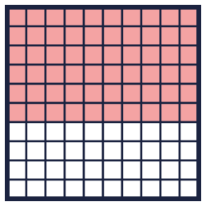  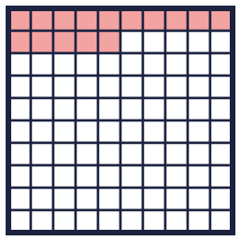
    a) Fraction:
    b) Fraction:
  1 | What fraction, decimal and percentage of each hundred square is shaded? Write the fraction in its simplest form.
    a) Fraction:
    b) Fraction:
  2 | Match each fraction to the equal percentage. Write the letter.  A: 95% B: 20% C: 35% D: 12.5%
    a) ¹⁹⁄₂₀ →
    b) ⁷⁄₂₀ →
    c) ¹⁄₅ →
    d) ¹⁄₈ →
  2 | Match each fraction to the equal percentage. Write the letter.  A: 95% B: 20% C: 35% D: 12.5%
    a) ¹⁹⁄₂₀ →
    b) ⁷⁄₂₀ →
    c) ¹⁄₅ →
    d) ¹⁄₈ →
  3 | Complete the table. Each column shows one amount in three ways.  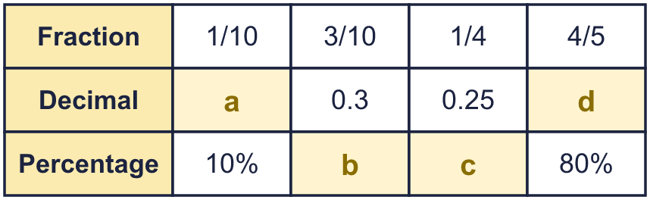
  3 | Complete the table. Each column shows one amount in three ways.
  4 | Write each decimal as a percentage.
    a) 0.12 = |  | %
    b) 0.95 = |  | %
    c) 0.25 = |  | %
    d) 0.5 = |  | %
  4 | Write each decimal as a percentage.
    a) 0.12 = |  | %
    b) 0.95 = |  | %
    c) 0.25 = |  | %
    d) 0.5 = |  | %
  5 | Write each percentage as a decimal.
    a) 12% =
    b) 45% =
    c) 55% =
    d) 75% =
  5 | Write each percentage as a decimal.
    a) 12% =
    b) 45% =
    c) 55% =
    d) 75% =
  6 | Write <, > or = in each box.
    a) ³⁄₂₀ |  | 15%
    b) 55% |  | 0.4
    c) ¹⁄₁₀ |  | 10%
    d) 0.2 |  | ¹⁄₅
  6 | Write <, > or = in each box.
    a) ³⁄₂₀ |  | 15%
    b) 55% |  | 0.4
    c) ¹⁄₁₀ |  | 10%
    d) 0.2 |  | ¹⁄₅
  7 | A hundred square is shaded: ²⁄₅ green, 0.11 red, 10% blue and 0.3 yellow.
    What is left unshaded?
    as a fraction,
     | as a decimal and |  | %
  7 | A hundred square is shaded: ²⁄₅ green, 0.11 red, 10% blue and 0.3 yellow.
    What is left unshaded?
    as a fraction,
     | as a decimal and |  | %
  8 | Write each decimal as a percentage. The answers have a decimal.
    a) 0.125 = |  | %
    b) 0.625 = |  | %
  8 | Write each decimal as a percentage. The answers have a decimal.
    a) 0.125 = |  | %
    b) 0.625 = |  | %

  9 | Amir wants to complete the statement using < , > or =.  16% > 0.3  Is Amir’s statement correct? Circle yes or no.  Yes / No  Explain the mistake. Then write the correct symbol.
     | 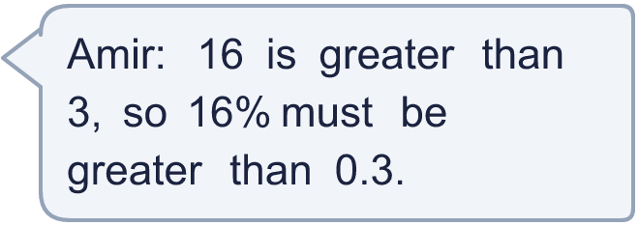
  9 | Amir wants to complete the statement using < , > or =.  16% > 0.3  Is Amir’s statement correct? Circle yes or no.  Yes / No  Explain the mistake. Then write the correct symbol.
  10 | Write a decimal that is greater than ¹⁄₄ but less than 40%.
  10 | Write a decimal that is greater than ¹⁄₄ but less than 40%.
  11 | Write <, > or = in each box.
    a) ¹⁷⁄₂₀ |  | 35%
    b) 0.55 |  | ³⁄₄
  11 | Write <, > or = in each box.
    a) ¹⁷⁄₂₀ |  | 35%
    b) 0.55 |  | ³⁄₄
  12 | Which of these are equal to 0.4? Write the letters.  A: ⁴⁄₁₀₀  B: 0.04  C: 40%  D: ²⁄₅
  12 | Which of these are equal to 0.4? Write the letters.  A: ⁴⁄₁₀₀  B: 0.04  C: 40%  D: ²⁄₅
  13 | A bag has ¹⁄₅ red counters and 15% blue counters. The rest are green.
    What percentage are green? |  | %
  13 | A bag has ¹⁄₅ red counters and 15% blue counters. The rest are green.
    What percentage are green? |  | %
  14 | Challenge  Write a decimal that is greater than ¹⁄₅ but less than 40%.
  14 | Challenge  Write a decimal that is greater than ¹⁄₅ but less than 40%.

Year 6 · Fractions, decimals and percentages · Step 5
Equivalent fractions, decimals and percentages
Answers (teacher copy)

  1 | What fraction, decimal and percentage of each hundred square is shaded? Write the fraction in its simplest form.  a) Fraction: ³⁄₅  Decimal: 0.6  Percentage: 60 %  b) Fraction: ³⁄₂₀  Decimal: 0.15  Percentage: 15 %
  2 | Match each fraction to the equal percentage. Write the letter.  A: 95% B: 20% C: 35% D: 12.5%  a) ¹⁹⁄₂₀ → A  b) ⁷⁄₂₀ → C  c) ¹⁄₅ → B  d) ¹⁄₈ → D
  3 | Complete the table. Each column shows one amount in three ways.  a = 0.1  b = 30%  c = 25%  d = 0.8
  4 | Write each decimal as a percentage.  a) 0.12 = 12 %  b) 0.95 = 95 %  c) 0.25 = 25 %  d) 0.5 = 50 %
  5 | Write each percentage as a decimal.  a) 12% = 0.12  b) 45% = 0.45  c) 55% = 0.55  d) 75% = 0.75
  6 | Write <, > or = in each box.  a) ³⁄₂₀ = 15%  b) 55% > 0.4  c) ¹⁄₁₀ = 10%  d) 0.2 = ¹⁄₅
  7 | A hundred square is shaded: ²⁄₅ green, 0.11 red, 10% blue and 0.3 yellow.  What is left unshaded? ⁹⁄₁₀₀ as a fraction, 0.09 as a decimal and 9 %
  8 | Write each decimal as a percentage. The answers have a decimal.  a) 0.125 = 12.5 %  b) 0.625 = 62.5 %
  9 | Amir wants to complete the statement using < , > or =.  16% > 0.3  Is Amir’s statement correct? Circle yes or no.  Yes / No  Explain the mistake. Then write the correct symbol.  16% = 0.16, which is less compared with 0.3.  <
  10 | Write a decimal that is greater than ¹⁄₄ but less than 40%.  0.325
  11 | Write <, > or = in each box.  a) ¹⁷⁄₂₀ > 35%  b) 0.55 < ³⁄₄
  12 | Which of these are equal to 0.4? Write the letters.  A: ⁴⁄₁₀₀  B: 0.04  C: 40%  D: ²⁄₅  C, D
  13 | A bag has ¹⁄₅ red counters and 15% blue counters. The rest are green.  What percentage are green? 65 %
  14 | Challenge  Write a decimal that is greater than ¹⁄₅ but less than 40%.  0.3

