A fraction, a decimal and a percentage can all show the same amount:  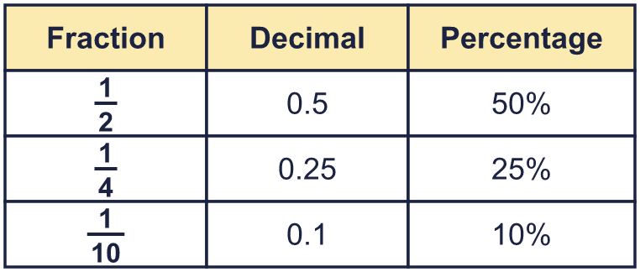 |  | A fraction, a decimal and a percentage can all show the same amount:
  Year 6 · Fractions, decimals and percentages · Step 5  Equivalent fractions, decimals and percentages | 
  Year 6 · Fractions, decimals and percentages · Step 5
  Equivalent fractions, decimals and percentages
  1 | What fraction, decimal and percentage of each hundred square is shaded? Write the fraction in its simplest form.  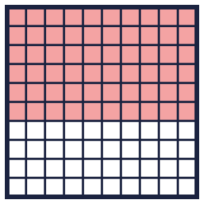  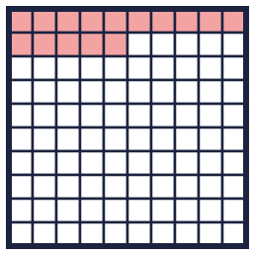  Hint: Count the shaded squares. That is the number out of 100.
    a) Fraction:
    b) Fraction:
  1 | What fraction, decimal and percentage of each hundred square is shaded? Write the fraction in its simplest form.  Hint: Count the shaded squares. That is the number out of 100.
    a) Fraction:
    b) Fraction:
  2 | Match each fraction to the equal percentage. Write the letter.  A: 95% B: 20% C: 35% D: 12.5%  Hint: Change each fraction to a percentage.
    a) ¹⁹⁄₂₀ →
    b) ⁷⁄₂₀ →
    c) ¹⁄₅ →
    d) ¹⁄₈ →
  2 | Match each fraction to the equal percentage. Write the letter.  A: 95% B: 20% C: 35% D: 12.5%  Hint: Change each fraction to a percentage.
    a) ¹⁹⁄₂₀ →
    b) ⁷⁄₂₀ →
    c) ¹⁄₅ →
    d) ¹⁄₈ →
  3 | Complete the table. Each column shows one amount in three ways.  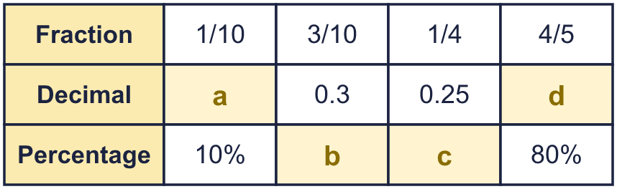  Hint: Change between fractions, decimals and percentages. Use hundredths.
  3 | Complete the table. Each column shows one amount in three ways.  Hint: Change between fractions, decimals and percentages. Use hundredths.
  4 | Write each decimal as a percentage.  Hint: Multiply by 100. Move the digits two places to the left.
    a) 0.12 = |  | %
    b) 0.95 = |  | %
    c) 0.25 = |  | %
    d) 0.5 = |  | %
  4 | Write each decimal as a percentage.  Hint: Multiply by 100. Move the digits two places to the left.
    a) 0.12 = |  | %
    b) 0.95 = |  | %
    c) 0.25 = |  | %
    d) 0.5 = |  | %
  5 | Write each percentage as a decimal.  Hint: Divide by 100. Move the digits two places to the right.
    a) 12% =
    b) 45% =
    c) 55% =
    d) 75% =
  5 | Write each percentage as a decimal.  Hint: Divide by 100. Move the digits two places to the right.
    a) 12% =
    b) 45% =
    c) 55% =
    d) 75% =
  6 | Write <, > or = in each box.  Hint: Change both to the same form first.
    a) ³⁄₂₀ |  | 15%
    b) 55% |  | 0.4
    c) ¹⁄₁₀ |  | 10%
    d) 0.2 |  | ¹⁄₅
  6 | Write <, > or = in each box.  Hint: Change both to the same form first.
    a) ³⁄₂₀ |  | 15%
    b) 55% |  | 0.4
    c) ¹⁄₁₀ |  | 10%
    d) 0.2 |  | ¹⁄₅
  7 | A hundred square is shaded: ²⁄₅ green, 0.11 red, 10% blue and 0.3 yellow.  Hint: Change everything to hundredths. Add. Take the total from 100.
    What is left unshaded?
    as a fraction,
     | as a decimal and |  | %
  7 | A hundred square is shaded: ²⁄₅ green, 0.11 red, 10% blue and 0.3 yellow.  Hint: Change everything to hundredths. Add. Take the total from 100.
    What is left unshaded?
    as a fraction,
     | as a decimal and |  | %
  8 | Write each decimal as a percentage. The answers have a decimal.  Hint: Multiply by 100.
    a) 0.125 = |  | %
    b) 0.625 = |  | %
  8 | Write each decimal as a percentage. The answers have a decimal.  Hint: Multiply by 100.
    a) 0.125 = |  | %
    b) 0.625 = |  | %

  9 | Amir wants to complete the statement using < , > or =.  16% > 0.3  Is Amir’s statement correct? Circle yes or no.  Yes / No  Explain the mistake. Then write the correct symbol.  Hint: Change the percentage to a decimal first.
     | 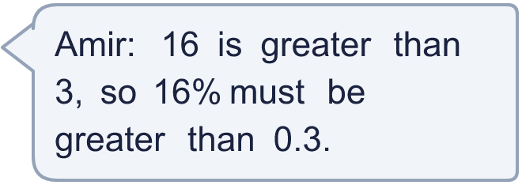
  9 | Amir wants to complete the statement using < , > or =.  16% > 0.3  Is Amir’s statement correct? Circle yes or no.  Yes / No  Explain the mistake. Then write the correct symbol.  Hint: Change the percentage to a decimal first.
  10 | Write a decimal that is greater than ¹⁄₄ but less than 40%.  Hint: Change both to decimals. Choose one in the middle.
  10 | Write a decimal that is greater than ¹⁄₄ but less than 40%.  Hint: Change both to decimals. Choose one in the middle.
  11 | Write <, > or = in each box.  Hint: Change both to decimals.
    a) ¹⁷⁄₂₀ |  | 35%
    b) 0.55 |  | ³⁄₄
  11 | Write <, > or = in each box.  Hint: Change both to decimals.
    a) ¹⁷⁄₂₀ |  | 35%
    b) 0.55 |  | ³⁄₄
  12 | Which of these are equal to 0.4? Write the letters.  A: ⁴⁄₁₀₀  B: 0.04  C: 40%  D: ²⁄₅  Hint: Change each one to a decimal.
  12 | Which of these are equal to 0.4? Write the letters.  A: ⁴⁄₁₀₀  B: 0.04  C: 40%  D: ²⁄₅  Hint: Change each one to a decimal.
  13 | A bag has ¹⁄₅ red counters and 15% blue counters. The rest are green.  Hint: Change the fraction to a percentage. Add. Take the total from 100%.
    What percentage are green? |  | %
  13 | A bag has ¹⁄₅ red counters and 15% blue counters. The rest are green.  Hint: Change the fraction to a percentage. Add. Take the total from 100%.
    What percentage are green? |  | %
  14 | Challenge  Write a decimal that is greater than ¹⁄₅ but less than 40%.  Hint: ¹⁄₅ is 0.2 and 40% is 0.4.
  14 | Challenge  Write a decimal that is greater than ¹⁄₅ but less than 40%.  Hint: ¹⁄₅ is 0.2 and 40% is 0.4.

Year 6 · Fractions, decimals and percentages · Step 5
Equivalent fractions, decimals and percentages
Answers (teacher copy)

A fraction, a decimal and a percentage can all show the same amount:
  1 | What fraction, decimal and percentage of each hundred square is shaded? Write the fraction in its simplest form.  a) Fraction: ³⁄₅  Decimal: 0.6  Percentage: 60 %  b) Fraction: ³⁄₂₀  Decimal: 0.15  Percentage: 15 %  Hint: Count the shaded squares. That is the number out of 100.
  2 | Match each fraction to the equal percentage. Write the letter.  A: 95% B: 20% C: 35% D: 12.5%  a) ¹⁹⁄₂₀ → A  b) ⁷⁄₂₀ → C  c) ¹⁄₅ → B  d) ¹⁄₈ → D  Hint: Change each fraction to a percentage.
  3 | Complete the table. Each column shows one amount in three ways.  a = 0.1  b = 30%  c = 25%  d = 0.8  Hint: Change between fractions, decimals and percentages. Use hundredths.
  4 | Write each decimal as a percentage.  a) 0.12 = 12 %  b) 0.95 = 95 %  c) 0.25 = 25 %  d) 0.5 = 50 %  Hint: Multiply by 100. Move the digits two places to the left.
  5 | Write each percentage as a decimal.  a) 12% = 0.12  b) 45% = 0.45  c) 55% = 0.55  d) 75% = 0.75  Hint: Divide by 100. Move the digits two places to the right.
  6 | Write <, > or = in each box.  a) ³⁄₂₀ = 15%  b) 55% > 0.4  c) ¹⁄₁₀ = 10%  d) 0.2 = ¹⁄₅  Hint: Change both to the same form first.
  7 | A hundred square is shaded: ²⁄₅ green, 0.11 red, 10% blue and 0.3 yellow.  What is left unshaded? ⁹⁄₁₀₀ as a fraction, 0.09 as a decimal and 9 %  Hint: Change everything to hundredths. Add. Take the total from 100.
  8 | Write each decimal as a percentage. The answers have a decimal.  a) 0.125 = 12.5 %  b) 0.625 = 62.5 %  Hint: Multiply by 100.
  9 | Amir wants to complete the statement using < , > or =.  16% > 0.3  Is Amir’s statement correct? Circle yes or no.  Yes / No  Explain the mistake. Then write the correct symbol.  16% = 0.16, which is less compared with 0.3.  <  Hint: Change the percentage to a decimal first.
  10 | Write a decimal that is greater than ¹⁄₄ but less than 40%.  0.325  Hint: Change both to decimals. Choose one in the middle.
  11 | Write <, > or = in each box.  a) ¹⁷⁄₂₀ > 35%  b) 0.55 < ³⁄₄  Hint: Change both to decimals.
  12 | Which of these are equal to 0.4? Write the letters.  A: ⁴⁄₁₀₀  B: 0.04  C: 40%  D: ²⁄₅  C, D  Hint: Change each one to a decimal.
  13 | A bag has ¹⁄₅ red counters and 15% blue counters. The rest are green.  What percentage are green? 65 %  Hint: Change the fraction to a percentage. Add. Take the total from 100%.
  14 | Challenge  Write a decimal that is greater than ¹⁄₅ but less than 40%.  0.3  Hint: ¹⁄₅ is 0.2 and 40% is 0.4.

