Change everything to the same form (for example percentages) before you compare:  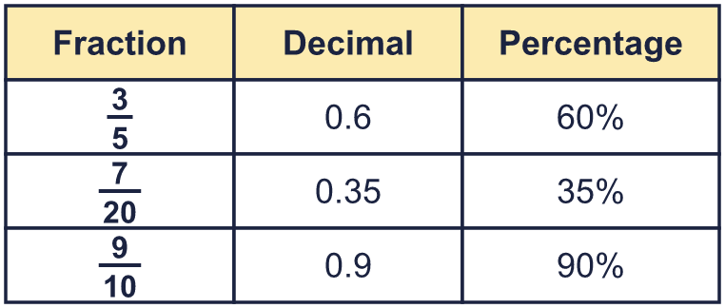 |  | Change everything to the same form (for example percentages) before you compare:
  Year 6 · Fractions, decimals and percentages · Step 6  Ordering fractions, decimals and percentages | 
  Year 6 · Fractions, decimals and percentages · Step 6
  Ordering fractions, decimals and percentages
  1 | Compare each pair. Write <, > or = in each box.  Hint: Change both to percentages.
    a) 0.1 |  | 0.89
    b) 0.38 |  | 60%
    c) ³⁄₂₀ |  | 0.56
    d) ²³⁄₂₅ |  | 0.68
  1 | Compare each pair. Write <, > or = in each box.  Hint: Change both to percentages.
    a) 0.1 |  | 0.89
    b) 0.38 |  | 60%
    c) ³⁄₂₀ |  | 0.56
    d) ²³⁄₂₅ |  | 0.68
  2 | Write these in order, starting with the smallest.  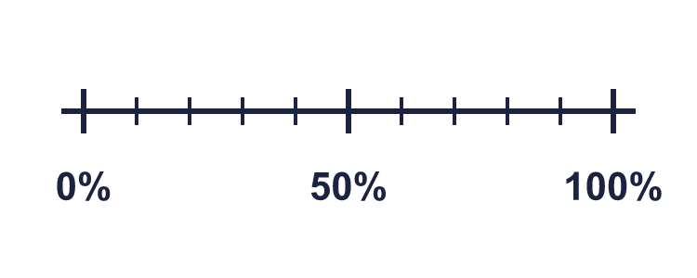  ¹²⁄₅₀ ⁴⁄₂₅ 0.05 70%  Hint: Change every number to a percentage. Then put the percentages in order.
  2 | Write these in order, starting with the smallest.  ¹²⁄₅₀ ⁴⁄₂₅ 0.05 70%  Hint: Change every number to a percentage. Then put the percentages in order.
  3 | Write these in order, starting with the greatest.  0.36 38% 0.48 64%  Hint: Change every number to a percentage. Then put the percentages in order.
  3 | Write these in order, starting with the greatest.  0.36 38% 0.48 64%  Hint: Change every number to a percentage. Then put the percentages in order.
  4 | Write these in ascending order (smallest first).  0.8 25% 0.6 ⁹⁄₂₀  Hint: Change every number to a percentage. Then put the percentages in order.
  4 | Write these in ascending order (smallest first).  0.8 25% 0.6 ⁹⁄₂₀  Hint: Change every number to a percentage. Then put the percentages in order.
  5 | Write these in ascending order (smallest first).  0.1 ⁷⁄₁₀ ¹⁶⁄₂₅ 22% 0.48  Hint: Change every number to a percentage. Then put the percentages in order.
  5 | Write these in ascending order (smallest first).  0.1 ⁷⁄₁₀ ¹⁶⁄₂₅ 22% 0.48  Hint: Change every number to a percentage. Then put the percentages in order.
  6 | These numbers are in descending order (greatest first). Which of the options could fill the gap? Write the letters.  78% , 0.55 , ____ , ³⁹⁄₁₀₀ , 23%  A: 65% B: 0.52 C: ⁷⁷⁄₁₀₀ D: 17%  Hint: The gap number must be smaller than the one before and greater than the one after.
  6 | These numbers are in descending order (greatest first). Which of the options could fill the gap? Write the letters.  78% , 0.55 , ____ , ³⁹⁄₁₀₀ , 23%  A: 65% B: 0.52 C: ⁷⁷⁄₁₀₀ D: 17%  Hint: The gap number must be smaller than the one before and greater than the one after.
  7 | Huan, Nijah and Scott each started with a 1-litre bottle of juice.  Huan drank 0.65 litres.  Nijah drank 70% of her juice.  Scott has ⁴⁄₁₀ of his juice left.  Who drank the most?  Hint: Work out how much each person drank. Use percentages.
  7 | Huan, Nijah and Scott each started with a 1-litre bottle of juice.  Huan drank 0.65 litres.  Nijah drank 70% of her juice.  Scott has ⁴⁄₁₀ of his juice left.  Who drank the most?  Hint: Work out how much each person drank. Use percentages.
  8 | Write these in order, starting with the smallest.  ⁴⁹⁄₅₀ 0.69 8% ⁷⁄₁₀₀  Hint: Change every number to a decimal.
  8 | Write these in order, starting with the smallest.  ⁴⁹⁄₅₀ 0.69 8% ⁷⁄₁₀₀  Hint: Change every number to a decimal.

  9 | Eva scored ¹⁷⁄₂₀ on a test. Amir got 78% of the questions right. Alex scored 0.75 as a decimal.  Who did the best? Write the name.  Hint: Change the three scores to percentages.
  9 | Eva scored ¹⁷⁄₂₀ on a test. Amir got 78% of the questions right. Alex scored 0.75 as a decimal.  Who did the best? Write the name.  Hint: Change the three scores to percentages.
  10 | Huan, Nijah and Scott each started with a 1-litre bottle of juice.  Huan drank 0.35 litres.  Nijah drank 49% of her juice.  Scott has ³⁄₁₀ of his juice left.  Who drank the least?  Hint: Scott has a fraction left. What fraction did he drink?
  10 | Huan, Nijah and Scott each started with a 1-litre bottle of juice.  Huan drank 0.35 litres.  Nijah drank 49% of her juice.  Scott has ³⁄₁₀ of his juice left.  Who drank the least?  Hint: Scott has a fraction left. What fraction did he drink?
  11 | Write a fraction, decimal or percentage that is between 30% and 0.5.  Hint: Change both to decimals. Choose a number in the middle.
  11 | Write a fraction, decimal or percentage that is between 30% and 0.5.  Hint: Change both to decimals. Choose a number in the middle.
  12 | Write these in order, starting with the greatest.  35% 0.25 0.7 0.5 0.84 20%  Hint: Change everything to percentages.
  12 | Write these in order, starting with the greatest.  35% 0.25 0.7 0.5 0.84 20%  Hint: Change everything to percentages.
  13 | Write <, > or = in each box.  Hint: Change both to decimals.
    a) 40% |  | ³⁄₁₀
    b) ³⁄₂₅ |  | 90%
    c) 80% |  | ⁸⁄₂₀
  13 | Write <, > or = in each box.  Hint: Change both to decimals.
    a) 40% |  | ³⁄₁₀
    b) ³⁄₂₅ |  | 90%
    c) 80% |  | ⁸⁄₂₀
  14 | Challenge  These numbers are in descending order. Which options could fill the gap? Write the letters.  83% , 0.69 , ____ , 32% , ¹⁵⁄₁₀₀  A: 46% B: 72% C: 85% D: 42%  Hint: Change the numbers either side of the gap to percentages.
  14 | Challenge  These numbers are in descending order. Which options could fill the gap? Write the letters.  83% , 0.69 , ____ , 32% , ¹⁵⁄₁₀₀  A: 46% B: 72% C: 85% D: 42%  Hint: Change the numbers either side of the gap to percentages.

Year 6 · Fractions, decimals and percentages · Step 6
Ordering fractions, decimals and percentages
Answers (teacher copy)

Change everything to the same form (for example percentages) before you compare:
  1 | Compare each pair. Write <, > or = in each box.  a) 0.1 < 0.89  b) 0.38 < 60%  c) ³⁄₂₀ < 0.56  d) ²³⁄₂₅ > 0.68  Hint: Change both to percentages.
  2 | Write these in order, starting with the smallest.  ¹²⁄₅₀ ⁴⁄₂₅ 0.05 70%  0.05, ⁴⁄₂₅, ¹²⁄₅₀, 70%  Hint: Change every number to a percentage. Then put the percentages in order.
  3 | Write these in order, starting with the greatest.  0.36 38% 0.48 64%  64%, 0.48, 38%, 0.36  Hint: Change every number to a percentage. Then put the percentages in order.
  4 | Write these in ascending order (smallest first).  0.8 25% 0.6 ⁹⁄₂₀  25%, ⁹⁄₂₀, 0.6, 0.8  Hint: Change every number to a percentage. Then put the percentages in order.
  5 | Write these in ascending order (smallest first).  0.1 ⁷⁄₁₀ ¹⁶⁄₂₅ 22% 0.48  0.1, 22%, 0.48, ¹⁶⁄₂₅, ⁷⁄₁₀  Hint: Change every number to a percentage. Then put the percentages in order.
  6 | These numbers are in descending order (greatest first). Which of the options could fill the gap? Write the letters.  78% , 0.55 , ____ , ³⁹⁄₁₀₀ , 23%  A: 65% B: 0.52 C: ⁷⁷⁄₁₀₀ D: 17%  B  Hint: The gap number must be smaller than the one before and greater than the one after.
  7 | Huan, Nijah and Scott each started with a 1-litre bottle of juice.  Huan drank 0.65 litres.  Nijah drank 70% of her juice.  Scott has ⁴⁄₁₀ of his juice left.  Who drank the most?  Nijah  Hint: Work out how much each person drank. Use percentages.
  8 | Write these in order, starting with the smallest.  ⁴⁹⁄₅₀ 0.69 8% ⁷⁄₁₀₀  ⁷⁄₁₀₀, 8%, 0.69, ⁴⁹⁄₅₀  Hint: Change every number to a decimal.
  9 | Eva scored ¹⁷⁄₂₀ on a test. Amir got 78% of the questions right. Alex scored 0.75 as a decimal.  Who did the best? Write the name.  Eva  Hint: Change the three scores to percentages.
  10 | Huan, Nijah and Scott each started with a 1-litre bottle of juice.  Huan drank 0.35 litres.  Nijah drank 49% of her juice.  Scott has ³⁄₁₀ of his juice left.  Who drank the least?  Huan  Hint: Scott has a fraction left. What fraction did he drink?
  11 | Write a fraction, decimal or percentage that is between 30% and 0.5.  0.4  Hint: Change both to decimals. Choose a number in the middle.
  12 | Write these in order, starting with the greatest.  35% 0.25 0.7 0.5 0.84 20%  0.84, 0.7, 0.5, 35%, 0.25, 20%  Hint: Change everything to percentages.
  13 | Write <, > or = in each box.  a) 40% > ³⁄₁₀  b) ³⁄₂₅ < 90%  c) 80% > ⁸⁄₂₀  Hint: Change both to decimals.
  14 | Challenge  These numbers are in descending order. Which options could fill the gap? Write the letters.  83% , 0.69 , ____ , 32% , ¹⁵⁄₁₀₀  A: 46% B: 72% C: 85% D: 42%  A, D  Hint: Change the numbers either side of the gap to percentages.

