Find 10% first (÷ 10). Then build the percentage: 30% is 3 lots of 10%, and 5% is half of 10%:  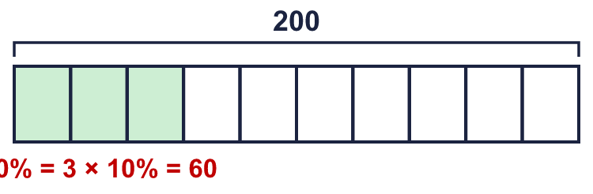 |  | Find 10% first (÷ 10). Then build the percentage: 30% is 3 lots of 10%, and 5% is half of 10%:
  Year 6 · Fractions, decimals and percentages · Step 8  Percentage of an amount: multi-step | 
  Year 6 · Fractions, decimals and percentages · Step 8
  Percentage of an amount: multi-step
  1 | 10% of 500 = 50. Use this to work out each percentage.  Hint: 20% is 2 lots of 10%. 30% is 3 lots of 10%, and so on.
    a) 20% of 500 =
    b) 90% of 500 =
    c) 60% of 500 =
    d) 40% of 500 =
  1 | 10% of 500 = 50. Use this to work out each percentage.  Hint: 20% is 2 lots of 10%. 30% is 3 lots of 10%, and so on.
    a) 20% of 500 =
    b) 90% of 500 =
    c) 60% of 500 =
    d) 40% of 500 =
  2 | Work out each percentage. What do you notice?  Hint: 5% is half of 10%.
    a) 5% of 80 =
    b) 5% of 800 =
    c) 5% of 8,000 =
  2 | Work out each percentage. What do you notice?  Hint: 5% is half of 10%.
    a) 5% of 80 =
    b) 5% of 800 =
    c) 5% of 8,000 =
  3 | Work out each percentage.  Hint: Find 10%. Then halve it to find 5%.
    a) 5% of 1,000 =
    b) 5% of 8,000 =
    c) 5% of 3,400 =
  3 | Work out each percentage.  Hint: Find 10%. Then halve it to find 5%.
    a) 5% of 1,000 =
    b) 5% of 8,000 =
    c) 5% of 3,400 =
  4 | Work out 75% of the amount. Use 25% × 3, or 50% + 25%.  Hint: 25% of 420 is 105. 75% is 3 lots of that.
    a) 75% of 420 =
  4 | Work out 75% of the amount. Use 25% × 3, or 50% + 25%.  Hint: 25% of 420 is 105. 75% is 3 lots of that.
    a) 75% of 420 =
  5 | Work out each percentage.  Hint: 20% is double 10%.
    a) 20% of 1,000 =
    b) 20% of 350 =
    c) 20% of 60 =
  5 | Work out each percentage.  Hint: 20% is double 10%.
    a) 20% of 1,000 =
    b) 20% of 350 =
    c) 20% of 60 =
  6 | Work out each percentage.  Hint: 15% is 10% + 5%.
    a) 15% of 1,000 =
    b) 15% of 400 =
    c) 15% of 60 =
  6 | Work out each percentage.  Hint: 15% is 10% + 5%.
    a) 15% of 1,000 =
    b) 15% of 400 =
    c) 15% of 60 =
  7 | Work out each percentage.  Hint: Find 10% or 1%. Then build the percentage.
    a) 90% of 400 =
    b) 55% of 1,000 =
    c) 40% of 60 =
  7 | Work out each percentage.  Hint: Find 10% or 1%. Then build the percentage.
    a) 90% of 400 =
    b) 55% of 1,000 =
    c) 40% of 60 =
  8 | Work out each percentage.  Hint: 40% is 4 lots of 10%.
    a) 40% of 1,000 =
    b) 40% of 400 =
    c) 40% of 45 =
  8 | Work out each percentage.  Hint: 40% is 4 lots of 10%.
    a) 40% of 1,000 =
    b) 40% of 400 =
    c) 40% of 45 =

  9 | Is Ron correct? Circle yes or no.  Yes / No  Explain. Then write 5% of 120.  Hint: Is 5% half of 10%?
     | 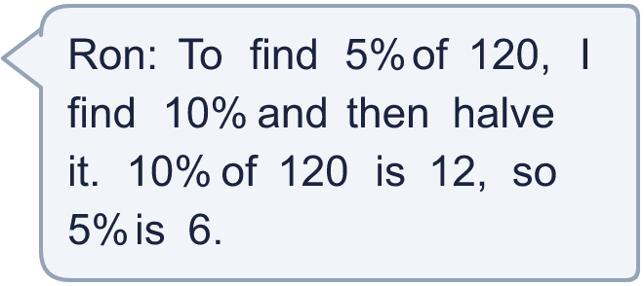
  9 | Is Ron correct? Circle yes or no.  Yes / No  Explain. Then write 5% of 120.  Hint: Is 5% half of 10%?
  10 | Dora says: “40% of 40 is the same as 40% of 40.”  Is Dora correct? Circle yes or no.  Yes / No  Explain how you know.  Hint: Work out both percentages.
  10 | Dora says: “40% of 40 is the same as 40% of 40.”  Is Dora correct? Circle yes or no.  Yes / No  Explain how you know.  Hint: Work out both percentages.
  11 | Complete the calculations. What do you notice about the answers?  Hint: Work out each one separately.
    a) 60% of 30 =
    b) 30% of 60 =
  11 | Complete the calculations. What do you notice about the answers?  Hint: Work out each one separately.
    a) 60% of 30 =
    b) 30% of 60 =
  12 | A school has 840 pupils. 75% of them have school dinners.  How many pupils have school dinners?  Hint: Find 25%. Then multiply by 3.
  12 | A school has 840 pupils. 75% of them have school dinners.  How many pupils have school dinners?  Hint: Find 25%. Then multiply by 3.
  13 | Work out each percentage.  Hint: Use 10% and 5%, or 25%.
    a) 35% of 40 =
    b) 65% of 20 =
  13 | Work out each percentage.  Hint: Use 10% and 5%, or 25%.
    a) 35% of 40 =
    b) 65% of 20 =
  14 | Challenge  Does 80% of 50 equal 50% of 80? Circle yes or no.  Yes / No  Explain how you know.  Hint: Work out both. Does this always happen?
  14 | Challenge  Does 80% of 50 equal 50% of 80? Circle yes or no.  Yes / No  Explain how you know.  Hint: Work out both. Does this always happen?

Year 6 · Fractions, decimals and percentages · Step 8
Percentage of an amount: multi-step
Answers (teacher copy)

Find 10% first (÷ 10). Then build the percentage: 30% is 3 lots of 10%, and 5% is half of 10%:
  1 | 10% of 500 = 50. Use this to work out each percentage.  a) 20% of 500 = 100  b) 90% of 500 = 450  c) 60% of 500 = 300  d) 40% of 500 = 200  Hint: 20% is 2 lots of 10%. 30% is 3 lots of 10%, and so on.
  2 | Work out each percentage. What do you notice?  a) 5% of 80 = 4  b) 5% of 800 = 40  c) 5% of 8,000 = 400  Hint: 5% is half of 10%.
  3 | Work out each percentage.  a) 5% of 1,000 = 50  b) 5% of 8,000 = 400  c) 5% of 3,400 = 170  Hint: Find 10%. Then halve it to find 5%.
  4 | Work out 75% of the amount. Use 25% × 3, or 50% + 25%.  a) 75% of 420 = 315  Hint: 25% of 420 is 105. 75% is 3 lots of that.
  5 | Work out each percentage.  a) 20% of 1,000 = 200  b) 20% of 350 = 70  c) 20% of 60 = 12  Hint: 20% is double 10%.
  6 | Work out each percentage.  a) 15% of 1,000 = 150  b) 15% of 400 = 60  c) 15% of 60 = 9  Hint: 15% is 10% + 5%.
  7 | Work out each percentage.  a) 90% of 400 = 360  b) 55% of 1,000 = 550  c) 40% of 60 = 24  Hint: Find 10% or 1%. Then build the percentage.
  8 | Work out each percentage.  a) 40% of 1,000 = 400  b) 40% of 400 = 160  c) 40% of 45 = 18  Hint: 40% is 4 lots of 10%.
  9 | Is Ron correct? Circle yes or no.  Yes / No  Explain. Then write 5% of 120.  Yes. 5% is half of 10%. 10% of 120 = 12, and half of that is 6.  6  Hint: Is 5% half of 10%?
  10 | Dora says: “40% of 40 is the same as 40% of 40.”  Is Dora correct? Circle yes or no.  Yes / No  Explain how you know.  Yes. 40% of 40 = 16 and 40% of 40 = 16.  Hint: Work out both percentages.
  11 | Complete the calculations. What do you notice about the answers?  a) 60% of 30 = 18  b) 30% of 60 = 18  Hint: Work out each one separately.
  12 | A school has 840 pupils. 75% of them have school dinners.  How many pupils have school dinners? 630  Hint: Find 25%. Then multiply by 3.
  13 | Work out each percentage.  a) 35% of 40 = 14  b) 65% of 20 = 13  Hint: Use 10% and 5%, or 25%.
  14 | Challenge  Does 80% of 50 equal 50% of 80? Circle yes or no.  Yes / No  Explain how you know.  Yes. 80% of 50 = 40 and 50% of 80 = 40.  Hint: Work out both. Does this always happen?

