10% is 1/10, so divide by 10. 50% is 1/2, so divide by 2. 25% is 1/4, so divide by 4. 1% is 1/100, so divide by 100:  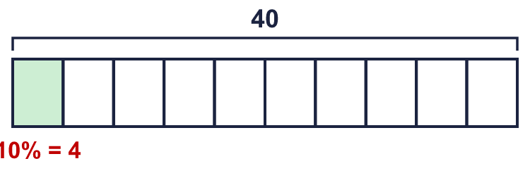 |  | 10% is 1/10, so divide by 10. 50% is 1/2, so divide by 2. 25% is 1/4, so divide by 4. 1% is 1/100, so divide by 100:
  Year 6 · Fractions, decimals and percentages · Step 7  Percentage of an amount: one step | 
  Year 6 · Fractions, decimals and percentages · Step 7
  Percentage of an amount: one step
  1 | Match each fraction to the equal percentage. Write the letter.  A: 50% B: 1% C: 10% D: 25%  Hint: Change each fraction to a percentage.
    a) ¹⁄₁₀ →
    b) ¹⁄₄ →
    c) ¹⁄₁₀₀ →
    d) ¹⁄₂ →
  1 | Match each fraction to the equal percentage. Write the letter.  A: 50% B: 1% C: 10% D: 25%  Hint: Change each fraction to a percentage.
    a) ¹⁄₁₀ →
    b) ¹⁄₄ →
    c) ¹⁄₁₀₀ →
    d) ¹⁄₂ →
  2 | A bar model shows 200. Work out each percentage of 200.  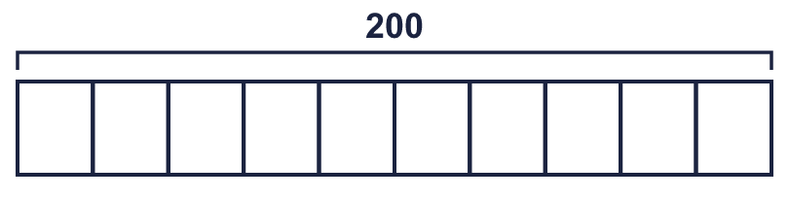  Hint: 10%: divide by 10. 25%: divide by 4. 50%: divide by 2.
    a) 10% of 200 =
    b) 25% of 200 =
    c) 50% of 200 =
  2 | A bar model shows 200. Work out each percentage of 200.  Hint: 10%: divide by 10. 25%: divide by 4. 50%: divide by 2.
    a) 10% of 200 =
    b) 25% of 200 =
    c) 50% of 200 =
  3 | Work out each percentage.  Hint: 50% is a half. 25% is half of a half.
    a) 50% of 520 =
    b) 25% of 520 =
  3 | Work out each percentage.  Hint: 50% is a half. 25% is half of a half.
    a) 50% of 520 =
    b) 25% of 520 =
  4 | Work out each percentage.  Hint: Draw a bar model if it helps.
    a) 50% of 1,560 =
    b) 25% of 1,560 =
    c) 10% of 1,560 =
  4 | Work out each percentage.  Hint: Draw a bar model if it helps.
    a) 50% of 1,560 =
    b) 25% of 1,560 =
    c) 10% of 1,560 =
  5 | Work out each percentage. What do you notice?  Hint: Halving the amount halves the answer.
    a) 50% of 2,000 =
    b) 50% of 1,000 =
    c) 25% of 2,000 =
    d) 10% of 1,000 =
  5 | Work out each percentage. What do you notice?  Hint: Halving the amount halves the answer.
    a) 50% of 2,000 =
    b) 50% of 1,000 =
    c) 25% of 2,000 =
    d) 10% of 1,000 =
  6 | Workers in a toy factory aim to pack 1,600 boxes each day. At 10 am they have completed 25% of their target.  How many boxes have they packed?  Hint: 25% is a quarter. Divide by 4.
  6 | Workers in a toy factory aim to pack 1,600 boxes each day. At 10 am they have completed 25% of their target.  How many boxes have they packed?  Hint: 25% is a quarter. Divide by 4.
  7 | A jumper costs £80. A shop takes 10% off.  Hint: 10% is a tenth. Divide by 10.
  7 | A jumper costs £80. A shop takes 10% off.  Hint: 10% is a tenth. Divide by 10.
  8 | Work out each percentage.  Hint: 1% is ¹⁄₁₀₀. Divide by 100.
    a) 1% of 4,500 =
    b) 1% of 2,250 =
    c) 10% of 9,000 =
  8 | Work out each percentage.  Hint: 1% is ¹⁄₁₀₀. Divide by 100.
    a) 1% of 4,500 =
    b) 1% of 2,250 =
    c) 10% of 9,000 =

  9 | Workers aim to pack 1,600 boxes in a day. By midday they have packed 50% of the target. By 2 pm they have packed another 10% of the target.  How many more boxes must they pack to meet the target?  Hint: How much of the target have they done in total? How much is left?
  9 | Workers aim to pack 1,600 boxes in a day. By midday they have packed 50% of the target. By 2 pm they have packed another 10% of the target.  How many more boxes must they pack to meet the target?  Hint: How much of the target have they done in total? How much is left?
  10 | Tiny works out 25% of 120.  Is Tiny correct? Circle yes or no.  Yes / No  Explain the mistake. Then write the correct answer.  Hint: Is 20% the same as ÷ 20? Think of 10%.
    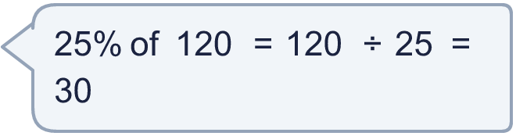
  10 | Tiny works out 25% of 120.  Is Tiny correct? Circle yes or no.  Yes / No  Explain the mistake. Then write the correct answer.  Hint: Is 20% the same as ÷ 20? Think of 10%.
  11 | There are 360 children in a school. 25% of the children walk. 10% of the children cycle.  Hint: 25% is a quarter. 10% is a tenth.
  11 | There are 360 children in a school. 25% of the children walk. 10% of the children cycle.  Hint: 25% is a quarter. 10% is a tenth.
  12 | Work out each percentage.  Hint: Use fractions of the amount.
    a) 50% of 60 =
    b) 10% of 60 =
    c) 1% of 600 =
  12 | Work out each percentage.  Hint: Use fractions of the amount.
    a) 50% of 60 =
    b) 10% of 60 =
    c) 1% of 600 =
  13 | Work out each percentage.  Hint: 20% is 2 lots of 10%. 25% is a quarter.
    a) 20% of 1,200 =
    b) 25% of 1,200 =
  13 | Work out each percentage.  Hint: 20% is 2 lots of 10%. 25% is a quarter.
    a) 20% of 1,200 =
    b) 25% of 1,200 =
  14 | Challenge  A coat costs £200. In a sale it is 25% off.  Hint: Find the discount first. Then take it away from the price.
  14 | Challenge  A coat costs £200. In a sale it is 25% off.  Hint: Find the discount first. Then take it away from the price.

Year 6 · Fractions, decimals and percentages · Step 7
Percentage of an amount: one step
Answers (teacher copy)

10% is 1/10, so divide by 10. 50% is 1/2, so divide by 2. 25% is 1/4, so divide by 4. 1% is 1/100, so divide by 100:
  1 | Match each fraction to the equal percentage. Write the letter.  A: 50% B: 1% C: 10% D: 25%  a) ¹⁄₁₀ → C  b) ¹⁄₄ → D  c) ¹⁄₁₀₀ → B  d) ¹⁄₂ → A  Hint: Change each fraction to a percentage.
  2 | A bar model shows 200. Work out each percentage of 200.  a) 10% of 200 = 20  b) 25% of 200 = 50  c) 50% of 200 = 100  Hint: 10%: divide by 10. 25%: divide by 4. 50%: divide by 2.
  3 | Work out each percentage.  a) 50% of 520 = 260  b) 25% of 520 = 130  Hint: 50% is a half. 25% is half of a half.
  4 | Work out each percentage.  a) 50% of 1,560 = 780  b) 25% of 1,560 = 390  c) 10% of 1,560 = 156  Hint: Draw a bar model if it helps.
  5 | Work out each percentage. What do you notice?  a) 50% of 2,000 = 1,000  b) 50% of 1,000 = 500  c) 25% of 2,000 = 500  d) 10% of 1,000 = 100  Hint: Halving the amount halves the answer.
  6 | Workers in a toy factory aim to pack 1,600 boxes each day. At 10 am they have completed 25% of their target.  How many boxes have they packed? 400  Hint: 25% is a quarter. Divide by 4.
  7 | A jumper costs £80. A shop takes 10% off.  How much is taken off? £8  Hint: 10% is a tenth. Divide by 10.
  8 | Work out each percentage.  a) 1% of 4,500 = 45  b) 1% of 2,250 = 22.5  c) 10% of 9,000 = 900  Hint: 1% is ¹⁄₁₀₀. Divide by 100.
  9 | Workers aim to pack 1,600 boxes in a day. By midday they have packed 50% of the target. By 2 pm they have packed another 10% of the target.  How many more boxes must they pack to meet the target? 640  Hint: How much of the target have they done in total? How much is left?
  10 | Tiny works out 25% of 120.  Is Tiny correct? Circle yes or no.  Yes / No  Explain the mistake. Then write the correct answer.  Yes. 25% of 120 is ²⁵⁄₁₀₀ of 120, which is 30.  30  Hint: Is 20% the same as ÷ 20? Think of 10%.
  11 | There are 360 children in a school. 25% of the children walk. 10% of the children cycle.  How many walk? 90  How many cycle? 36  Hint: 25% is a quarter. 10% is a tenth.
  12 | Work out each percentage.  a) 50% of 60 = 30  b) 10% of 60 = 6  c) 1% of 600 = 6  Hint: Use fractions of the amount.
  13 | Work out each percentage.  a) 20% of 1,200 = 240  b) 25% of 1,200 = 300  Hint: 20% is 2 lots of 10%. 25% is a quarter.
  14 | Challenge  A coat costs £200. In a sale it is 25% off.  What is the sale price? £150  Hint: Find the discount first. Then take it away from the price.

