  Year 6 · Ratio · Step 1  Choosing to add or multiply | 
  Year 6 · Ratio · Step 1
  Choosing to add or multiply
  1 | Write the missing number in each calculation.
    a) | 6 + |  | = 9
    b) | 6 × |  | = 36
    c) |  | − 7 = 6
    d) |  | ÷ 6 = 6
  1 | Write the missing number in each calculation.
    a) | 6 + |  | = 9
    b) | 6 × |  | = 36
    c) |  | − 7 = 6
    d) |  | ÷ 6 = 6
  2 | Choose more than or times the size of to make each sentence true.
    a) | 81 is 9 |  | 9
    b) | 16 is 9 |  | 7
    c) | 24 is 3 |  | 8
    d) | 10 is 4 |  | 6
  2 | Choose more than or times the size of to make each sentence true.
    a) | 81 is 9 |  | 9
    b) | 16 is 9 |  | 7
    c) | 24 is 3 |  | 8
    d) | 10 is 4 |  | 6
  3 | Complete each sentence.
    a) | 32 is |  | more than 8
    b) | 18 is |  | times the size of 9
    c) | 10 is |  | times the size of 2
    d) | 36 is |  | more than 4
  3 | Complete each sentence.
    a) | 32 is |  | more than 8
    b) | 18 is |  | times the size of 9
    c) | 10 is |  | times the size of 2
    d) | 36 is |  | more than 4
  4 | Each sequence follows the rule in brackets: add the same number each time, or multiply by the same number each time. Write the next number.
    a) | 4, 16, … | (multiply)
    b) | 9, 18, … | (multiply)
    c) | 2, 5, … | (add)
    d) | 7, 10, … | (add)
  4 | Each sequence follows the rule in brackets: add the same number each time, or multiply by the same number each time. Write the next number.
    a) | 4, 16, … | (multiply)
    b) | 9, 18, … | (multiply)
    c) | 2, 5, … | (add)
    d) | 7, 10, … | (add)
  5 | Each box holds the same number of pens. Write the missing numbers on the double number line.  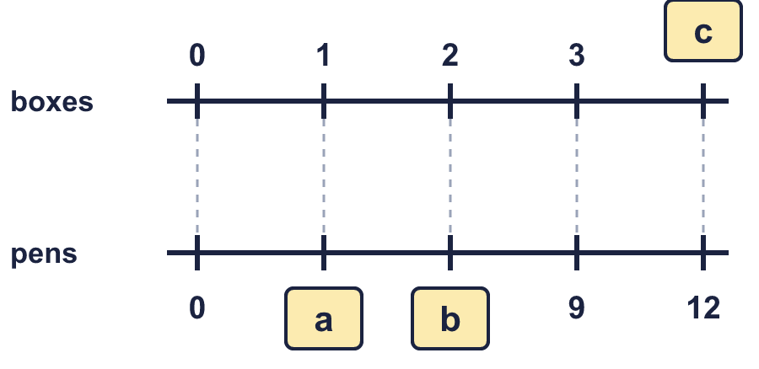
  5 | Each box holds the same number of pens. Write the missing numbers on the double number line.
  6 | Decide whether you need to add or multiply. Then work out the answer.  A: Eva is 6 years older than Mia. Mia is 9 years old now. How old is Eva when Mia is 14 years old?  B: 5 pens cost £15. How much do 10 pens cost?
  6 | Decide whether you need to add or multiply. Then work out the answer.  A: Eva is 6 years older than Mia. Mia is 9 years old now. How old is Eva when Mia is 14 years old?  B: 5 pens cost £15. How much do 10 pens cost?
  7 | The numbers in row B come from the numbers in row A by one rule. Write the missing numbers.  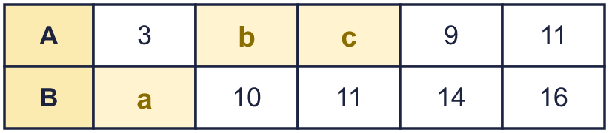
  7 | The numbers in row B come from the numbers in row A by one rule. Write the missing numbers.
  8 | Complete each sentence.
    a) | 110 is
    times the size of 10
    b) | 90 is |  | more than 9
    c) | 64 is |  | more than 8
    d) | 60 is |  | times the size of 10
  8 | Complete each sentence.
    a) | 110 is
    times the size of 10
    b) | 90 is |  | more than 9
    c) | 64 is |  | more than 8
    d) | 60 is |  | times the size of 10

  9 | Is Boba’s answer correct? Circle yes or no.  Yes / No  Explain the mistake.
     | 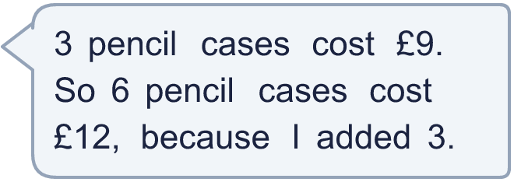
  9 | Is Boba’s answer correct? Circle yes or no.  Yes / No  Explain the mistake.
  10 | Two of these situations need multiplying to compare the amounts. The other two need adding.  A: A tree is 5 m taller than a hedge.  B: Leo is 3 years older than Ron.  C: Each pen costs 5p, so 8 pens cost 40p.  D: Each bag holds 3 apples, so 7 bags hold 21 apples.  Write the letters of the two multiplying situations.
  10 | Two of these situations need multiplying to compare the amounts. The other two need adding.  A: A tree is 5 m taller than a hedge.  B: Leo is 3 years older than Ron.  C: Each pen costs 5p, so 8 pens cost 40p.  D: Each bag holds 3 apples, so 7 bags hold 21 apples.  Write the letters of the two multiplying situations.
  11 | A sequence starts 8, 32, …  Is Leo correct? Circle yes or no.  Yes / No  Explain. Then write a different number that could come next.
     | 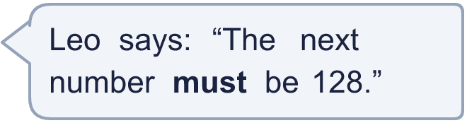
  11 | A sequence starts 8, 32, …  Is Leo correct? Circle yes or no.  Yes / No  Explain. Then write a different number that could come next.
  12 | Two numbers, A and B, fit both of these facts.  A is 15 more than B.  A is 4 times the size of B.  Work out A and B.
  12 | Two numbers, A and B, fit both of these facts.  A is 15 more than B.  A is 4 times the size of B.  Work out A and B.
  13 | In three of these pairs the second number is the same number of times the first number. One pair is different.  A: 8 and 16  B: 9 and 18  C: 10 and 20  D: 11 and 21  Which pair is the odd one out? Write its letter.
  13 | In three of these pairs the second number is the same number of times the first number. One pair is different.  A: 8 and 16  B: 9 and 18  C: 10 and 20  D: 11 and 21  Which pair is the odd one out? Write its letter.
  14 | Challenge  Tia has 3 stickers. Leo has 12 stickers, which is 4 times as many.  They each get 8 more stickers.  Tia says: “Leo still has 4 times as many stickers as Tia.”  Is Tia correct? Circle yes or no.  Yes / No  Explain how you know.
  14 | Challenge  Tia has 3 stickers. Leo has 12 stickers, which is 4 times as many.  They each get 8 more stickers.  Tia says: “Leo still has 4 times as many stickers as Tia.”  Is Tia correct? Circle yes or no.  Yes / No  Explain how you know.

Year 6 · Ratio · Step 1
Choosing to add or multiply
Answers (teacher copy)

  1 | Write the missing number in each calculation.  a) 6 + 3 = 9  b) 6 × 6 = 36  c) 13 − 7 = 6  d) 36 ÷ 6 = 6
  2 | Choose more than or times the size of to make each sentence true.  a) 81 is 9 times the size of 9  b) 16 is 9 more than 7  c) 24 is 3 times the size of 8  d) 10 is 4 more than 6
  3 | Complete each sentence.  a) 32 is 24 more than 8  b) 18 is 2 times the size of 9  c) 10 is 5 times the size of 2  d) 36 is 32 more than 4
  4 | Each sequence follows the rule in brackets: add the same number each time, or multiply by the same number each time. Write the next number.  a) 4, 16, … (multiply) 64  b) 9, 18, … (multiply) 36  c) 2, 5, … (add) 8  d) 7, 10, … (add) 13
  5 | Each box holds the same number of pens. Write the missing numbers on the double number line.  a = 3  b = 6  c = 4
  6 | Decide whether you need to add or multiply. Then work out the answer.  A: Eva is 6 years older than Mia. Mia is 9 years old now. How old is Eva when Mia is 14 years old?  Add or multiply? Add Answer: 20  B: 5 pens cost £15. How much do 10 pens cost?  Add or multiply? Multiply Answer: 30
  7 | The numbers in row B come from the numbers in row A by one rule. Write the missing numbers.  a = 8  b = 5  c = 6
  8 | Complete each sentence.  a) 110 is 11 times the size of 10  b) 90 is 81 more than 9  c) 64 is 56 more than 8  d) 60 is 6 times the size of 10
  9 | Is Boba’s answer correct? Circle yes or no.  Yes / No  Explain the mistake.  Boba added 3. But 6 pencil cases is 2 times as many as 3, so the cost is 2 times as much: £9 × 2 = £18.  Correct cost: £18
  10 | Two of these situations need multiplying to compare the amounts. The other two need adding.  A: A tree is 5 m taller than a hedge.  B: Leo is 3 years older than Ron.  C: Each pen costs 5p, so 8 pens cost 40p.  D: Each bag holds 3 apples, so 7 bags hold 21 apples.  Write the letters of the two multiplying situations.  C, D
  11 | A sequence starts 8, 32, …  Is Leo correct? Circle yes or no.  Yes / No  Explain. Then write a different number that could come next.  No. The next number could be 128 (multiplying by 4 each time) or 56 (adding 24 each time).  Another number: 56
  12 | Two numbers, A and B, fit both of these facts.  A is 15 more than B.  A is 4 times the size of B.  Work out A and B.  A = 20 B = 5
  13 | In three of these pairs the second number is the same number of times the first number. One pair is different.  A: 8 and 16  B: 9 and 18  C: 10 and 20  D: 11 and 21  Which pair is the odd one out? Write its letter.  D
  14 | Challenge  Tia has 3 stickers. Leo has 12 stickers, which is 4 times as many.  They each get 8 more stickers.  Tia says: “Leo still has 4 times as many stickers as Tia.”  Is Tia correct? Circle yes or no.  Yes / No  Explain how you know.  No. Now Tia has 11 and Leo has 20. 20 is not 4 times 11.

