Two ways to compare numbers:  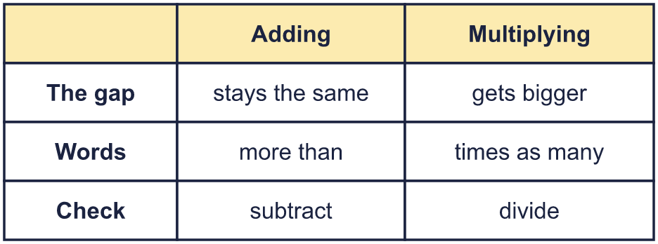 |  | Two ways to compare numbers:
  Year 6 · Ratio · Step 1  Choosing to add or multiply | 
  Year 6 · Ratio · Step 1
  Choosing to add or multiply
  1 | Write the missing number in each calculation.  Hint: Use the opposite (inverse) operation. The opposite of + is −. The opposite of × is ÷.
    a) | 6 + |  | = 9
    b) | 6 × |  | = 36
    c) |  | − 7 = 6
    d) |  | ÷ 6 = 6
  1 | Write the missing number in each calculation.  Hint: Use the opposite (inverse) operation. The opposite of + is −. The opposite of × is ÷.
    a) | 6 + |  | = 9
    b) | 6 × |  | = 36
    c) |  | − 7 = 6
    d) |  | ÷ 6 = 6
  2 | Choose more than or times the size of to make each sentence true.  Hint: Try adding first. Does the sum give the bigger number? If not, try multiplying.
    a) | 81 is 9 |  | 9
    b) | 16 is 9 |  | 7
    c) | 24 is 3 |  | 8
    d) | 10 is 4 |  | 6
  2 | Choose more than or times the size of to make each sentence true.  Hint: Try adding first. Does the sum give the bigger number? If not, try multiplying.
    a) | 81 is 9 |  | 9
    b) | 16 is 9 |  | 7
    c) | 24 is 3 |  | 8
    d) | 10 is 4 |  | 6
  3 | Complete each sentence.  Hint: To find how much more, subtract. To find how many times the size, divide.
    a) | 32 is |  | more than 8
    b) | 18 is |  | times the size of 9
    c) | 10 is |  | times the size of 2
    d) | 36 is |  | more than 4
  3 | Complete each sentence.  Hint: To find how much more, subtract. To find how many times the size, divide.
    a) | 32 is |  | more than 8
    b) | 18 is |  | times the size of 9
    c) | 10 is |  | times the size of 2
    d) | 36 is |  | more than 4
  4 | Each sequence follows the rule in brackets: add the same number each time, or multiply by the same number each time. Write the next number.  Hint: Work out the gap, or how many times bigger the second number is. Then do it again.
    a) | 4, 16, … | (multiply)
    b) | 9, 18, … | (multiply)
    c) | 2, 5, … | (add)
    d) | 7, 10, … | (add)
  4 | Each sequence follows the rule in brackets: add the same number each time, or multiply by the same number each time. Write the next number.  Hint: Work out the gap, or how many times bigger the second number is. Then do it again.
    a) | 4, 16, … | (multiply)
    b) | 9, 18, … | (multiply)
    c) | 2, 5, … | (add)
    d) | 7, 10, … | (add)
  5 | Each box holds the same number of pens. Write the missing numbers on the double number line.  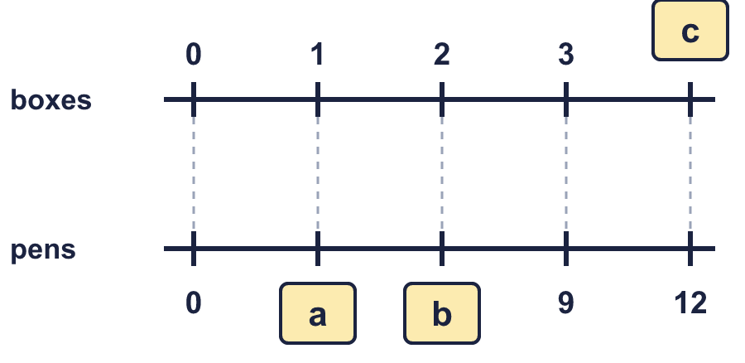  Hint: Each pair of numbers is level. Look at a pair with no missing number to see how many pens are in one box.
  5 | Each box holds the same number of pens. Write the missing numbers on the double number line.  Hint: Each pair of numbers is level. Look at a pair with no missing number to see how many pens are in one box.
  6 | Decide whether you need to add or multiply. Then work out the answer.  A: Eva is 6 years older than Mia. Mia is 9 years old now. How old is Eva when Mia is 14 years old?  B: 5 pens cost £15. How much do 10 pens cost?  Hint: If the gap between two numbers stays the same, add. If every amount grows the same number of times, multiply.
  6 | Decide whether you need to add or multiply. Then work out the answer.  A: Eva is 6 years older than Mia. Mia is 9 years old now. How old is Eva when Mia is 14 years old?  B: 5 pens cost £15. How much do 10 pens cost?  Hint: If the gap between two numbers stays the same, add. If every amount grows the same number of times, multiply.
  7 | The numbers in row B come from the numbers in row A by one rule. Write the missing numbers.  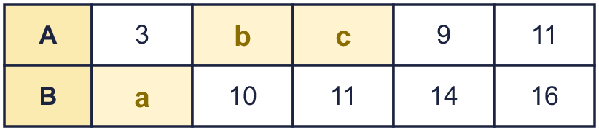  Hint: Find the rule from a column with no missing number. Check it with a second column.
  7 | The numbers in row B come from the numbers in row A by one rule. Write the missing numbers.  Hint: Find the rule from a column with no missing number. Check it with a second column.
  8 | Complete each sentence.  Hint: To find how much more, subtract. To find how many times the size, divide.
    a) | 110 is
    times the size of 10
    b) | 90 is |  | more than 9
    c) | 64 is |  | more than 8
    d) | 60 is |  | times the size of 10
  8 | Complete each sentence.  Hint: To find how much more, subtract. To find how many times the size, divide.
    a) | 110 is
    times the size of 10
    b) | 90 is |  | more than 9
    c) | 64 is |  | more than 8
    d) | 60 is |  | times the size of 10

  9 | Is Boba’s answer correct? Circle yes or no.  Yes / No  Explain the mistake.  Hint: 6 is 2 times 3. Multiply the cost by 2.
     | 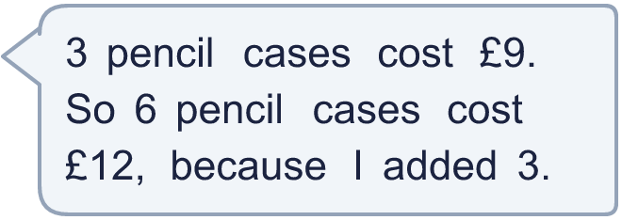
  9 | Is Boba’s answer correct? Circle yes or no.  Yes / No  Explain the mistake.  Hint: 6 is 2 times 3. Multiply the cost by 2.
  10 | Two of these situations need multiplying to compare the amounts. The other two need adding.  A: A tree is 5 m taller than a hedge.  B: Leo is 3 years older than Ron.  C: Each pen costs 5p, so 8 pens cost 40p.  D: Each bag holds 3 apples, so 7 bags hold 21 apples.  Write the letters of the two multiplying situations.  Hint: Ask: does the same number get added each time, or does everything grow the same number of times?
  10 | Two of these situations need multiplying to compare the amounts. The other two need adding.  A: A tree is 5 m taller than a hedge.  B: Leo is 3 years older than Ron.  C: Each pen costs 5p, so 8 pens cost 40p.  D: Each bag holds 3 apples, so 7 bags hold 21 apples.  Write the letters of the two multiplying situations.  Hint: Ask: does the same number get added each time, or does everything grow the same number of times?
  11 | A sequence starts 8, 32, …  Is Leo correct? Circle yes or no.  Yes / No  Explain. Then write a different number that could come next.  Hint: A sequence could add the same number each time, or multiply by the same number each time.
     | 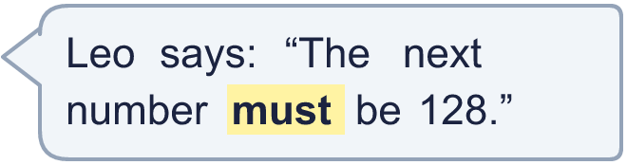
  11 | A sequence starts 8, 32, …  Is Leo correct? Circle yes or no.  Yes / No  Explain. Then write a different number that could come next.  Hint: A sequence could add the same number each time, or multiply by the same number each time.
  12 | Two numbers, A and B, fit both of these facts.  A is 15 more than B.  A is 4 times the size of B.  Work out A and B.  Hint: 15 is the gap between A and B. A is 4 times B, so the gap is 3 lots of B. Divide 15 by 3.
  12 | Two numbers, A and B, fit both of these facts.  A is 15 more than B.  A is 4 times the size of B.  Work out A and B.  Hint: 15 is the gap between A and B. A is 4 times B, so the gap is 3 lots of B. Divide 15 by 3.
  13 | In three of these pairs the second number is the same number of times the first number. One pair is different.  A: 8 and 16  B: 9 and 18  C: 10 and 20  D: 11 and 21  Which pair is the odd one out? Write its letter.  Hint: Divide the bigger number by the smaller one for each pair.
  13 | In three of these pairs the second number is the same number of times the first number. One pair is different.  A: 8 and 16  B: 9 and 18  C: 10 and 20  D: 11 and 21  Which pair is the odd one out? Write its letter.  Hint: Divide the bigger number by the smaller one for each pair.
  14 | Challenge  Tia has 3 stickers. Leo has 12 stickers, which is 4 times as many.  They each get 8 more stickers.  Tia says: “Leo still has 4 times as many stickers as Tia.”  Is Tia correct? Circle yes or no.  Yes / No  Explain how you know.  Hint: Work out how many each person has now. Then divide the bigger number by the smaller number.
  14 | Challenge  Tia has 3 stickers. Leo has 12 stickers, which is 4 times as many.  They each get 8 more stickers.  Tia says: “Leo still has 4 times as many stickers as Tia.”  Is Tia correct? Circle yes or no.  Yes / No  Explain how you know.  Hint: Work out how many each person has now. Then divide the bigger number by the smaller number.

Year 6 · Ratio · Step 1
Choosing to add or multiply
Answers (teacher copy)

Two ways to compare numbers:
  1 | Write the missing number in each calculation.  a) 6 + 3 = 9  b) 6 × 6 = 36  c) 13 − 7 = 6  d) 36 ÷ 6 = 6  Hint: Use the opposite (inverse) operation. The opposite of + is −. The opposite of × is ÷.
  2 | Choose more than or times the size of to make each sentence true.  a) 81 is 9 times the size of 9  b) 16 is 9 more than 7  c) 24 is 3 times the size of 8  d) 10 is 4 more than 6  Hint: Try adding first. Does the sum give the bigger number? If not, try multiplying.
  3 | Complete each sentence.  a) 32 is 24 more than 8  b) 18 is 2 times the size of 9  c) 10 is 5 times the size of 2  d) 36 is 32 more than 4  Hint: To find how much more, subtract. To find how many times the size, divide.
  4 | Each sequence follows the rule in brackets: add the same number each time, or multiply by the same number each time. Write the next number.  a) 4, 16, … (multiply) 64  b) 9, 18, … (multiply) 36  c) 2, 5, … (add) 8  d) 7, 10, … (add) 13  Hint: Work out the gap, or how many times bigger the second number is. Then do it again.
  5 | Each box holds the same number of pens. Write the missing numbers on the double number line.  a = 3  b = 6  c = 4  Hint: Each pair of numbers is level. Look at a pair with no missing number to see how many pens are in one box.
  6 | Decide whether you need to add or multiply. Then work out the answer.  A: Eva is 6 years older than Mia. Mia is 9 years old now. How old is Eva when Mia is 14 years old?  Add or multiply? Add Answer: 20  B: 5 pens cost £15. How much do 10 pens cost?  Add or multiply? Multiply Answer: 30  Hint: If the gap between two numbers stays the same, add. If every amount grows the same number of times, multiply.
  7 | The numbers in row B come from the numbers in row A by one rule. Write the missing numbers.  a = 8  b = 5  c = 6  Hint: Find the rule from a column with no missing number. Check it with a second column.
  8 | Complete each sentence.  a) 110 is 11 times the size of 10  b) 90 is 81 more than 9  c) 64 is 56 more than 8  d) 60 is 6 times the size of 10  Hint: To find how much more, subtract. To find how many times the size, divide.
  9 | Is Boba’s answer correct? Circle yes or no.  Yes / No  Explain the mistake.  Boba added 3. But 6 pencil cases is 2 times as many as 3, so the cost is 2 times as much: £9 × 2 = £18.  Correct cost: £18  Hint: 6 is 2 times 3. Multiply the cost by 2.
  10 | Two of these situations need multiplying to compare the amounts. The other two need adding.  A: A tree is 5 m taller than a hedge.  B: Leo is 3 years older than Ron.  C: Each pen costs 5p, so 8 pens cost 40p.  D: Each bag holds 3 apples, so 7 bags hold 21 apples.  Write the letters of the two multiplying situations.  C, D  Hint: Ask: does the same number get added each time, or does everything grow the same number of times?
  11 | A sequence starts 8, 32, …  Is Leo correct? Circle yes or no.  Yes / No  Explain. Then write a different number that could come next.  No. The next number could be 128 (multiplying by 4 each time) or 56 (adding 24 each time).  Another number: 56  Hint: A sequence could add the same number each time, or multiply by the same number each time.
  12 | Two numbers, A and B, fit both of these facts.  A is 15 more than B.  A is 4 times the size of B.  Work out A and B.  A = 20 B = 5  Hint: 15 is the gap between A and B. A is 4 times B, so the gap is 3 lots of B. Divide 15 by 3.
  13 | In three of these pairs the second number is the same number of times the first number. One pair is different.  A: 8 and 16  B: 9 and 18  C: 10 and 20  D: 11 and 21  Which pair is the odd one out? Write its letter.  D  Hint: Divide the bigger number by the smaller one for each pair.
  14 | Challenge  Tia has 3 stickers. Leo has 12 stickers, which is 4 times as many.  They each get 8 more stickers.  Tia says: “Leo still has 4 times as many stickers as Tia.”  Is Tia correct? Circle yes or no.  Yes / No  Explain how you know.  No. Now Tia has 11 and Leo has 20. 20 is not 4 times 11.  Hint: Work out how many each person has now. Then divide the bigger number by the smaller number.

