Find the cost of 1 first. Then multiply:  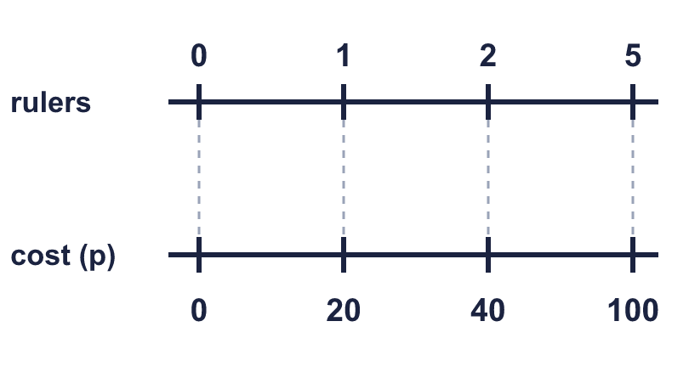 |  | Find the cost of 1 first. Then multiply:
  Year 6 · Ratio · Step 9  Proportion problems | 
  Year 6 · Ratio · Step 9
  Proportion problems
  1 | One pen costs 40p. Write the missing numbers on the double number line.  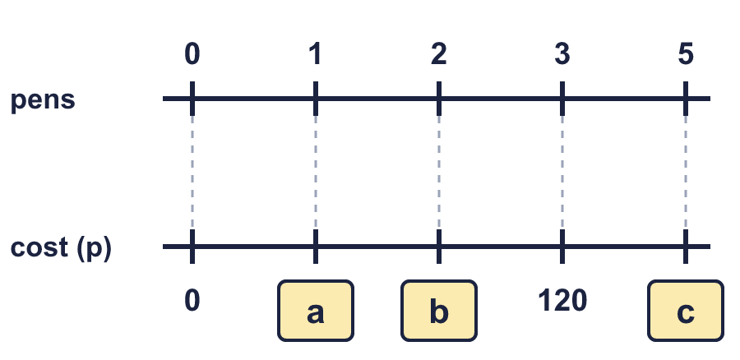  Hint: Each pair of numbers is level. The cost of 2 is double the cost of 1.
  1 | One pen costs 40p. Write the missing numbers on the double number line.  Hint: Each pair of numbers is level. The cost of 2 is double the cost of 1.
  2 | Work out the cost. First find the cost of one.  a) 3 rulers cost £1.35. How much do 6 rulers cost?  b) 6 notebooks cost 90p. How much do 12 notebooks cost?  c) 2 pencils cost 30p. How much do 6 pencils cost?  Hint: Divide the cost by the number of items to find the cost of one. Then multiply.
  2 | Work out the cost. First find the cost of one.  a) 3 rulers cost £1.35. How much do 6 rulers cost?  b) 6 notebooks cost 90p. How much do 12 notebooks cost?  c) 2 pencils cost 30p. How much do 6 pencils cost?  Hint: Divide the cost by the number of items to find the cost of one. Then multiply.
  3 | 8 rulers cost £2.  a) 16 rulers:  b) 40 rulers:  Hint: Find the cost of one. Or double the cost, then multiply by 5.
  3 | 8 rulers cost £2.  a) 16 rulers:  b) 40 rulers:  Hint: Find the cost of one. Or double the cost, then multiply by 5.
  4 | 4 erasers cost £3. How many erasers can you buy for £4.50?  Hint: Find the cost of one eraser. Then divide the money by it.
  4 | 4 erasers cost £3. How many erasers can you buy for £4.50?  Hint: Find the cost of one eraser. Then divide the money by it.
  5 | A machine makes 95 biscuits in 5 minutes.  a) 15 minutes: biscuits  b) 50 minutes: biscuits  Hint: How many biscuits does the machine make in 1 minute?
  5 | A machine makes 95 biscuits in 5 minutes.  a) 15 minutes: biscuits  b) 50 minutes: biscuits  Hint: How many biscuits does the machine make in 1 minute?
  6 | 2 boxes of rulers contain 68 rulers altogether.  a) How many rulers in 6 boxes?  b) How many rulers in 10 boxes?  c) How many boxes hold 680 rulers?  Hint: Find how many rulers are in 1 box. Multiply or divide.
  6 | 2 boxes of rulers contain 68 rulers altogether.  a) How many rulers in 6 boxes?  b) How many rulers in 10 boxes?  c) How many boxes hold 680 rulers?  Hint: Find how many rulers are in 1 box. Multiply or divide.
  7 | A car travels at a steady speed. It goes 20 miles in 20 minutes. How far will it go in 1 hour?  Hint: There are 60 minutes in 1 hour. How many lots of 20 minutes is that?
  7 | A car travels at a steady speed. It goes 20 miles in 20 minutes. How far will it go in 1 hour?  Hint: There are 60 minutes in 1 hour. How many lots of 20 minutes is that?
  8 | 8 litres of petrol cost £14.80. How much do 11 litres of petrol cost?  Hint: Find the cost of 1 litre. Then multiply by the number of litres.
  8 | 8 litres of petrol cost £14.80. How much do 11 litres of petrol cost?  Hint: Find the cost of 1 litre. Then multiply by the number of litres.

  9 | 2 folders cost £6.  Is Boba’s answer correct? Circle yes or no.  Yes / No  Explain the mistake.  Hint: Find the cost of one first: £6 ÷ 2.
     | 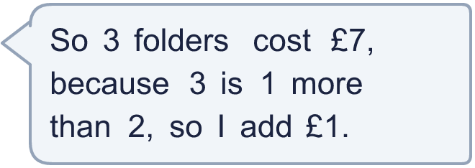
  9 | 2 folders cost £6.  Is Boba’s answer correct? Circle yes or no.  Yes / No  Explain the mistake.  Hint: Find the cost of one first: £6 ÷ 2.
  10 | Shop X sells 5 pencils for £1.50. Shop Y sells 15 pencils for £5.25.  Hint: Work out the cost of 1 in each shop. The smaller cost is the better value.
  10 | Shop X sells 5 pencils for £1.50. Shop Y sells 15 pencils for £5.25.  Hint: Work out the cost of 1 in each shop. The smaller cost is the better value.
  11 | It costs £2.40 to make 25 key rings. Key rings are sold in boxes of 250 for £75.  It costs £2 to make 10 bangles. Bangles are sold in boxes of 500 for £120.  Profit = selling price − cost to make. How much more profit is made on a box of key rings than on a box of bangles?  Hint: Find the cost to make everything in one box. Subtract it from the selling price to find the profit for each box.
  11 | It costs £2.40 to make 25 key rings. Key rings are sold in boxes of 250 for £75.  It costs £2 to make 10 bangles. Bangles are sold in boxes of 500 for £120.  Profit = selling price − cost to make. How much more profit is made on a box of key rings than on a box of bangles?  Hint: Find the cost to make everything in one box. Subtract it from the selling price to find the profit for each box.
  12 | A pump fills 6 litres in 15 seconds.  a) Litres in 1 minute:  b) Seconds to fill 60 litres:  Hint: Find how many litres per second, or how many seconds for 6 litres. Then scale up.
  12 | A pump fills 6 litres in 15 seconds.  a) Litres in 1 minute:  b) Seconds to fill 60 litres:  Hint: Find how many litres per second, or how many seconds for 6 litres. Then scale up.
  13 | Dora cycles 15 km in 45 minutes at a steady speed.  How far does Dora cycle in 2 hours?  Hint: 2 hours is 2 × 60 minutes. How many lots of the time given are there in that?
  13 | Dora cycles 15 km in 45 minutes at a steady speed.  How far does Dora cycle in 2 hours?  Hint: 2 hours is 2 × 60 minutes. How many lots of the time given are there in that?
  14 | Challenge  A shop sells apples in three different packs.  A: 10 apples for £4.20  B: 5 apples for £1.60  C: 3 apples for £1.14  Which pack is the best value? How much would 60 apples cost at the best value price?  Hint: Find the cost of one apple in each pack. Choose the smallest. Then multiply by the number you want.
  14 | Challenge  A shop sells apples in three different packs.  A: 10 apples for £4.20  B: 5 apples for £1.60  C: 3 apples for £1.14  Which pack is the best value? How much would 60 apples cost at the best value price?  Hint: Find the cost of one apple in each pack. Choose the smallest. Then multiply by the number you want.

Year 6 · Ratio · Step 9
Proportion problems
Answers (teacher copy)

Find the cost of 1 first. Then multiply:
  1 | One pen costs 40p. Write the missing numbers on the double number line.  a = 40  b = 80  c = 200  Hint: Each pair of numbers is level. The cost of 2 is double the cost of 1.
  2 | Work out the cost. First find the cost of one.  a) 3 rulers cost £1.35. How much do 6 rulers cost?  Cost: £2.70  b) 6 notebooks cost 90p. How much do 12 notebooks cost?  Cost: £1.80  c) 2 pencils cost 30p. How much do 6 pencils cost?  Cost: 90p  Hint: Divide the cost by the number of items to find the cost of one. Then multiply.
  3 | 8 rulers cost £2.  a) 16 rulers: £4  b) 40 rulers: £10  Hint: Find the cost of one. Or double the cost, then multiply by 5.
  4 | 4 erasers cost £3. How many erasers can you buy for £4.50?  6 erasers  Hint: Find the cost of one eraser. Then divide the money by it.
  5 | A machine makes 95 biscuits in 5 minutes.  a) 15 minutes: 285 biscuits  b) 50 minutes: 950 biscuits  Hint: How many biscuits does the machine make in 1 minute?
  6 | 2 boxes of rulers contain 68 rulers altogether.  a) How many rulers in 6 boxes? 204  b) How many rulers in 10 boxes? 340  c) How many boxes hold 680 rulers? 20  Hint: Find how many rulers are in 1 box. Multiply or divide.
  7 | A car travels at a steady speed. It goes 20 miles in 20 minutes. How far will it go in 1 hour?  60 miles  Hint: There are 60 minutes in 1 hour. How many lots of 20 minutes is that?
  8 | 8 litres of petrol cost £14.80. How much do 11 litres of petrol cost?  £20.35  Hint: Find the cost of 1 litre. Then multiply by the number of litres.
  9 | 2 folders cost £6.  Is Boba’s answer correct? Circle yes or no.  Yes / No  Explain the mistake.  Boba added. The number of folders is 1.5 times as many, so the cost is 1.5 times as much: £6 × 1.5 = £9.  Correct cost: £9  Hint: Find the cost of one first: £6 ÷ 2.
  10 | Shop X sells 5 pencils for £1.50. Shop Y sells 15 pencils for £5.25.  Cost of one in shop X: 30 p  Cost of one in shop Y: 35 p  Better value: X  Hint: Work out the cost of 1 in each shop. The smaller cost is the better value.
  11 | It costs £2.40 to make 25 key rings. Key rings are sold in boxes of 250 for £75.  It costs £2 to make 10 bangles. Bangles are sold in boxes of 500 for £120.  Profit = selling price − cost to make. How much more profit is made on a box of key rings than on a box of bangles?  £31  Hint: Find the cost to make everything in one box. Subtract it from the selling price to find the profit for each box.
  12 | A pump fills 6 litres in 15 seconds.  a) Litres in 1 minute: 24  b) Seconds to fill 60 litres: 150  Hint: Find how many litres per second, or how many seconds for 6 litres. Then scale up.
  13 | Dora cycles 15 km in 45 minutes at a steady speed.  How far does Dora cycle in 2 hours?  40 km  Hint: 2 hours is 2 × 60 minutes. How many lots of the time given are there in that?
  14 | Challenge  A shop sells apples in three different packs.  A: 10 apples for £4.20  B: 5 apples for £1.60  C: 3 apples for £1.14  Which pack is the best value? How much would 60 apples cost at the best value price?  B  £19.20  Hint: Find the cost of one apple in each pack. Choose the smallest. Then multiply by the number you want.

