  Year 6 · Ratio · Step 8  Ratio problems | 
  Year 6 · Ratio · Step 8
  Ratio problems
  1 | The ratio of red to blue is 5 : 2. There are 28 altogether.  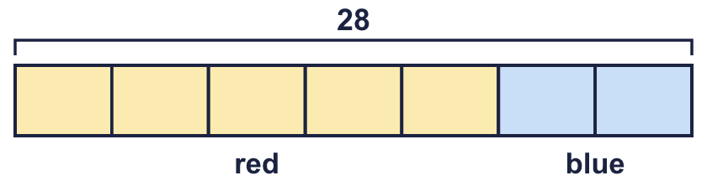
  1 | The ratio of red to blue is 5 : 2. There are 28 altogether.
  2 | Use the ratio to work out the missing number.  a) The ratio of bikes to scooters is 5 : 3. There are 27 scooters.  b) The ratio of bikes to scooters is 2 : 5. There are 15 scooters.  c) The ratio of cows to sheep is 2 : 5. There are 14 cows.
  2 | Use the ratio to work out the missing number.  a) The ratio of bikes to scooters is 5 : 3. There are 27 scooters.  b) The ratio of bikes to scooters is 2 : 5. There are 15 scooters.  c) The ratio of cows to sheep is 2 : 5. There are 14 cows.
  3 | Dora and Tia share 35 stickers in the ratio 3 : 2.
    Dora gets |  | and Tia gets
  3 | Dora and Tia share 35 stickers in the ratio 3 : 2.
    Dora gets |  | and Tia gets
  4 | Mia and Leo share £175 in the ratio 2 : 3.
    Mia gets |  | and Leo gets
  4 | Mia and Leo share £175 in the ratio 2 : 3.
    Mia gets |  | and Leo gets
  5 | 88 stickers are shared in the ratio 4 : 2 : 5.
    The three shares are
    and
  5 | 88 stickers are shared in the ratio 4 : 2 : 5.
    The three shares are
    and
  6 | The ratio of boys to girls is 7 : 4. There are 21 more boys than girls.
  6 | The ratio of boys to girls is 7 : 4. There are 21 more boys than girls.
  7 | A money box has 20p coins and 5p coins in the ratio 3 : 5. There are 30 5p coins.  How much money is in the box?
  7 | A money box has 20p coins and 5p coins in the ratio 3 : 5. There are 30 5p coins.  How much money is in the box?
  8 | A mix has gravel A and gravel B in the ratio 9 : 2. The mix has a mass of 440 g.
  8 | A mix has gravel A and gravel B in the ratio 9 : 2. The mix has a mass of 440 g.

  9 | Dora shares 36 sweets between two friends in the ratio 5 : 1.  Is Boba correct? Circle yes or no.  Yes / No  Explain the mistake. Then write the correct shares.
    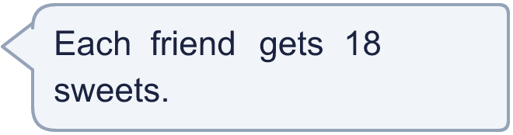
    Shares: |  | and
  9 | Dora shares 36 sweets between two friends in the ratio 5 : 1.  Is Boba correct? Circle yes or no.  Yes / No  Explain the mistake. Then write the correct shares.
    Shares: |  | and
  10 | Eva has a box of counters. For every 5 blue counters there are 2 yellow counters.  Eva takes out 9 blue counters. Now there are the same number of blue and yellow counters in the box.  How many yellow counters are in the box?
  10 | Eva has a box of counters. For every 5 blue counters there are 2 yellow counters.  Eva takes out 9 blue counters. Now there are the same number of blue and yellow counters in the box.  How many yellow counters are in the box?
  11 | The ratio of 20p coins to 5p coins in a jar is 6 : 1. There are 24 20p coins.  How much money is in the jar? Write your answer in pounds.
  11 | The ratio of 20p coins to 5p coins in a jar is 6 : 1. There are 24 20p coins.  How much money is in the jar? Write your answer in pounds.
  12 | The ratio of adults to children at a club is 6 : 1. There are 15 more adults than children.  How many people are at the club altogether?
  12 | The ratio of adults to children at a club is 6 : 1. There are 15 more adults than children.  How many people are at the club altogether?
  13 | A bag holds 1 kg of mixed nuts. The ratio of almonds to cashews is 3 : 5.  What is the mass of the almonds in grams?
  13 | A bag holds 1 kg of mixed nuts. The ratio of almonds to cashews is 3 : 5.  What is the mass of the almonds in grams?
  14 | Challenge  A bag has green and yellow counters in the ratio 5 : 6. 2 more green counters are added. Now there are the same number of green and yellow counters.  How many counters are in the bag now?
  14 | Challenge  A bag has green and yellow counters in the ratio 5 : 6. 2 more green counters are added. Now there are the same number of green and yellow counters.  How many counters are in the bag now?

Year 6 · Ratio · Step 8
Ratio problems
Answers (teacher copy)

  1 | The ratio of red to blue is 5 : 2. There are 28 altogether.  One equal part is worth 4  Number of red: 20  Number of blue: 8
  2 | Use the ratio to work out the missing number.  a) The ratio of bikes to scooters is 5 : 3. There are 27 scooters.  How many bikes? 45  b) The ratio of bikes to scooters is 2 : 5. There are 15 scooters.  How many bikes? 6  c) The ratio of cows to sheep is 2 : 5. There are 14 cows.  How many sheep? 35
  3 | Dora and Tia share 35 stickers in the ratio 3 : 2.  Dora gets 21 and Tia gets 14
  4 | Mia and Leo share £175 in the ratio 2 : 3.  Mia gets £70 and Leo gets £105
  5 | 88 stickers are shared in the ratio 4 : 2 : 5.  The three shares are 32 16 and 40
  6 | The ratio of boys to girls is 7 : 4. There are 21 more boys than girls.  How many boys? 49  How many girls? 28
  7 | A money box has 20p coins and 5p coins in the ratio 3 : 5. There are 30 5p coins.  How much money is in the box?  £5.10
  8 | A mix has gravel A and gravel B in the ratio 9 : 2. The mix has a mass of 440 g.  Mass of A: 360 g Mass of B: 80 g
  9 | Dora shares 36 sweets between two friends in the ratio 5 : 1.  Is Boba correct? Circle yes or no.  Yes / No  Explain the mistake. Then write the correct shares.  No. Boba shared them equally, but the ratio 5 : 1 is not equal. There are 5 + 1 = 6 parts, so one part is 6.  Shares: 30 and 6
  10 | Eva has a box of counters. For every 5 blue counters there are 2 yellow counters.  Eva takes out 9 blue counters. Now there are the same number of blue and yellow counters in the box.  How many yellow counters are in the box?  6
  11 | The ratio of 20p coins to 5p coins in a jar is 6 : 1. There are 24 20p coins.  How much money is in the jar? Write your answer in pounds.  £5
  12 | The ratio of adults to children at a club is 6 : 1. There are 15 more adults than children.  How many people are at the club altogether?  21
  13 | A bag holds 1 kg of mixed nuts. The ratio of almonds to cashews is 3 : 5.  What is the mass of the almonds in grams?  375 g
  14 | Challenge  A bag has green and yellow counters in the ratio 5 : 6. 2 more green counters are added. Now there are the same number of green and yellow counters.  How many counters are in the bag now?  24

