  Year 6 · Ratio · Step 10  Recipes and scaling | 
  Year 6 · Ratio · Step 10
  Recipes and scaling
  1 | Here is a recipe for 10 scones. How much of each ingredient is needed to make 20 scones?  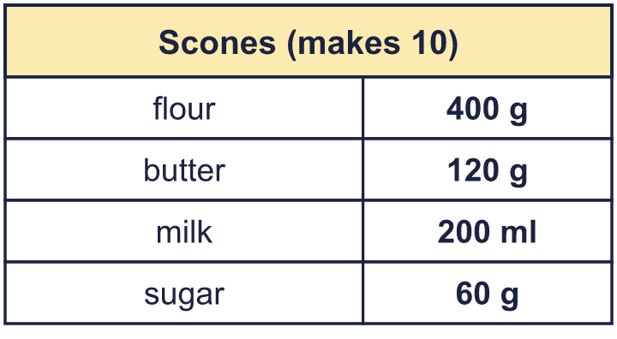
  1 | Here is a recipe for 10 scones. How much of each ingredient is needed to make 20 scones?
  2 | Here is a recipe for 8 flapjacks. How much of each ingredient is needed to make 4 flapjacks?  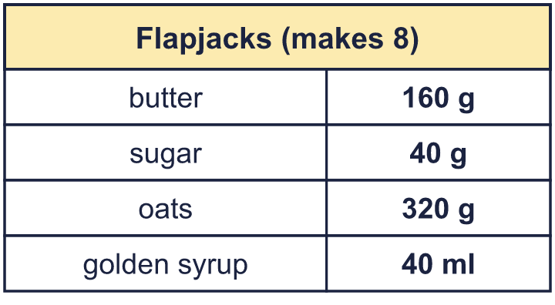
  2 | Here is a recipe for 8 flapjacks. How much of each ingredient is needed to make 4 flapjacks?
  3 | Here is a recipe for 10 muffins. How much of each ingredient is needed to make 1 muffin?  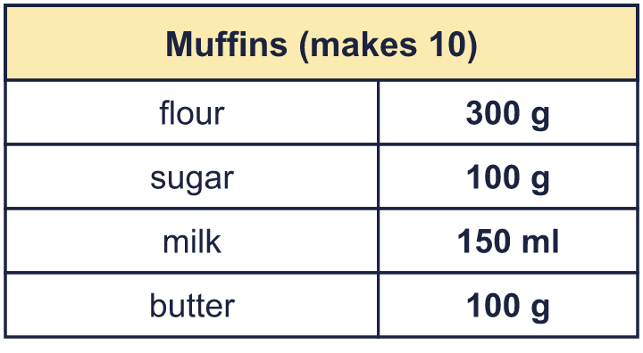
  3 | Here is a recipe for 10 muffins. How much of each ingredient is needed to make 1 muffin?
  4 | Here is a recipe for 4 muffins. How much of each ingredient is needed to make 10 muffins?  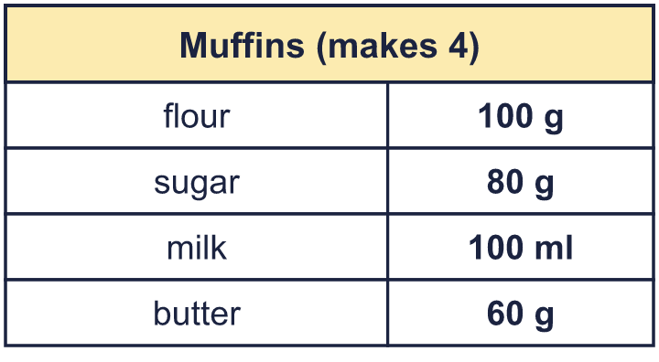
  4 | Here is a recipe for 4 muffins. How much of each ingredient is needed to make 10 muffins?
  5 | Here is a recipe for 8 cupcakes. Write the amounts for 4 cupcakes.  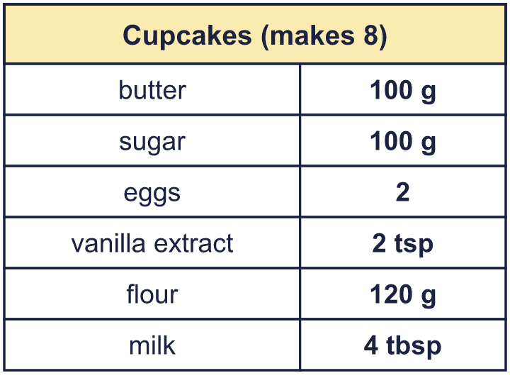
  5 | Here is a recipe for 8 cupcakes. Write the amounts for 4 cupcakes.
  6 | A recipe for 8 muffins uses 96 g of butter. Nina has 684 g of butter and plenty of everything else.  What is the greatest number of muffins Nina can make?
  6 | A recipe for 8 muffins uses 96 g of butter. Nina has 684 g of butter and plenty of everything else.  What is the greatest number of muffins Nina can make?
  7 | Here is a soup recipe for 8 people. How much of each ingredient is needed for 20 people?  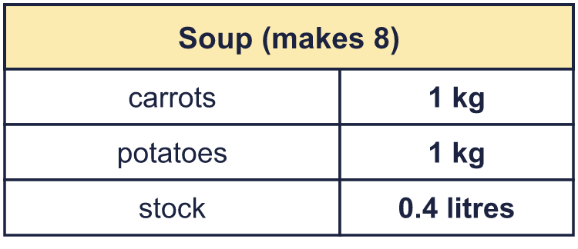
  7 | Here is a soup recipe for 8 people. How much of each ingredient is needed for 20 people?
  8 | A recipe for 4 cupcakes uses 120 g of flour and 2 eggs. Mo uses 840 g of flour for a bigger batch.  How many cupcakes does it make?
  8 | A recipe for 4 cupcakes uses 120 g of flour and 2 eggs. Mo uses 840 g of flour for a bigger batch.  How many cupcakes does it make?

  9 | A recipe for 6 pancakes uses 7 eggs.  Is Boba correct? Circle yes or no.  Yes / No  Explain the mistake.
    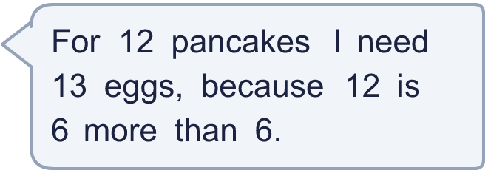
  9 | A recipe for 6 pancakes uses 7 eggs.  Is Boba correct? Circle yes or no.  Yes / No  Explain the mistake.
  10 | This recipe makes 8 buns. Nina has 300 g of flour, 60 g of butter and 90 g of sugar.  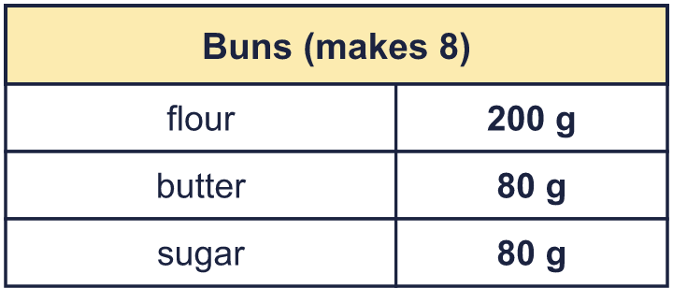  What is the greatest number of buns Nina can make? Which ingredient runs out first?
  10 | This recipe makes 8 buns. Nina has 300 g of flour, 60 g of butter and 90 g of sugar.  What is the greatest number of buns Nina can make? Which ingredient runs out first?
  11 | A recipe for 6 pancakes uses 2 eggs. Eggs are sold in boxes of 12.  Eva wants to make 54 pancakes. How many boxes of eggs must Eva buy?
  11 | A recipe for 6 pancakes uses 2 eggs. Eggs are sold in boxes of 12.  Eva wants to make 54 pancakes. How many boxes of eggs must Eva buy?
  12 | A recipe for 12 scones uses 0.4 kg of flour. How many grams of flour are needed for 30 scones?
  12 | A recipe for 12 scones uses 0.4 kg of flour. How many grams of flour are needed for 30 scones?
  13 | A recipe for 4 people uses 200 g of flour and 160 g of sugar.  Eva uses 600 g of flour. How many people is that for? How much sugar is needed?
  13 | A recipe for 4 people uses 200 g of flour and 160 g of sugar.  Eva uses 600 g of flour. How many people is that for? How much sugar is needed?
  14 | Challenge  A recipe for 12 pancakes uses 3 eggs. At a party, 40 guests each eat 2 pancakes. Eggs are sold in boxes of 6.  How many boxes of eggs are needed?
  14 | Challenge  A recipe for 12 pancakes uses 3 eggs. At a party, 40 guests each eat 2 pancakes. Eggs are sold in boxes of 6.  How many boxes of eggs are needed?

Year 6 · Ratio · Step 10
Recipes and scaling
Answers (teacher copy)

  1 | Here is a recipe for 10 scones. How much of each ingredient is needed to make 20 scones?  a) flour: 800 g  b) butter: 240 g  c) milk: 400 ml  d) sugar: 120 g
  2 | Here is a recipe for 8 flapjacks. How much of each ingredient is needed to make 4 flapjacks?  a) butter: 80 g  b) sugar: 20 g  c) oats: 160 g  d) golden syrup: 20 ml
  3 | Here is a recipe for 10 muffins. How much of each ingredient is needed to make 1 muffin?  a) flour: 30 g  b) sugar: 10 g  c) milk: 15 ml  d) butter: 10 g
  4 | Here is a recipe for 4 muffins. How much of each ingredient is needed to make 10 muffins?  a) flour: 250 g  b) sugar: 200 g  c) milk: 250 ml  d) butter: 150 g
  5 | Here is a recipe for 8 cupcakes. Write the amounts for 4 cupcakes.  a) butter: 50 g  b) sugar: 50 g  c) eggs: 1  d) vanilla extract: 1 tsp  e) flour: 60 g  f) milk: 2 tbsp
  6 | A recipe for 8 muffins uses 96 g of butter. Nina has 684 g of butter and plenty of everything else.  What is the greatest number of muffins Nina can make?  57 muffins
  7 | Here is a soup recipe for 8 people. How much of each ingredient is needed for 20 people?  a) carrots: 2.5 kg  b) potatoes: 2.5 kg  c) stock: 1 litres
  8 | A recipe for 4 cupcakes uses 120 g of flour and 2 eggs. Mo uses 840 g of flour for a bigger batch.  How many cupcakes does it make? 28  How many eggs are needed? 14
  9 | A recipe for 6 pancakes uses 7 eggs.  Is Boba correct? Circle yes or no.  Yes / No  Explain the mistake.  Boba added. 12 pancakes is 2 times as many as 6, so multiply: 7 × 2 = 14 eggs.  Correct amount: 14 eggs
  10 | This recipe makes 8 buns. Nina has 300 g of flour, 60 g of butter and 90 g of sugar.  What is the greatest number of buns Nina can make? Which ingredient runs out first?  6 buns  Runs out first: butter
  11 | A recipe for 6 pancakes uses 2 eggs. Eggs are sold in boxes of 12.  Eva wants to make 54 pancakes. How many boxes of eggs must Eva buy?  2 boxes
  12 | A recipe for 12 scones uses 0.4 kg of flour. How many grams of flour are needed for 30 scones?  1,000 g
  13 | A recipe for 4 people uses 200 g of flour and 160 g of sugar.  Eva uses 600 g of flour. How many people is that for? How much sugar is needed?  12 people  480 g of sugar
  14 | Challenge  A recipe for 12 pancakes uses 3 eggs. At a party, 40 guests each eat 2 pancakes. Eggs are sold in boxes of 6.  How many boxes of eggs are needed?  4 boxes

