To make 8 pancakes (2 times as many), multiply every amount by 2. To make 1 pancake, divide every amount by 4:  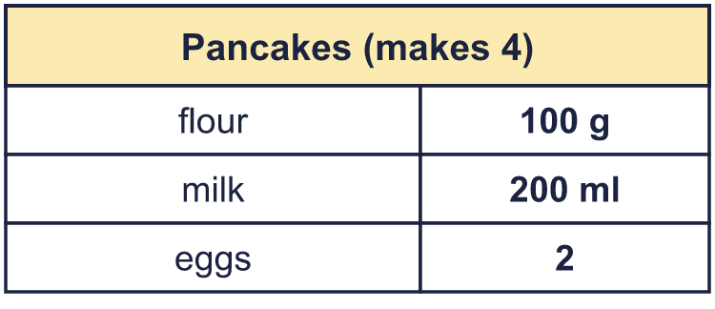 |  | To make 8 pancakes (2 times as many), multiply every amount by 2. To make 1 pancake, divide every amount by 4:
  Year 6 · Ratio · Step 10  Recipes and scaling | 
  Year 6 · Ratio · Step 10
  Recipes and scaling
  1 | Here is a recipe for 10 scones. How much of each ingredient is needed to make 20 scones?  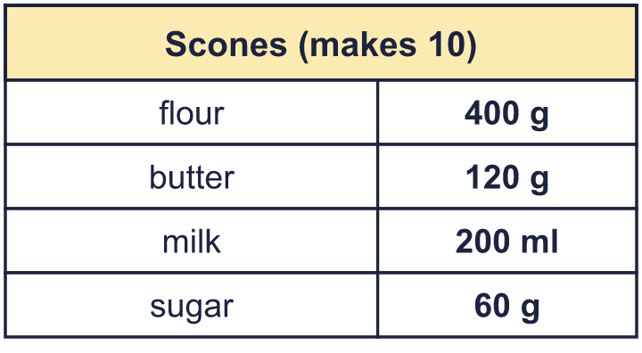  Hint: Twice as many means every amount is multiplied by 2.
  1 | Here is a recipe for 10 scones. How much of each ingredient is needed to make 20 scones?  Hint: Twice as many means every amount is multiplied by 2.
  2 | Here is a recipe for 8 flapjacks. How much of each ingredient is needed to make 4 flapjacks?  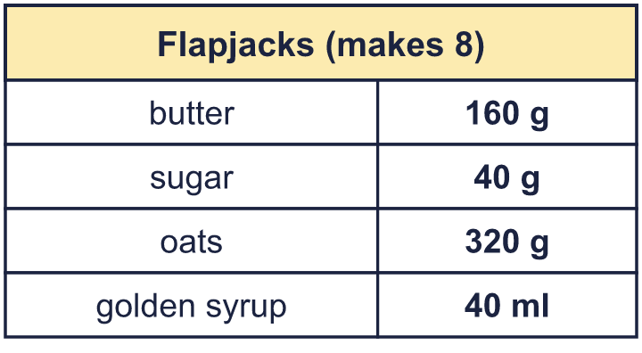  Hint: Half as many means every amount is divided by 2.
  2 | Here is a recipe for 8 flapjacks. How much of each ingredient is needed to make 4 flapjacks?  Hint: Half as many means every amount is divided by 2.
  3 | Here is a recipe for 10 muffins. How much of each ingredient is needed to make 1 muffin?  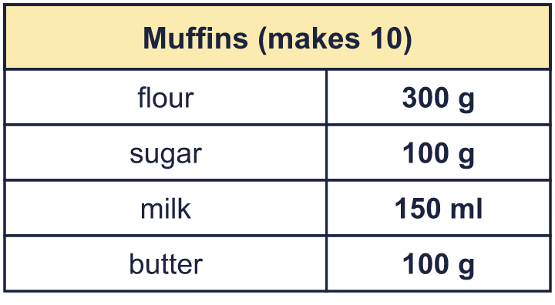  Hint: Divide each amount by 10.
  3 | Here is a recipe for 10 muffins. How much of each ingredient is needed to make 1 muffin?  Hint: Divide each amount by 10.
  4 | Here is a recipe for 4 muffins. How much of each ingredient is needed to make 10 muffins?  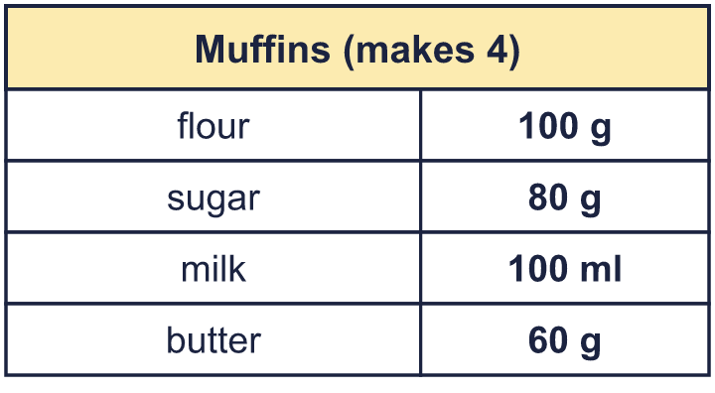  Hint: Find the amount for 1 first (divide by 4). Then multiply by 10.
  4 | Here is a recipe for 4 muffins. How much of each ingredient is needed to make 10 muffins?  Hint: Find the amount for 1 first (divide by 4). Then multiply by 10.
  5 | Here is a recipe for 8 cupcakes. Write the amounts for 4 cupcakes.  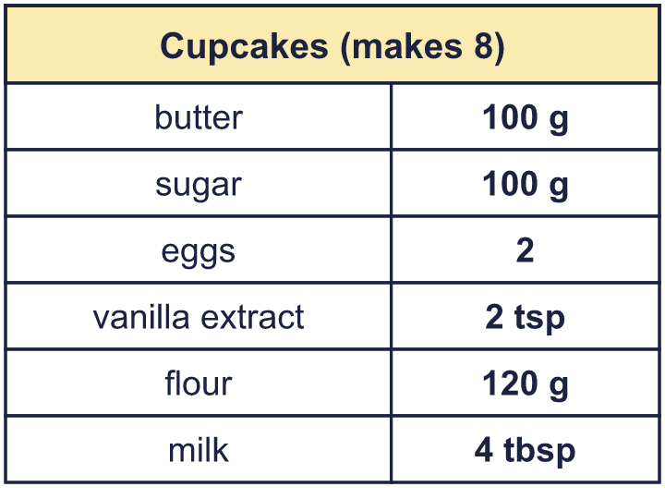  Hint: Half as many cupcakes means half of each amount.
  5 | Here is a recipe for 8 cupcakes. Write the amounts for 4 cupcakes.  Hint: Half as many cupcakes means half of each amount.
  6 | A recipe for 8 muffins uses 96 g of butter. Nina has 684 g of butter and plenty of everything else.  What is the greatest number of muffins Nina can make?  Hint: How much butter is needed for 1? Divide 684 by that.
  6 | A recipe for 8 muffins uses 96 g of butter. Nina has 684 g of butter and plenty of everything else.  What is the greatest number of muffins Nina can make?  Hint: How much butter is needed for 1? Divide 684 by that.
  7 | Here is a soup recipe for 8 people. How much of each ingredient is needed for 20 people?  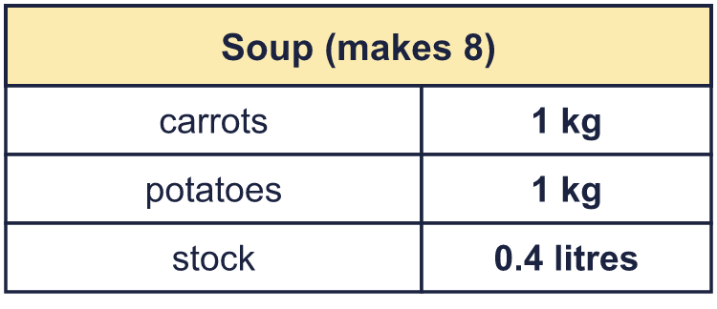  Hint: 20 is 2.5 times 8. Multiply each amount by 2.5.
  7 | Here is a soup recipe for 8 people. How much of each ingredient is needed for 20 people?  Hint: 20 is 2.5 times 8. Multiply each amount by 2.5.
  8 | A recipe for 4 cupcakes uses 120 g of flour and 2 eggs. Mo uses 840 g of flour for a bigger batch.  How many cupcakes does it make?  Hint: How many times more flour is it? Multiply the cupcakes and the eggs by the same number.
  8 | A recipe for 4 cupcakes uses 120 g of flour and 2 eggs. Mo uses 840 g of flour for a bigger batch.  How many cupcakes does it make?  Hint: How many times more flour is it? Multiply the cupcakes and the eggs by the same number.

  9 | A recipe for 6 pancakes uses 7 eggs.  Is Boba correct? Circle yes or no.  Yes / No  Explain the mistake.  Hint: How many times more pancakes is it? Multiply the eggs by that number.
    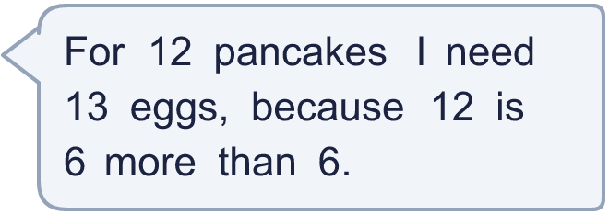
  9 | A recipe for 6 pancakes uses 7 eggs.  Is Boba correct? Circle yes or no.  Yes / No  Explain the mistake.  Hint: How many times more pancakes is it? Multiply the eggs by that number.
  10 | This recipe makes 8 buns. Nina has 300 g of flour, 60 g of butter and 90 g of sugar.  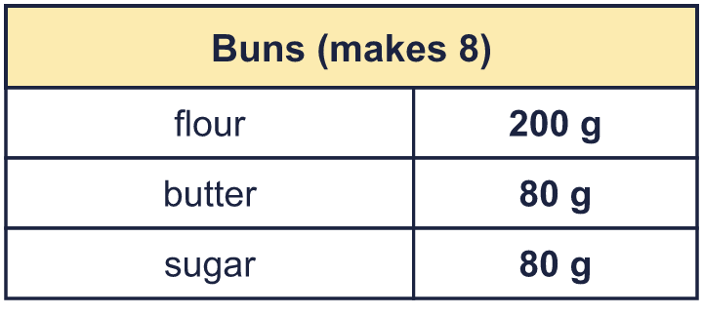  What is the greatest number of buns Nina can make? Which ingredient runs out first?  Hint: Work out how many buns each ingredient would make. The smallest number is the answer.
  10 | This recipe makes 8 buns. Nina has 300 g of flour, 60 g of butter and 90 g of sugar.  What is the greatest number of buns Nina can make? Which ingredient runs out first?  Hint: Work out how many buns each ingredient would make. The smallest number is the answer.
  11 | A recipe for 6 pancakes uses 2 eggs. Eggs are sold in boxes of 12.  Eva wants to make 54 pancakes. How many boxes of eggs must Eva buy?  Hint: First work out how many eggs are needed. Then work out how many boxes hold that many eggs. Round up.
  11 | A recipe for 6 pancakes uses 2 eggs. Eggs are sold in boxes of 12.  Eva wants to make 54 pancakes. How many boxes of eggs must Eva buy?  Hint: First work out how many eggs are needed. Then work out how many boxes hold that many eggs. Round up.
  12 | A recipe for 12 scones uses 0.4 kg of flour. How many grams of flour are needed for 30 scones?  Hint: Change 0.4 kg to grams first (1 kg = 1,000 g). Then scale the amount.
  12 | A recipe for 12 scones uses 0.4 kg of flour. How many grams of flour are needed for 30 scones?  Hint: Change 0.4 kg to grams first (1 kg = 1,000 g). Then scale the amount.
  13 | A recipe for 4 people uses 200 g of flour and 160 g of sugar.  Eva uses 600 g of flour. How many people is that for? How much sugar is needed?  Hint: How many times more flour is 600 g than 200 g? Multiply the people and the sugar by the same number.
  13 | A recipe for 4 people uses 200 g of flour and 160 g of sugar.  Eva uses 600 g of flour. How many people is that for? How much sugar is needed?  Hint: How many times more flour is 600 g than 200 g? Multiply the people and the sugar by the same number.
  14 | Challenge  A recipe for 12 pancakes uses 3 eggs. At a party, 40 guests each eat 2 pancakes. Eggs are sold in boxes of 6.  How many boxes of eggs are needed?  Hint: Work out the number of pancakes. Then the number of eggs. Then divide by the box size and round up.
  14 | Challenge  A recipe for 12 pancakes uses 3 eggs. At a party, 40 guests each eat 2 pancakes. Eggs are sold in boxes of 6.  How many boxes of eggs are needed?  Hint: Work out the number of pancakes. Then the number of eggs. Then divide by the box size and round up.

Year 6 · Ratio · Step 10
Recipes and scaling
Answers (teacher copy)

To make 8 pancakes (2 times as many), multiply every amount by 2. To make 1 pancake, divide every amount by 4:
  1 | Here is a recipe for 10 scones. How much of each ingredient is needed to make 20 scones?  a) flour: 800 g  b) butter: 240 g  c) milk: 400 ml  d) sugar: 120 g  Hint: Twice as many means every amount is multiplied by 2.
  2 | Here is a recipe for 8 flapjacks. How much of each ingredient is needed to make 4 flapjacks?  a) butter: 80 g  b) sugar: 20 g  c) oats: 160 g  d) golden syrup: 20 ml  Hint: Half as many means every amount is divided by 2.
  3 | Here is a recipe for 10 muffins. How much of each ingredient is needed to make 1 muffin?  a) flour: 30 g  b) sugar: 10 g  c) milk: 15 ml  d) butter: 10 g  Hint: Divide each amount by 10.
  4 | Here is a recipe for 4 muffins. How much of each ingredient is needed to make 10 muffins?  a) flour: 250 g  b) sugar: 200 g  c) milk: 250 ml  d) butter: 150 g  Hint: Find the amount for 1 first (divide by 4). Then multiply by 10.
  5 | Here is a recipe for 8 cupcakes. Write the amounts for 4 cupcakes.  a) butter: 50 g  b) sugar: 50 g  c) eggs: 1  d) vanilla extract: 1 tsp  e) flour: 60 g  f) milk: 2 tbsp  Hint: Half as many cupcakes means half of each amount.
  6 | A recipe for 8 muffins uses 96 g of butter. Nina has 684 g of butter and plenty of everything else.  What is the greatest number of muffins Nina can make?  57 muffins  Hint: How much butter is needed for 1? Divide 684 by that.
  7 | Here is a soup recipe for 8 people. How much of each ingredient is needed for 20 people?  a) carrots: 2.5 kg  b) potatoes: 2.5 kg  c) stock: 1 litres  Hint: 20 is 2.5 times 8. Multiply each amount by 2.5.
  8 | A recipe for 4 cupcakes uses 120 g of flour and 2 eggs. Mo uses 840 g of flour for a bigger batch.  How many cupcakes does it make? 28  How many eggs are needed? 14  Hint: How many times more flour is it? Multiply the cupcakes and the eggs by the same number.
  9 | A recipe for 6 pancakes uses 7 eggs.  Is Boba correct? Circle yes or no.  Yes / No  Explain the mistake.  Boba added. 12 pancakes is 2 times as many as 6, so multiply: 7 × 2 = 14 eggs.  Correct amount: 14 eggs  Hint: How many times more pancakes is it? Multiply the eggs by that number.
  10 | This recipe makes 8 buns. Nina has 300 g of flour, 60 g of butter and 90 g of sugar.  What is the greatest number of buns Nina can make? Which ingredient runs out first?  6 buns  Runs out first: butter  Hint: Work out how many buns each ingredient would make. The smallest number is the answer.
  11 | A recipe for 6 pancakes uses 2 eggs. Eggs are sold in boxes of 12.  Eva wants to make 54 pancakes. How many boxes of eggs must Eva buy?  2 boxes  Hint: First work out how many eggs are needed. Then work out how many boxes hold that many eggs. Round up.
  12 | A recipe for 12 scones uses 0.4 kg of flour. How many grams of flour are needed for 30 scones?  1,000 g  Hint: Change 0.4 kg to grams first (1 kg = 1,000 g). Then scale the amount.
  13 | A recipe for 4 people uses 200 g of flour and 160 g of sugar.  Eva uses 600 g of flour. How many people is that for? How much sugar is needed?  12 people  480 g of sugar  Hint: How many times more flour is 600 g than 200 g? Multiply the people and the sugar by the same number.
  14 | Challenge  A recipe for 12 pancakes uses 3 eggs. At a party, 40 guests each eat 2 pancakes. Eggs are sold in boxes of 6.  How many boxes of eggs are needed?  4 boxes  Hint: Work out the number of pancakes. Then the number of eggs. Then divide by the box size and round up.

