A and B are similar. Both sides of A are multiplied by the same number (1 1/2) to make B:  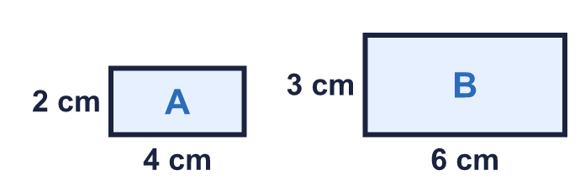 |  | A and B are similar. Both sides of A are multiplied by the same number (1 1/2) to make B:
  Year 6 · Ratio · Step 7  Similar shapes | 
  Year 6 · Ratio · Step 7
  Similar shapes
  1 | Look at each pair of rectangles. Are they similar? Circle yes or no.  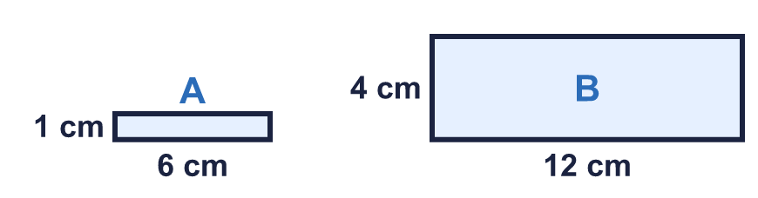  a) Are A and B similar?  Yes / No  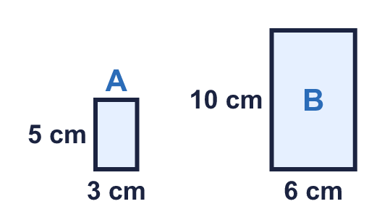  b) Are A and B similar?  Yes / No  Hint: Similar shapes have all their sides multiplied by the same number. Check the length and the width.
  1 | Look at each pair of rectangles. Are they similar? Circle yes or no.  a) Are A and B similar?  Yes / No  b) Are A and B similar?  Yes / No  Hint: Similar shapes have all their sides multiplied by the same number. Check the length and the width.
  2 | The first rectangle is C. Two of the other three rectangles are similar to C. One is not similar.  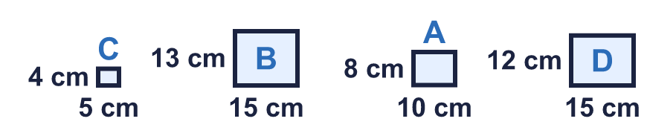  Which rectangle is not similar to C? Write its letter.  Hint: Find the scale factor from C to a rectangle that is similar. Then check the others.
  2 | The first rectangle is C. Two of the other three rectangles are similar to C. One is not similar.  Which rectangle is not similar to C? Write its letter.  Hint: Find the scale factor from C to a rectangle that is similar. Then check the others.
  3 | Each pair of rectangles is similar. Work out the missing length.  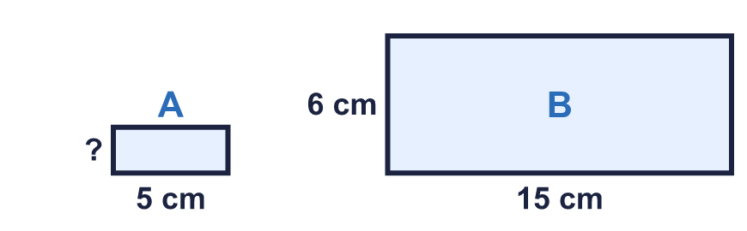  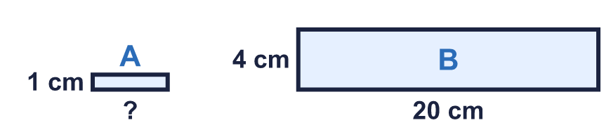  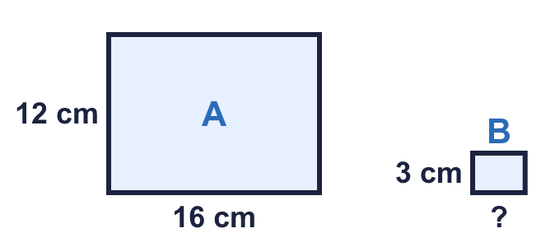  Hint: Use the two sides you can see on both rectangles to find the scale factor. Multiply or divide the other side.
  3 | Each pair of rectangles is similar. Work out the missing length.  Hint: Use the two sides you can see on both rectangles to find the scale factor. Multiply or divide the other side.
  4 | The two rectangles are similar. Work out the missing length.  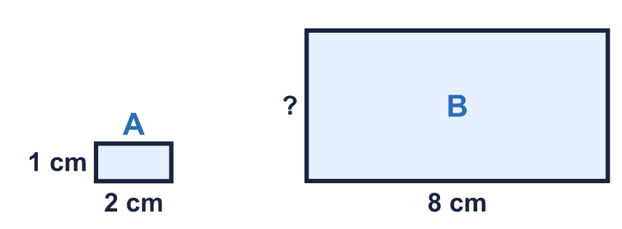  Hint: Find the scale factor from A to B. Then multiply the matching side of A.
  4 | The two rectangles are similar. Work out the missing length.  Hint: Find the scale factor from A to B. Then multiply the matching side of A.
  5 | These two rectangles are similar.  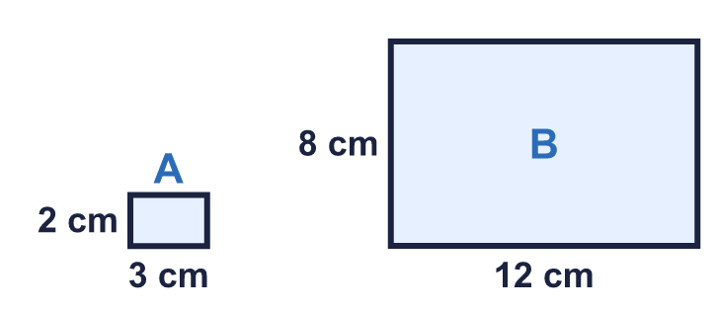  Hint: Add the four sides of each rectangle. What do you notice about the scale factor?
    c) The perimeter of B is
    times the perimeter of A
  5 | These two rectangles are similar.  Hint: Add the four sides of each rectangle. What do you notice about the scale factor?
    c) The perimeter of B is
    times the perimeter of A
  6 | Rectangle E is the first one. Two of the other rectangles are similar to E.  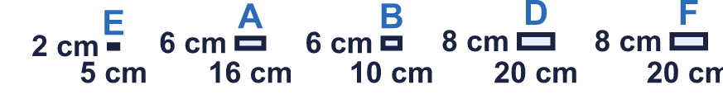  Write the letters of the two rectangles that are similar to E.  Hint: Find a scale factor that works for both sides. Check each rectangle.
  6 | Rectangle E is the first one. Two of the other rectangles are similar to E.  Write the letters of the two rectangles that are similar to E.  Hint: Find a scale factor that works for both sides. Check each rectangle.
  7 | The rectangles in the table are all similar. Write the missing numbers.  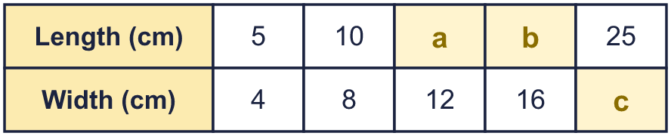  Hint: Look at the first column. Each other column is the first column multiplied by the same number.
  7 | The rectangles in the table are all similar. Write the missing numbers.  Hint: Look at the first column. Each other column is the first column multiplied by the same number.
  8 | These two rectangles are similar. Work out the missing length.  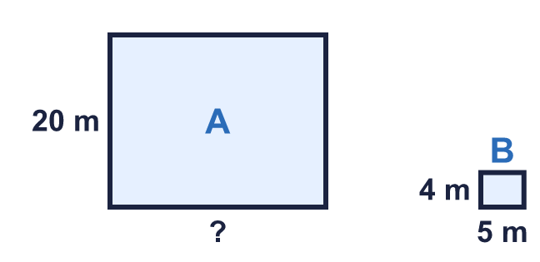  Hint: Find the scale factor from the sides you can see. Then multiply or divide.
  8 | These two rectangles are similar. Work out the missing length.  Hint: Find the scale factor from the sides you can see. Then multiply or divide.

  9 | Rectangle A is 5 cm by 2 cm. Rectangle B is 8 cm by 5 cm.  Is B similar to A? Circle yes or no.  Yes / No  Explain how you know.  Hint: Similar means every side is multiplied by the same number. Check both sides with multiplying.
     | 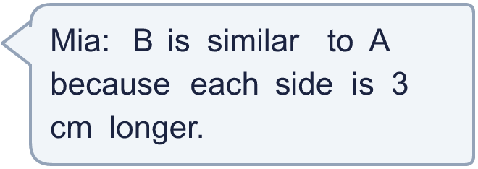
  9 | Rectangle A is 5 cm by 2 cm. Rectangle B is 8 cm by 5 cm.  Is B similar to A? Circle yes or no.  Yes / No  Explain how you know.  Hint: Similar means every side is multiplied by the same number. Check both sides with multiplying.
  10 | A poster is 7 cm wide and 4 cm high. It is enlarged so that the new poster is similar.  The new poster is 12 cm high. How wide is it?  Hint: Find the scale factor first: divide the new height by the old one.
  10 | A poster is 7 cm wide and 4 cm high. It is enlarged so that the new poster is similar.  The new poster is 12 cm high. How wide is it?  Hint: Find the scale factor first: divide the new height by the old one.
  11 | A flag is 8 cm wide and 6 cm high. A small flag is similar to it.  The small flag is 4 cm wide. How high is it?  Hint: The small flag is smaller, so divide. How many times smaller is it?
  11 | A flag is 8 cm wide and 6 cm high. A small flag is similar to it.  The small flag is 4 cm wide. How high is it?  Hint: The small flag is smaller, so divide. How many times smaller is it?
  12 | Two rectangles are similar. The perimeter of the small rectangle is 20 cm. Each side of the big rectangle is 4 times as long as the matching side of the small one.  a) Perimeter of the big rectangle: cm  Hint: The perimeter is multiplied by the same scale factor as the sides.
  12 | Two rectangles are similar. The perimeter of the small rectangle is 20 cm. Each side of the big rectangle is 4 times as long as the matching side of the small one.  a) Perimeter of the big rectangle: cm  Hint: The perimeter is multiplied by the same scale factor as the sides.
  13 | Three of these four rectangles are similar to each other. One is different.  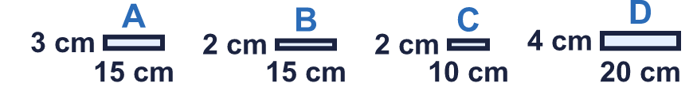  Which rectangle is the odd one out? Write its letter.  Hint: Write the length and width of each as a ratio in its simplest form. Three will match.
  13 | Three of these four rectangles are similar to each other. One is different.  Which rectangle is the odd one out? Write its letter.  Hint: Write the length and width of each as a ratio in its simplest form. Three will match.
  14 | Challenge  A rectangle has a length to width ratio of 3 : 2. Its perimeter is 50 cm.  Hint: The perimeter is 2 × (length + width). Find how many cm each part of the ratio is.
  14 | Challenge  A rectangle has a length to width ratio of 3 : 2. Its perimeter is 50 cm.  Hint: The perimeter is 2 × (length + width). Find how many cm each part of the ratio is.

Year 6 · Ratio · Step 7
Similar shapes
Answers (teacher copy)

A and B are similar. Both sides of A are multiplied by the same number (1 1/2) to make B:
  1 | Look at each pair of rectangles. Are they similar? Circle yes or no.  a) Are A and B similar?  Yes / No  b) Are A and B similar?  Yes / No  Hint: Similar shapes have all their sides multiplied by the same number. Check the length and the width.
  2 | The first rectangle is C. Two of the other three rectangles are similar to C. One is not similar.  Which rectangle is not similar to C? Write its letter.  B  Hint: Find the scale factor from C to a rectangle that is similar. Then check the others.
  3 | Each pair of rectangles is similar. Work out the missing length.  a = 2 cm  b = 5 cm  c = 4 cm  Hint: Use the two sides you can see on both rectangles to find the scale factor. Multiply or divide the other side.
  4 | The two rectangles are similar. Work out the missing length.  Missing length: 4 cm  Hint: Find the scale factor from A to B. Then multiply the matching side of A.
  5 | These two rectangles are similar.  a) Perimeter of A: 10 cm  b) Perimeter of B: 40 cm  c) The perimeter of B is 4 times the perimeter of A  Hint: Add the four sides of each rectangle. What do you notice about the scale factor?
  6 | Rectangle E is the first one. Two of the other rectangles are similar to E.  Write the letters of the two rectangles that are similar to E.  D, F  Hint: Find a scale factor that works for both sides. Check each rectangle.
  7 | The rectangles in the table are all similar. Write the missing numbers.  a = 15  b = 20  c = 20  Hint: Look at the first column. Each other column is the first column multiplied by the same number.
  8 | These two rectangles are similar. Work out the missing length.  Missing length: 25 m  Hint: Find the scale factor from the sides you can see. Then multiply or divide.
  9 | Rectangle A is 5 cm by 2 cm. Rectangle B is 8 cm by 5 cm.  Is B similar to A? Circle yes or no.  Yes / No  Explain how you know.  No. 5 + 3 = 8 and 2 + 3 = 5, but adding does not keep the shape. 8 ÷ 5 is not 5 ÷ 2.  Hint: Similar means every side is multiplied by the same number. Check both sides with multiplying.
  10 | A poster is 7 cm wide and 4 cm high. It is enlarged so that the new poster is similar.  The new poster is 12 cm high. How wide is it?  21 cm  Hint: Find the scale factor first: divide the new height by the old one.
  11 | A flag is 8 cm wide and 6 cm high. A small flag is similar to it.  The small flag is 4 cm wide. How high is it?  3 cm  Hint: The small flag is smaller, so divide. How many times smaller is it?
  12 | Two rectangles are similar. The perimeter of the small rectangle is 20 cm. Each side of the big rectangle is 4 times as long as the matching side of the small one.  a) Perimeter of the big rectangle: 80 cm  b) How much bigger is it? 60 cm  Hint: The perimeter is multiplied by the same scale factor as the sides.
  13 | Three of these four rectangles are similar to each other. One is different.  Which rectangle is the odd one out? Write its letter.  B  Hint: Write the length and width of each as a ratio in its simplest form. Three will match.
  14 | Challenge  A rectangle has a length to width ratio of 3 : 2. Its perimeter is 50 cm.  Length: 15 cm Width: 10 cm  Hint: The perimeter is 2 × (length + width). Find how many cm each part of the ratio is.

