2 red counters and 5 yellow counters. Red to yellow is 2 : 5. Yellow to red is 5 : 2:   |  | 2 red counters and 5 yellow counters. Red to yellow is 2 : 5. Yellow to red is 5 : 2:
  Year 6 · Ratio · Step 3  The ratio symbol | 
  Year 6 · Ratio · Step 3
  The ratio symbol
  1 | Look at the counters.  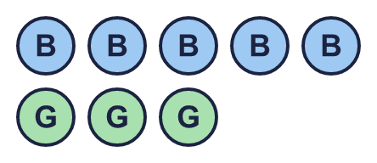  Hint: Count each colour. Write the numbers in the same order as the colours in the sentence.
    The ratio of blue to green is
    :
    The ratio of green to blue is
    :
  1 | Look at the counters.  Hint: Count each colour. Write the numbers in the same order as the colours in the sentence.
    The ratio of blue to green is
    :
    The ratio of green to blue is
    :
  2 | Dani has some counters. Complete the ratios.  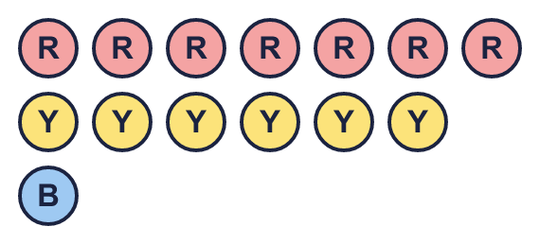  Hint: Write the numbers in the same order as the colours.
    red to yellow: |  | :
    yellow to blue: |  | :
    All three colours: |  | : |  | :
  2 | Dani has some counters. Complete the ratios.  Hint: Write the numbers in the same order as the colours.
    red to yellow: |  | :
    yellow to blue: |  | :
    All three colours: |  | : |  | :
  3 | Write each ratio. Keep the numbers in the order of the words.  Hint: The first thing named goes first. Use a colon : between the numbers.
    a) 5 cats and 1 dog: cats to dogs =
    :
    b) 1 cat and 3 dogs: cats to dogs =
    :
  3 | Write each ratio. Keep the numbers in the order of the words.  Hint: The first thing named goes first. Use a colon : between the numbers.
    a) 5 cats and 1 dog: cats to dogs =
    :
    b) 1 cat and 3 dogs: cats to dogs =
    :
  4 | Write each ratio in its simplest form.      Hint: Count the shaded parts and the parts that are not shaded. Then divide both numbers by the same number to make them smaller.
    a) shaded to not shaded: |  | :
    b) not shaded to shaded: |  | :
  4 | Write each ratio in its simplest form.  Hint: Count the shaded parts and the parts that are not shaded. Then divide both numbers by the same number to make them smaller.
    a) shaded to not shaded: |  | :
    b) not shaded to shaded: |  | :
  5 | Write the missing number in each pair of equal ratios.  Hint: Multiply both numbers by the same number.
    a) | 1 : 4 = | 2 :
    b) | 1 : 2 = |  | : 8
    c) | 7 : 6 = | 42 :
    d) | 5 : 3 = |  | : 12
  5 | Write the missing number in each pair of equal ratios.  Hint: Multiply both numbers by the same number.
    a) | 1 : 4 = | 2 :
    b) | 1 : 2 = |  | : 8
    c) | 7 : 6 = | 42 :
    d) | 5 : 3 = |  | : 12
  6 | Write each ratio in its simplest form.  Hint: Find a number that divides into every number in the ratio. Divide until you cannot divide any more.
    a) 21 : 15 = |  | :
    b) 32 : 20 = |  | :
    c) 56 : 35 = |  | :
    d) 4 : 20 : 12 = |  | : |  | :
  6 | Write each ratio in its simplest form.  Hint: Find a number that divides into every number in the ratio. Divide until you cannot divide any more.
    a) 21 : 15 = |  | :
    b) 32 : 20 = |  | :
    c) 56 : 35 = |  | :
    d) 4 : 20 : 12 = |  | : |  | :
  7 | Write each ratio in its simplest form.  Hint: Divide both numbers by the same number until you cannot divide any more.
    a) 480 g of juice and 60 g of water: juice to water =
    :
    b) 450 g of sand and 720 g of cement: sand to cement =
    :
  7 | Write each ratio in its simplest form.  Hint: Divide both numbers by the same number until you cannot divide any more.
    a) 480 g of juice and 60 g of water: juice to water =
    :
    b) 450 g of sand and 720 g of cement: sand to cement =
    :
  8 | Change both amounts to the same unit. Then write the ratio in its simplest form.  Hint: Change the bigger unit into the smaller unit first (1 m = 100 cm, 1 kg = 1,000 g, 1 litre = 1,000 ml, £1 = 100p).
    a) 6 kg to 1,500 g = |  | :
    b) £10 to 40p = |  | :
  8 | Change both amounts to the same unit. Then write the ratio in its simplest form.  Hint: Change the bigger unit into the smaller unit first (1 m = 100 cm, 1 kg = 1,000 g, 1 litre = 1,000 ml, £1 = 100p).
    a) 6 kg to 1,500 g = |  | :
    b) £10 to 40p = |  | :

  9 | Here are some counters.  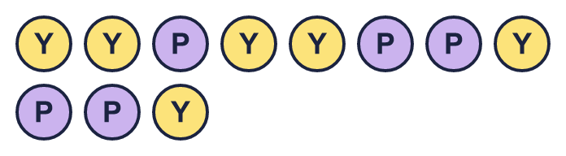  Who is correct? Write Nina or Tia.  Explain how you know.  Hint: Count the purple counters, then count the yellow counters. The order of the numbers must match the order of the colours.
     | 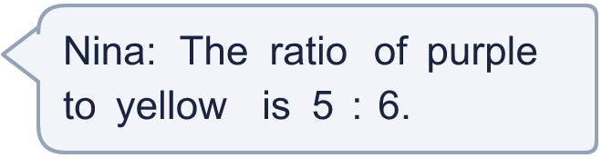
     | 
  9 | Here are some counters.  Who is correct? Write Nina or Tia.  Explain how you know.  Hint: Count the purple counters, then count the yellow counters. The order of the numbers must match the order of the colours.
  10 | Brett draws some stars and some circles. The ratio of stars to circles is 2 : 3.  a) Are there more stars or more circles?  b) Brett draws more than 10 shapes altogether. Write how many stars and how many circles he could have drawn.  Hint: For every 2 stars there are 3 circles. Make a group of 5 shapes, then make more groups until there are more than 10 shapes.
     | stars |  | circles
  10 | Brett draws some stars and some circles. The ratio of stars to circles is 2 : 3.  a) Are there more stars or more circles?  b) Brett draws more than 10 shapes altogether. Write how many stars and how many circles he could have drawn.  Hint: For every 2 stars there are 3 circles. Make a group of 5 shapes, then make more groups until there are more than 10 shapes.
     | stars |  | circles
  11 | Mia’s class has 10 cats and 4 dogs. Amir’s class has 30 cats and 14 dogs.  Is the ratio of cats to dogs the same in both classes? Circle yes or no.  Yes / No  Explain how you know.  Hint: Write each ratio in its simplest form. Are they equal?
  11 | Mia’s class has 10 cats and 4 dogs. Amir’s class has 30 cats and 14 dogs.  Is the ratio of cats to dogs the same in both classes? Circle yes or no.  Yes / No  Explain how you know.  Hint: Write each ratio in its simplest form. Are they equal?
  12 | The ratio of pens to pencils is 6 : 5.  There are 12 pens. How many pencils are there?  Hint: How many groups are there? In every group there are 6 pens and 5 pencils.
  12 | The ratio of pens to pencils is 6 : 5.  There are 12 pens. How many pencils are there?  Hint: How many groups are there? In every group there are 6 pens and 5 pencils.
  13 | A box has 15 pens, 3 pencils and 9 rulers.  Hint: Divide all the numbers by the same number to make the ratio simpler.
    pens to pencils to rulers in its simplest form:
     | : |  | :
    rulers to pens in its simplest form:
    :
  13 | A box has 15 pens, 3 pencils and 9 rulers.  Hint: Divide all the numbers by the same number to make the ratio simpler.
    pens to pencils to rulers in its simplest form:
     | : |  | :
    rulers to pens in its simplest form:
    :
  14 | Challenge  In a bag, the ratio of red counters to blue counters is 4 : 3.  Tia says: “The ratio of red counters to all the counters is 4 : 3.”  Is Tia correct? Circle yes or no.  Yes / No  Explain how you know.  Hint: How many counters are in one group altogether? Add the two numbers in the ratio.
  14 | Challenge  In a bag, the ratio of red counters to blue counters is 4 : 3.  Tia says: “The ratio of red counters to all the counters is 4 : 3.”  Is Tia correct? Circle yes or no.  Yes / No  Explain how you know.  Hint: How many counters are in one group altogether? Add the two numbers in the ratio.

Year 6 · Ratio · Step 3
The ratio symbol
Answers (teacher copy)

2 red counters and 5 yellow counters. Red to yellow is 2 : 5. Yellow to red is 5 : 2:
  1 | Look at the counters.  The ratio of blue to green is 5 : 3 :  The ratio of green to blue is 3 : 5 :  Hint: Count each colour. Write the numbers in the same order as the colours in the sentence.
  2 | Dani has some counters. Complete the ratios.  red to yellow: 7 : 6 :  yellow to blue: 6 : 1 :  All three colours: 7 : 6 : 1 : :  Hint: Write the numbers in the same order as the colours.
  3 | Write each ratio. Keep the numbers in the order of the words.  a) 5 cats and 1 dog: cats to dogs = 5 : 1 :  b) 1 cat and 3 dogs: cats to dogs = 1 : 3 :  Hint: The first thing named goes first. Use a colon : between the numbers.
  4 | Write each ratio in its simplest form.  a) shaded to not shaded: 3 : 1 :  b) not shaded to shaded: 5 : 3 :  Hint: Count the shaded parts and the parts that are not shaded. Then divide both numbers by the same number to make them smaller.
  5 | Write the missing number in each pair of equal ratios.  a) 1 : 4 = 2 : 8  b) 1 : 2 = 4 : 8  c) 7 : 6 = 42 : 36  d) 5 : 3 = 20 : 12  Hint: Multiply both numbers by the same number.
  6 | Write each ratio in its simplest form.  a) 21 : 15 = 7 : 5 :  b) 32 : 20 = 8 : 5 :  c) 56 : 35 = 8 : 5 :  d) 4 : 20 : 12 = 1 : 5 : 3 : :  Hint: Find a number that divides into every number in the ratio. Divide until you cannot divide any more.
  7 | Write each ratio in its simplest form.  a) 480 g of juice and 60 g of water: juice to water = 8 : 1 :  b) 450 g of sand and 720 g of cement: sand to cement = 5 : 8 :  Hint: Divide both numbers by the same number until you cannot divide any more.
  8 | Change both amounts to the same unit. Then write the ratio in its simplest form.  a) 6 kg to 1,500 g = 4 : 1 :  b) £10 to 40p = 25 : 1 :  Hint: Change the bigger unit into the smaller unit first (1 m = 100 cm, 1 kg = 1,000 g, 1 litre = 1,000 ml, £1 = 100p).
  9 | Here are some counters.  Who is correct? Write Nina or Tia.  Nina  Explain how you know.  Nina is correct. There are 5 purple counters and 6 yellow counters, so purple to yellow is 5 : 6.  Hint: Count the purple counters, then count the yellow counters. The order of the numbers must match the order of the colours.
  10 | Brett draws some stars and some circles. The ratio of stars to circles is 2 : 3.  a) Are there more stars or more circles?  circles  b) Brett draws more than 10 shapes altogether. Write how many stars and how many circles he could have drawn.  6 stars 9 circles  Hint: For every 2 stars there are 3 circles. Make a group of 5 shapes, then make more groups until there are more than 10 shapes.
  11 | Mia’s class has 10 cats and 4 dogs. Amir’s class has 30 cats and 14 dogs.  Is the ratio of cats to dogs the same in both classes? Circle yes or no.  Yes / No  Explain how you know.  No. 10 : 4 simplifies to 5 : 2, but 30 : 14 does not simplify to 5 : 2.  Hint: Write each ratio in its simplest form. Are they equal?
  12 | The ratio of pens to pencils is 6 : 5.  There are 12 pens. How many pencils are there?  10  Hint: How many groups are there? In every group there are 6 pens and 5 pencils.
  13 | A box has 15 pens, 3 pencils and 9 rulers.  pens to pencils to rulers in its simplest form: 5 : 1 : 3 : :  rulers to pens in its simplest form: 3 : 5 :  Hint: Divide all the numbers by the same number to make the ratio simpler.
  14 | Challenge  In a bag, the ratio of red counters to blue counters is 4 : 3.  Tia says: “The ratio of red counters to all the counters is 4 : 3.”  Is Tia correct? Circle yes or no.  Yes / No  Explain how you know.  No. For every 4 red counters there are 3 blue counters, so there are 4 + 3 = 7 counters in each group. The ratio of red to all is 4 : 7.  Hint: How many counters are in one group altogether? Add the two numbers in the ratio.

