  Year 6 · Ratio · Step 6  Using scale factors | 
  Year 6 · Ratio · Step 6
  Using scale factors
  1 | This rectangle is enlarged by scale factor 3. Write the width and height of the new rectangle.  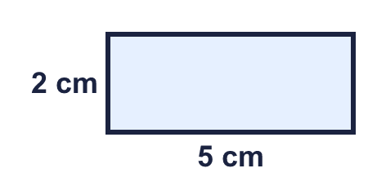
  1 | This rectangle is enlarged by scale factor 3. Write the width and height of the new rectangle.
  2 | A square has sides of 4 cm. It is enlarged by scale factor 5.  b) Perimeter of the new square: cm
  2 | A square has sides of 4 cm. It is enlarged by scale factor 5.  b) Perimeter of the new square: cm
  3 | Each side of a shape changes as described. Write the scale factor of the enlargement.
    a) Each side has tripled.
    b) Each side has doubled.
    c) Each side has quadrupled.
    d) Each side has become 5 times as long.
  3 | Each side of a shape changes as described. Write the scale factor of the enlargement.
    a) Each side has tripled.
    b) Each side has doubled.
    c) Each side has quadrupled.
    d) Each side has become 5 times as long.
  4 | Rectangle B is an enlargement of rectangle A. What is the scale factor?  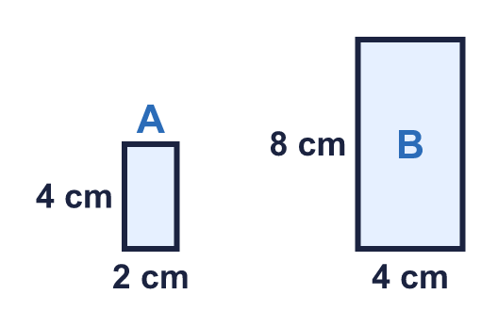
  4 | Rectangle B is an enlargement of rectangle A. What is the scale factor?
  5 | Triangle A is enlarged by scale factor 2 to make triangle B.  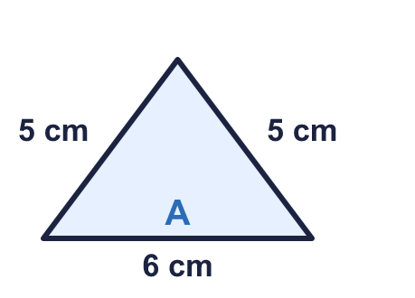
  5 | Triangle A is enlarged by scale factor 2 to make triangle B.
  6 | a) This rectangle is enlarged by scale factor 1 ¹⁄₂.  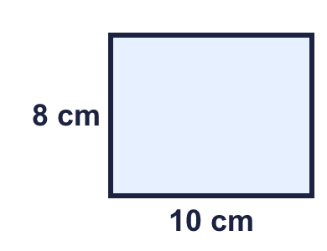  b) This rectangle is enlarged by scale factor ¹⁄₂.  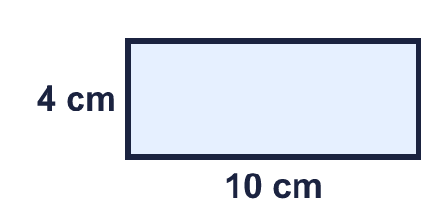
  6 | a) This rectangle is enlarged by scale factor 1 ¹⁄₂.  b) This rectangle is enlarged by scale factor ¹⁄₂.
  7 | A rectangle is 5 cm long and 2 cm wide. It is enlarged by scale factor 4.  Perimeter of the new rectangle: cm
  7 | A rectangle is 5 cm long and 2 cm wide. It is enlarged by scale factor 4.  Perimeter of the new rectangle: cm
  8 | Rectangle B is an enlargement of rectangle A. Find the missing measurement.  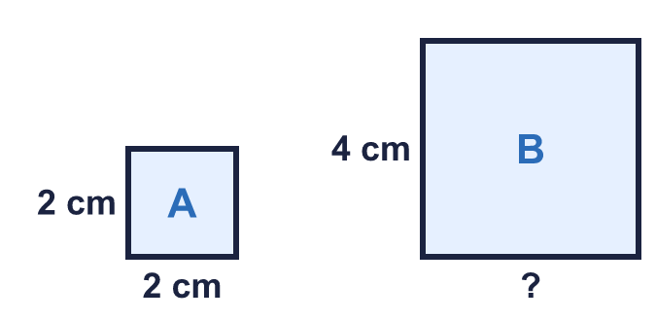
  8 | Rectangle B is an enlargement of rectangle A. Find the missing measurement.

  9 | Square A has sides of 4 cm. Square B is an enlargement of A by scale factor 3.  The area of B is how many times the area of A?
  9 | Square A has sides of 4 cm. Square B is an enlargement of A by scale factor 3.  The area of B is how many times the area of A?
  10 | A rectangle is 5 cm by 3 cm. It is enlarged by scale factor 2.  Is Eva correct? Circle yes or no.  Yes / No  Explain and write the area of the new rectangle.
     | 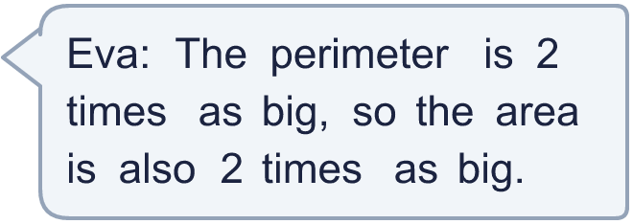
  10 | A rectangle is 5 cm by 3 cm. It is enlarged by scale factor 2.  Is Eva correct? Circle yes or no.  Yes / No  Explain and write the area of the new rectangle.
  11 | B is an enlargement of A. A is 6 cm long and 5 cm wide. B is 30 cm long.  How wide is B?
  11 | B is an enlargement of A. A is 6 cm long and 5 cm wide. B is 30 cm long.  How wide is B?
  12 | A square has sides of 3 cm. It is enlarged by scale factor 2 to make square B. Square B is then enlarged by scale factor 3 to make square C.
    a) Square C is
    times as big as square A
  12 | A square has sides of 3 cm. It is enlarged by scale factor 2 to make square B. Square B is then enlarged by scale factor 3 to make square C.
    a) Square C is
    times as big as square A
  13 | The perimeter of shape A is 22 cm. Nina makes shape B by enlarging A by scale factor ¹⁄₂.
  13 | The perimeter of shape A is 22 cm. Nina makes shape B by enlarging A by scale factor ¹⁄₂.
  14 | Challenge  Square X has sides of 3 cm. Square Y has sides of 15 cm.
    a) The perimeter of Y is
    times the perimeter of X
    b) The area of Y is
    times the area of X
  14 | Challenge  Square X has sides of 3 cm. Square Y has sides of 15 cm.
    a) The perimeter of Y is
    times the perimeter of X
    b) The area of Y is
    times the area of X

Year 6 · Ratio · Step 6
Using scale factors
Answers (teacher copy)

  1 | This rectangle is enlarged by scale factor 3. Write the width and height of the new rectangle.  New width: 15 cm  New height: 6 cm
  2 | A square has sides of 4 cm. It is enlarged by scale factor 5.  a) Side of the new square: 20 cm  b) Perimeter of the new square: 80 cm
  3 | Each side of a shape changes as described. Write the scale factor of the enlargement.  a) Each side has tripled. 3  b) Each side has doubled. 2  c) Each side has quadrupled. 4  d) Each side has become 5 times as long. 5
  4 | Rectangle B is an enlargement of rectangle A. What is the scale factor?  Scale factor: 2
  5 | Triangle A is enlarged by scale factor 2 to make triangle B.  a) Perimeter of A: 16 cm  b) Perimeter of B: 32 cm
  6 | a) This rectangle is enlarged by scale factor 1 ¹⁄₂.  New width: 15 cm New height: 12 cm  b) This rectangle is enlarged by scale factor ¹⁄₂.  New width: 5 cm New height: 2 cm
  7 | A rectangle is 5 cm long and 2 cm wide. It is enlarged by scale factor 4.  Perimeter of the new rectangle: 56 cm
  8 | Rectangle B is an enlargement of rectangle A. Find the missing measurement.  Width of B: 4 cm
  9 | Square A has sides of 4 cm. Square B is an enlargement of A by scale factor 3.  Perimeter of A: 16 cm Perimeter of B: 48 cm  Area of A: 16 cm² Area of B: 144 cm²  The area of B is how many times the area of A?  9
  10 | A rectangle is 5 cm by 3 cm. It is enlarged by scale factor 2.  Is Eva correct? Circle yes or no.  Yes / No  Explain and write the area of the new rectangle.  No. The new rectangle is 10 cm by 6 cm, so its area is 60 cm². The old area was 15 cm². 60 ÷ 15 = 4, so the area is 4 times as big.  New area: 60 cm²
  11 | B is an enlargement of A. A is 6 cm long and 5 cm wide. B is 30 cm long.  How wide is B?  25 cm
  12 | A square has sides of 3 cm. It is enlarged by scale factor 2 to make square B. Square B is then enlarged by scale factor 3 to make square C.  a) Square C is 6 times as big as square A  b) Side of square C: 18 cm
  13 | The perimeter of shape A is 22 cm. Nina makes shape B by enlarging A by scale factor ¹⁄₂.  Perimeter of B: 11 cm
  14 | Challenge  Square X has sides of 3 cm. Square Y has sides of 15 cm.  a) The perimeter of Y is 5 times the perimeter of X  b) The area of Y is 25 times the area of X

