B is an enlargement of A by scale factor 2. Every length in A is multiplied by 2:  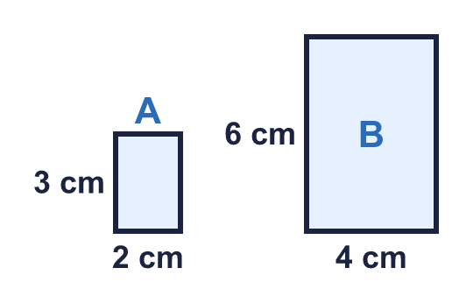 |  | B is an enlargement of A by scale factor 2. Every length in A is multiplied by 2:
  Year 6 · Ratio · Step 6  Using scale factors | 
  Year 6 · Ratio · Step 6
  Using scale factors
  1 | This rectangle is enlarged by scale factor 3. Write the width and height of the new rectangle.  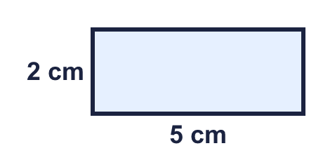  Hint: Scale factor 3 means every length is multiplied by 3.
  1 | This rectangle is enlarged by scale factor 3. Write the width and height of the new rectangle.  Hint: Scale factor 3 means every length is multiplied by 3.
  2 | A square has sides of 4 cm. It is enlarged by scale factor 5.  b) Perimeter of the new square: cm  Hint: Multiply the side by 5. A square has 4 equal sides.
  2 | A square has sides of 4 cm. It is enlarged by scale factor 5.  b) Perimeter of the new square: cm  Hint: Multiply the side by 5. A square has 4 equal sides.
  3 | Each side of a shape changes as described. Write the scale factor of the enlargement.  Hint: Doubled means × 2. Tripled means × 3. Quadrupled means × 4.
    a) Each side has tripled.
    b) Each side has doubled.
    c) Each side has quadrupled.
    d) Each side has become 5 times as long.
  3 | Each side of a shape changes as described. Write the scale factor of the enlargement.  Hint: Doubled means × 2. Tripled means × 3. Quadrupled means × 4.
    a) Each side has tripled.
    b) Each side has doubled.
    c) Each side has quadrupled.
    d) Each side has become 5 times as long.
  4 | Rectangle B is an enlargement of rectangle A. What is the scale factor?  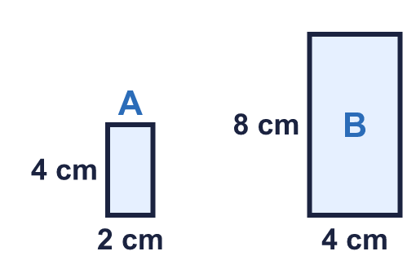  Hint: How many times longer is a side of B than the matching side of A? Divide.
  4 | Rectangle B is an enlargement of rectangle A. What is the scale factor?  Hint: How many times longer is a side of B than the matching side of A? Divide.
  5 | Triangle A is enlarged by scale factor 2 to make triangle B.  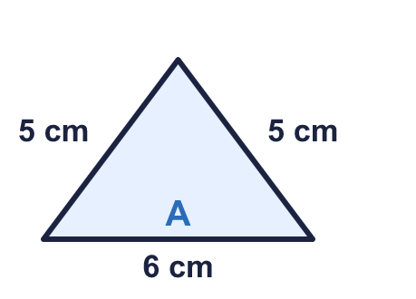  Hint: Add the three sides of A. The perimeter of B is the perimeter of A multiplied by the scale factor.
  5 | Triangle A is enlarged by scale factor 2 to make triangle B.  Hint: Add the three sides of A. The perimeter of B is the perimeter of A multiplied by the scale factor.
  6 | a) This rectangle is enlarged by scale factor 1 ¹⁄₂.  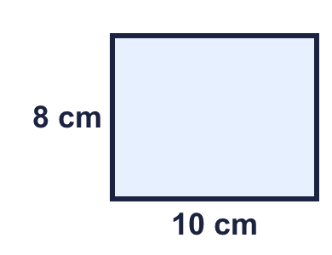  b) This rectangle is enlarged by scale factor ¹⁄₂.  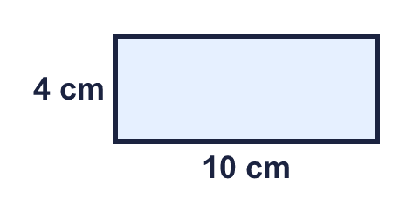  Hint: ¹⁄₂ means half of each length. 1 ¹⁄₂ means the length plus half of it.
  6 | a) This rectangle is enlarged by scale factor 1 ¹⁄₂.  b) This rectangle is enlarged by scale factor ¹⁄₂.  Hint: ¹⁄₂ means half of each length. 1 ¹⁄₂ means the length plus half of it.
  7 | A rectangle is 5 cm long and 2 cm wide. It is enlarged by scale factor 4.  Perimeter of the new rectangle: cm  Hint: First find the new length and width. Then add the four sides.
  7 | A rectangle is 5 cm long and 2 cm wide. It is enlarged by scale factor 4.  Perimeter of the new rectangle: cm  Hint: First find the new length and width. Then add the four sides.
  8 | Rectangle B is an enlargement of rectangle A. Find the missing measurement.  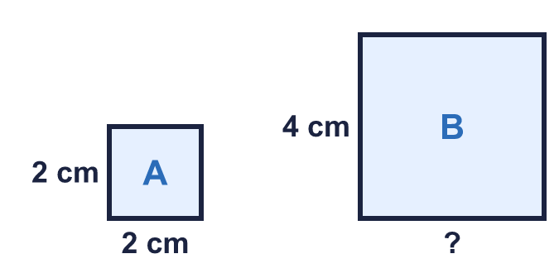  Hint: Use the sides you can see on both rectangles to find the scale factor. Then multiply.
  8 | Rectangle B is an enlargement of rectangle A. Find the missing measurement.  Hint: Use the sides you can see on both rectangles to find the scale factor. Then multiply.

  9 | Square A has sides of 4 cm. Square B is an enlargement of A by scale factor 3.  The area of B is how many times the area of A?  Hint: Perimeter is the distance around. Area is length × width. Compare your answers.
  9 | Square A has sides of 4 cm. Square B is an enlargement of A by scale factor 3.  The area of B is how many times the area of A?  Hint: Perimeter is the distance around. Area is length × width. Compare your answers.
  10 | A rectangle is 5 cm by 3 cm. It is enlarged by scale factor 2.  Is Eva correct? Circle yes or no.  Yes / No  Explain and write the area of the new rectangle.  Hint: Find the new length and width. Multiply them. Compare with the old area.
     | 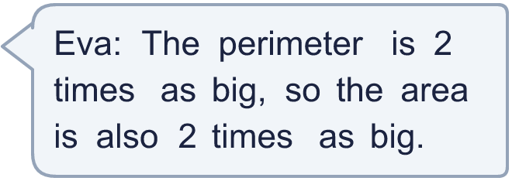
  10 | A rectangle is 5 cm by 3 cm. It is enlarged by scale factor 2.  Is Eva correct? Circle yes or no.  Yes / No  Explain and write the area of the new rectangle.  Hint: Find the new length and width. Multiply them. Compare with the old area.
  11 | B is an enlargement of A. A is 6 cm long and 5 cm wide. B is 30 cm long.  How wide is B?  Hint: Find the scale factor first: divide the known side of B by the matching side of A.
  11 | B is an enlargement of A. A is 6 cm long and 5 cm wide. B is 30 cm long.  How wide is B?  Hint: Find the scale factor first: divide the known side of B by the matching side of A.
  12 | A square has sides of 3 cm. It is enlarged by scale factor 2 to make square B. Square B is then enlarged by scale factor 3 to make square C.  Hint: Side of B = 3 × 2. Then multiply that by 3.
    a) Square C is
    times as big as square A
  12 | A square has sides of 3 cm. It is enlarged by scale factor 2 to make square B. Square B is then enlarged by scale factor 3 to make square C.  Hint: Side of B = 3 × 2. Then multiply that by 3.
    a) Square C is
    times as big as square A
  13 | The perimeter of shape A is 22 cm. Nina makes shape B by enlarging A by scale factor ¹⁄₂.  Hint: ¹⁄₂ means half. Every length is halved, so the perimeter is halved too.
  13 | The perimeter of shape A is 22 cm. Nina makes shape B by enlarging A by scale factor ¹⁄₂.  Hint: ¹⁄₂ means half. Every length is halved, so the perimeter is halved too.
  14 | Challenge  Square X has sides of 3 cm. Square Y has sides of 15 cm.  Hint: Find the scale factor from X to Y. The perimeter is multiplied by it. The area is multiplied by it twice.
    a) The perimeter of Y is
    times the perimeter of X
    b) The area of Y is
    times the area of X
  14 | Challenge  Square X has sides of 3 cm. Square Y has sides of 15 cm.  Hint: Find the scale factor from X to Y. The perimeter is multiplied by it. The area is multiplied by it twice.
    a) The perimeter of Y is
    times the perimeter of X
    b) The area of Y is
    times the area of X

Year 6 · Ratio · Step 6
Using scale factors
Answers (teacher copy)

B is an enlargement of A by scale factor 2. Every length in A is multiplied by 2:
  1 | This rectangle is enlarged by scale factor 3. Write the width and height of the new rectangle.  New width: 15 cm  New height: 6 cm  Hint: Scale factor 3 means every length is multiplied by 3.
  2 | A square has sides of 4 cm. It is enlarged by scale factor 5.  a) Side of the new square: 20 cm  b) Perimeter of the new square: 80 cm  Hint: Multiply the side by 5. A square has 4 equal sides.
  3 | Each side of a shape changes as described. Write the scale factor of the enlargement.  a) Each side has tripled. 3  b) Each side has doubled. 2  c) Each side has quadrupled. 4  d) Each side has become 5 times as long. 5  Hint: Doubled means × 2. Tripled means × 3. Quadrupled means × 4.
  4 | Rectangle B is an enlargement of rectangle A. What is the scale factor?  Scale factor: 2  Hint: How many times longer is a side of B than the matching side of A? Divide.
  5 | Triangle A is enlarged by scale factor 2 to make triangle B.  a) Perimeter of A: 16 cm  b) Perimeter of B: 32 cm  Hint: Add the three sides of A. The perimeter of B is the perimeter of A multiplied by the scale factor.
  6 | a) This rectangle is enlarged by scale factor 1 ¹⁄₂.  New width: 15 cm New height: 12 cm  b) This rectangle is enlarged by scale factor ¹⁄₂.  New width: 5 cm New height: 2 cm  Hint: ¹⁄₂ means half of each length. 1 ¹⁄₂ means the length plus half of it.
  7 | A rectangle is 5 cm long and 2 cm wide. It is enlarged by scale factor 4.  Perimeter of the new rectangle: 56 cm  Hint: First find the new length and width. Then add the four sides.
  8 | Rectangle B is an enlargement of rectangle A. Find the missing measurement.  Width of B: 4 cm  Hint: Use the sides you can see on both rectangles to find the scale factor. Then multiply.
  9 | Square A has sides of 4 cm. Square B is an enlargement of A by scale factor 3.  Perimeter of A: 16 cm Perimeter of B: 48 cm  Area of A: 16 cm² Area of B: 144 cm²  The area of B is how many times the area of A?  9  Hint: Perimeter is the distance around. Area is length × width. Compare your answers.
  10 | A rectangle is 5 cm by 3 cm. It is enlarged by scale factor 2.  Is Eva correct? Circle yes or no.  Yes / No  Explain and write the area of the new rectangle.  No. The new rectangle is 10 cm by 6 cm, so its area is 60 cm². The old area was 15 cm². 60 ÷ 15 = 4, so the area is 4 times as big.  New area: 60 cm²  Hint: Find the new length and width. Multiply them. Compare with the old area.
  11 | B is an enlargement of A. A is 6 cm long and 5 cm wide. B is 30 cm long.  How wide is B?  25 cm  Hint: Find the scale factor first: divide the known side of B by the matching side of A.
  12 | A square has sides of 3 cm. It is enlarged by scale factor 2 to make square B. Square B is then enlarged by scale factor 3 to make square C.  a) Square C is 6 times as big as square A  b) Side of square C: 18 cm  Hint: Side of B = 3 × 2. Then multiply that by 3.
  13 | The perimeter of shape A is 22 cm. Nina makes shape B by enlarging A by scale factor ¹⁄₂.  Perimeter of B: 11 cm  Hint: ¹⁄₂ means half. Every length is halved, so the perimeter is halved too.
  14 | Challenge  Square X has sides of 3 cm. Square Y has sides of 15 cm.  a) The perimeter of Y is 5 times the perimeter of X  b) The area of Y is 25 times the area of X  Hint: Find the scale factor from X to Y. The perimeter is multiplied by it. The area is multiplied by it twice.

