  Year 6 · Statistics · Step 5  Drawing pie charts | 
  Year 6 · Statistics · Step 5
  Drawing pie charts
  1 | 40 children were asked to choose their favourite sport. The table shows the results. You are going to draw a pie chart.  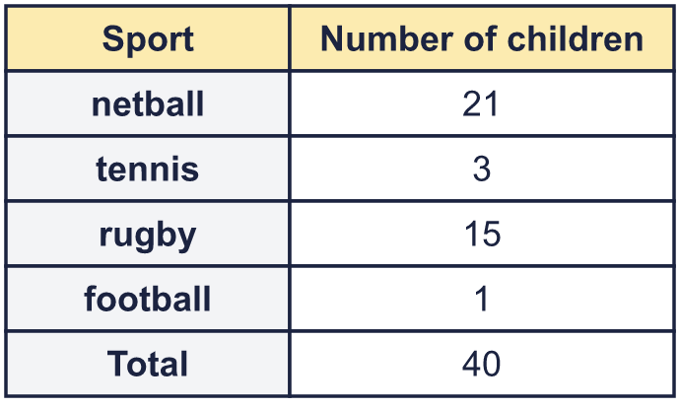  a) What fraction of the children chose rugby? Write it in its simplest form.  b) What fraction chose football? Write it in its simplest form.  c) What fraction chose tennis? Write it in its simplest form.
  1 | 40 children were asked to choose their favourite sport. The table shows the results. You are going to draw a pie chart.  a) What fraction of the children chose rugby? Write it in its simplest form.  b) What fraction chose football? Write it in its simplest form.  c) What fraction chose tennis? Write it in its simplest form.
  2 | A pie chart shows the answers of 30 children. There are 360° in a whole circle, so 30 children share 360°.  a) How many degrees does each child get? Write the number.  b) How many degrees is the sector for 4 children?
  2 | A pie chart shows the answers of 30 children. There are 360° in a whole circle, so 30 children share 360°.  a) How many degrees does each child get? Write the number.  b) How many degrees is the sector for 4 children?
  3 | 36 children were asked to choose their favourite lunch. The table shows the results.  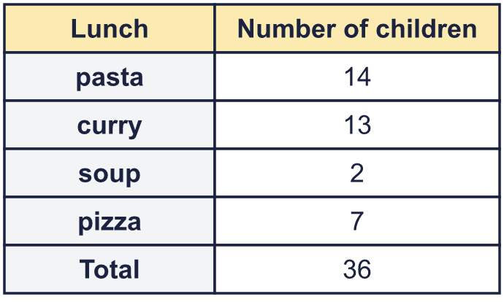  Work out the angle of each sector of the pie chart. Write the number of degrees.  a) soup  b) curry  c) pizza
  3 | 36 children were asked to choose their favourite lunch. The table shows the results.  Work out the angle of each sector of the pie chart. Write the number of degrees.  a) soup  b) curry  c) pizza
  4 | A percentage bar model shows how some children chose their favourite fruit. Use it to work out the angles for a pie chart. 1% of 360° is 3.6°.  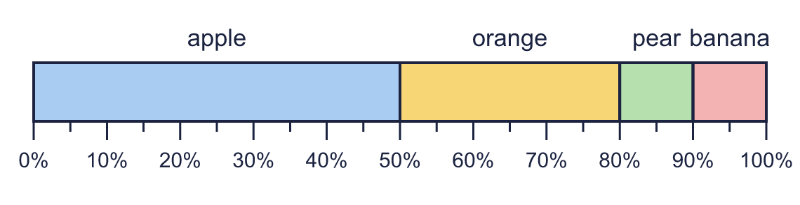  a) What is the angle for pear? Write the number of degrees.  b) What is the angle for banana? Write the number of degrees.
  4 | A percentage bar model shows how some children chose their favourite fruit. Use it to work out the angles for a pie chart. 1% of 360° is 3.6°.  a) What is the angle for pear? Write the number of degrees.  b) What is the angle for banana? Write the number of degrees.
  5 | A whole circle is 360°. Work out the angle for each fraction of a pie chart.  a) ¹⁄₁₀ of a circle  b) ¹⁄₂ of a circle  c) ⁵⁄₈ of a circle
  5 | A whole circle is 360°. Work out the angle for each fraction of a pie chart.  a) ¹⁄₁₀ of a circle  b) ¹⁄₂ of a circle  c) ⁵⁄₈ of a circle
  6 | A pie chart has four sectors. Three of the angles are 150°, 100° and 60°. What is the fourth angle? Write the number of degrees.
  6 | A pie chart has four sectors. Three of the angles are 150°, 100° and 60°. What is the fourth angle? Write the number of degrees.
  7 | 40 children were asked to choose their favourite lunch. The table shows the results. Draw a pie chart in your book. Work out each angle first and use a protractor. Label every sector.  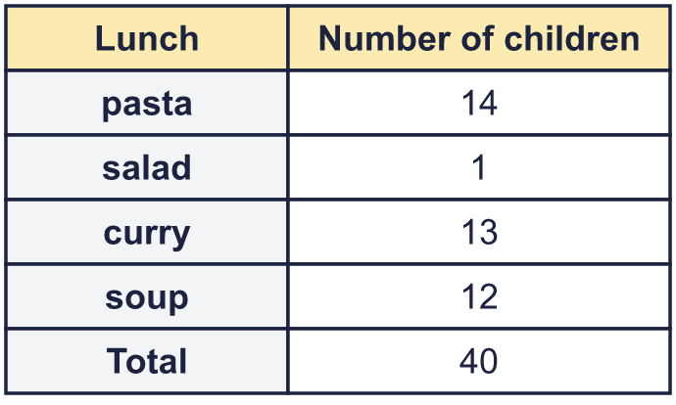  a) What is the angle of the biggest sector?  b) What is the angle of the smallest sector?
  7 | 40 children were asked to choose their favourite lunch. The table shows the results. Draw a pie chart in your book. Work out each angle first and use a protractor. Label every sector.  a) What is the angle of the biggest sector?  b) What is the angle of the smallest sector?
  8 | 60 children were asked how they travel to school. The table shows the results.  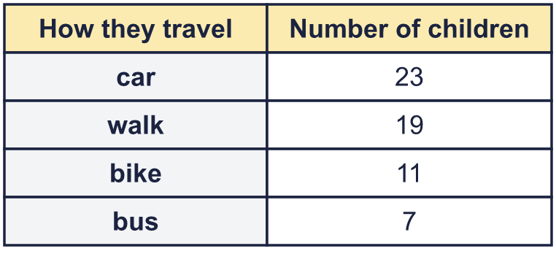  Work out the angle for each sector of a pie chart.  a) car  b) walk  c) bike  d) bus
  8 | 60 children were asked how they travel to school. The table shows the results.  Work out the angle for each sector of a pie chart.  a) car  b) walk  c) bike  d) bus

  9 | Is Boba correct? Circle yes or no.  Yes / No  Explain how you know.
     | 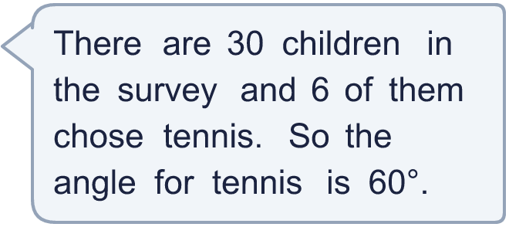
  9 | Is Boba correct? Circle yes or no.  Yes / No  Explain how you know.
  10 | A pie chart shows the answers of 36 children. One sector is 40° and another sector is 20°.  a) How many children are in the 40° sector?  b) How many children are in the 20° sector?
  10 | A pie chart shows the answers of 36 children. One sector is 40° and another sector is 20°.  a) How many children are in the 40° sector?  b) How many children are in the 20° sector?
  11 | 40 people chose a meal at a restaurant. The table is for a pie chart. Some numbers are missing.  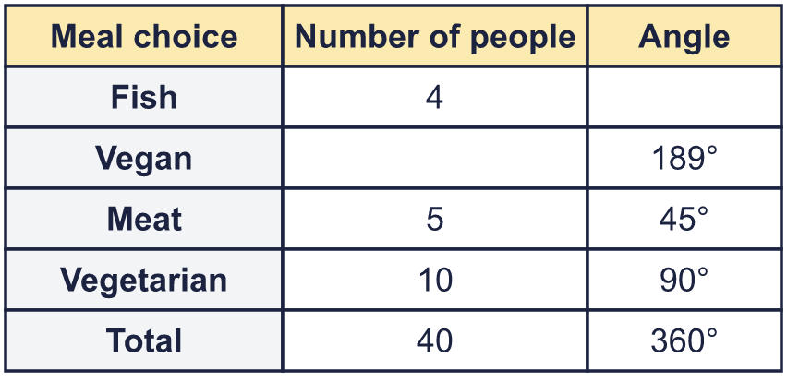  a) How many people chose Vegan? Write the number.  b) What is the angle for Fish? Write the number of degrees.
  11 | 40 people chose a meal at a restaurant. The table is for a pie chart. Some numbers are missing.  a) How many people chose Vegan? Write the number.  b) What is the angle for Fish? Write the number of degrees.
  12 | In a pie chart, the sector for 6 children has an angle of 90°.  a) How many children were asked altogether?  b) How many children are in a sector of 75°?
  12 | In a pie chart, the sector for 6 children has an angle of 90°.  a) How many children were asked altogether?  b) How many children are in a sector of 75°?
  13 | 36 children were asked to choose their favourite animal. The table shows the results. Only one of the pie charts A, B, C and D is correct.  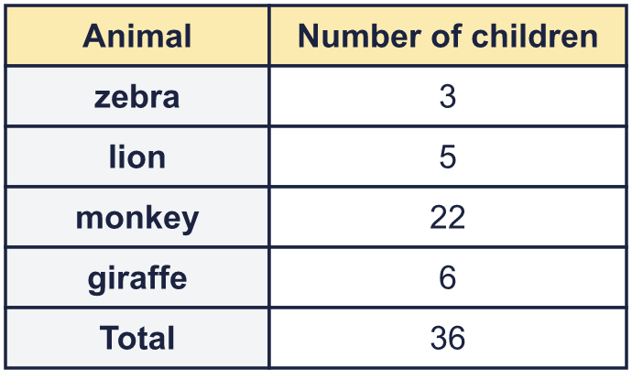  A  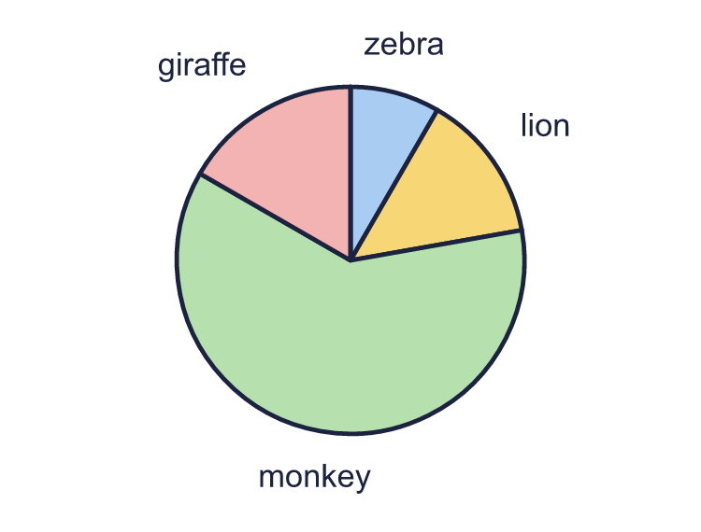  B  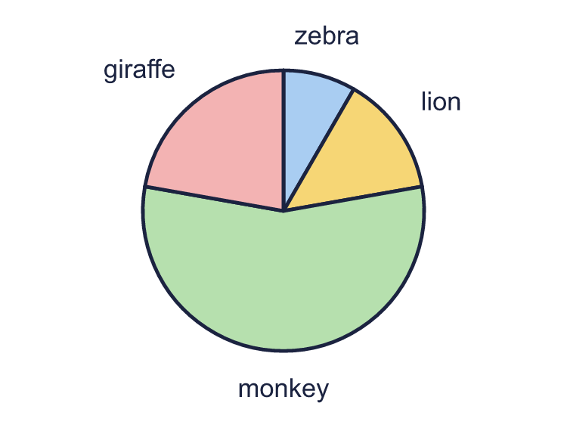  C  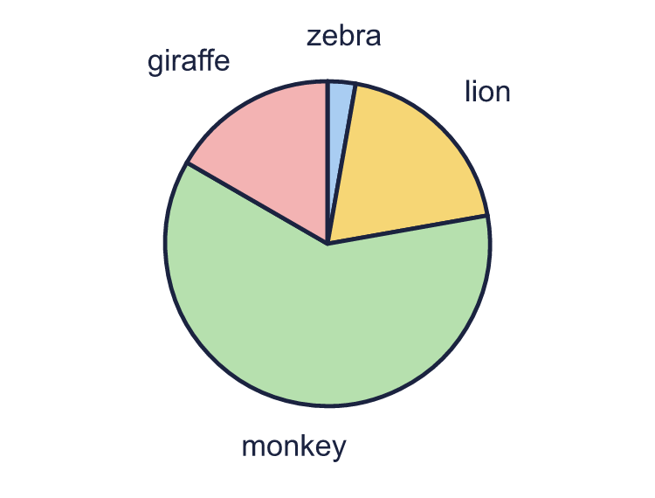  D  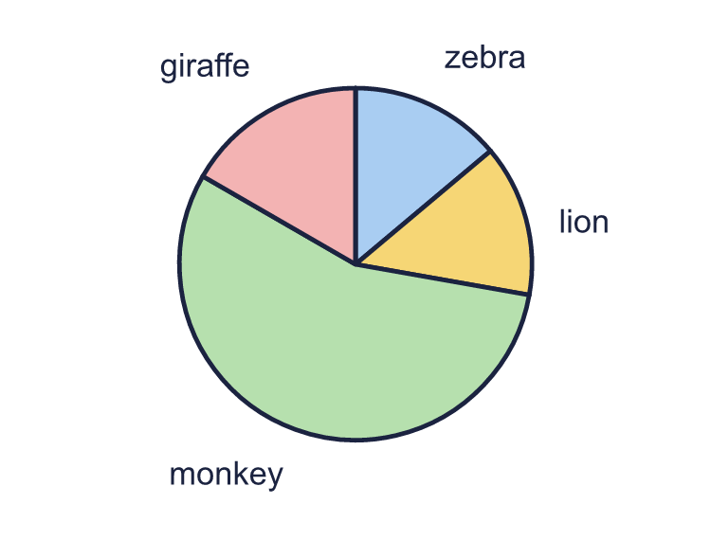
  13 | 36 children were asked to choose their favourite animal. The table shows the results. Only one of the pie charts A, B, C and D is correct.  A  B  C  D
  14 | Some children are asked a question. The angle for each child on the pie chart must be a whole number of degrees. Which of these could be the number of children asked? Write the letters of all that work.  a) 30 children  b) 24 children  c) 25 children  d) 9 children
  14 | Some children are asked a question. The angle for each child on the pie chart must be a whole number of degrees. Which of these could be the number of children asked? Write the letters of all that work.  a) 30 children  b) 24 children  c) 25 children  d) 9 children

Year 6 · Statistics · Step 5
Drawing pie charts
Answers (teacher copy)

  1 | 40 children were asked to choose their favourite sport. The table shows the results. You are going to draw a pie chart.  a) What fraction of the children chose rugby? Write it in its simplest form. ³⁄₈  b) What fraction chose football? Write it in its simplest form. ¹⁄₄₀  c) What fraction chose tennis? Write it in its simplest form. ³⁄₄₀
  2 | A pie chart shows the answers of 30 children. There are 360° in a whole circle, so 30 children share 360°.  a) How many degrees does each child get? Write the number. 12  b) How many degrees is the sector for 4 children? 48
  3 | 36 children were asked to choose their favourite lunch. The table shows the results.  Work out the angle of each sector of the pie chart. Write the number of degrees.  a) soup 20  b) curry 130  c) pizza 70
  4 | A percentage bar model shows how some children chose their favourite fruit. Use it to work out the angles for a pie chart. 1% of 360° is 3.6°.  a) What is the angle for pear? Write the number of degrees. 36  b) What is the angle for banana? Write the number of degrees. 36
  5 | A whole circle is 360°. Work out the angle for each fraction of a pie chart.  a) ¹⁄₁₀ of a circle 36  b) ¹⁄₂ of a circle 180  c) ⁵⁄₈ of a circle 225
  6 | A pie chart has four sectors. Three of the angles are 150°, 100° and 60°. What is the fourth angle? Write the number of degrees.  Fourth angle: 50
  7 | 40 children were asked to choose their favourite lunch. The table shows the results. Draw a pie chart in your book. Work out each angle first and use a protractor. Label every sector.  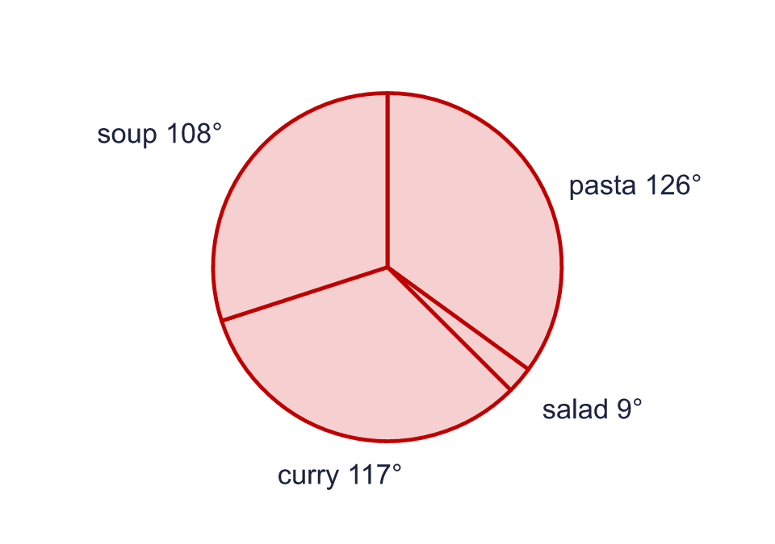  a) What is the angle of the biggest sector? 126  b) What is the angle of the smallest sector? 9
  8 | 60 children were asked how they travel to school. The table shows the results.  Work out the angle for each sector of a pie chart.  a) car 138  b) walk 114  c) bike 66  d) bus 42
  9 | Is Boba correct? Circle yes or no.  Yes / No  Explain how you know.  Each child is 360° ÷ 30 = 12°. So 6 children is 6 × 12° = 72°, not 60°.
  10 | A pie chart shows the answers of 36 children. One sector is 40° and another sector is 20°.  a) How many children are in the 40° sector? 4  b) How many children are in the 20° sector? 2
  11 | 40 people chose a meal at a restaurant. The table is for a pie chart. Some numbers are missing.  a) How many people chose Vegan? Write the number. 21  b) What is the angle for Fish? Write the number of degrees. 36
  12 | In a pie chart, the sector for 6 children has an angle of 90°.  a) How many children were asked altogether? 24  b) How many children are in a sector of 75°? 5
  13 | 36 children were asked to choose their favourite animal. The table shows the results. Only one of the pie charts A, B, C and D is correct.  A  B  C  D  The correct pie chart is: A
  14 | Some children are asked a question. The angle for each child on the pie chart must be a whole number of degrees. Which of these could be the number of children asked? Write the letters of all that work.  a) 30 children  b) 24 children  c) 25 children  d) 9 children  Letters: a, b, d

