  Year 6 · Statistics · Step 2  Dual bar charts | 
  Year 6 · Statistics · Step 2
  Dual bar charts
  1 | Children in Class 6 either have a school dinner or bring a packed lunch. The chart shows how many children chose each one each day.  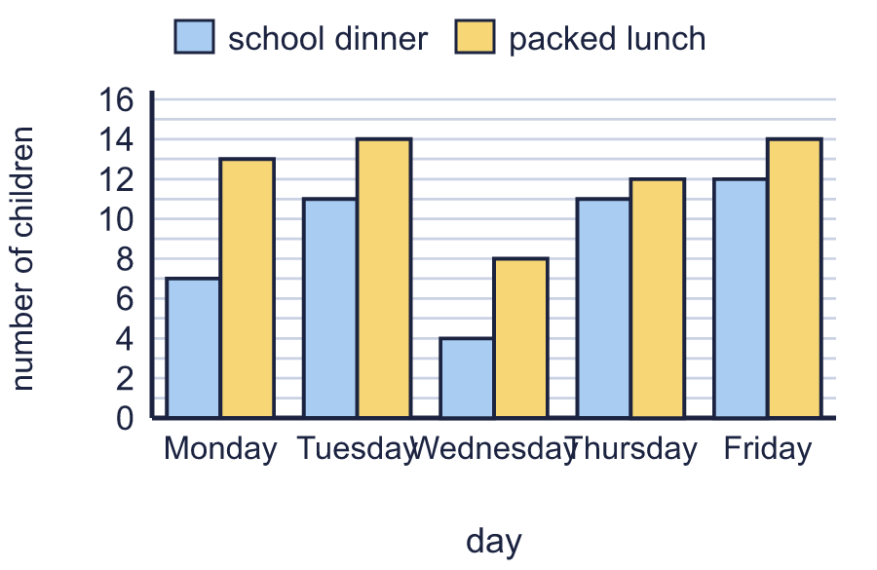  a) How many children had a school dinner on Tuesday?  b) How many children had a packed lunch on Friday?
  1 | Children in Class 6 either have a school dinner or bring a packed lunch. The chart shows how many children chose each one each day.  a) How many children had a school dinner on Tuesday?  b) How many children had a packed lunch on Friday?
  2 | Children in Class 6 either have a school dinner or bring a packed lunch. The chart shows how many children chose each one each day.  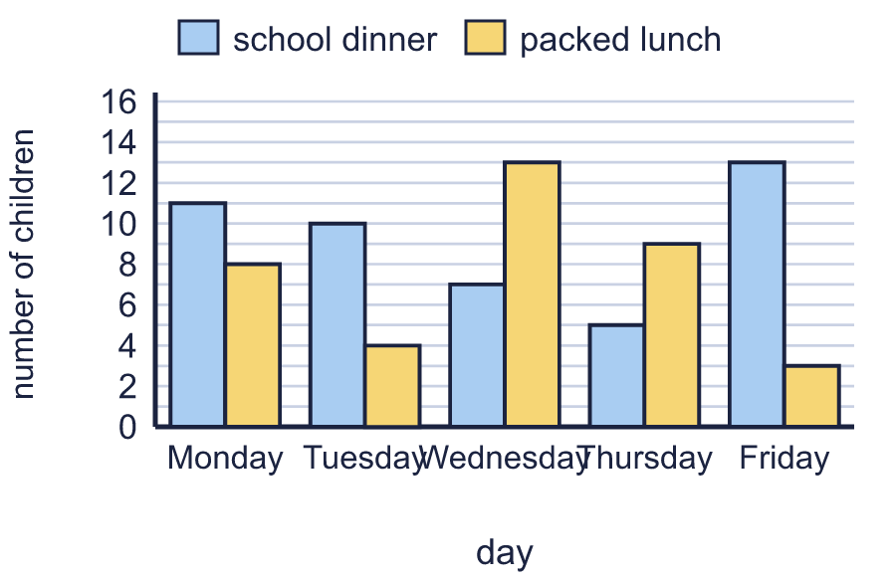  a) On which day did 9 children have a packed lunch?  b) On which day did the most children have a school dinner?
  2 | Children in Class 6 either have a school dinner or bring a packed lunch. The chart shows how many children chose each one each day.  a) On which day did 9 children have a packed lunch?  b) On which day did the most children have a school dinner?
  3 | Children in Class 6 either have a school dinner or bring a packed lunch. The chart shows how many children chose each one each day.  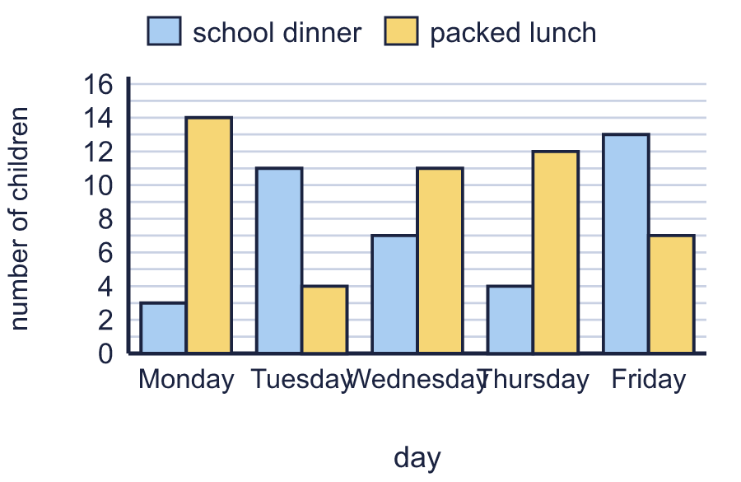  On which days did more children have a packed lunch than a school dinner? Write the days.
  3 | Children in Class 6 either have a school dinner or bring a packed lunch. The chart shows how many children chose each one each day.  On which days did more children have a packed lunch than a school dinner? Write the days.
  4 | Children in Class 6 either have a school dinner or bring a packed lunch. The chart shows how many children chose each one each day.  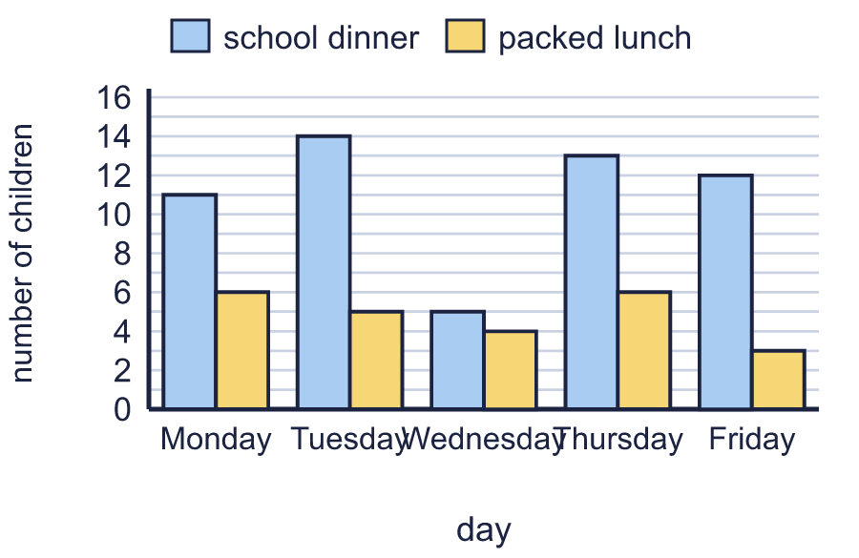  a) On Tuesday, how many more children had a school dinner than a packed lunch?  b) On Friday, how many more children had a school dinner than a packed lunch?
  4 | Children in Class 6 either have a school dinner or bring a packed lunch. The chart shows how many children chose each one each day.  a) On Tuesday, how many more children had a school dinner than a packed lunch?  b) On Friday, how many more children had a school dinner than a packed lunch?
  5 | Children in Class 6 either have a school dinner or bring a packed lunch. The chart shows how many children chose each one each day.  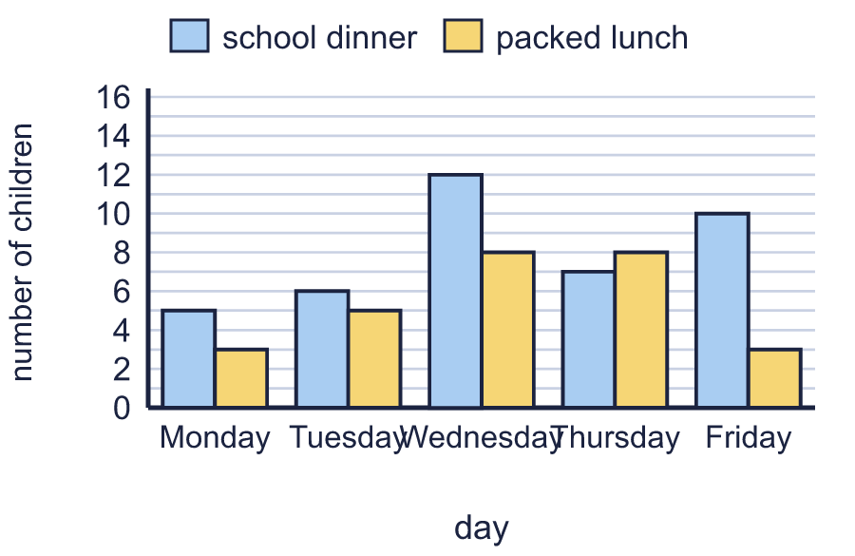  a) How many school dinners were eaten in the whole week?  b) How many children had lunch at school on Tuesday? Count both kinds of lunch.
  5 | Children in Class 6 either have a school dinner or bring a packed lunch. The chart shows how many children chose each one each day.  a) How many school dinners were eaten in the whole week?  b) How many children had lunch at school on Tuesday? Count both kinds of lunch.
  6 | The chart shows how many adults and how many children visited the Castle Museum each month.  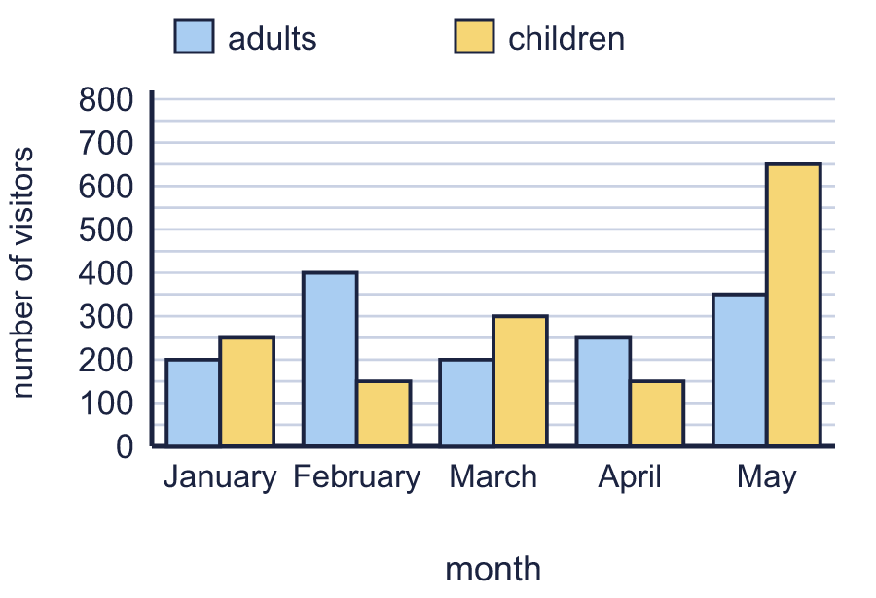  a) How many adults visited in February?  b) How many children visited in March?
  6 | The chart shows how many adults and how many children visited the Castle Museum each month.  a) How many adults visited in February?  b) How many children visited in March?
  7 | The chart shows how many adults and how many children visited the Mill Museum each month.  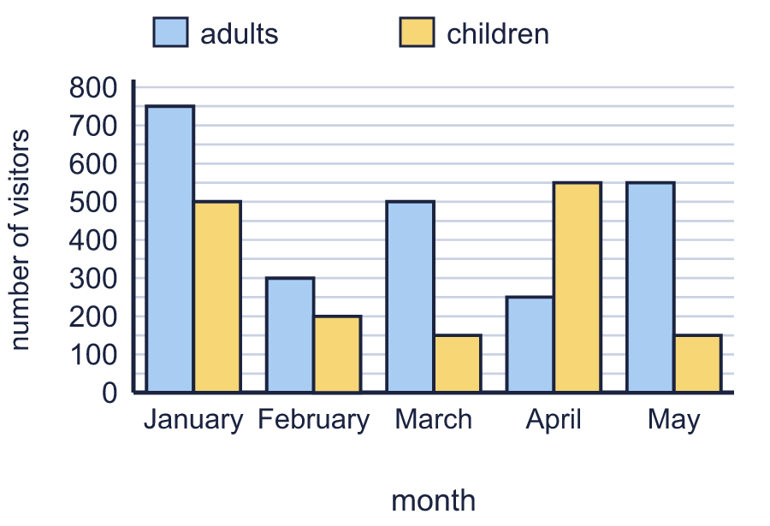  a) In April, how many more children than adults visited?  b) How many people visited altogether in February?
  7 | The chart shows how many adults and how many children visited the Mill Museum each month.  a) In April, how many more children than adults visited?  b) How many people visited altogether in February?
  8 | The chart shows how many adults and how many children visited the Mill Museum each month.  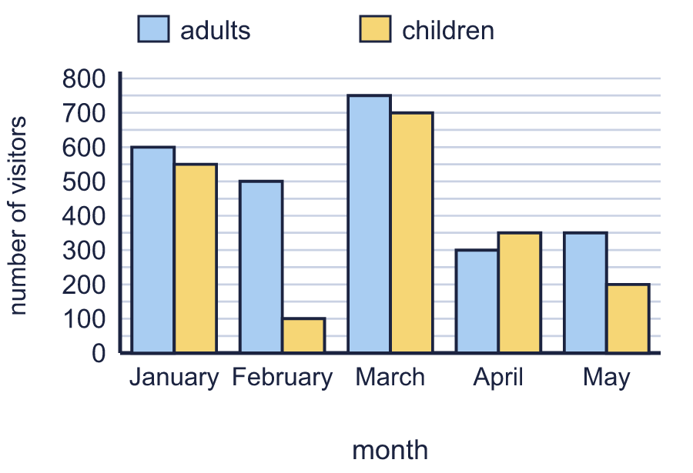  a) How many children visited altogether in the five months?  b) In which month was the difference between the number of adults and the number of children the greatest?
  8 | The chart shows how many adults and how many children visited the Mill Museum each month.  a) How many children visited altogether in the five months?  b) In which month was the difference between the number of adults and the number of children the greatest?

  9 | The chart shows what children in Class 6 had for lunch each day. Is Boba correct? Circle yes or no.  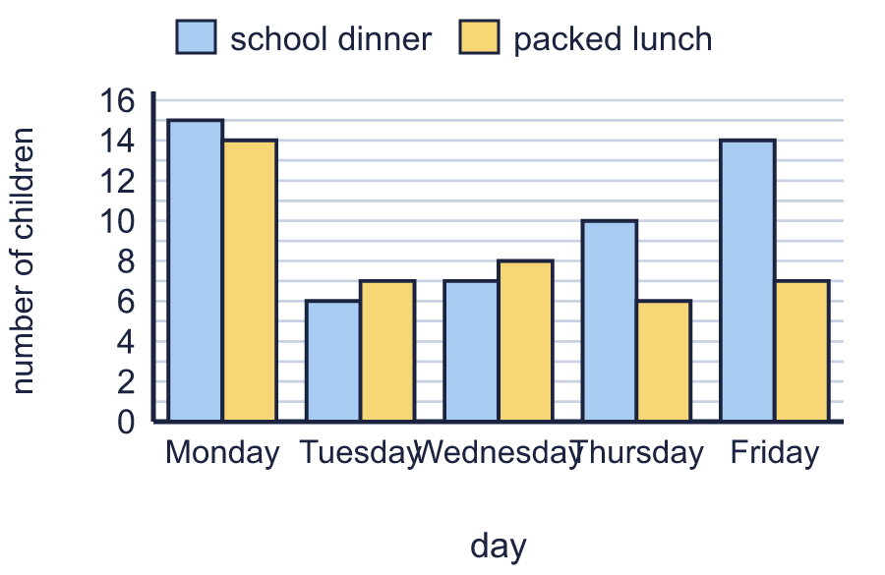  Yes / No  Explain how you know.
     | 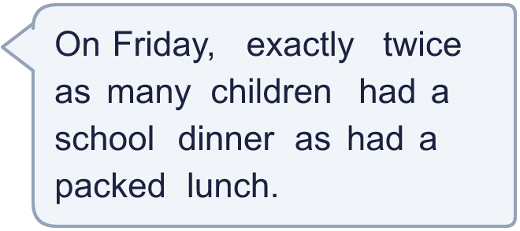
  9 | The chart shows what children in Class 6 had for lunch each day. Is Boba correct? Circle yes or no.  Yes / No  Explain how you know.
  10 | The table shows the rainfall in two towns, in millimetres. Draw a dual bar chart of the data in your book, with the two towns side by side for each month.  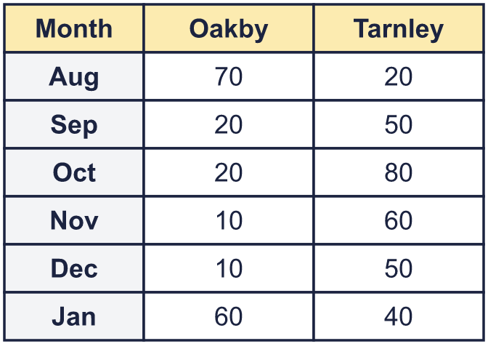  a) Use your chart. In which month was the difference between the two towns the greatest?  b) In that month, how many more millimetres of rain fell in Tarnley than in Oakby?
  10 | The table shows the rainfall in two towns, in millimetres. Draw a dual bar chart of the data in your book, with the two towns side by side for each month.  a) Use your chart. In which month was the difference between the two towns the greatest?  b) In that month, how many more millimetres of rain fell in Tarnley than in Oakby?
  11 | Three teams played four skill games. The chart shows the points each team scored in each game.  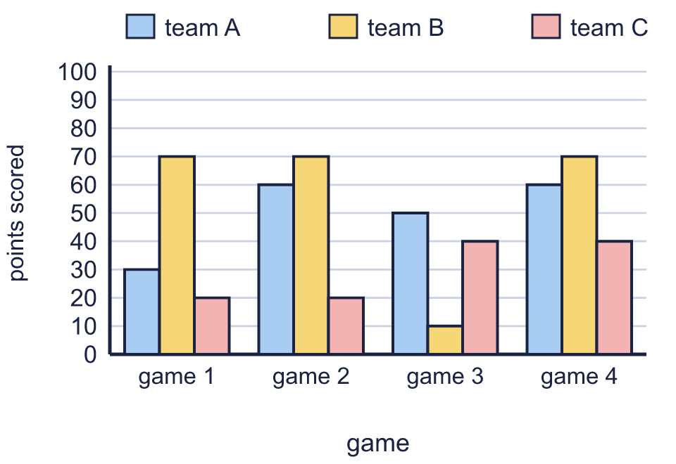  a) Which team won game 1? Write the team.  b) How many points did team B score in game 2?  c) Which team scored the most points altogether?  d) In which game were the fewest points scored altogether by the three teams?
  11 | Three teams played four skill games. The chart shows the points each team scored in each game.  a) Which team won game 1? Write the team.  b) How many points did team B score in game 2?  c) Which team scored the most points altogether?  d) In which game were the fewest points scored altogether by the three teams?
  12 | The chart shows the visitors to the Riverside Museum. In the month after May, there were 200 fewer visitors in total than in May.  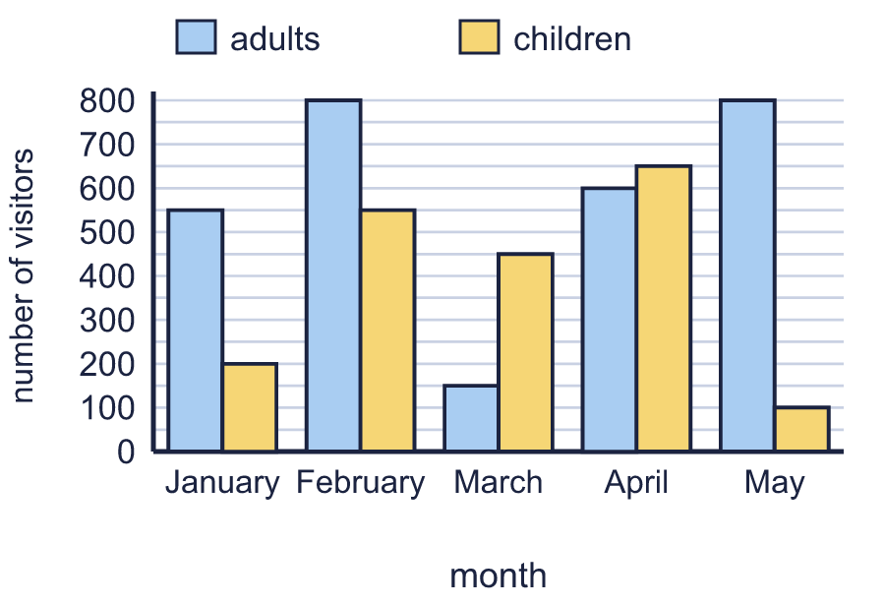  How many visitors were there in the month after May?
  12 | The chart shows the visitors to the Riverside Museum. In the month after May, there were 200 fewer visitors in total than in May.  How many visitors were there in the month after May?
  13 | One of the bars on this chart has been rubbed out. On Tuesday, 20 children had lunch at school altogether (school dinners and packed lunches).  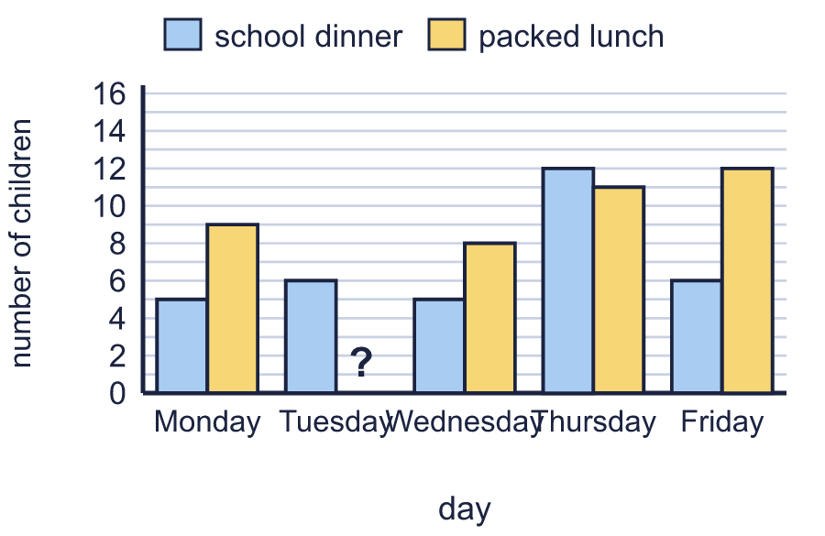  a) How many children had a packed lunch on Tuesday?  b) What is the difference between the number of school dinners on Monday and on Tuesday?
  13 | One of the bars on this chart has been rubbed out. On Tuesday, 20 children had lunch at school altogether (school dinners and packed lunches).  a) How many children had a packed lunch on Tuesday?  b) What is the difference between the number of school dinners on Monday and on Tuesday?
  14 | The chart shows what children in Class 6 had for lunch each day.  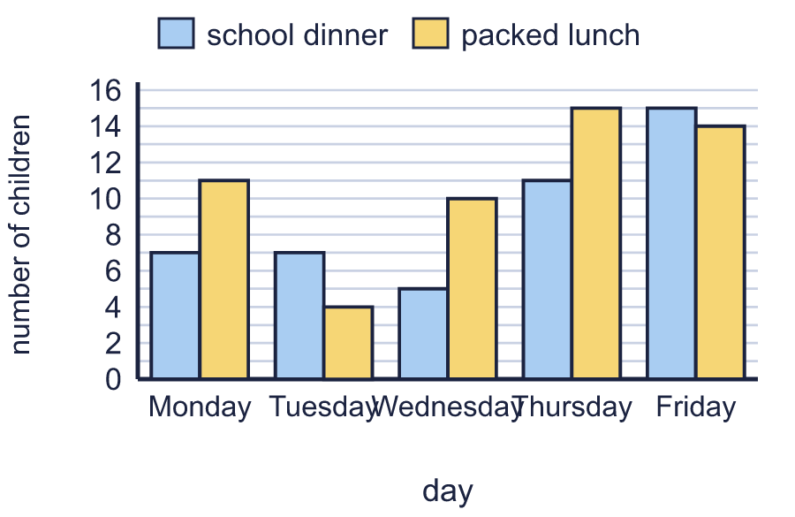  a) On which day did the most children have lunch? Count both kinds of lunch together.  b) How many children had lunch on that day?
  14 | The chart shows what children in Class 6 had for lunch each day.  a) On which day did the most children have lunch? Count both kinds of lunch together.  b) How many children had lunch on that day?

Year 6 · Statistics · Step 2
Dual bar charts
Answers (teacher copy)

  1 | Children in Class 6 either have a school dinner or bring a packed lunch. The chart shows how many children chose each one each day.  a) How many children had a school dinner on Tuesday? 11  b) How many children had a packed lunch on Friday? 14
  2 | Children in Class 6 either have a school dinner or bring a packed lunch. The chart shows how many children chose each one each day.  a) On which day did 9 children have a packed lunch? Thursday  b) On which day did the most children have a school dinner? Friday
  3 | Children in Class 6 either have a school dinner or bring a packed lunch. The chart shows how many children chose each one each day.  On which days did more children have a packed lunch than a school dinner? Write the days. Monday, Wednesday, Thursday
  4 | Children in Class 6 either have a school dinner or bring a packed lunch. The chart shows how many children chose each one each day.  a) On Tuesday, how many more children had a school dinner than a packed lunch? 9  b) On Friday, how many more children had a school dinner than a packed lunch? 9
  5 | Children in Class 6 either have a school dinner or bring a packed lunch. The chart shows how many children chose each one each day.  a) How many school dinners were eaten in the whole week? 40  b) How many children had lunch at school on Tuesday? Count both kinds of lunch. 11
  6 | The chart shows how many adults and how many children visited the Castle Museum each month.  a) How many adults visited in February? 400  b) How many children visited in March? 300
  7 | The chart shows how many adults and how many children visited the Mill Museum each month.  a) In April, how many more children than adults visited? 300  b) How many people visited altogether in February? 500
  8 | The chart shows how many adults and how many children visited the Mill Museum each month.  a) How many children visited altogether in the five months? 1,900  b) In which month was the difference between the number of adults and the number of children the greatest? February
  9 | The chart shows what children in Class 6 had for lunch each day. Is Boba correct? Circle yes or no.  Yes / No  Explain how you know.  14 children had a school dinner and 7 had a packed lunch. 7 × 2 = 14, so Boba is correct.
  10 | The table shows the rainfall in two towns, in millimetres. Draw a dual bar chart of the data in your book, with the two towns side by side for each month.  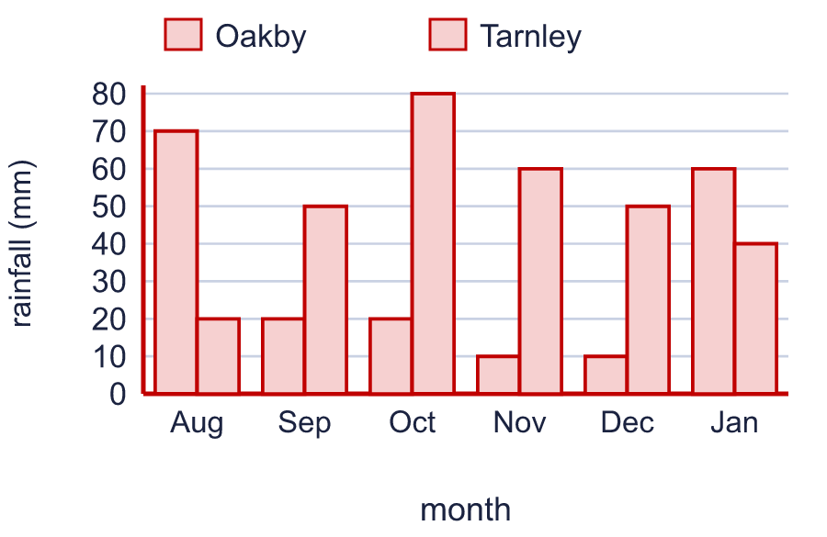  a) Use your chart. In which month was the difference between the two towns the greatest? Oct  b) In that month, how many more millimetres of rain fell in Tarnley than in Oakby? 60
  11 | Three teams played four skill games. The chart shows the points each team scored in each game.  a) Which team won game 1? Write the team. team B  b) How many points did team B score in game 2? 70  c) Which team scored the most points altogether? team B  d) In which game were the fewest points scored altogether by the three teams? game 3
  12 | The chart shows the visitors to the Riverside Museum. In the month after May, there were 200 fewer visitors in total than in May.  How many visitors were there in the month after May? 700
  13 | One of the bars on this chart has been rubbed out. On Tuesday, 20 children had lunch at school altogether (school dinners and packed lunches).  a) How many children had a packed lunch on Tuesday? 14  b) What is the difference between the number of school dinners on Monday and on Tuesday? 1
  14 | The chart shows what children in Class 6 had for lunch each day.  a) On which day did the most children have lunch? Count both kinds of lunch together. Friday  b) How many children had lunch on that day? 29

