  Year 6 · Statistics · Step 4  Pie charts with percentages | 
  Year 6 · Statistics · Step 4
  Pie charts with percentages
  1 | 60 children were asked to choose their favourite pet. The pie chart shows the results as percentages.  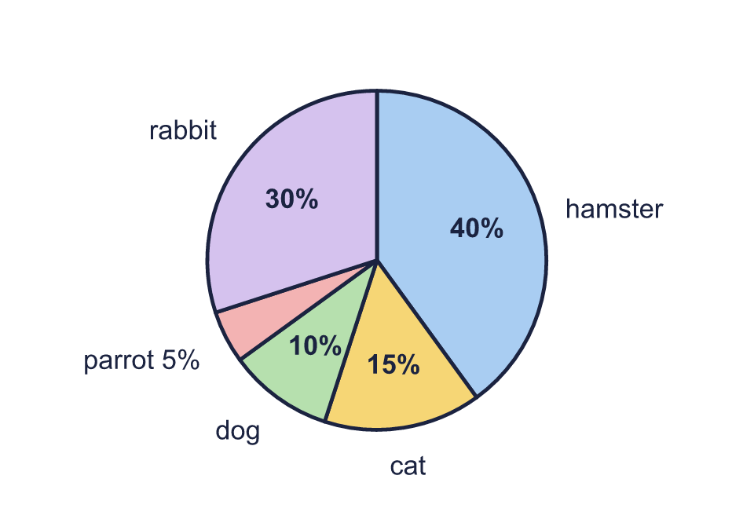  a) How many children chose dog?  b) How many children chose rabbit?  c) How many children chose hamster?
  1 | 60 children were asked to choose their favourite pet. The pie chart shows the results as percentages.  a) How many children chose dog?  b) How many children chose rabbit?  c) How many children chose hamster?
  2 | 400 people were asked to choose their favourite pet. The pie chart shows the results as percentages.  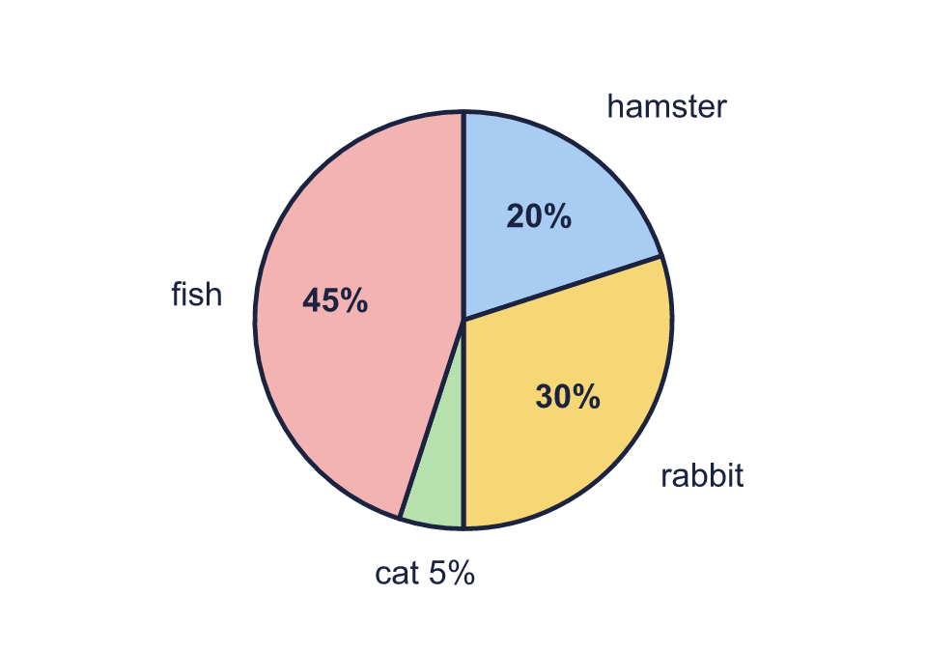  a) How many people chose cat?  b) How many people chose fish?
  2 | 400 people were asked to choose their favourite pet. The pie chart shows the results as percentages.  a) How many people chose cat?  b) How many people chose fish?
  3 | 200 children were asked to choose their favourite sport. The pie chart shows the results as percentages.  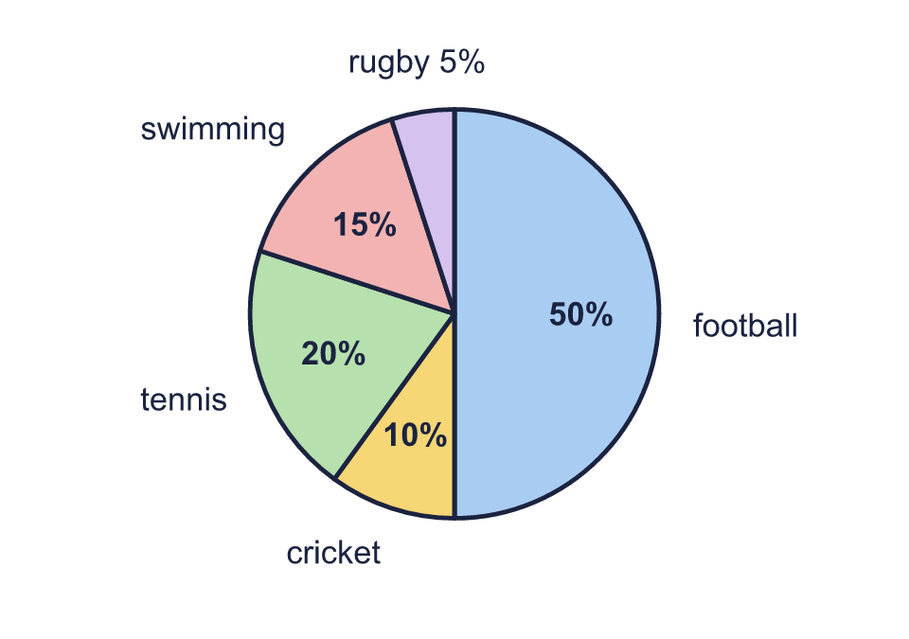  a) How many more children chose swimming than cricket?  b) How many children chose cricket or swimming?
  3 | 200 children were asked to choose their favourite sport. The pie chart shows the results as percentages.  a) How many more children chose swimming than cricket?  b) How many children chose cricket or swimming?
  4 | 40 people were asked to choose their favourite sport. The percentage for swimming is not shown on the pie chart.  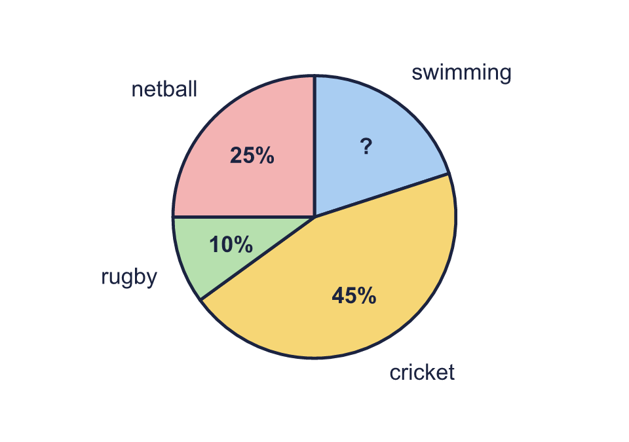  a) What percentage of the people chose swimming? Write the number.  b) How many people chose swimming?
  4 | 40 people were asked to choose their favourite sport. The percentage for swimming is not shown on the pie chart.  a) What percentage of the people chose swimming? Write the number.  b) How many people chose swimming?
  5 | Some children were asked to choose their favourite sport. The pie chart shows the results as percentages. 60 children chose swimming.  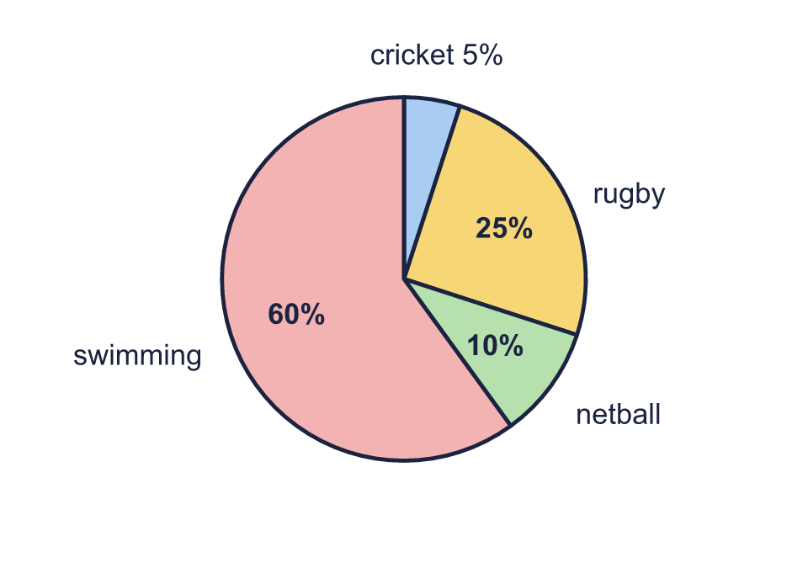  a) How many children were asked altogether?  b) How many children chose netball?
  5 | Some children were asked to choose their favourite sport. The pie chart shows the results as percentages. 60 children chose swimming.  a) How many children were asked altogether?  b) How many children chose netball?
  6 | Some children were asked to choose their favourite drink. The pie chart shows the results as percentages.  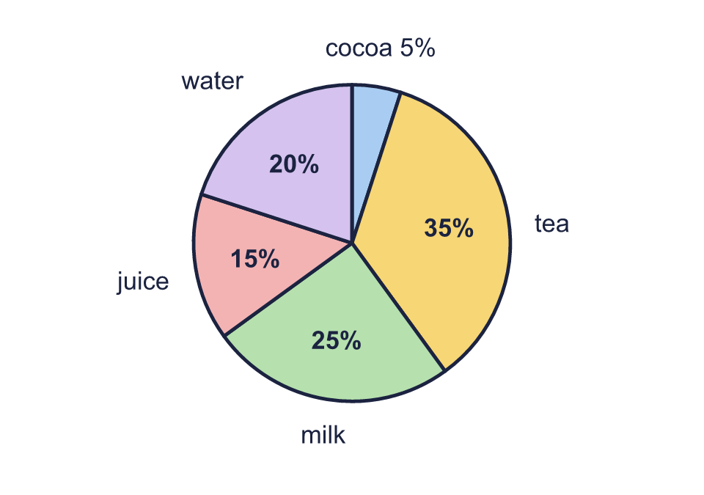  a) What fraction of the children chose juice? Write it in its simplest form.  b) What percentage of the children chose juice or milk? Write the number.
  6 | Some children were asked to choose their favourite drink. The pie chart shows the results as percentages.  a) What fraction of the children chose juice? Write it in its simplest form.  b) What percentage of the children chose juice or milk? Write the number.
  7 | The pie charts show the number of bedrooms in the houses in two towns.  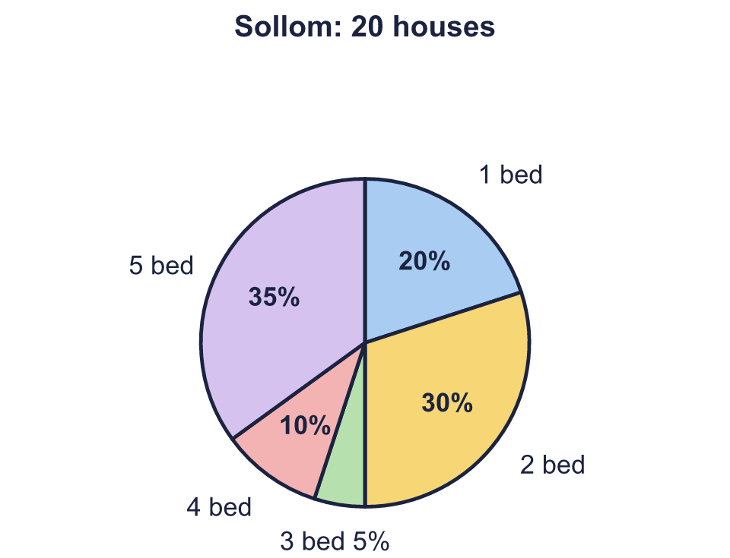  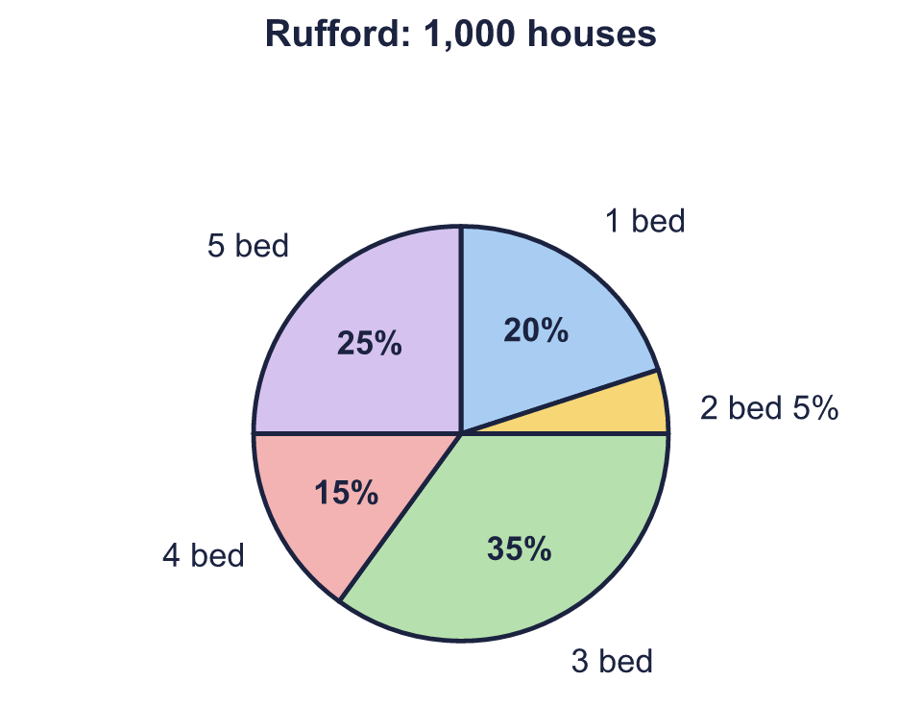  a) How many 3 bed houses are there in Sollom?  b) How many 3 bed houses are there in Rufford?
  7 | The pie charts show the number of bedrooms in the houses in two towns.  a) How many 3 bed houses are there in Sollom?  b) How many 3 bed houses are there in Rufford?
  8 | 500 children were asked to choose their favourite pet. The pie chart shows the results as percentages. Work out how many children chose each one.  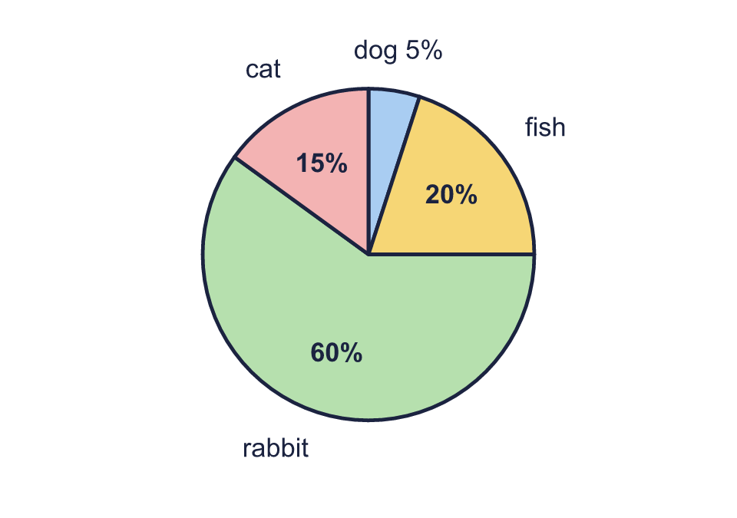  a) How many children chose dog?  b) How many children chose fish?  c) How many children chose rabbit?  d) How many children chose cat?
  8 | 500 children were asked to choose their favourite pet. The pie chart shows the results as percentages. Work out how many children chose each one.  a) How many children chose dog?  b) How many children chose fish?  c) How many children chose rabbit?  d) How many children chose cat?

  9 | The pie charts show the number of bedrooms in the houses in two towns.  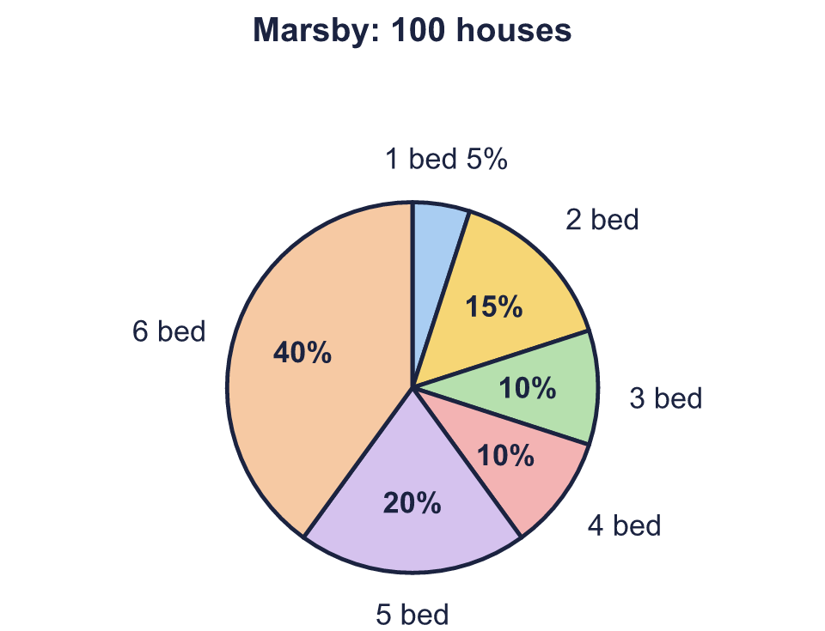  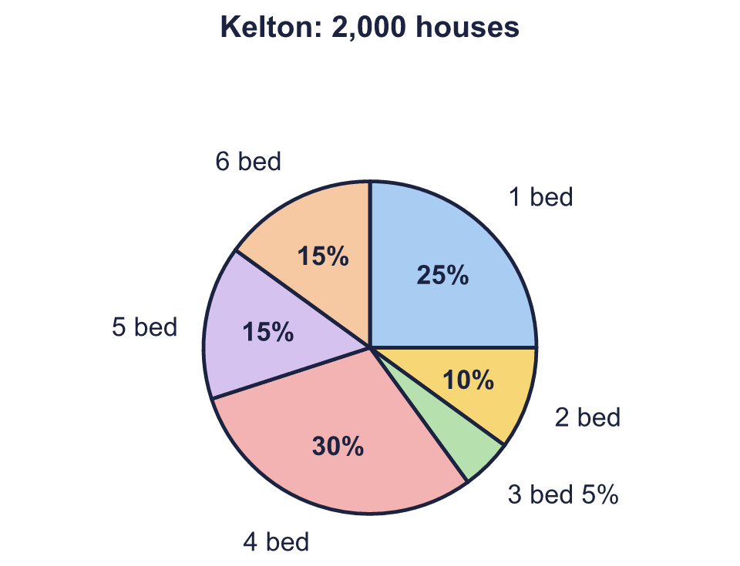  Is Boba correct? Circle yes or no.  Yes / No  Explain how you know.
     | 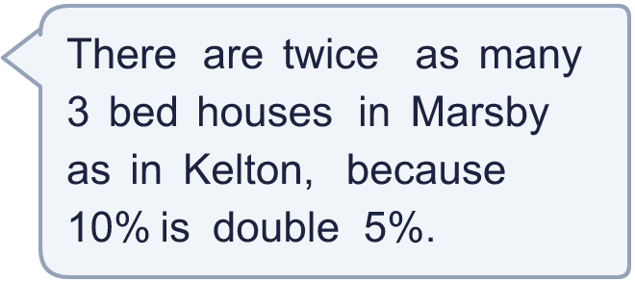
  9 | The pie charts show the number of bedrooms in the houses in two towns.  Is Boba correct? Circle yes or no.  Yes / No  Explain how you know.
  10 | The pie chart shows the colours of the cars in a car park. There were 20 yellow cars.  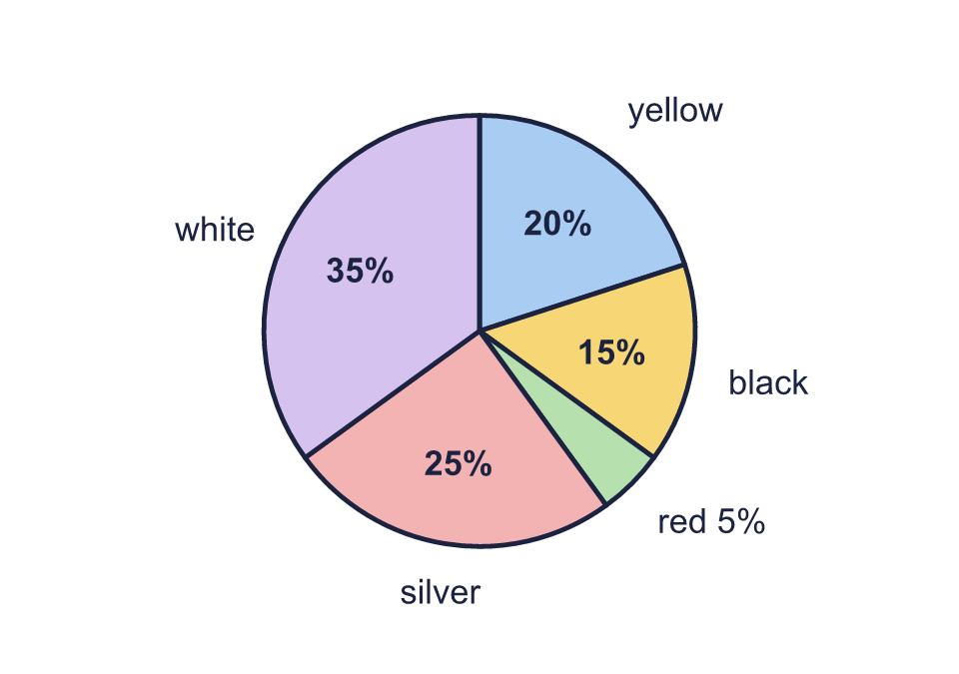  a) How many cars were in the car park altogether?  b) How many black cars were there?  c) How many silver cars were there?
  10 | The pie chart shows the colours of the cars in a car park. There were 20 yellow cars.  a) How many cars were in the car park altogether?  b) How many black cars were there?  c) How many silver cars were there?
  11 | The pie charts show the number of bedrooms in the houses in two towns.  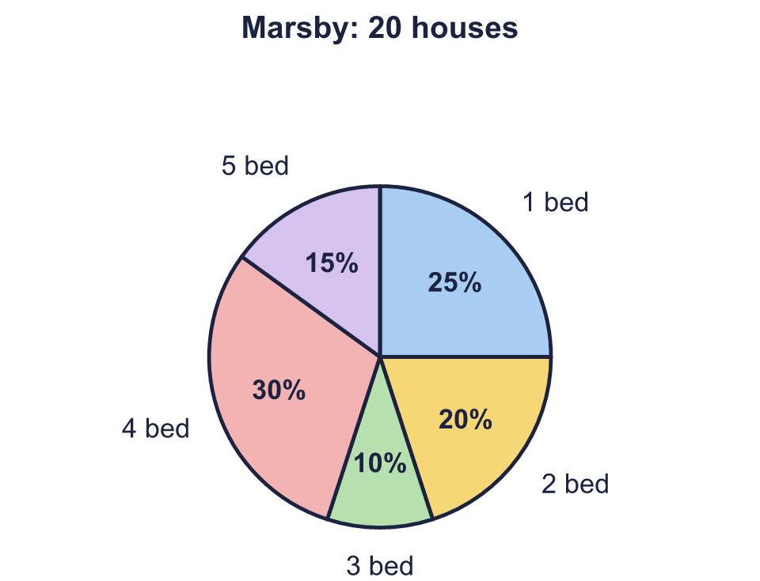  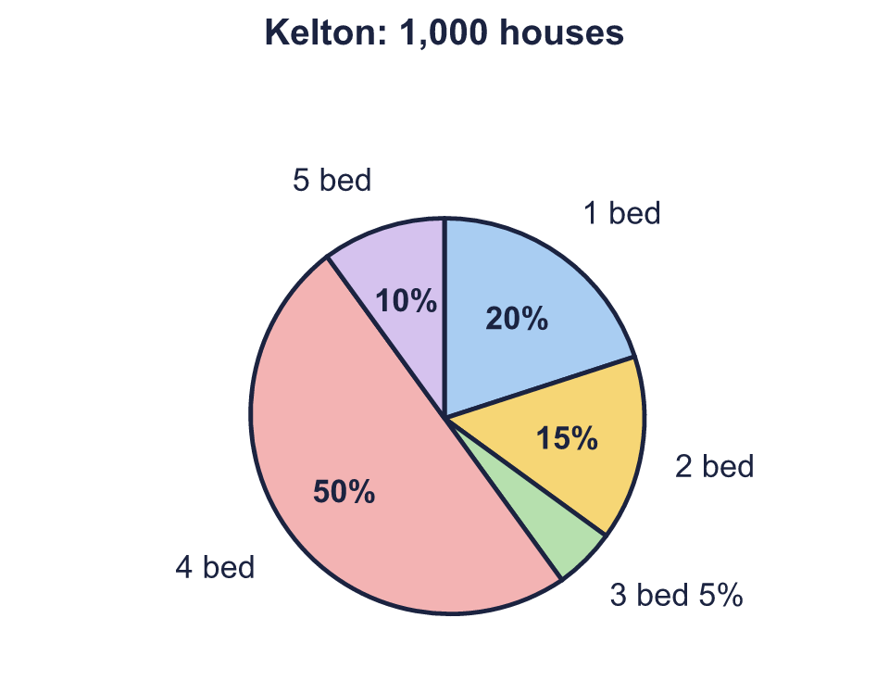  a) How many more 1 bed houses are there in Kelton than in Marsby?
  11 | The pie charts show the number of bedrooms in the houses in two towns.  a) How many more 1 bed houses are there in Kelton than in Marsby?
  12 | 800 people were asked to choose their favourite pet. The percentage for parrot is missing from the pie chart.  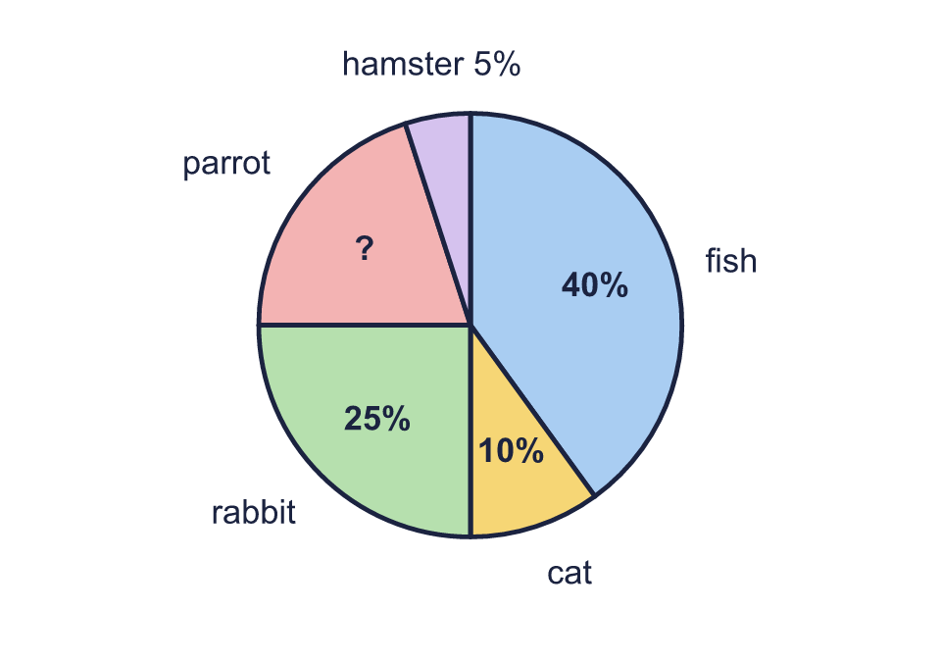  a) What percentage of the people chose parrot? Write the number.  b) How many more people chose parrot than hamster, or how many fewer? Write the difference.
  12 | 800 people were asked to choose their favourite pet. The percentage for parrot is missing from the pie chart.  a) What percentage of the people chose parrot? Write the number.  b) How many more people chose parrot than hamster, or how many fewer? Write the difference.
  13 | A pie chart shows that 25% of the people asked chose football. Every person is counted once. Which of these could be the number of people asked? Write the letters of all that work.  a) 100 people  b) 50 people  c) 30 people  d) 150 people
  13 | A pie chart shows that 25% of the people asked chose football. Every person is counted once. Which of these could be the number of people asked? Write the letters of all that work.  a) 100 people  b) 50 people  c) 30 people  d) 150 people
  14 | In a pie chart, 65% of the people surveyed chose cricket. Write two different numbers of people that could have been surveyed. The number of people who chose cricket must be a whole number.
  14 | In a pie chart, 65% of the people surveyed chose cricket. Write two different numbers of people that could have been surveyed. The number of people who chose cricket must be a whole number.

Year 6 · Statistics · Step 4
Pie charts with percentages
Answers (teacher copy)

  1 | 60 children were asked to choose their favourite pet. The pie chart shows the results as percentages.  a) How many children chose dog? 6  b) How many children chose rabbit? 18  c) How many children chose hamster? 24
  2 | 400 people were asked to choose their favourite pet. The pie chart shows the results as percentages.  a) How many people chose cat? 20  b) How many people chose fish? 180
  3 | 200 children were asked to choose their favourite sport. The pie chart shows the results as percentages.  a) How many more children chose swimming than cricket? 10  b) How many children chose cricket or swimming? 50
  4 | 40 people were asked to choose their favourite sport. The percentage for swimming is not shown on the pie chart.  a) What percentage of the people chose swimming? Write the number. 20  b) How many people chose swimming? 8
  5 | Some children were asked to choose their favourite sport. The pie chart shows the results as percentages. 60 children chose swimming.  a) How many children were asked altogether? 100  b) How many children chose netball? 10
  6 | Some children were asked to choose their favourite drink. The pie chart shows the results as percentages.  a) What fraction of the children chose juice? Write it in its simplest form. ³⁄₂₀  b) What percentage of the children chose juice or milk? Write the number. 40
  7 | The pie charts show the number of bedrooms in the houses in two towns.  a) How many 3 bed houses are there in Sollom? 1  b) How many 3 bed houses are there in Rufford? 350
  8 | 500 children were asked to choose their favourite pet. The pie chart shows the results as percentages. Work out how many children chose each one.  a) How many children chose dog? 25  b) How many children chose fish? 100  c) How many children chose rabbit? 300  d) How many children chose cat? 75
  9 | The pie charts show the number of bedrooms in the houses in two towns.  Is Boba correct? Circle yes or no.  Yes / No  Explain how you know.  Marsby has 10% of 100 = 10 3 bed houses. Kelton has 5% of 2,000 = 100. 100 × 2 = 200, not 10.
  10 | The pie chart shows the colours of the cars in a car park. There were 20 yellow cars.  a) How many cars were in the car park altogether? 100  b) How many black cars were there? 15  c) How many silver cars were there? 25
  11 | The pie charts show the number of bedrooms in the houses in two towns.  a) How many more 1 bed houses are there in Kelton than in Marsby? 195
  12 | 800 people were asked to choose their favourite pet. The percentage for parrot is missing from the pie chart.  a) What percentage of the people chose parrot? Write the number. 20  b) How many more people chose parrot than hamster, or how many fewer? Write the difference. 120
  13 | A pie chart shows that 25% of the people asked chose football. Every person is counted once. Which of these could be the number of people asked? Write the letters of all that work.  a) 100 people  b) 50 people  c) 30 people  d) 150 people  Letters: a
  14 | In a pie chart, 65% of the people surveyed chose cricket. Write two different numbers of people that could have been surveyed. The number of people who chose cricket must be a whole number.  Any two different numbers that give a whole number of people, for example 40 or 120

