  Year 6 · Statistics · Step 3  Reading pie charts | 
  Year 6 · Statistics · Step 3
  Reading pie charts
  1 | Some children were asked to choose their favourite fruit. The pie chart shows the results.  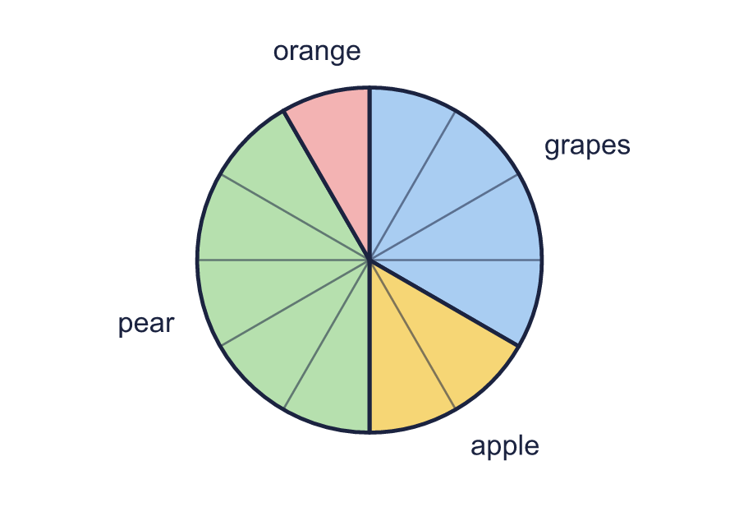  a) Which was the most popular? Write the name.  b) Which was the least popular? Write the name.
  1 | Some children were asked to choose their favourite fruit. The pie chart shows the results.  a) Which was the most popular? Write the name.  b) Which was the least popular? Write the name.
  2 | Some children were asked to choose their favourite pet. The pie chart shows the results.  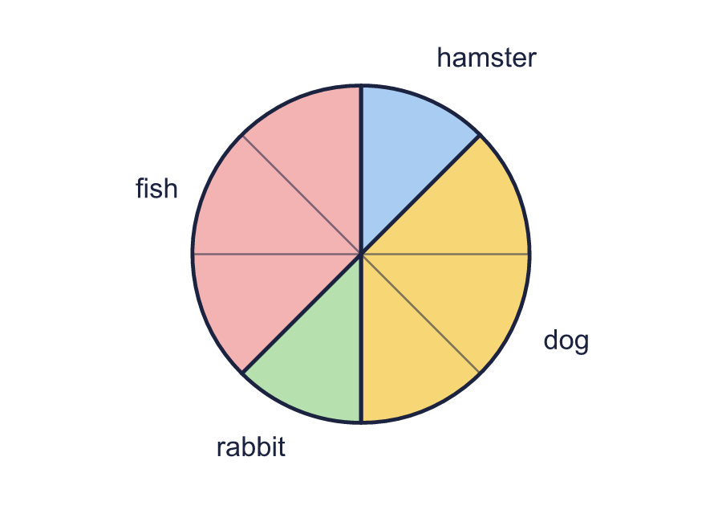  a) Did more or less than half of the children choose hamster? Write more or less.  b) Did more or less than a quarter of the children choose rabbit? Write more or less.
  2 | Some children were asked to choose their favourite pet. The pie chart shows the results.  a) Did more or less than half of the children choose hamster? Write more or less.  b) Did more or less than a quarter of the children choose rabbit? Write more or less.
  3 | Some children were asked to choose their favourite lesson. The pie chart shows the results.  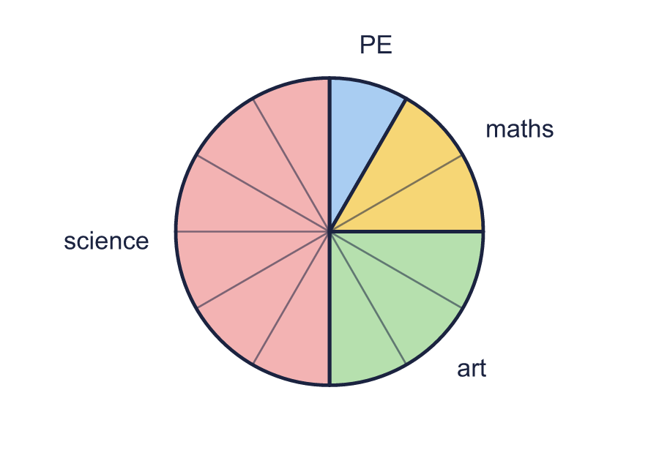  a) Did more children choose science or maths? Write the name.  b) What fraction of the children chose art? Write it in its simplest form.
  3 | Some children were asked to choose their favourite lesson. The pie chart shows the results.  a) Did more children choose science or maths? Write the name.  b) What fraction of the children chose art? Write it in its simplest form.
  4 | 2,000 people were asked how many televisions they have at home. The pie chart shows the results. Every part of the pie chart is the same size.  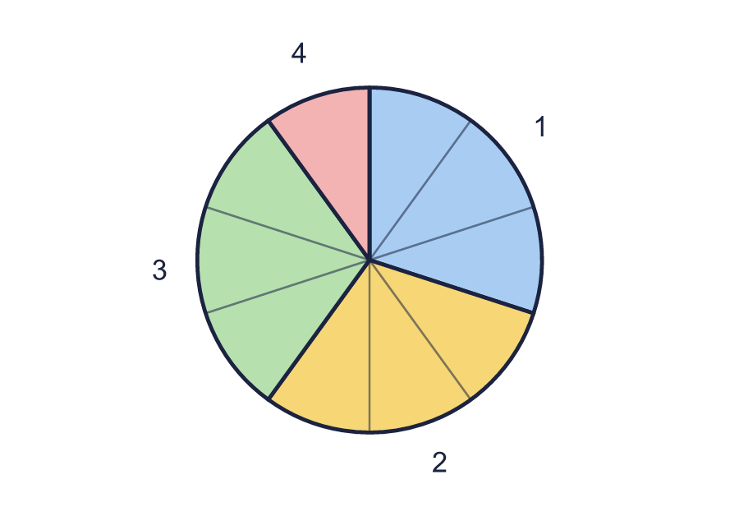  a) How many people have 2 televisions?  b) How many people have 4 televisions?
  4 | 2,000 people were asked how many televisions they have at home. The pie chart shows the results. Every part of the pie chart is the same size.  a) How many people have 2 televisions?  b) How many people have 4 televisions?
  5 | 500 people were asked how many televisions they have at home. The pie chart shows the results.  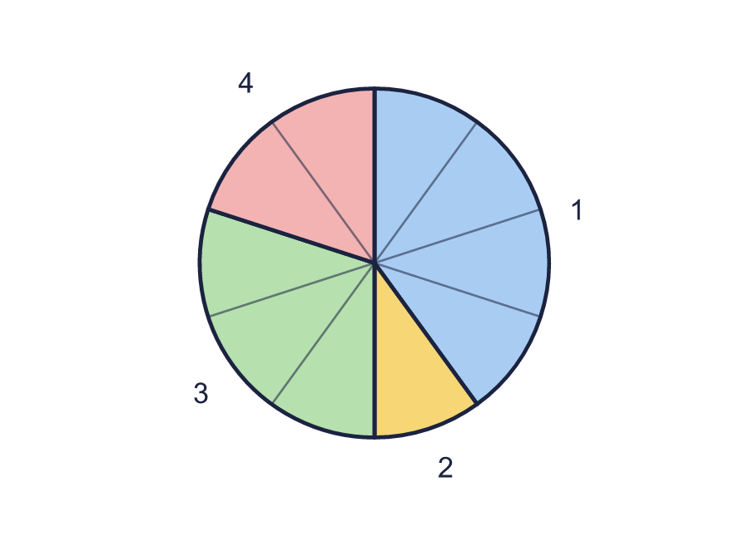  a) How many people have more than 2 televisions?  b) How many people have fewer than 3 televisions?
  5 | 500 people were asked how many televisions they have at home. The pie chart shows the results.  a) How many people have more than 2 televisions?  b) How many people have fewer than 3 televisions?
  6 | 1,000 people were asked how many televisions they have at home. The pie chart shows the results.  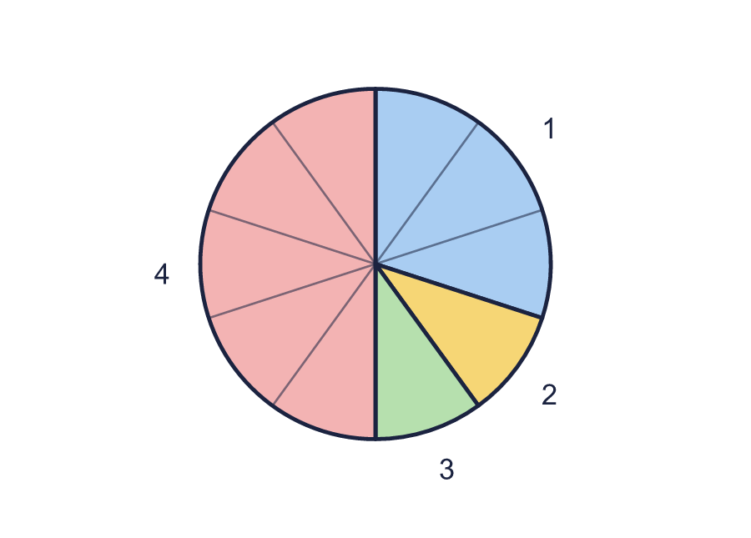  a) What fraction of the people have 4 televisions? Write it in its simplest form.  b) What fraction of the people have fewer than 3 televisions? Write it in its simplest form.
  6 | 1,000 people were asked how many televisions they have at home. The pie chart shows the results.  a) What fraction of the people have 4 televisions? Write it in its simplest form.  b) What fraction of the people have fewer than 3 televisions? Write it in its simplest form.
  7 | 320 children were asked how they travel to school. The pie chart shows the results.  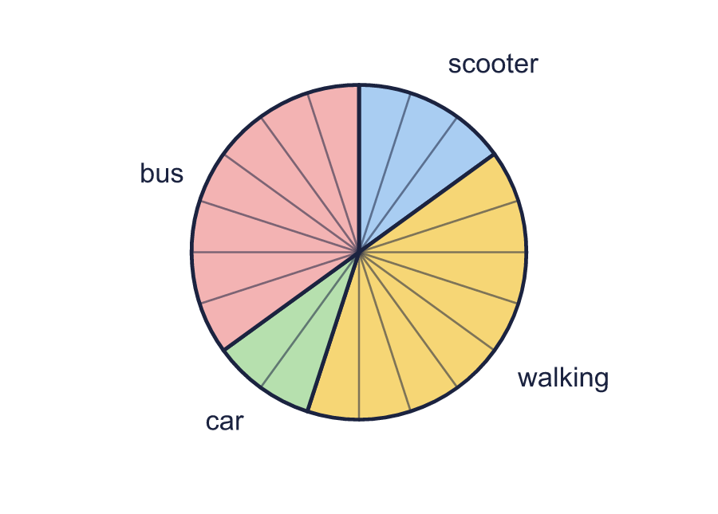  a) How many children chose bus?  b) How many more children chose bus than car?
  7 | 320 children were asked how they travel to school. The pie chart shows the results.  a) How many children chose bus?  b) How many more children chose bus than car?
  8 | 600 children were asked to choose their favourite lesson. The pie chart shows the results.  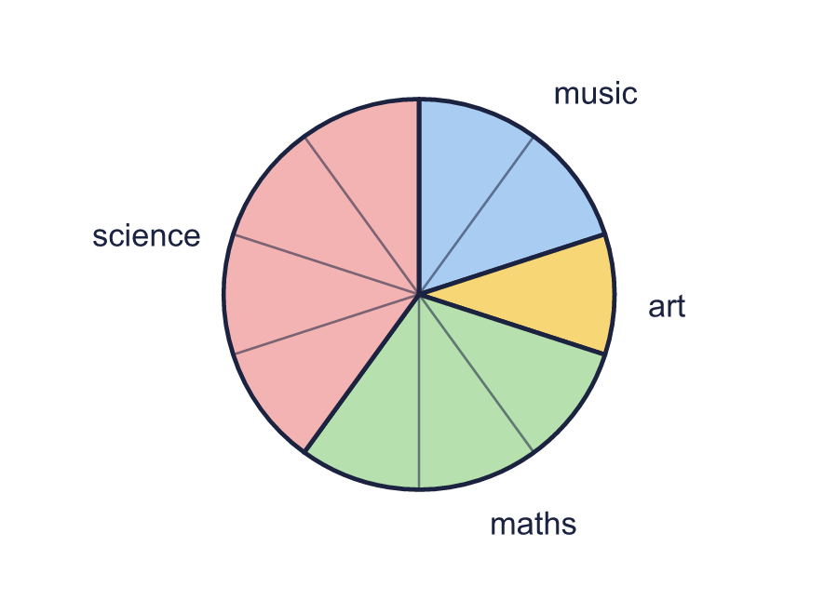  a) How many children chose art or maths?  b) How many children chose art?
  8 | 600 children were asked to choose their favourite lesson. The pie chart shows the results.  a) How many children chose art or maths?  b) How many children chose art?

  9 | Children from two schools were asked how they travel to school. The pie charts show the results.  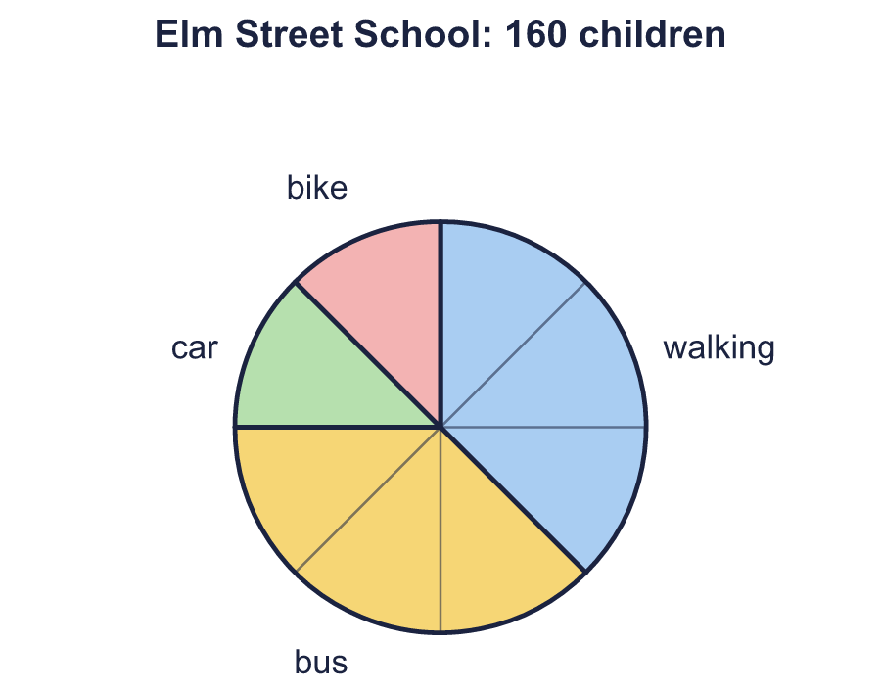  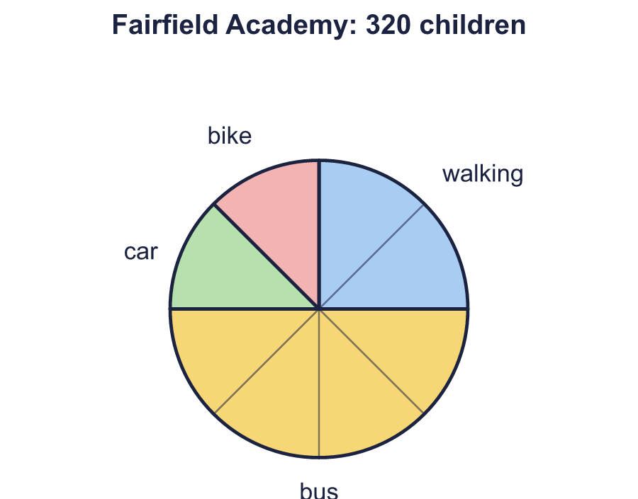  Is Boba correct? Circle yes or no.  Yes / No  Explain how you know.
     | 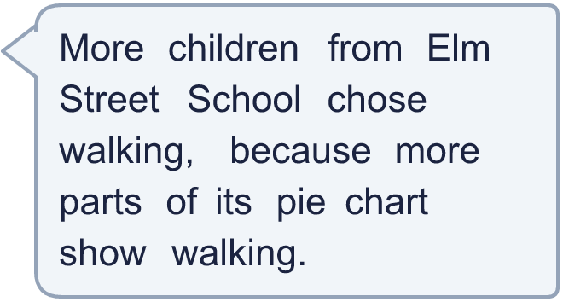
  9 | Children from two schools were asked how they travel to school. The pie charts show the results.  Is Boba correct? Circle yes or no.  Yes / No  Explain how you know.
  10 | Children from two schools were asked how they travel to school. The pie charts show the results.  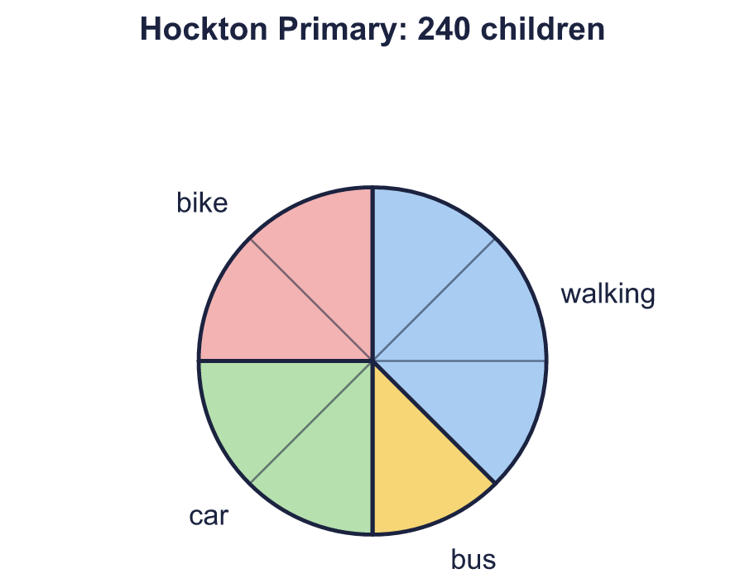  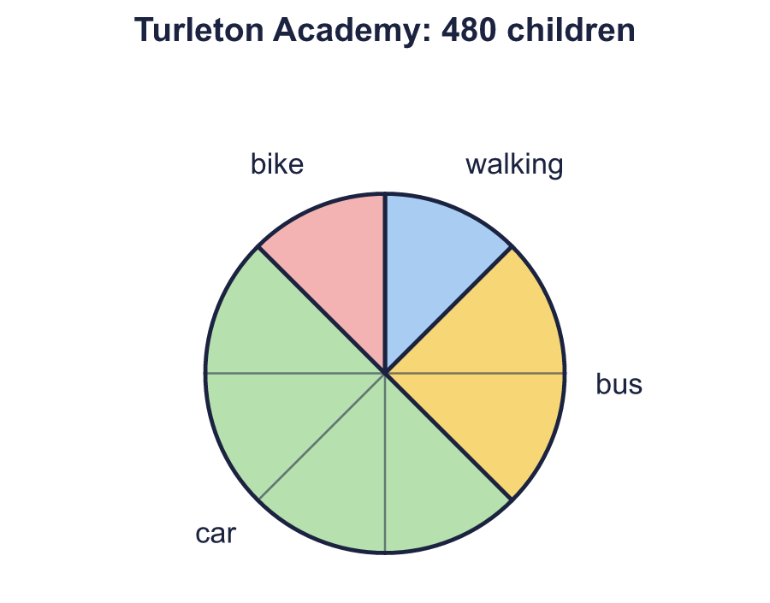  a) How many children from Hockton Primary travel by car?  b) How many children from Turleton Academy travel by car?
  10 | Children from two schools were asked how they travel to school. The pie charts show the results.  a) How many children from Hockton Primary travel by car?  b) How many children from Turleton Academy travel by car?
  11 | A bag has red, green, blue counters. The pie chart shows how many of each colour there are. Every part of the pie chart is the same size. There are 20 red counters.  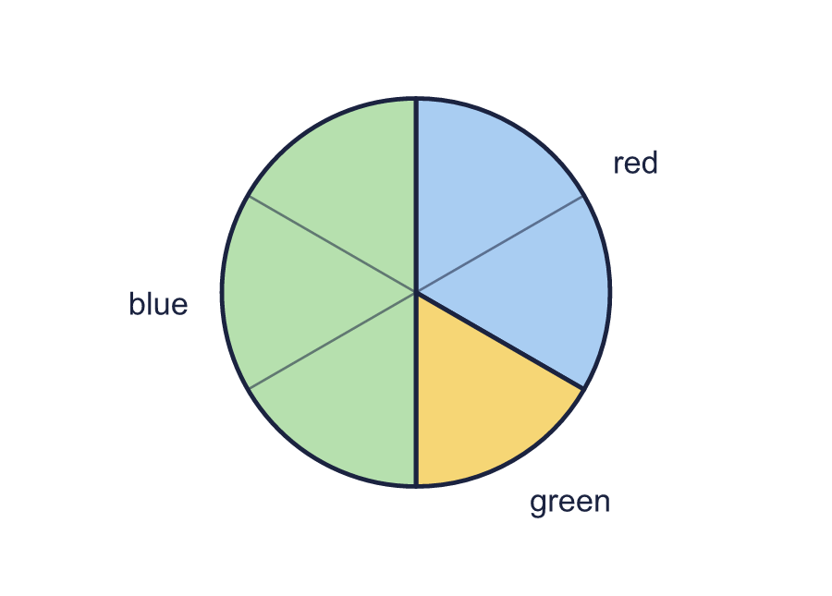  a) How many counters are in the bag altogether?  b) How many more blue counters than green counters are there?  c) Which colour has twice as many counters as green? Write the colour.
  11 | A bag has red, green, blue counters. The pie chart shows how many of each colour there are. Every part of the pie chart is the same size. There are 20 red counters.  a) How many counters are in the bag altogether?  b) How many more blue counters than green counters are there?  c) Which colour has twice as many counters as green? Write the colour.
  12 | 240 children were asked to choose their favourite fruit. The pie chart shows the results.  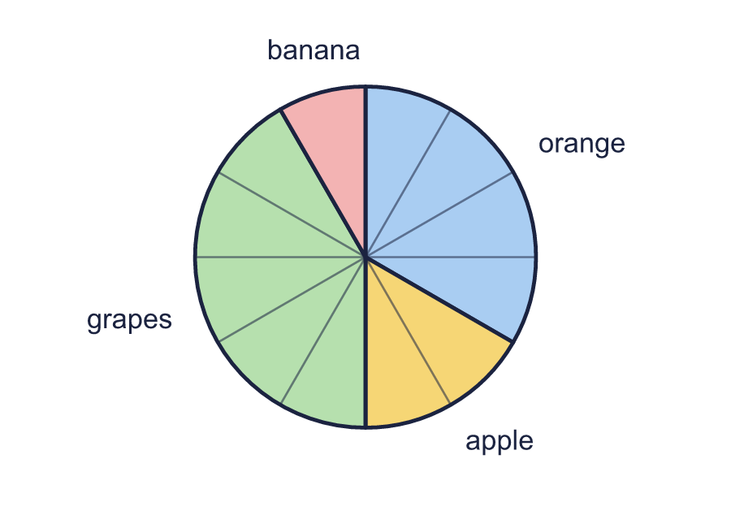  Is Boba correct? Circle yes or no.  Yes / No  Explain how you know.
    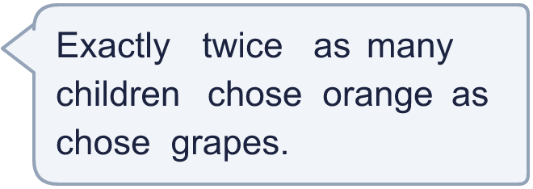
  12 | 240 children were asked to choose their favourite fruit. The pie chart shows the results.  Is Boba correct? Circle yes or no.  Yes / No  Explain how you know.
  13 | 240 children were asked how they travel to school. The pie chart shows the results.  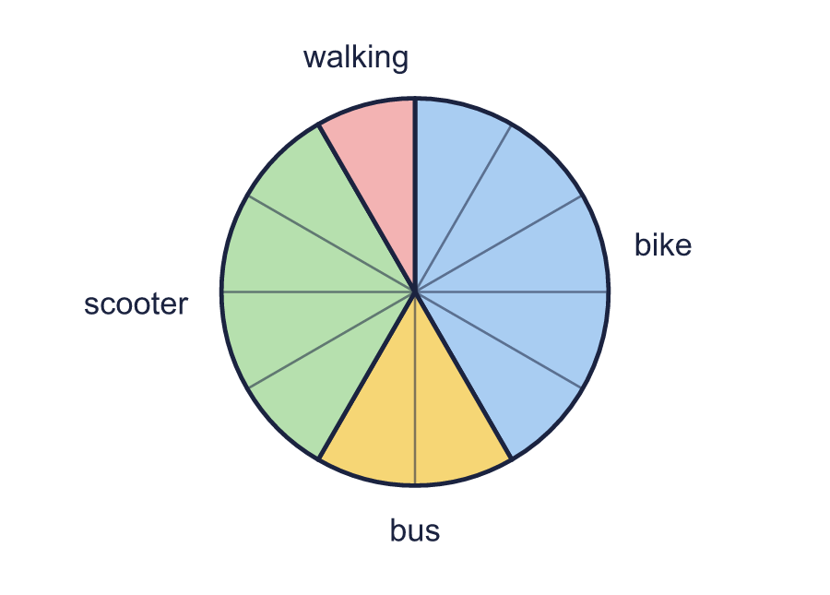  a) What fraction of the children chose bike or walking? Write it in its simplest form.  b) How many children chose bike or walking?
  13 | 240 children were asked how they travel to school. The pie chart shows the results.  a) What fraction of the children chose bike or walking? Write it in its simplest form.  b) How many children chose bike or walking?
  14 | Some children were asked to choose their favourite fruit. The pie chart shows the results. Every part of the pie chart is the same size. 60 children chose pear.  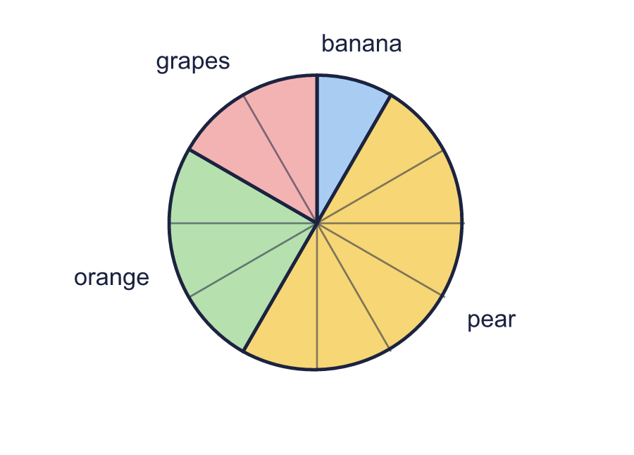  a) How many children were asked altogether?  b) How many children chose orange?
  14 | Some children were asked to choose their favourite fruit. The pie chart shows the results. Every part of the pie chart is the same size. 60 children chose pear.  a) How many children were asked altogether?  b) How many children chose orange?

Year 6 · Statistics · Step 3
Reading pie charts
Answers (teacher copy)

  1 | Some children were asked to choose their favourite fruit. The pie chart shows the results.  a) Which was the most popular? Write the name. pear  b) Which was the least popular? Write the name. orange
  2 | Some children were asked to choose their favourite pet. The pie chart shows the results.  a) Did more or less than half of the children choose hamster? Write more or less. less  b) Did more or less than a quarter of the children choose rabbit? Write more or less. less
  3 | Some children were asked to choose their favourite lesson. The pie chart shows the results.  a) Did more children choose science or maths? Write the name. science  b) What fraction of the children chose art? Write it in its simplest form. ¹⁄₄
  4 | 2,000 people were asked how many televisions they have at home. The pie chart shows the results. Every part of the pie chart is the same size.  a) How many people have 2 televisions? 600  b) How many people have 4 televisions? 200
  5 | 500 people were asked how many televisions they have at home. The pie chart shows the results.  a) How many people have more than 2 televisions? 250  b) How many people have fewer than 3 televisions? 250
  6 | 1,000 people were asked how many televisions they have at home. The pie chart shows the results.  a) What fraction of the people have 4 televisions? Write it in its simplest form. ¹⁄₂  b) What fraction of the people have fewer than 3 televisions? Write it in its simplest form. ²⁄₅
  7 | 320 children were asked how they travel to school. The pie chart shows the results.  a) How many children chose bus? 112  b) How many more children chose bus than car? 80
  8 | 600 children were asked to choose their favourite lesson. The pie chart shows the results.  a) How many children chose art or maths? 240  b) How many children chose art? 60
  9 | Children from two schools were asked how they travel to school. The pie charts show the results.  Is Boba correct? Circle yes or no.  Yes / No  Explain how you know.  Elm Street School: 3 parts out of 8 is 60 children. Fairfield Academy: 2 parts out of 8 is 80 children.
  10 | Children from two schools were asked how they travel to school. The pie charts show the results.  a) How many children from Hockton Primary travel by car? 60  b) How many children from Turleton Academy travel by car? 240
  11 | A bag has red, green, blue counters. The pie chart shows how many of each colour there are. Every part of the pie chart is the same size. There are 20 red counters.  a) How many counters are in the bag altogether? 60  b) How many more blue counters than green counters are there? 20  c) Which colour has twice as many counters as green? Write the colour. red
  12 | 240 children were asked to choose their favourite fruit. The pie chart shows the results.  Is Boba correct? Circle yes or no.  Yes / No  Explain how you know.  80 children chose orange and 100 chose grapes. Double 100 is 200, not 80.
  13 | 240 children were asked how they travel to school. The pie chart shows the results.  a) What fraction of the children chose bike or walking? Write it in its simplest form. ¹⁄₂  b) How many children chose bike or walking? 120
  14 | Some children were asked to choose their favourite fruit. The pie chart shows the results. Every part of the pie chart is the same size. 60 children chose pear.  a) How many children were asked altogether? 120  b) How many children chose orange? 30

