  Year 6 · Statistics · Step 6  The mean | 
  Year 6 · Statistics · Step 6
  The mean
  1 | Mo, Dora, Mia and Ron have some counters. The picture shows how many each person has. Imagine sharing all the counters out evenly between them.  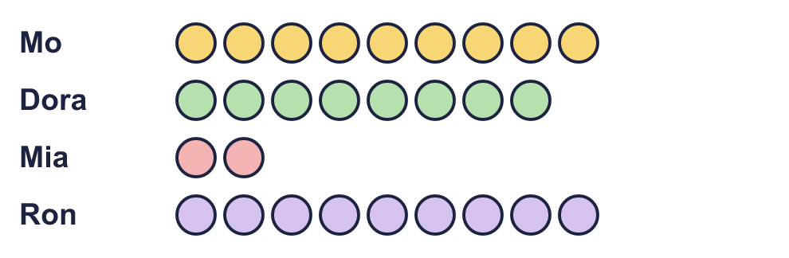  How many counters does each person get? This is the mean.
  1 | Mo, Dora, Mia and Ron have some counters. The picture shows how many each person has. Imagine sharing all the counters out evenly between them.  How many counters does each person get? This is the mean.
  2 | Work out the mean of these numbers.  5, 1, 6, 7, 6
    Mean =
  2 | Work out the mean of these numbers.  5, 1, 6, 7, 6
    Mean =
  3 | Work out the mean of each set of numbers.  13, 14, 2, 7, 2, 10
    Mean =
  3 | Work out the mean of each set of numbers.  13, 14, 2, 7, 2, 10
    Mean =
  4 | Eva collects football cards. The table shows how many cards Eva collected in each of four years.  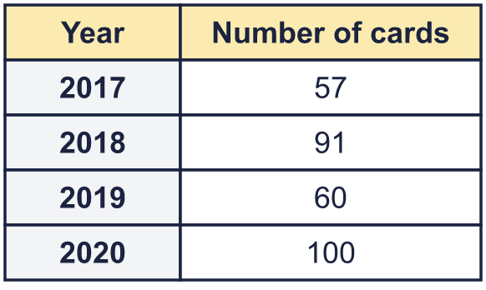  What is the mean number of cards collected each year?
  4 | Eva collects football cards. The table shows how many cards Eva collected in each of four years.  What is the mean number of cards collected each year?
  5 | The mean of 4 numbers is 9.  What is the total of the numbers?
  5 | The mean of 4 numbers is 9.  What is the total of the numbers?
  6 | The table shows how many pets six children have. One number is missing. The mean number of pets is 5.  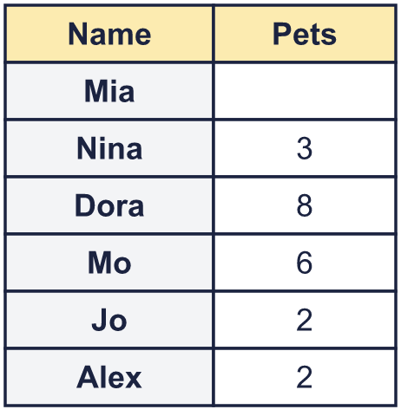
  6 | The table shows how many pets six children have. One number is missing. The mean number of pets is 5.
  7 | Work out the mean of these 10 numbers. Your answer has one decimal place.  3, 4, 6, 7, 3, 8, 4, 8, 2, 4
    Mean =
  7 | Work out the mean of these 10 numbers. Your answer has one decimal place.  3, 4, 6, 7, 3, 8, 4, 8, 2, 4
    Mean =
  8 | Here are heights of five plants, in cm. Work out the mean, in cm.  17, 17, 13, 22, 21
    Mean =
  8 | Here are heights of five plants, in cm. Work out the mean, in cm.  17, 17, 13, 22, 21
    Mean =

  9 | A basketball team played 4 games. The mean number of points they scored was 50.  a) How many points did they score in total in the four games?  After the fifth game, the mean number of points had gone up to 56.  b) How many points did they score in the fifth game?
  9 | A basketball team played 4 games. The mean number of points they scored was 50.  a) How many points did they score in total in the four games?  After the fifth game, the mean number of points had gone up to 56.  b) How many points did they score in the fifth game?
  10 | A group of children have a mean height of 1.5 m. Another child joins the group. Write increase, decrease or stay the same to say what happens to the mean.  a) The new child is 1.6 m tall.  b) The new child is 1.5 m tall.  c) The new child is 1.4 m tall.
  10 | A group of children have a mean height of 1.5 m. Another child joins the group. Write increase, decrease or stay the same to say what happens to the mean.  a) The new child is 1.6 m tall.  b) The new child is 1.5 m tall.  c) The new child is 1.4 m tall.
  11 | Six numbers are written on cards. Four of them are 13, 18, 20 and 12. The mean of all six numbers is 12. The other two cards have numbers on them: one number is double the other.  What are the two missing numbers? Smaller first.
  11 | Six numbers are written on cards. Four of them are 13, 18, 20 and 12. The mean of all six numbers is 12. The other two cards have numbers on them: one number is double the other.  What are the two missing numbers? Smaller first.
  12 | Is Boba correct? Circle yes or no.  Yes / No  Explain how you know.
     | 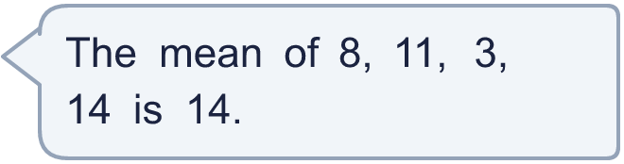
  12 | Is Boba correct? Circle yes or no.  Yes / No  Explain how you know.
  13 | Two teams scored goals in five matches.  Team A: 3, 5, 8, 11, 2  Team B: 12, 3, 10, 3, 4  a) Which team has the greater mean number of goals? Write A or B.  b) How much greater is it? Write the difference between the two means.
  13 | Two teams scored goals in five matches.  Team A: 3, 5, 8, 11, 2  Team B: 12, 3, 10, 3, 4  a) Which team has the greater mean number of goals? Write A or B.  b) How much greater is it? Write the difference between the two means.
  14 | Write 5 whole numbers that have a mean of 8. None of your numbers can be 8.
  14 | Write 5 whole numbers that have a mean of 8. None of your numbers can be 8.

Year 6 · Statistics · Step 6
The mean
Answers (teacher copy)

  1 | Mo, Dora, Mia and Ron have some counters. The picture shows how many each person has. Imagine sharing all the counters out evenly between them.  How many counters does each person get? This is the mean. 7
  2 | Work out the mean of these numbers.  5, 1, 6, 7, 6  Mean = 5
  3 | Work out the mean of each set of numbers.  13, 14, 2, 7, 2, 10  Mean = 8
  4 | Eva collects football cards. The table shows how many cards Eva collected in each of four years.  What is the mean number of cards collected each year? 77
  5 | The mean of 4 numbers is 9.  What is the total of the numbers? 36
  6 | The table shows how many pets six children have. One number is missing. The mean number of pets is 5.  How many pets does Mia have? 9
  7 | Work out the mean of these 10 numbers. Your answer has one decimal place.  3, 4, 6, 7, 3, 8, 4, 8, 2, 4  Mean = 4.9
  8 | Here are heights of five plants, in cm. Work out the mean, in cm.  17, 17, 13, 22, 21  Mean = 18
  9 | A basketball team played 4 games. The mean number of points they scored was 50.  a) How many points did they score in total in the four games? 200  After the fifth game, the mean number of points had gone up to 56.  b) How many points did they score in the fifth game? 80
  10 | A group of children have a mean height of 1.5 m. Another child joins the group. Write increase, decrease or stay the same to say what happens to the mean.  a) The new child is 1.6 m tall. increase  b) The new child is 1.5 m tall. stay the same  c) The new child is 1.4 m tall. decrease
  11 | Six numbers are written on cards. Four of them are 13, 18, 20 and 12. The mean of all six numbers is 12. The other two cards have numbers on them: one number is double the other.  What are the two missing numbers? Smaller first. 3 and 6
  12 | Is Boba correct? Circle yes or no.  Yes / No  Explain how you know.  8 + 11 + 3 + 14 = 36. 36 ÷ 4 = 9. The mean is 9, not 14.
  13 | Two teams scored goals in five matches.  Team A: 3, 5, 8, 11, 2  Team B: 12, 3, 10, 3, 4  a) Which team has the greater mean number of goals? Write A or B. B  b) How much greater is it? Write the difference between the two means. 0.6
  14 | Write 5 whole numbers that have a mean of 8. None of your numbers can be 8.  Any 5 whole numbers with a total of 40 and none equal to 8, for example 2, 2, 5, 9, 22 or 1, 3, 6, 11, 19

