  Year 6 · Position and direction · Step 3  Problems with coordinates | 
  Year 6 · Position and direction · Step 3
  Problems with coordinates
  1 | Three points are plotted on the coordinate grid. They are in a straight line.  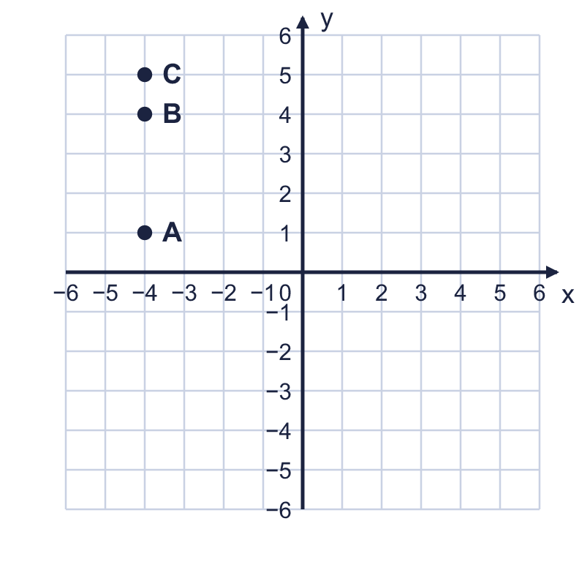  a) Write the coordinates of A.  b) Is the line horizontal or vertical?  c) Which x-coordinate is the same in all three points?
  1 | Three points are plotted on the coordinate grid. They are in a straight line.  a) Write the coordinates of A.  b) Is the line horizontal or vertical?  c) Which x-coordinate is the same in all three points?
  2 | A vertical line goes through the point (4, −1). A horizontal line goes through the point (5, 3).  Write the coordinates of the point where the two lines cross.
  2 | A vertical line goes through the point (4, −1). A horizontal line goes through the point (5, 3).  Write the coordinates of the point where the two lines cross.
  3 | The line x = 2 is a vertical line. The line y = −1 is a horizontal line.  Write the coordinates of the point where the two lines cross.
  3 | The line x = 2 is a vertical line. The line y = −1 is a horizontal line.  Write the coordinates of the point where the two lines cross.
  4 | CDEF is a square. Two of its corners are shown with their coordinates.  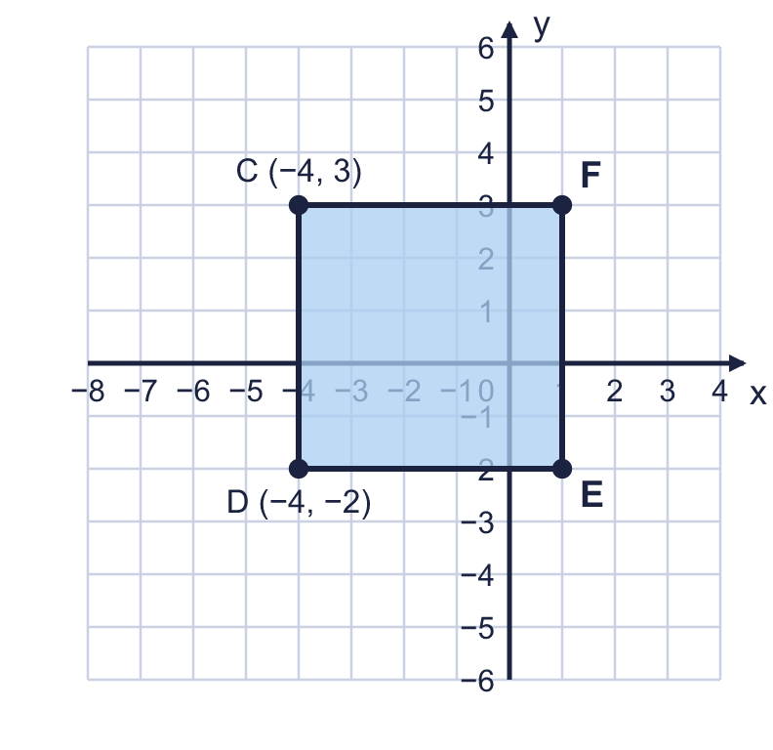  a) What are the coordinates of E?  b) What are the coordinates of F?
  4 | CDEF is a square. Two of its corners are shown with their coordinates.  a) What are the coordinates of E?  b) What are the coordinates of F?
  5 | The points (4, 3) and (4, −5) are joined by a straight line. Count the squares along the line.  How many squares long is the line?
  5 | The points (4, 3) and (4, −5) are joined by a straight line. Count the squares along the line.  How many squares long is the line?
  6 | The perimeter of the rectangle is 26 units. Two corners are shown with their coordinates.  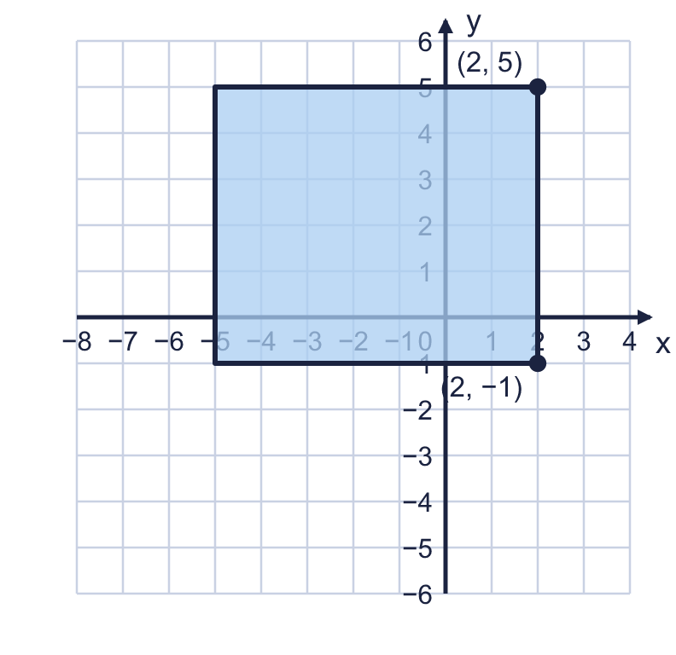  a) What are the coordinates of the top left corner?  b) What are the coordinates of the bottom left corner?
  6 | The perimeter of the rectangle is 26 units. Two corners are shown with their coordinates.  a) What are the coordinates of the top left corner?  b) What are the coordinates of the bottom left corner?
  7 | Point M is exactly half way between (−6, −2) and (4, −2). The line between them is horizontal.
  7 | Point M is exactly half way between (−6, −2) and (4, −2). The line between them is horizontal.
  8 | A shape has corners at (−5, −4), (−2, −4), (−2, −2), (−5, −2), joined in order.  a) What is the area of the shape?  b) What is its perimeter?
  8 | A shape has corners at (−5, −4), (−2, −4), (−2, −2), (−5, −2), joined in order.  a) What is the area of the shape?  b) What is its perimeter?

  9 | On this coordinate grid, one square is 10 units long.  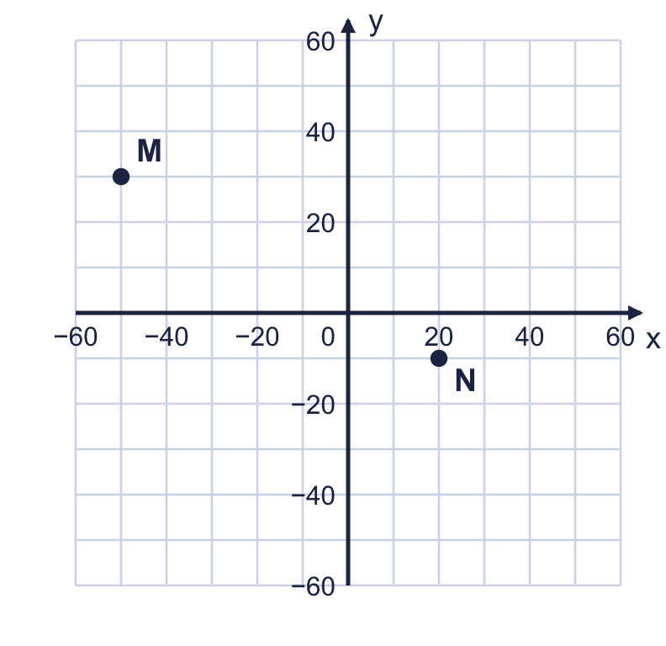  a) Write the coordinates of M.  b) Write the coordinates of N.
  9 | On this coordinate grid, one square is 10 units long.  a) Write the coordinates of M.  b) Write the coordinates of N.
  10 | A vertical line and a horizontal line are drawn on the coordinate grid.  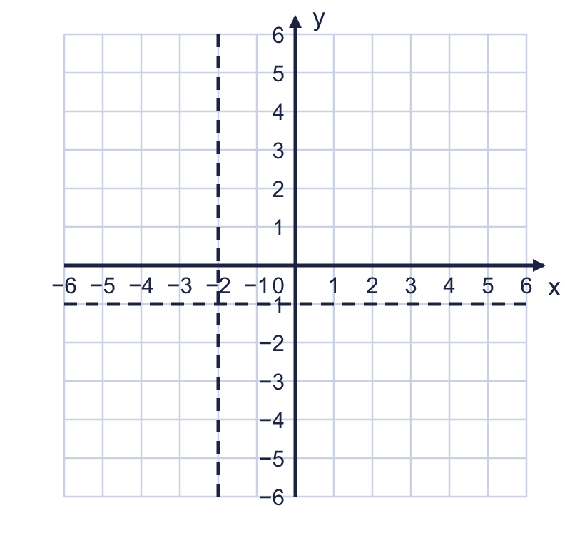  Write the coordinates of the point where the two lines cross.
  10 | A vertical line and a horizontal line are drawn on the coordinate grid.  Write the coordinates of the point where the two lines cross.
  11 | The line x = −1 and the line y = 3 are drawn on a coordinate grid.  Is Boba correct? Circle yes or no.  Yes / No  Explain how you know.
     | 
  11 | The line x = −1 and the line y = 3 are drawn on a coordinate grid.  Is Boba correct? Circle yes or no.  Yes / No  Explain how you know.
  12 | Points with whole-number coordinates are marked on the line x = −5 from y = −2 to y = 5. Both ends are included.
  12 | Points with whole-number coordinates are marked on the line x = −5 from y = −2 to y = 5. Both ends are included.
  13 | I am thinking of a point on the coordinate grid. Both coordinates are whole numbers between −6 and 6.  • The point is in the bottom left quadrant.  • The x-coordinate is twice the y-coordinate.  • The coordinates add up to −3.  What are the coordinates of my point?
  13 | I am thinking of a point on the coordinate grid. Both coordinates are whole numbers between −6 and 6.  • The point is in the bottom left quadrant.  • The x-coordinate is twice the y-coordinate.  • The coordinates add up to −3.  What are the coordinates of my point?
  14 | Two corners of a rectangle are at (−4, −1) and (−4, 5). The perimeter of the rectangle is 18 units. The rest of the rectangle is to the right of the line between these two corners. The sides are parallel to the axes.  Write the coordinates of the other two corners.
  14 | Two corners of a rectangle are at (−4, −1) and (−4, 5). The perimeter of the rectangle is 18 units. The rest of the rectangle is to the right of the line between these two corners. The sides are parallel to the axes.  Write the coordinates of the other two corners.

Year 6 · Position and direction · Step 3
Problems with coordinates
Answers (teacher copy)

  1 | Three points are plotted on the coordinate grid. They are in a straight line.  a) Write the coordinates of A. (−4, 1)  b) Is the line horizontal or vertical? vertical  c) Which x-coordinate is the same in all three points? −4
  2 | A vertical line goes through the point (4, −1). A horizontal line goes through the point (5, 3).  Write the coordinates of the point where the two lines cross. (4, 3)
  3 | The line x = 2 is a vertical line. The line y = −1 is a horizontal line.  Write the coordinates of the point where the two lines cross. (2, −1)
  4 | CDEF is a square. Two of its corners are shown with their coordinates.  a) What are the coordinates of E? (1, −2)  b) What are the coordinates of F? (1, 3)
  5 | The points (4, 3) and (4, −5) are joined by a straight line. Count the squares along the line.  How many squares long is the line? 8
  6 | The perimeter of the rectangle is 26 units. Two corners are shown with their coordinates.  a) What are the coordinates of the top left corner? (−5, 5)  b) What are the coordinates of the bottom left corner? (−5, −1)
  7 | Point M is exactly half way between (−6, −2) and (4, −2). The line between them is horizontal.  Write the coordinates of M. (−1, −2)
  8 | A shape has corners at (−5, −4), (−2, −4), (−2, −2), (−5, −2), joined in order.  a) What is the area of the shape? 6  b) What is its perimeter? 10
  9 | On this coordinate grid, one square is 10 units long.  a) Write the coordinates of M. (−50, 30)  b) Write the coordinates of N. (20, −10)
  10 | A vertical line and a horizontal line are drawn on the coordinate grid.  Write the coordinates of the point where the two lines cross. (−2, −1)
  11 | The line x = −1 and the line y = 3 are drawn on a coordinate grid.  Is Boba correct? Circle yes or no.  Yes / No  Explain how you know.  The line x = −1 gives the x-coordinate and the line y = 3 gives the y-coordinate, so they cross at (−1, 3), not (3, −1).
  12 | Points with whole-number coordinates are marked on the line x = −5 from y = −2 to y = 5. Both ends are included.  How many points are marked? 8
  13 | I am thinking of a point on the coordinate grid. Both coordinates are whole numbers between −6 and 6.  • The point is in the bottom left quadrant.  • The x-coordinate is twice the y-coordinate.  • The coordinates add up to −3.  What are the coordinates of my point? (−2, −1)
  14 | Two corners of a rectangle are at (−4, −1) and (−4, 5). The perimeter of the rectangle is 18 units. The rest of the rectangle is to the right of the line between these two corners. The sides are parallel to the axes.  Write the coordinates of the other two corners. (−1, −1) and (−1, 5)

