  Year 6 · Position and direction · Step 2  Reading and plotting points in four quadrants | 
  Year 6 · Position and direction · Step 2
  Reading and plotting points in four quadrants
  1 | Four points are plotted on the coordinate grid. Write the coordinates of each point.  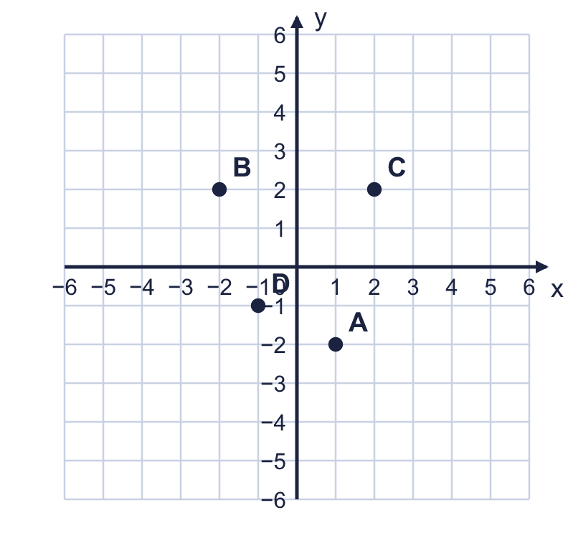  a) Point A  b) Point B  c) Point C  d) Point D
  1 | Four points are plotted on the coordinate grid. Write the coordinates of each point.  a) Point A  b) Point B  c) Point C  d) Point D
  2 | The axes divide the grid into four quadrants, P, Q, R and S.  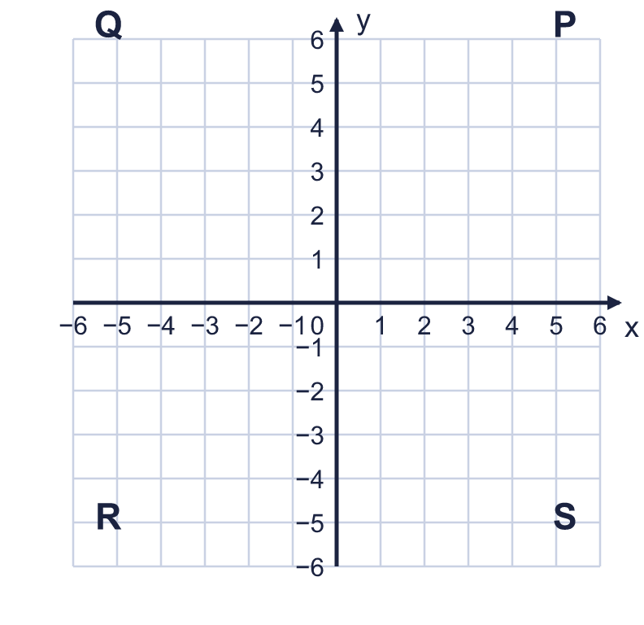  In which quadrant is each point? Write P, Q, R or S.  a) (5, −4)  b) (3, −5)  c) (5, 4)
  2 | The axes divide the grid into four quadrants, P, Q, R and S.  In which quadrant is each point? Write P, Q, R or S.  a) (5, −4)  b) (3, −5)  c) (5, 4)
  3 | Plot these points on a coordinate grid in your book. Join them in order, A to B to C to D and back to A. A (0, 3), B (3, 0), C (0, −1), D (−3, 0).  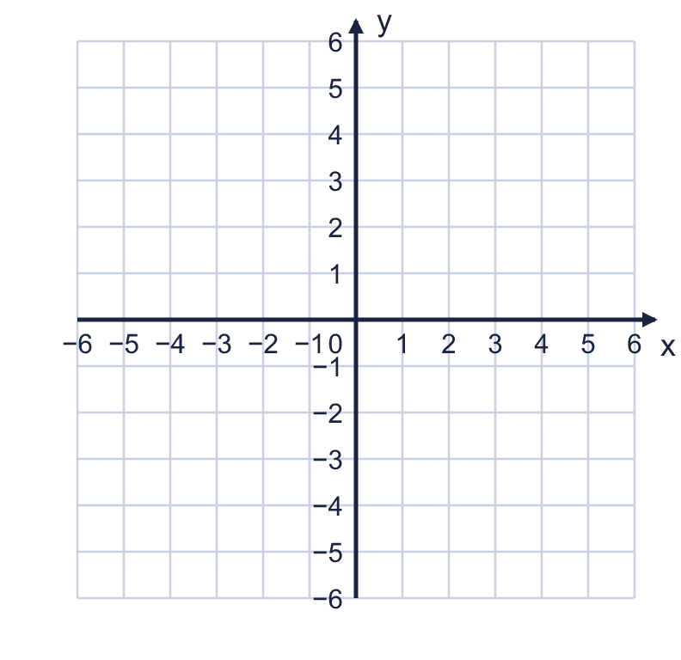  What is the name of the shape? Write square, rectangle, parallelogram, kite or trapezium.
  3 | Plot these points on a coordinate grid in your book. Join them in order, A to B to C to D and back to A. A (0, 3), B (3, 0), C (0, −1), D (−3, 0).  What is the name of the shape? Write square, rectangle, parallelogram, kite or trapezium.
  4 | Two squares, A and B, are drawn on the coordinate grid.  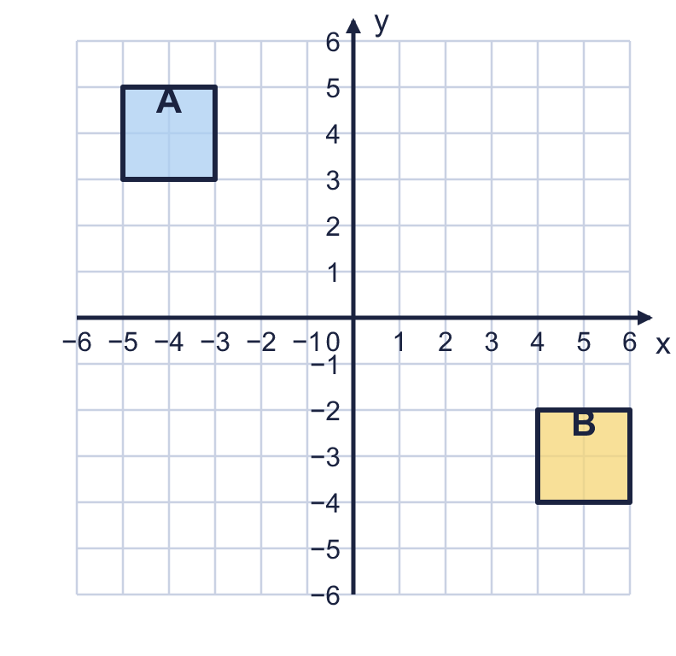  a) What are the coordinates of the top left corner of square A?  b) What are the coordinates of the bottom right corner of square B?
  4 | Two squares, A and B, are drawn on the coordinate grid.  a) What are the coordinates of the top left corner of square A?  b) What are the coordinates of the bottom right corner of square B?
  5 | Here are five points: A (1, 0), B (0, −1), C (−3, −2), D (−1, 0), E (0, 0).  Which points are on the y-axis? Write the letters.
  5 | Here are five points: A (1, 0), B (0, −1), C (−3, −2), D (−1, 0), E (0, 0).  Which points are on the y-axis? Write the letters.
  6 | The points (−5, −2) and (3, −2) are joined by a straight line. Count the squares along the line.  How many squares long is the line?
  6 | The points (−5, −2) and (3, −2) are joined by a straight line. Count the squares along the line.  How many squares long is the line?
  7 | Three corners of a rectangle are at (−5, −4), (3, −4), (−5, 2). The sides of the rectangle are parallel to the axes.  Write the coordinates of the fourth corner.
  7 | Three corners of a rectangle are at (−5, −4), (3, −4), (−5, 2). The sides of the rectangle are parallel to the axes.  Write the coordinates of the fourth corner.
  8 | Point M is exactly half way between (−14, 0) and (14, 0). All three points are on the same horizontal line.
  8 | Point M is exactly half way between (−14, 0) and (14, 0). All three points are on the same horizontal line.

  9 | Is Boba correct? Circle yes or no.  Yes / No  Explain how you know.
    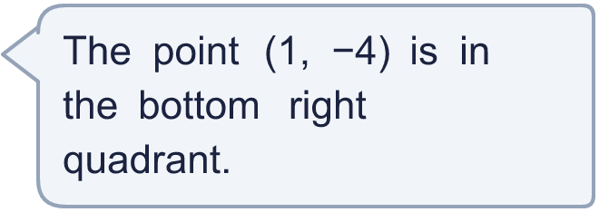
  9 | Is Boba correct? Circle yes or no.  Yes / No  Explain how you know.
  10 | A shape has corners at (−5, 0), (3, 0), (3, −3), (−5, −3), joined in order.  a) What is the mathematical name of the shape? Write square or rectangle.  Here are four points: A (−2, −2), B (4, 0), C (−4, 0), D (−5, −1).  b) Which points are on the edge (the perimeter) of the shape? Write the letters.
  10 | A shape has corners at (−5, 0), (3, 0), (3, −3), (−5, −3), joined in order.  a) What is the mathematical name of the shape? Write square or rectangle.  Here are four points: A (−2, −2), B (4, 0), C (−4, 0), D (−5, −1).  b) Which points are on the edge (the perimeter) of the shape? Write the letters.
  11 | Write three different points in the bottom right quadrant where the two coordinates add up to 2.
  11 | Write three different points in the bottom right quadrant where the two coordinates add up to 2.
  12 | ABCD is a rectangle with its sides parallel to the axes. A is at (−6, −5), B is at (4, −5) and C is at (4, 5).  a) What are the coordinates of D?  b) The diagonals AC and BD cross in the middle of the rectangle. What are the coordinates of the middle?
  12 | ABCD is a rectangle with its sides parallel to the axes. A is at (−6, −5), B is at (4, −5) and C is at (4, 5).  a) What are the coordinates of D?  b) The diagonals AC and BD cross in the middle of the rectangle. What are the coordinates of the middle?
  13 | A rectangle has corners at (−5, −2), (5, −2), (5, 2), (−5, 2). Count the points with whole-number coordinates that are not corners.  a) How many are inside the rectangle (not on the edge)?  b) How many are on the edge, not counting the 4 corners?
  13 | A rectangle has corners at (−5, −2), (5, −2), (5, 2), (−5, 2). Count the points with whole-number coordinates that are not corners.  a) How many are inside the rectangle (not on the edge)?  b) How many are on the edge, not counting the 4 corners?
  14 | I am thinking of a point on the coordinate grid. Both coordinates are whole numbers between −6 and 6.  • The coordinates add up to −4.  • The x-coordinate is 6 more than the y-coordinate.  • The point is in the bottom right quadrant.  What are the coordinates of my point?
  14 | I am thinking of a point on the coordinate grid. Both coordinates are whole numbers between −6 and 6.  • The coordinates add up to −4.  • The x-coordinate is 6 more than the y-coordinate.  • The point is in the bottom right quadrant.  What are the coordinates of my point?

Year 6 · Position and direction · Step 2
Reading and plotting points in four quadrants
Answers (teacher copy)

  1 | Four points are plotted on the coordinate grid. Write the coordinates of each point.  a) Point A (1, −2)  b) Point B (−2, 2)  c) Point C (2, 2)  d) Point D (−1, −1)
  2 | The axes divide the grid into four quadrants, P, Q, R and S.  In which quadrant is each point? Write P, Q, R or S.  a) (5, −4) S  b) (3, −5) S  c) (5, 4) P
  3 | Plot these points on a coordinate grid in your book. Join them in order, A to B to C to D and back to A. A (0, 3), B (3, 0), C (0, −1), D (−3, 0).  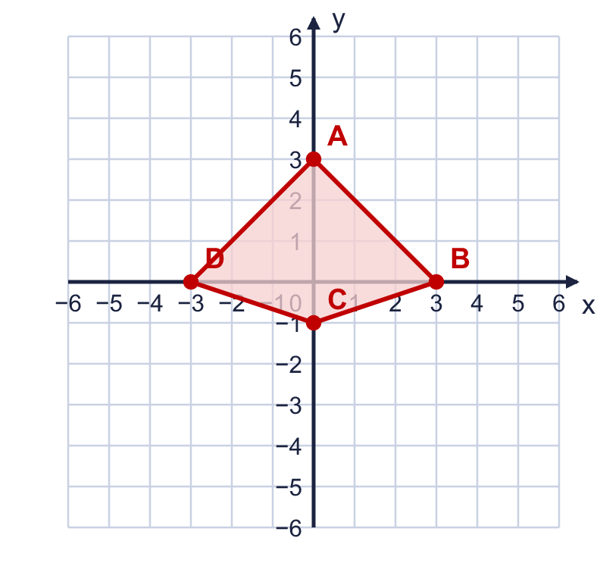  What is the name of the shape? Write square, rectangle, parallelogram, kite or trapezium. kite
  4 | Two squares, A and B, are drawn on the coordinate grid.  a) What are the coordinates of the top left corner of square A? (−5, 5)  b) What are the coordinates of the bottom right corner of square B? (6, −4)
  5 | Here are five points: A (1, 0), B (0, −1), C (−3, −2), D (−1, 0), E (0, 0).  Which points are on the y-axis? Write the letters. B, E
  6 | The points (−5, −2) and (3, −2) are joined by a straight line. Count the squares along the line.  How many squares long is the line? 8
  7 | Three corners of a rectangle are at (−5, −4), (3, −4), (−5, 2). The sides of the rectangle are parallel to the axes.  Write the coordinates of the fourth corner. (3, 2)
  8 | Point M is exactly half way between (−14, 0) and (14, 0). All three points are on the same horizontal line.  Write the coordinates of M. (0, 0)
  9 | Is Boba correct? Circle yes or no.  Yes / No  Explain how you know.  The x-coordinate is positive, so it is to the right of the y-axis and the y-coordinate is negative, so it is below the x-axis: bottom right.
  10 | A shape has corners at (−5, 0), (3, 0), (3, −3), (−5, −3), joined in order.  a) What is the mathematical name of the shape? Write square or rectangle. rectangle  Here are four points: A (−2, −2), B (4, 0), C (−4, 0), D (−5, −1).  b) Which points are on the edge (the perimeter) of the shape? Write the letters. C, D
  11 | Write three different points in the bottom right quadrant where the two coordinates add up to 2.  Any three different points in the bottom right quadrant where the two coordinates add up to 2, for example (3, −1), (4, −2), (5, −3)
  12 | ABCD is a rectangle with its sides parallel to the axes. A is at (−6, −5), B is at (4, −5) and C is at (4, 5).  a) What are the coordinates of D? (−6, 5)  b) The diagonals AC and BD cross in the middle of the rectangle. What are the coordinates of the middle? (−1, 0)
  13 | A rectangle has corners at (−5, −2), (5, −2), (5, 2), (−5, 2). Count the points with whole-number coordinates that are not corners.  a) How many are inside the rectangle (not on the edge)? 27  b) How many are on the edge, not counting the 4 corners? 24
  14 | I am thinking of a point on the coordinate grid. Both coordinates are whole numbers between −6 and 6.  • The coordinates add up to −4.  • The x-coordinate is 6 more than the y-coordinate.  • The point is in the bottom right quadrant.  What are the coordinates of my point? (1, −5)

