  Year 6 · Position and direction · Step 1  The first quadrant | 
  Year 6 · Position and direction · Step 1
  The first quadrant
  1 | Four points are plotted on the coordinate grid. Write the coordinates of each point. Remember: the x-coordinate (across) comes first, then the y-coordinate (up).  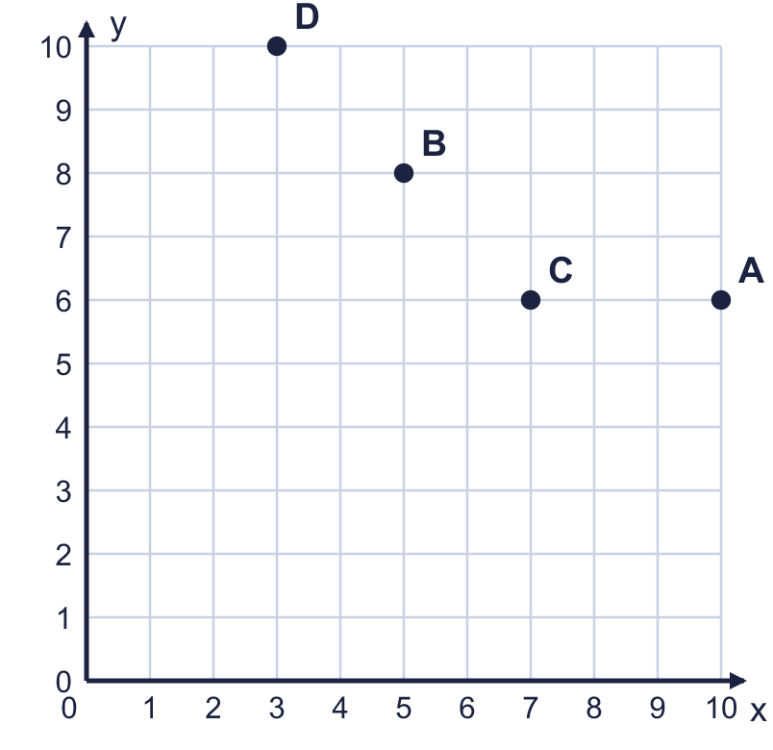  a) Point A  b) Point B  c) Point C  d) Point D
  1 | Four points are plotted on the coordinate grid. Write the coordinates of each point. Remember: the x-coordinate (across) comes first, then the y-coordinate (up).  a) Point A  b) Point B  c) Point C  d) Point D
  2 | Plot these points on a coordinate grid in your book. Use the same scale as the grid shown. E (5, 4), F (10, 9), G (9, 6), H (4, 10).  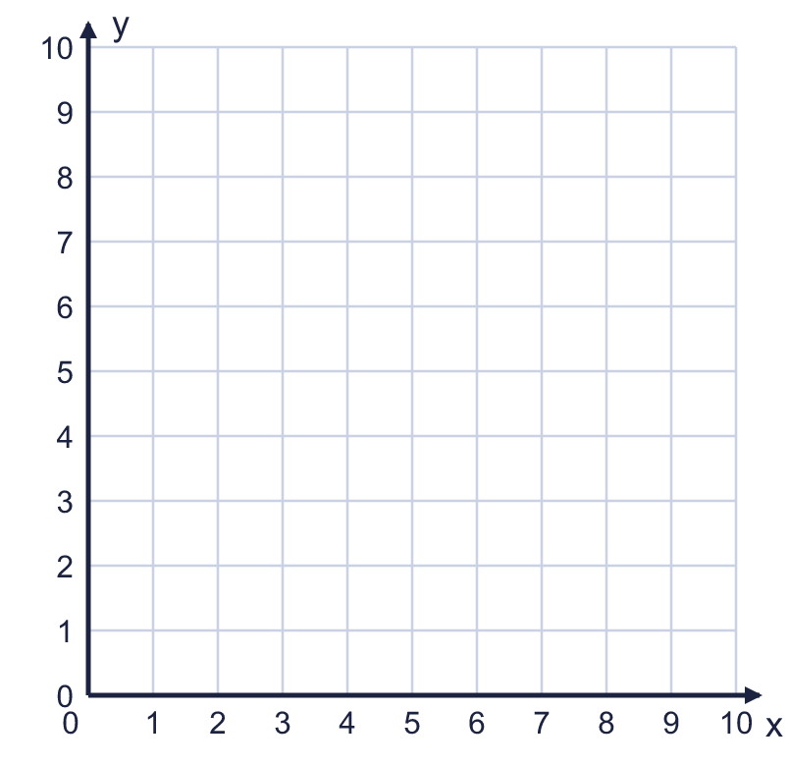  a) Which point is the closest to the x-axis? Write the letter.  b) Which point is the furthest from the y-axis? Write the letter.
  2 | Plot these points on a coordinate grid in your book. Use the same scale as the grid shown. E (5, 4), F (10, 9), G (9, 6), H (4, 10).  a) Which point is the closest to the x-axis? Write the letter.  b) Which point is the furthest from the y-axis? Write the letter.
  3 | Look at the coordinate grid.  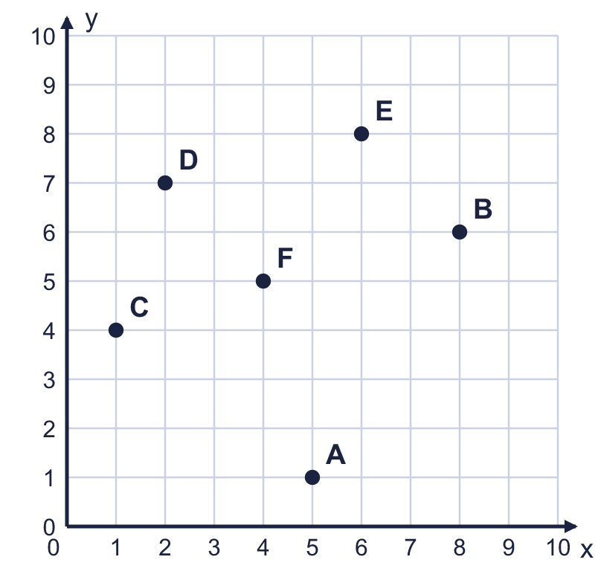  a) Which point is at (1, 4)? Write the letter.  b) Which point is at (2, 7)? Write the letter.
  3 | Look at the coordinate grid.  a) Which point is at (1, 4)? Write the letter.  b) Which point is at (2, 7)? Write the letter.
  4 | Look at the coordinate grid. Count the squares along the line from one point to the other.  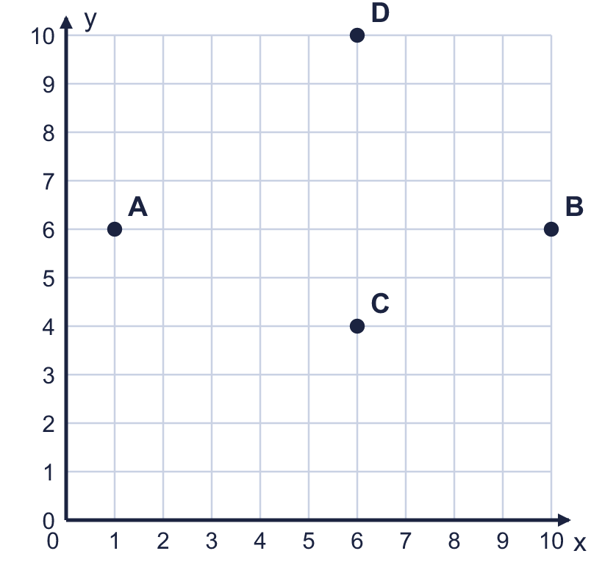  a) How many squares is it from A to B?  b) How many squares is it from C to D?
  4 | Look at the coordinate grid. Count the squares along the line from one point to the other.  a) How many squares is it from A to B?  b) How many squares is it from C to D?
  5 | A, B and C are three corners of a rectangle. Write the coordinates of the fourth corner, D.  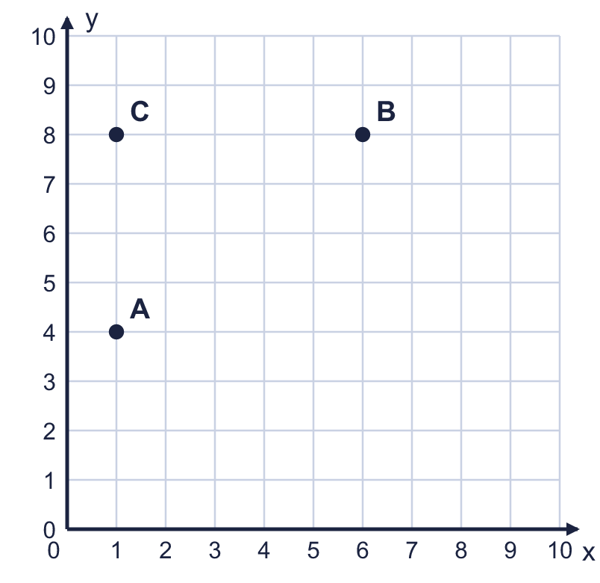
    D =
  5 | A, B and C are three corners of a rectangle. Write the coordinates of the fourth corner, D.
    D =
  6 | The points (1, 6), (2, 6), (4, 6) are in a straight line.  a) Is the line horizontal or vertical?  b) Which number is the same in all three points?
  6 | The points (1, 6), (2, 6), (4, 6) are in a straight line.  a) Is the line horizontal or vertical?  b) Which number is the same in all three points?
  7 | The rectangle is drawn on a coordinate grid. Each square is 1 unit long.  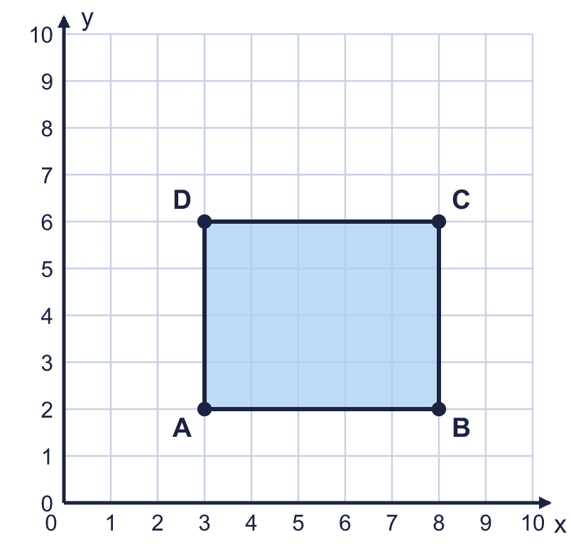  a) What is the perimeter of the rectangle?  b) What is the area of the rectangle?
  7 | The rectangle is drawn on a coordinate grid. Each square is 1 unit long.  a) What is the perimeter of the rectangle?  b) What is the area of the rectangle?
  8 | A rectangle has its corners at (1, 4), (6, 4), (6, 6), (1, 6).  a) What is the length of the longer side?  b) What is the perimeter of the rectangle?
  8 | A rectangle has its corners at (1, 4), (6, 4), (6, 6), (1, 6).  a) What is the length of the longer side?  b) What is the perimeter of the rectangle?

  9 | The point P is plotted on the coordinate grid.  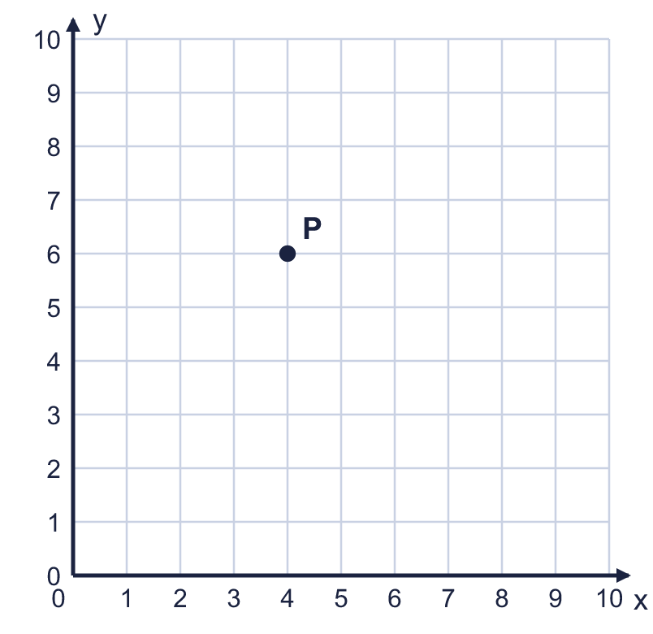  Is Boba correct? Circle yes or no.  Yes / No  Explain how you know.
     | 
  9 | The point P is plotted on the coordinate grid.  Is Boba correct? Circle yes or no.  Yes / No  Explain how you know.
  10 | Two corners of a square are at (2, 3) and (6, 3). The other two corners are above these two corners.  Write the coordinates of the other two corners.
  10 | Two corners of a square are at (2, 3) and (6, 3). The other two corners are above these two corners.  Write the coordinates of the other two corners.
  11 | ABC is an isosceles triangle. A is at (10, 20) and B is at (30, 20). C is directly above the middle of AB at (?, 60).  What is the missing x-coordinate of C?
  11 | ABC is an isosceles triangle. A is at (10, 20) and B is at (30, 20). C is directly above the middle of AB at (?, 60).  What is the missing x-coordinate of C?
  12 | Five points are marked on the coordinate grid with a rectangle.  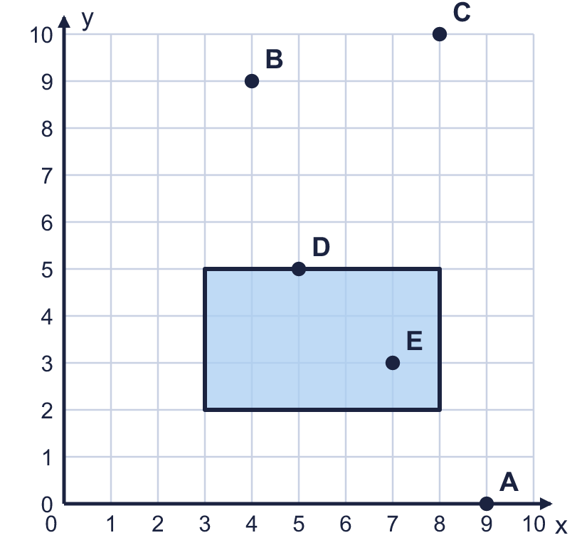  a) Which points are inside the rectangle? Write the letters.  b) Which points are on the edge (the perimeter) of the rectangle? Write the letters.
  12 | Five points are marked on the coordinate grid with a rectangle.  a) Which points are inside the rectangle? Write the letters.  b) Which points are on the edge (the perimeter) of the rectangle? Write the letters.
  13 | A rectangle has its corners at (1, 3), (7, 3), (7, 8), (1, 8). A point with whole-number coordinates, such as (2, 4), can be inside the rectangle, on its edge or outside it. Count the points with whole-number coordinates that are not corners.  a) How many are inside the rectangle (not on the edge)?  b) How many are on the edge, not counting the 4 corners?
  13 | A rectangle has its corners at (1, 3), (7, 3), (7, 8), (1, 8). A point with whole-number coordinates, such as (2, 4), can be inside the rectangle, on its edge or outside it. Count the points with whole-number coordinates that are not corners.  a) How many are inside the rectangle (not on the edge)?  b) How many are on the edge, not counting the 4 corners?
  14 | I am thinking of a point in the first quadrant. Both of its coordinates are whole numbers from 0 to 10.  • The x-coordinate is 9 more than the y-coordinate.  • The y-coordinate is greater than 0.  • The x-coordinate is greater than 8.  What are the coordinates of my point?
  14 | I am thinking of a point in the first quadrant. Both of its coordinates are whole numbers from 0 to 10.  • The x-coordinate is 9 more than the y-coordinate.  • The y-coordinate is greater than 0.  • The x-coordinate is greater than 8.  What are the coordinates of my point?

Year 6 · Position and direction · Step 1
The first quadrant
Answers (teacher copy)

  1 | Four points are plotted on the coordinate grid. Write the coordinates of each point. Remember: the x-coordinate (across) comes first, then the y-coordinate (up).  a) Point A (10, 6)  b) Point B (5, 8)  c) Point C (7, 6)  d) Point D (3, 10)
  2 | Plot these points on a coordinate grid in your book. Use the same scale as the grid shown. E (5, 4), F (10, 9), G (9, 6), H (4, 10).  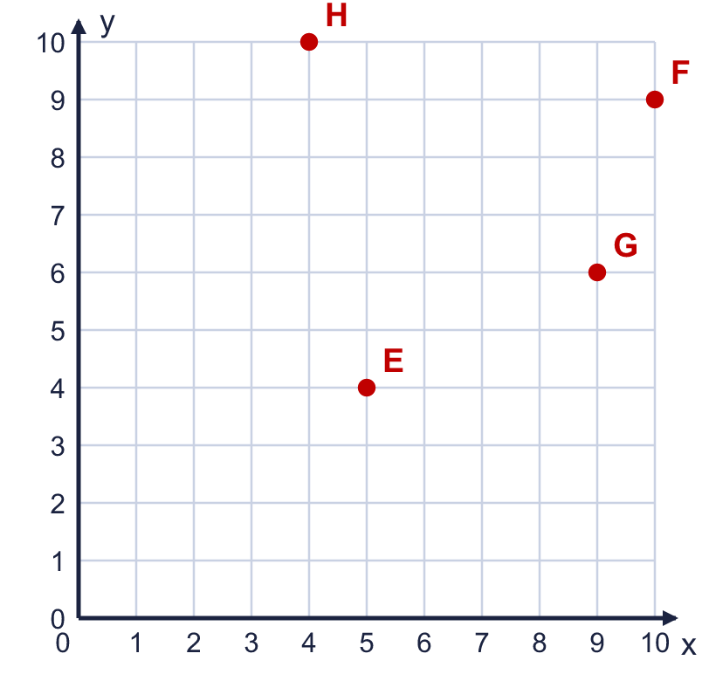  a) Which point is the closest to the x-axis? Write the letter. E  b) Which point is the furthest from the y-axis? Write the letter. F
  3 | Look at the coordinate grid.  a) Which point is at (1, 4)? Write the letter. C  b) Which point is at (2, 7)? Write the letter. D
  4 | Look at the coordinate grid. Count the squares along the line from one point to the other.  a) How many squares is it from A to B? 9  b) How many squares is it from C to D? 6
  5 | A, B and C are three corners of a rectangle. Write the coordinates of the fourth corner, D.  D = (6, 4)
  6 | The points (1, 6), (2, 6), (4, 6) are in a straight line.  a) Is the line horizontal or vertical? horizontal  b) Which number is the same in all three points? 6
  7 | The rectangle is drawn on a coordinate grid. Each square is 1 unit long.  a) What is the perimeter of the rectangle? 18  b) What is the area of the rectangle? 20
  8 | A rectangle has its corners at (1, 4), (6, 4), (6, 6), (1, 6).  a) What is the length of the longer side? 5  b) What is the perimeter of the rectangle? 14
  9 | The point P is plotted on the coordinate grid.  Is Boba correct? Circle yes or no.  Yes / No  Explain how you know.  P is 4 squares across and 6 squares up. The x-coordinate is written first, so P is at (4, 6), not (6, 4).
  10 | Two corners of a square are at (2, 3) and (6, 3). The other two corners are above these two corners.  Write the coordinates of the other two corners. (2, 7) and (6, 7)
  11 | ABC is an isosceles triangle. A is at (10, 20) and B is at (30, 20). C is directly above the middle of AB at (?, 60).  What is the missing x-coordinate of C? 20
  12 | Five points are marked on the coordinate grid with a rectangle.  a) Which points are inside the rectangle? Write the letters. E  b) Which points are on the edge (the perimeter) of the rectangle? Write the letters. D
  13 | A rectangle has its corners at (1, 3), (7, 3), (7, 8), (1, 8). A point with whole-number coordinates, such as (2, 4), can be inside the rectangle, on its edge or outside it. Count the points with whole-number coordinates that are not corners.  a) How many are inside the rectangle (not on the edge)? 20  b) How many are on the edge, not counting the 4 corners? 18
  14 | I am thinking of a point in the first quadrant. Both of its coordinates are whole numbers from 0 to 10.  • The x-coordinate is 9 more than the y-coordinate.  • The y-coordinate is greater than 0.  • The x-coordinate is greater than 8.  What are the coordinates of my point? (10, 1)

