  Year 6 · Shape · Step 4  Angles in a triangle | 
  Year 6 · Shape · Step 4
  Angles in a triangle
  1 | The three angles of a triangle are shown.  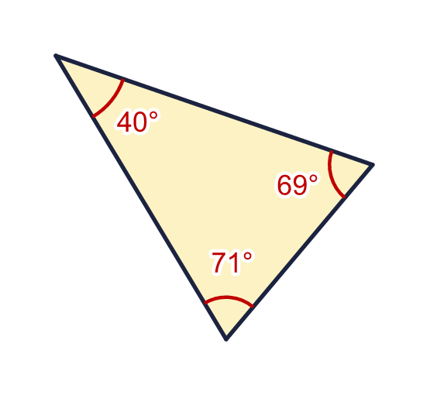  a) What is the sum of the three angles?
  1 | The three angles of a triangle are shown.  a) What is the sum of the three angles?
  2 | Work out the size of angle x.  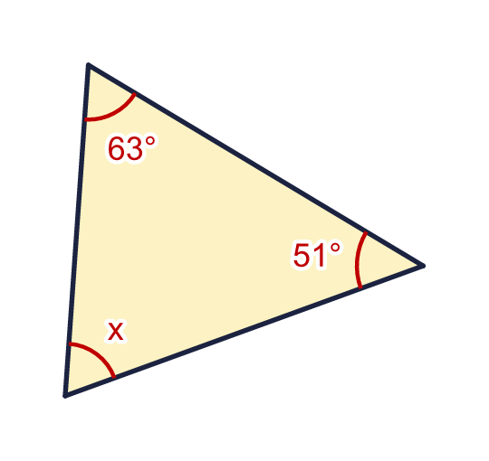
    x = |  | °
  2 | Work out the size of angle x.
    x = |  | °
  3 | Work out the size of angle y.  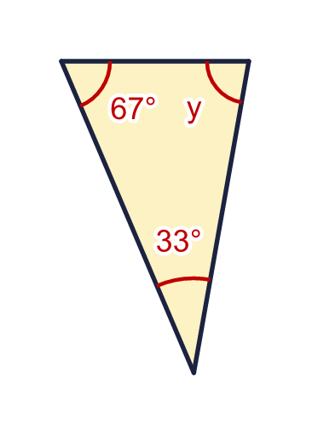
    y = |  | °
  3 | Work out the size of angle y.
    y = |  | °
  4 | This triangle has a right angle. Work out the size of angle z.  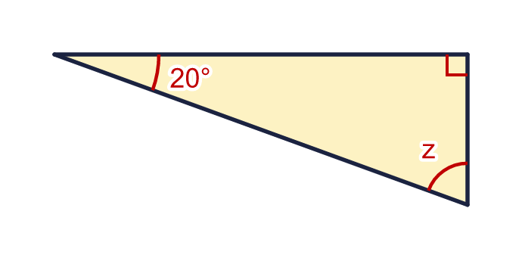
    z = |  | °
  4 | This triangle has a right angle. Work out the size of angle z.
    z = |  | °
  5 | This triangle has one obtuse angle. Work out the size of angle w.  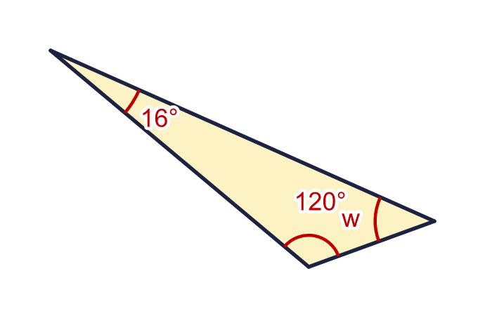
    w = |  | °
  5 | This triangle has one obtuse angle. Work out the size of angle w.
    w = |  | °
  6 | Work out the size of angle q.  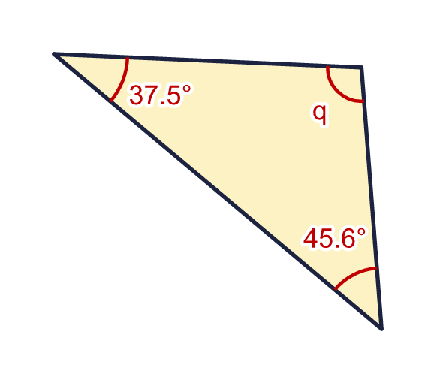
    q = |  | °
  6 | Work out the size of angle q.
    q = |  | °
  7 | Two angles in a triangle are 66° and 34°. What is the size of the third angle?  a) The third angle is
  7 | Two angles in a triangle are 66° and 34°. What is the size of the third angle?  a) The third angle is
  8 | Look at the three triangles. Write how many acute angles each triangle has.  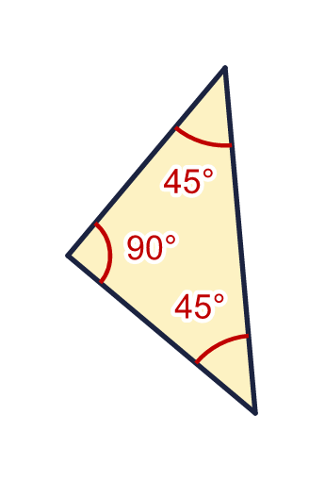  a) Triangle A: acute angles  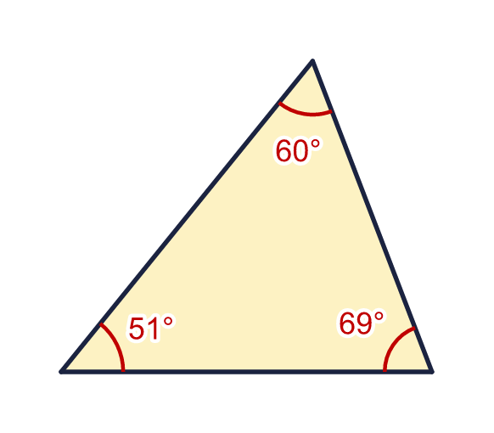  b) Triangle B: acute angles  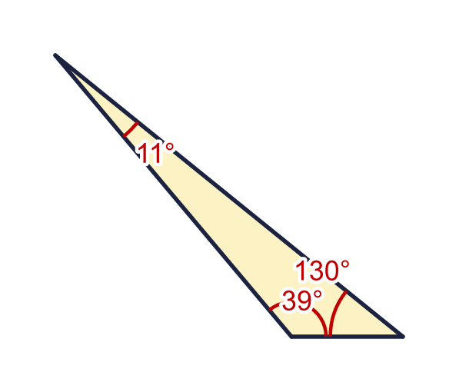  c) Triangle C: acute angles
  8 | Look at the three triangles. Write how many acute angles each triangle has.  a) Triangle A: acute angles  b) Triangle B: acute angles  c) Triangle C: acute angles

  9 | This triangle has a right angle.  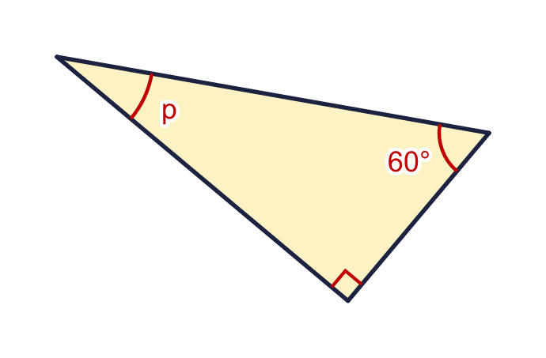  Is Boba correct? Circle yes or no.  Yes / No  Explain how you know.
     | 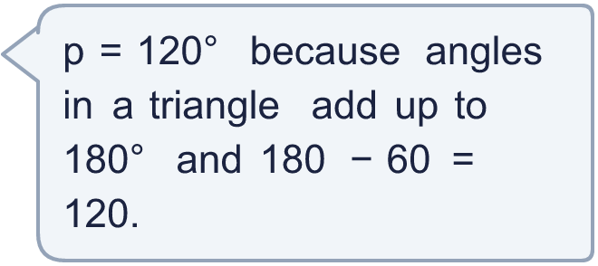
  9 | This triangle has a right angle.  Is Boba correct? Circle yes or no.  Yes / No  Explain how you know.
  10 | One of the angles in a triangle is 29°. Another angle is twice the size of the first angle.  a) What is the size of the third angle?
  10 | One of the angles in a triangle is 29°. Another angle is twice the size of the first angle.  a) What is the size of the third angle?
  11 | Can a triangle have these three angles? Write yes or no.  a) 29°, 85° and 76°  b) 70°, 45° and 84°  c) 29°, 85° and 66°
  11 | Can a triangle have these three angles? Write yes or no.  a) 29°, 85° and 76°  b) 70°, 45° and 84°  c) 29°, 85° and 66°
  12 | Look at the five triangles.  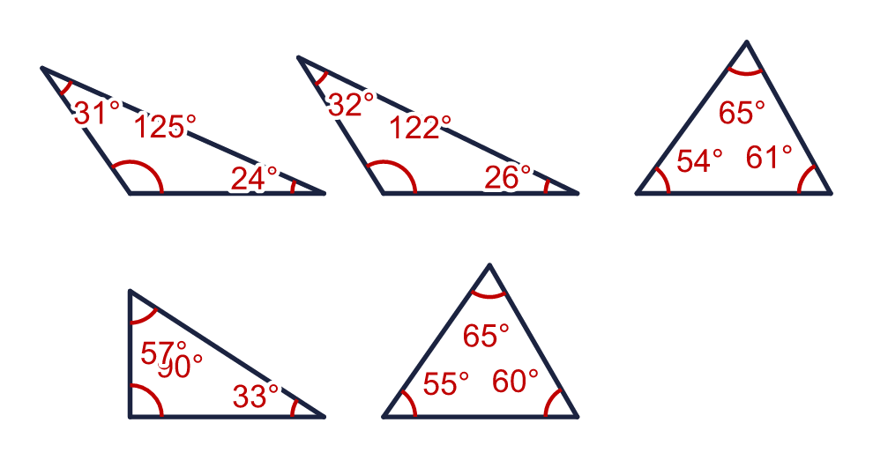  a) How many of the triangles have three acute angles?  b) How many have exactly two acute angles?  c) Can a triangle have no acute angles? Write yes or no.
  12 | Look at the five triangles.  a) How many of the triangles have three acute angles?  b) How many have exactly two acute angles?  c) Can a triangle have no acute angles? Write yes or no.
  13 | The three angles in a triangle are x, 2x and 3x.  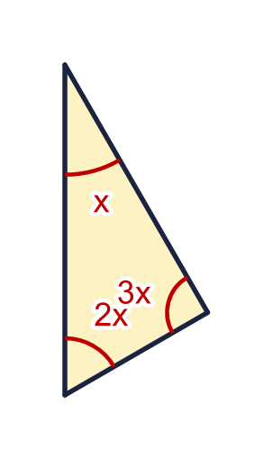
    x = |  | °
    3x = |  | °
  13 | The three angles in a triangle are x, 2x and 3x.
    x = |  | °
    3x = |  | °
  14 | The angles in a triangle are marked with expressions.  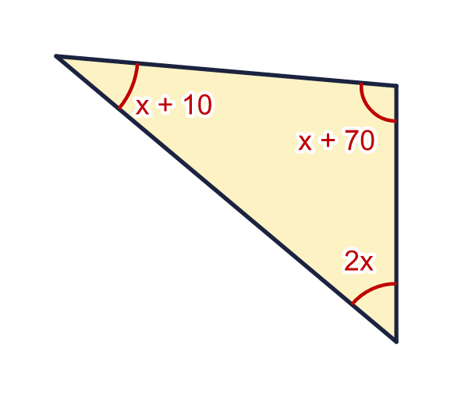  a) Work out the value of x.  b) What is the size of the largest angle?
  14 | The angles in a triangle are marked with expressions.  a) Work out the value of x.  b) What is the size of the largest angle?

Year 6 · Shape · Step 4
Angles in a triangle
Answers (teacher copy)

  1 | The three angles of a triangle are shown.  a) What is the sum of the three angles? 180
  2 | Work out the size of angle x.  x = 66 °
  3 | Work out the size of angle y.  y = 80 °
  4 | This triangle has a right angle. Work out the size of angle z.  z = 70 °
  5 | This triangle has one obtuse angle. Work out the size of angle w.  w = 44 °
  6 | Work out the size of angle q.  q = 96.9 °
  7 | Two angles in a triangle are 66° and 34°. What is the size of the third angle?  a) The third angle is 80
  8 | Look at the three triangles. Write how many acute angles each triangle has.  a) Triangle A: acute angles 2  b) Triangle B: acute angles 3  c) Triangle C: acute angles 2
  9 | This triangle has a right angle.  Is Boba correct? Circle yes or no.  Yes / No  Explain how you know.  There is also a right angle of 90°. 180 − 90 − 60 = 30, so p = 30°, not 120°.
  10 | One of the angles in a triangle is 29°. Another angle is twice the size of the first angle.  a) What is the size of the third angle? 93
  11 | Can a triangle have these three angles? Write yes or no.  a) 29°, 85° and 76° No  b) 70°, 45° and 84° No  c) 29°, 85° and 66° Yes
  12 | Look at the five triangles.  a) How many of the triangles have three acute angles? 2  b) How many have exactly two acute angles? 3  c) Can a triangle have no acute angles? Write yes or no. No
  13 | The three angles in a triangle are x, 2x and 3x.  x = 30 °  3x = 90 °
  14 | The angles in a triangle are marked with expressions.  a) Work out the value of x. 25  b) What is the size of the largest angle? 95

