  Year 6 · Shape · Step 8  Angles in polygons | 
  Year 6 · Shape · Step 8
  Angles in polygons
  1 | The pentagon is cut into triangles by lines from corner A. The angles in a triangle add up to 180°.  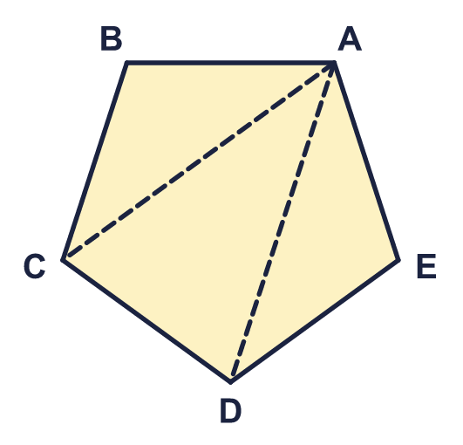  a) How many triangles are there?  b) What is the sum of the angles of the pentagon?
  1 | The pentagon is cut into triangles by lines from corner A. The angles in a triangle add up to 180°.  a) How many triangles are there?  b) What is the sum of the angles of the pentagon?
  2 | The octagon is cut into triangles by lines from corner A.  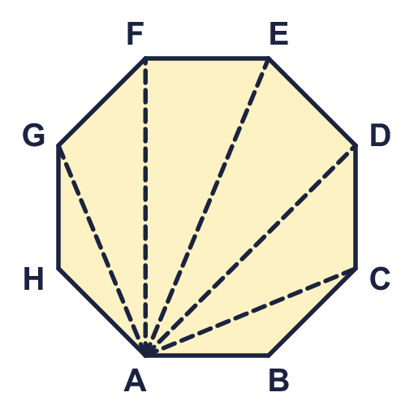  a) How many triangles are there?  b) What is the sum of the angles of the octagon?
  2 | The octagon is cut into triangles by lines from corner A.  a) How many triangles are there?  b) What is the sum of the angles of the octagon?
  3 | A polygon with n sides can be cut into n − 2 triangles. Work out the sum of the angles of each polygon.  a) A pentagon (5 sides)  b) A hexagon (6 sides)  c) A octagon (8 sides)
  3 | A polygon with n sides can be cut into n − 2 triangles. Work out the sum of the angles of each polygon.  a) A pentagon (5 sides)  b) A hexagon (6 sides)  c) A octagon (8 sides)
  4 | All the angles of a regular polygon are equal. Work out the size of one angle of each regular polygon.  a) A regular decagon  b) A regular octagon  c) A regular dodecagon
  4 | All the angles of a regular polygon are equal. Work out the size of one angle of each regular polygon.  a) A regular decagon  b) A regular octagon  c) A regular dodecagon
  5 | The angles of a pentagon add up to 540°. Work out the size of angle x.  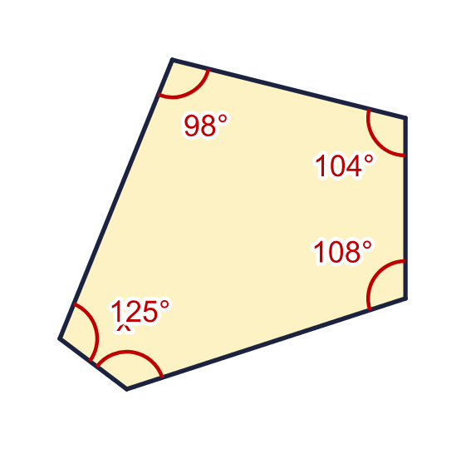
    x = |  | °
  5 | The angles of a pentagon add up to 540°. Work out the size of angle x.
    x = |  | °
  6 | The angles of a hexagon add up to 720°. Work out the size of angle y.  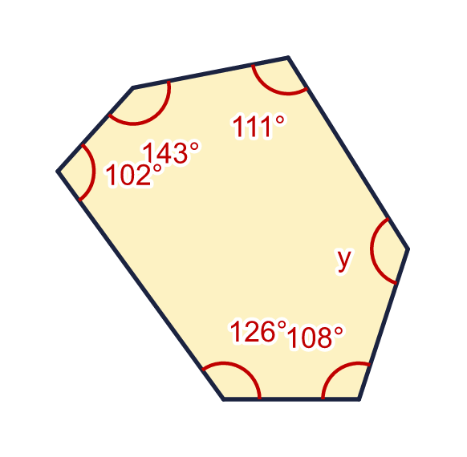
    y = |  | °
  6 | The angles of a hexagon add up to 720°. Work out the size of angle y.
    y = |  | °
  7 | The angles of a polygon add up to 900°. How many sides does the polygon have?  a) Number of sides
  7 | The angles of a polygon add up to 900°. How many sides does the polygon have?  a) Number of sides
  8 | Each angle of a regular polygon is 150°. How many sides does the polygon have?  a) Number of sides
  8 | Each angle of a regular polygon is 150°. How many sides does the polygon have?  a) Number of sides

  9 | This decagon is cut into 10 triangles by lines from a point in the middle.  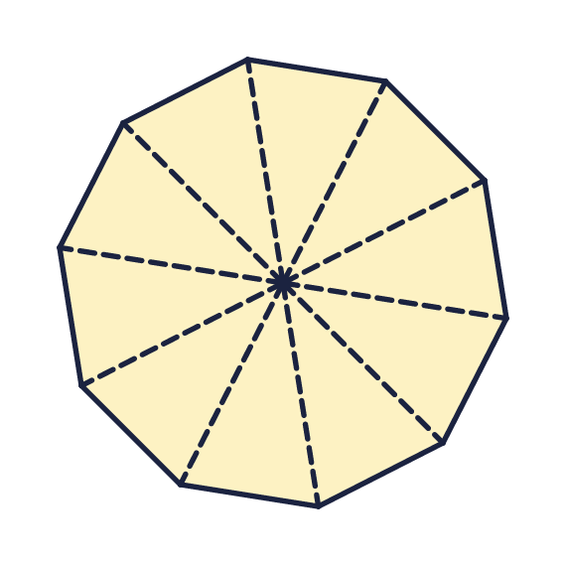  Is Boba correct? Circle yes or no.  Yes / No  Explain how you know.
     | 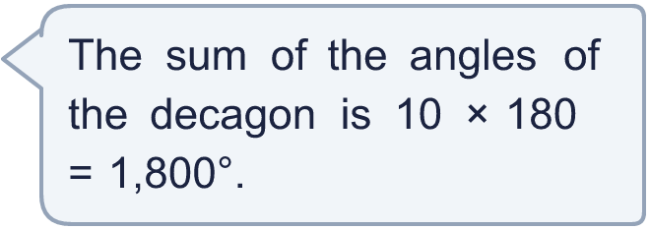
  9 | This decagon is cut into 10 triangles by lines from a point in the middle.  Is Boba correct? Circle yes or no.  Yes / No  Explain how you know.
  10 | Shape A is a regular octagon. Shape B is an irregular pentagon. Angle a is a corner of shape A, and angle b is a corner of shape B.  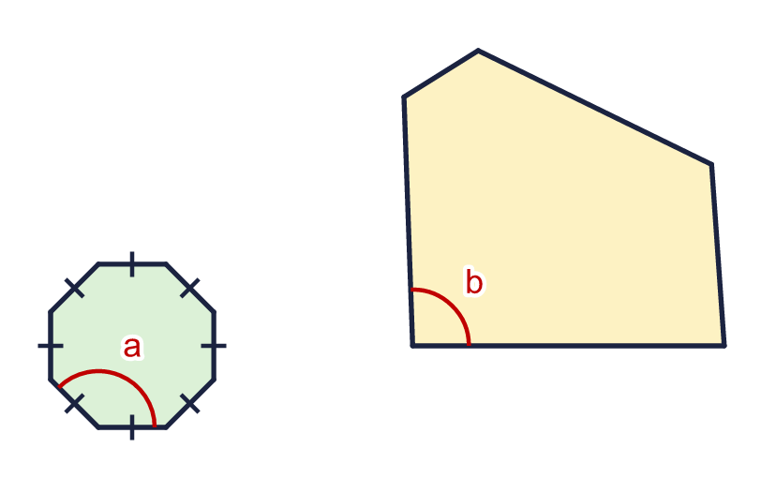  a) Work out the size of angle a.  b) Can you work out the size of angle b? Write yes or no.
  10 | Shape A is a regular octagon. Shape B is an irregular pentagon. Angle a is a corner of shape A, and angle b is a corner of shape B.  a) Work out the size of angle a.  b) Can you work out the size of angle b? Write yes or no.
  11 | A regular decagon and a regular quadrilateral share a side. The angle y is outside both shapes.  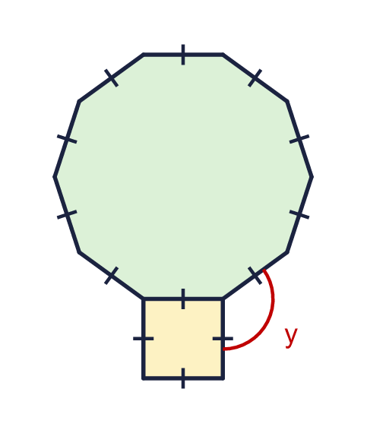
    y = |  | °
  11 | A regular decagon and a regular quadrilateral share a side. The angle y is outside both shapes.
    y = |  | °
  12 | Two identical regular decagons meet at a point. The angle x is the gap between them.  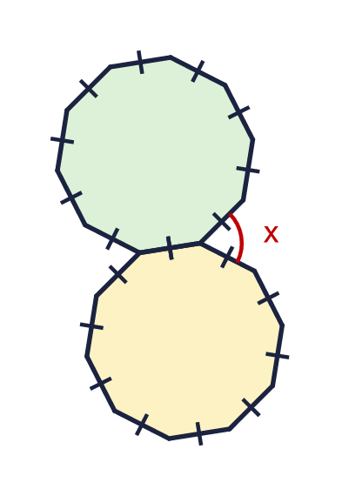
    x = |  | °
  12 | Two identical regular decagons meet at a point. The angle x is the gap between them.
    x = |  | °
  13 | Each angle of a regular polygon is 150°.  a) How many sides does the polygon have?  b) What is the sum of all its angles?
  13 | Each angle of a regular polygon is 150°.  a) How many sides does the polygon have?  b) What is the sum of all its angles?
  14 | Use the rule: the sum of the angles of a polygon = (number of sides − 2) × 180°.  a) A polygon with 12 sides: the sum of its angles is  b) A polygon is cut into 6 triangles. It has how many sides?  c) The angles of a polygon add up to 1,620°. It has how many sides?
  14 | Use the rule: the sum of the angles of a polygon = (number of sides − 2) × 180°.  a) A polygon with 12 sides: the sum of its angles is  b) A polygon is cut into 6 triangles. It has how many sides?  c) The angles of a polygon add up to 1,620°. It has how many sides?

Year 6 · Shape · Step 8
Angles in polygons
Answers (teacher copy)

  1 | The pentagon is cut into triangles by lines from corner A. The angles in a triangle add up to 180°.  a) How many triangles are there? 3  b) What is the sum of the angles of the pentagon? 540
  2 | The octagon is cut into triangles by lines from corner A.  a) How many triangles are there? 6  b) What is the sum of the angles of the octagon? 1,080
  3 | A polygon with n sides can be cut into n − 2 triangles. Work out the sum of the angles of each polygon.  a) A pentagon (5 sides) 540  b) A hexagon (6 sides) 720  c) A octagon (8 sides) 1,080
  4 | All the angles of a regular polygon are equal. Work out the size of one angle of each regular polygon.  a) A regular decagon 144  b) A regular octagon 135  c) A regular dodecagon 150
  5 | The angles of a pentagon add up to 540°. Work out the size of angle x.  x = 105 °
  6 | The angles of a hexagon add up to 720°. Work out the size of angle y.  y = 130 °
  7 | The angles of a polygon add up to 900°. How many sides does the polygon have?  a) Number of sides 7
  8 | Each angle of a regular polygon is 150°. How many sides does the polygon have?  a) Number of sides 12
  9 | This decagon is cut into 10 triangles by lines from a point in the middle.  Is Boba correct? Circle yes or no.  Yes / No  Explain how you know.  The angles around the middle point (360°) are not angles of the decagon. The sum is 10 × 180 − 360 = 1,440°.
  10 | Shape A is a regular octagon. Shape B is an irregular pentagon. Angle a is a corner of shape A, and angle b is a corner of shape B.  a) Work out the size of angle a. 135  b) Can you work out the size of angle b? Write yes or no. No
  11 | A regular decagon and a regular quadrilateral share a side. The angle y is outside both shapes.  y = 126 °
  12 | Two identical regular decagons meet at a point. The angle x is the gap between them.  x = 72 °
  13 | Each angle of a regular polygon is 150°.  a) How many sides does the polygon have? 12  b) What is the sum of all its angles? 1,800
  14 | Use the rule: the sum of the angles of a polygon = (number of sides − 2) × 180°.  a) A polygon with 12 sides: the sum of its angles is 1,800  b) A polygon is cut into 6 triangles. It has how many sides? 8  c) The angles of a polygon add up to 1,620°. It has how many sides? 11

