  Year 6 · Shape · Step 7  Angles in quadrilaterals | 
  Year 6 · Shape · Step 7
  Angles in quadrilaterals
  1 | Work out the sum of the angles in each quadrilateral.  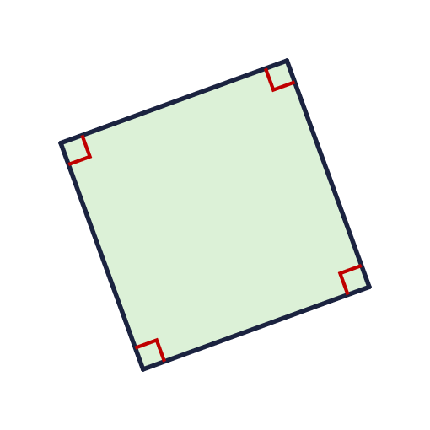  a) The rectangle (every angle is a right angle)  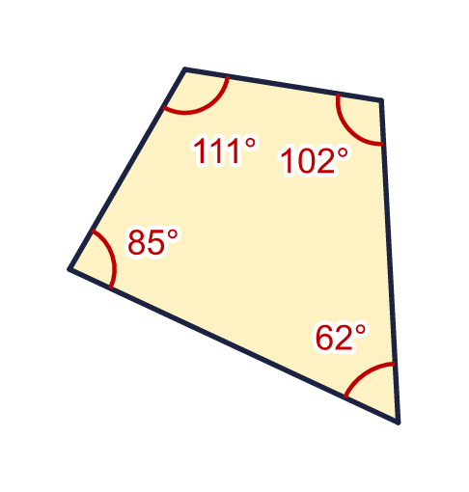  b) The quadrilateral with its angles marked
  1 | Work out the sum of the angles in each quadrilateral.  a) The rectangle (every angle is a right angle)  b) The quadrilateral with its angles marked
  2 | The angles of a quadrilateral add up to 360°. Work out the size of angle x.  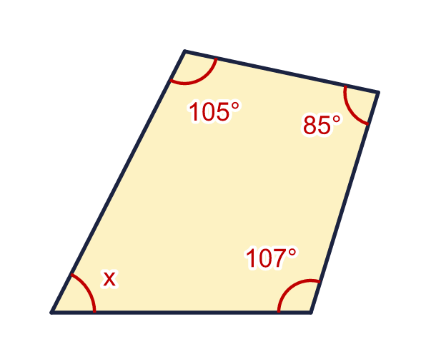
    x = |  | °
  2 | The angles of a quadrilateral add up to 360°. Work out the size of angle x.
    x = |  | °
  3 | Work out the size of angle y.  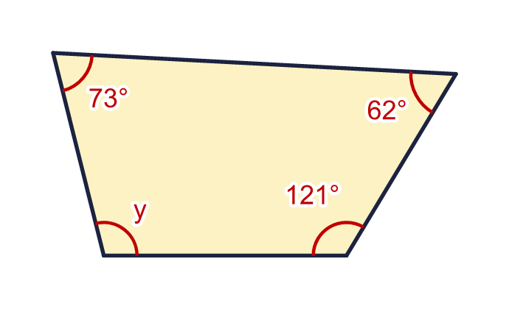
    y = |  | °
  3 | Work out the size of angle y.
    y = |  | °
  4 | This trapezium has two right angles. Work out the size of angle a.  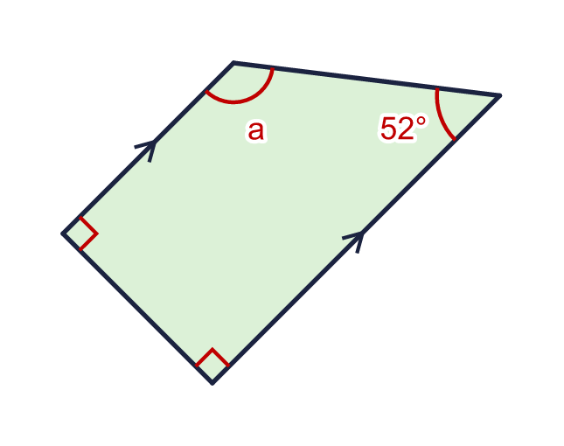
    a = |  | °
  4 | This trapezium has two right angles. Work out the size of angle a.
    a = |  | °
  5 | This shape is a parallelogram. Work out the sizes of angles a and b.  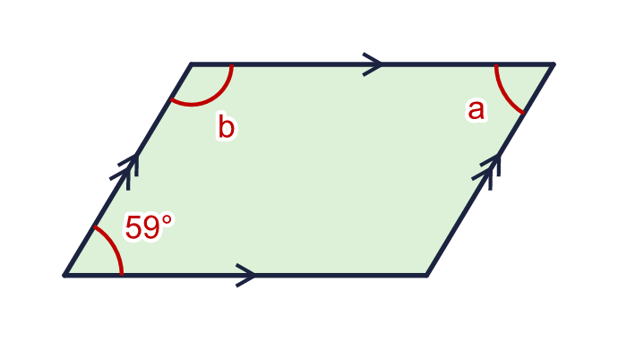
    a = |  | °
    b = |  | °
  5 | This shape is a parallelogram. Work out the sizes of angles a and b.
    a = |  | °
    b = |  | °
  6 | This shape is a kite. The marks show the equal sides. Work out the size of angle w.  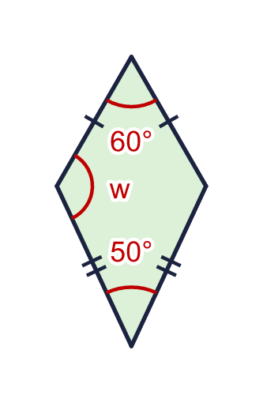
    w = |  | °
  6 | This shape is a kite. The marks show the equal sides. Work out the size of angle w.
    w = |  | °
  7 | This shape is a rhombus. All four sides are equal. Work out the sizes of angles c and d.  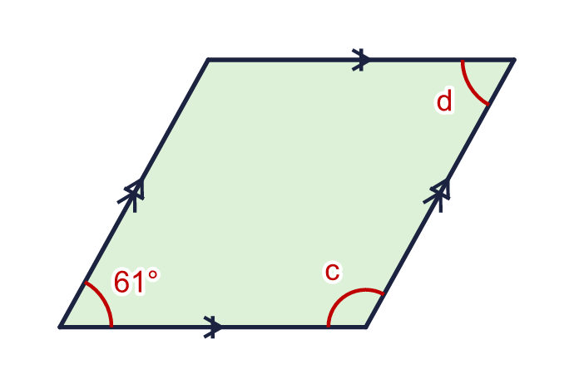
    c = |  | °
    d = |  | °
  7 | This shape is a rhombus. All four sides are equal. Work out the sizes of angles c and d.
    c = |  | °
    d = |  | °
  8 | Three angles of a quadrilateral are 71°, 119° and 63°. What is the fourth angle?  a) The fourth angle is
  8 | Three angles of a quadrilateral are 71°, 119° and 63°. What is the fourth angle?  a) The fourth angle is

  9 | A quadrilateral has three angles of 90°.  a) What is the size of the fourth angle?  b) Can a quadrilateral have exactly three right angles? Write yes or no.
  9 | A quadrilateral has three angles of 90°.  a) What is the size of the fourth angle?  b) Can a quadrilateral have exactly three right angles? Write yes or no.
  10 | This trapezium has two sloping sides of equal length (the marks) and two parallel sides (the arrows). Work out the sizes of angles b and c.  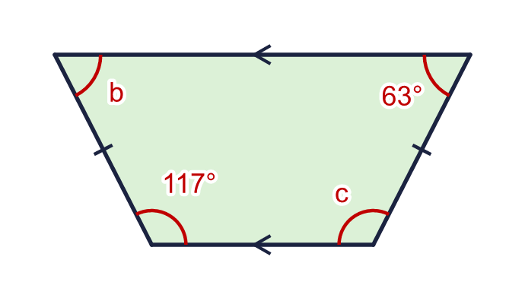
    b = |  | °
    c = |  | °
  10 | This trapezium has two sloping sides of equal length (the marks) and two parallel sides (the arrows). Work out the sizes of angles b and c.
    b = |  | °
    c = |  | °
  11 | This shape is a parallelogram. Two angles next to each other are x and 3x.  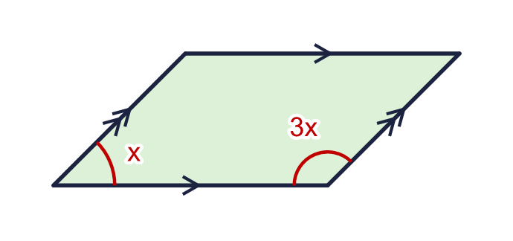
    x = |  | °
    3x = |  | °
  11 | This shape is a parallelogram. Two angles next to each other are x and 3x.
    x = |  | °
    3x = |  | °
  12 | This shape is a kite. The marks show the equal sides.  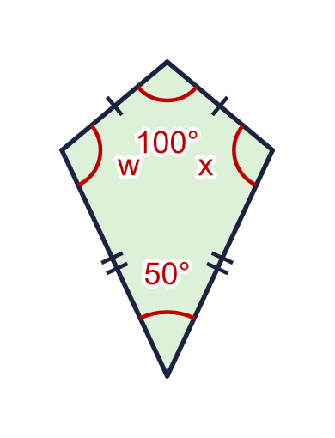  b) What is w + x?
    w = |  | °
  12 | This shape is a kite. The marks show the equal sides.  b) What is w + x?
    w = |  | °
  13 | The four angles of a quadrilateral are in the ratio 1 : 2 : 4 : 5.  a) What is the size of the smallest angle?  b) What is the size of the largest angle?
  13 | The four angles of a quadrilateral are in the ratio 1 : 2 : 4 : 5.  a) What is the size of the smallest angle?  b) What is the size of the largest angle?
  14 | The four angles of this quadrilateral are written as expressions.  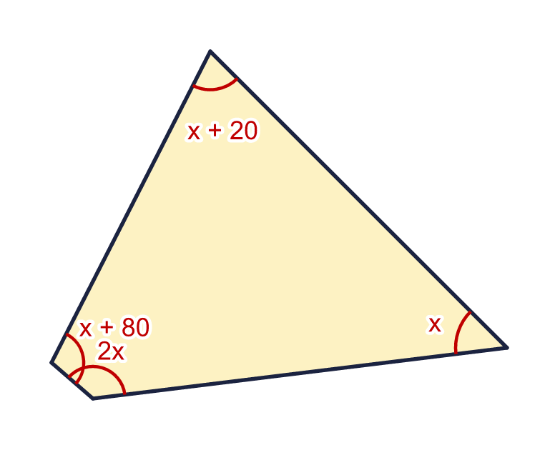  a) Work out the value of x.  b) Work out the size of the largest angle.
  14 | The four angles of this quadrilateral are written as expressions.  a) Work out the value of x.  b) Work out the size of the largest angle.

Year 6 · Shape · Step 7
Angles in quadrilaterals
Answers (teacher copy)

  1 | Work out the sum of the angles in each quadrilateral.  a) The rectangle (every angle is a right angle) 360  b) The quadrilateral with its angles marked 360
  2 | The angles of a quadrilateral add up to 360°. Work out the size of angle x.  x = 63 °
  3 | Work out the size of angle y.  y = 104 °
  4 | This trapezium has two right angles. Work out the size of angle a.  a = 128 °
  5 | This shape is a parallelogram. Work out the sizes of angles a and b.  a = 59 °  b = 121 °
  6 | This shape is a kite. The marks show the equal sides. Work out the size of angle w.  w = 125 °
  7 | This shape is a rhombus. All four sides are equal. Work out the sizes of angles c and d.  c = 119 °  d = 61 °
  8 | Three angles of a quadrilateral are 71°, 119° and 63°. What is the fourth angle?  a) The fourth angle is 107
  9 | A quadrilateral has three angles of 90°.  a) What is the size of the fourth angle? 90  b) Can a quadrilateral have exactly three right angles? Write yes or no. No
  10 | This trapezium has two sloping sides of equal length (the marks) and two parallel sides (the arrows). Work out the sizes of angles b and c.  b = 63 °  c = 117 °
  11 | This shape is a parallelogram. Two angles next to each other are x and 3x.  x = 45 °  3x = 135 °
  12 | This shape is a kite. The marks show the equal sides.  w = 105 °  b) What is w + x? 210
  13 | The four angles of a quadrilateral are in the ratio 1 : 2 : 4 : 5.  a) What is the size of the smallest angle? 30  b) What is the size of the largest angle? 150
  14 | The four angles of this quadrilateral are written as expressions.  a) Work out the value of x. 52  b) Work out the size of the largest angle. 132

