  Year 6 · Shape · Step 5  Angles in special triangles | 
  Year 6 · Shape · Step 5
  Angles in special triangles
  1 | This is an isosceles triangle. The marks show the equal sides. Work out the size of angle m.  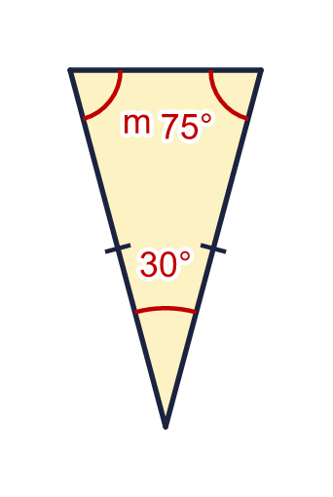
    m = |  | °
  1 | This is an isosceles triangle. The marks show the equal sides. Work out the size of angle m.
    m = |  | °
  2 | This is an isosceles triangle. Work out the size of angle x.  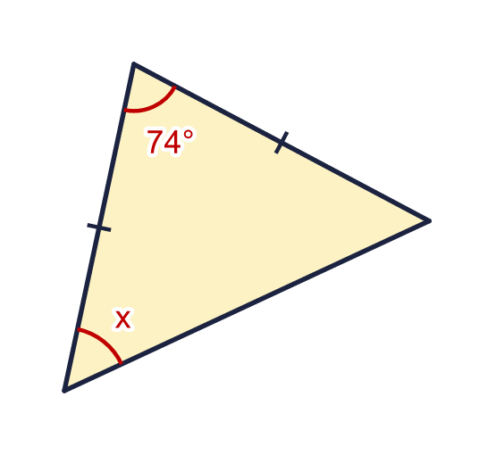
    x = |  | °
  2 | This is an isosceles triangle. Work out the size of angle x.
    x = |  | °
  3 | This is an isosceles triangle. Work out the size of angle y.  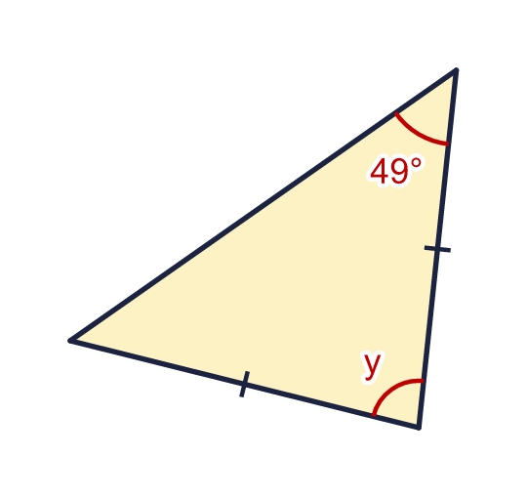
    y = |  | °
  3 | This is an isosceles triangle. Work out the size of angle y.
    y = |  | °
  4 | This is an equilateral triangle. All its sides are equal. Work out the size of angle x.  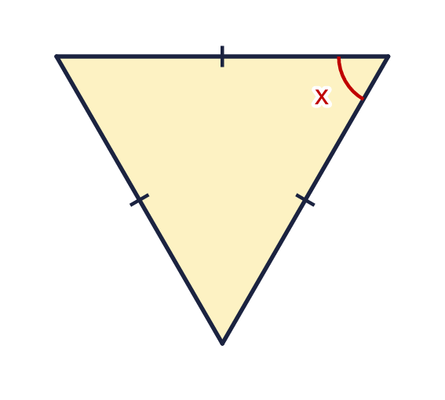
    x = |  | °
  4 | This is an equilateral triangle. All its sides are equal. Work out the size of angle x.
    x = |  | °
  5 | This triangle has a right angle and two equal sides. Work out the size of angle a.  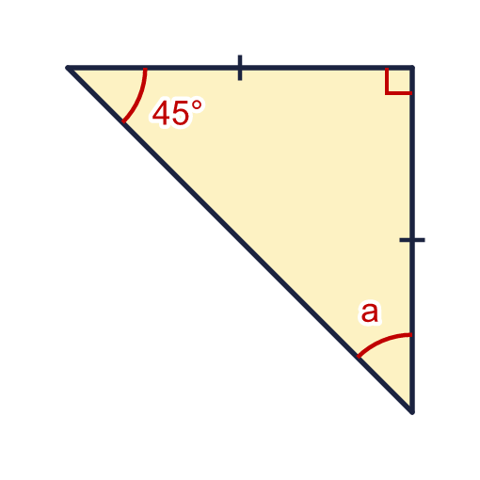
    a = |  | °
  5 | This triangle has a right angle and two equal sides. Work out the size of angle a.
    a = |  | °
  6 | This is an isosceles triangle. Work out the sizes of angles a and b.  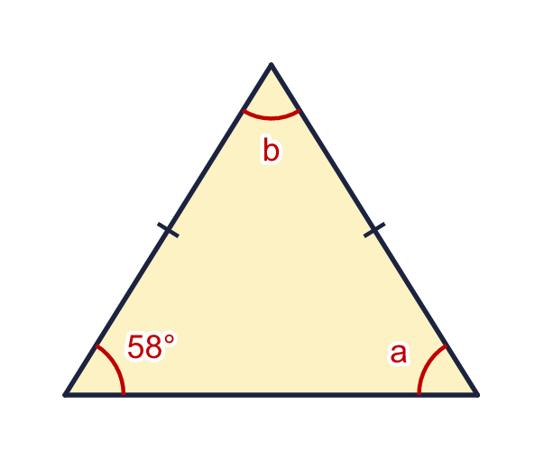
    a = |  | °
    b = |  | °
  6 | This is an isosceles triangle. Work out the sizes of angles a and b.
    a = |  | °
    b = |  | °
  7 | Two sides of this triangle are equal, as the marks show. Which two angles are equal? Write the letters, for example A and B.  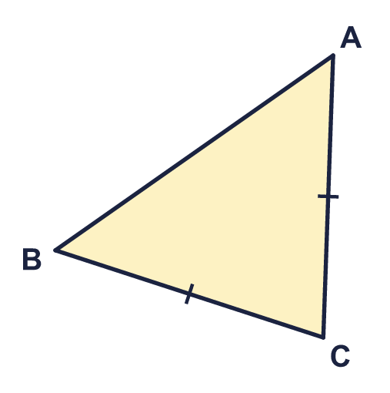  a) The equal angles are
  7 | Two sides of this triangle are equal, as the marks show. Which two angles are equal? Write the letters, for example A and B.  a) The equal angles are
  8 | Write whether each triangle is equilateral, isosceles or scalene.  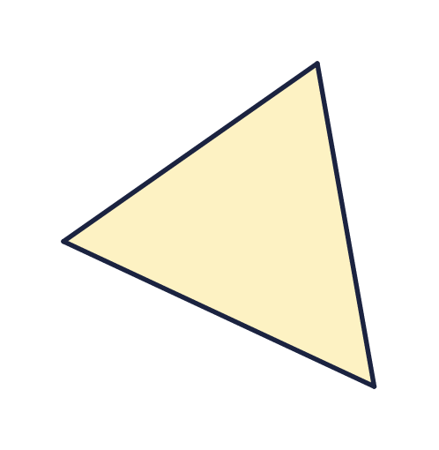  a) Triangle A is  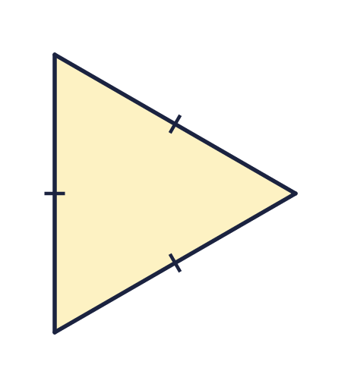  b) Triangle B is  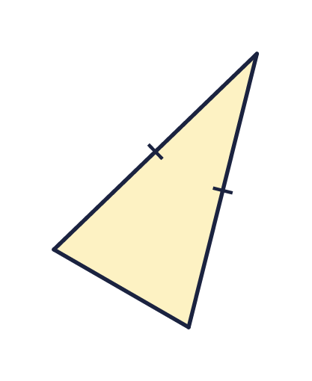  c) Triangle C is
  8 | Write whether each triangle is equilateral, isosceles or scalene.  a) Triangle A is  b) Triangle B is  c) Triangle C is

  9 | This is an isosceles triangle.  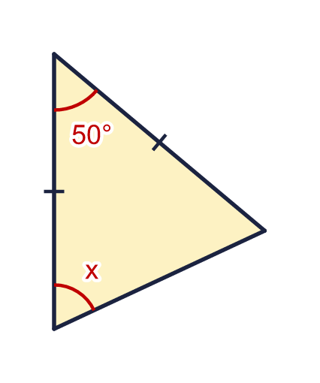  Is Boba correct? Circle yes or no.  Yes / No  Explain how you know.
     | 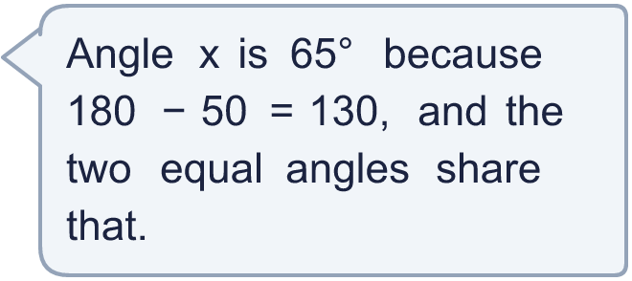
  9 | This is an isosceles triangle.  Is Boba correct? Circle yes or no.  Yes / No  Explain how you know.
  10 | Write whether each statement is true or false.  a) Every equilateral triangle is isosceles.  b) Every right-angled triangle is scalene.  c) A right-angled triangle can be equilateral.
  10 | Write whether each statement is true or false.  a) Every equilateral triangle is isosceles.  b) Every right-angled triangle is scalene.  c) A right-angled triangle can be equilateral.
  11 | Two angles in a triangle are 32° and 32°.  a) Is the triangle isosceles? Write yes or no.  b) What is the size of the third angle?
  11 | Two angles in a triangle are 32° and 32°.  a) Is the triangle isosceles? Write yes or no.  b) What is the size of the third angle?
  12 | One angle in an isosceles triangle is 35°.  a) What is the largest size another angle in the triangle could be?
  12 | One angle in an isosceles triangle is 35°.  a) What is the largest size another angle in the triangle could be?
  13 | This is an isosceles triangle. Angle b is four times the size of angle a.  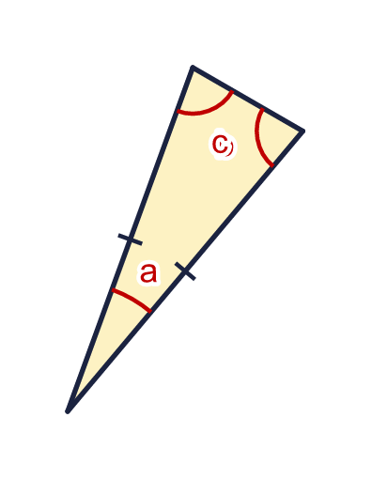
    a = |  | °
    c = |  | °
  13 | This is an isosceles triangle. Angle b is four times the size of angle a.
    a = |  | °
    c = |  | °
  14 | This is an isosceles triangle. The two equal angles are written as expressions.  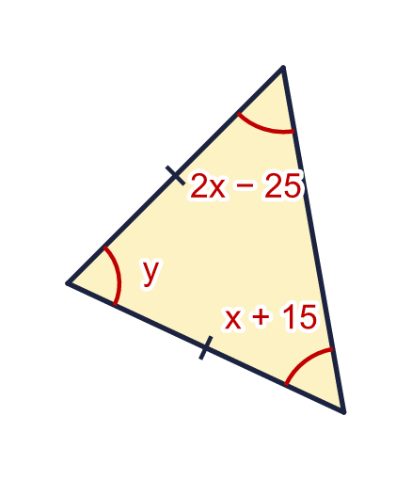  a) Work out the value of x.  b) Work out the size of angle y.
  14 | This is an isosceles triangle. The two equal angles are written as expressions.  a) Work out the value of x.  b) Work out the size of angle y.

Year 6 · Shape · Step 5
Angles in special triangles
Answers (teacher copy)

  1 | This is an isosceles triangle. The marks show the equal sides. Work out the size of angle m.  m = 75 °
  2 | This is an isosceles triangle. Work out the size of angle x.  x = 53 °
  3 | This is an isosceles triangle. Work out the size of angle y.  y = 82 °
  4 | This is an equilateral triangle. All its sides are equal. Work out the size of angle x.  x = 60 °
  5 | This triangle has a right angle and two equal sides. Work out the size of angle a.  a = 45 °
  6 | This is an isosceles triangle. Work out the sizes of angles a and b.  a = 58 °  b = 64 °
  7 | Two sides of this triangle are equal, as the marks show. Which two angles are equal? Write the letters, for example A and B.  a) The equal angles are A and B
  8 | Write whether each triangle is equilateral, isosceles or scalene.  a) Triangle A is scalene  b) Triangle B is equilateral  c) Triangle C is isosceles
  9 | This is an isosceles triangle.  Is Boba correct? Circle yes or no.  Yes / No  Explain how you know.  180 − 50 = 130, and this is shared by the two equal angles, so x = 65°.
  10 | Write whether each statement is true or false.  a) Every equilateral triangle is isosceles. True  b) Every right-angled triangle is scalene. False  c) A right-angled triangle can be equilateral. False
  11 | Two angles in a triangle are 32° and 32°.  a) Is the triangle isosceles? Write yes or no. Yes  b) What is the size of the third angle? 116
  12 | One angle in an isosceles triangle is 35°.  a) What is the largest size another angle in the triangle could be? 110
  13 | This is an isosceles triangle. Angle b is four times the size of angle a.  a = 20 °  c = 80 °
  14 | This is an isosceles triangle. The two equal angles are written as expressions.  a) Work out the value of x. 40  b) Work out the size of angle y. 70

