  Year 6 · Shape · Step 10  Drawing shapes accurately | 
  Year 6 · Shape · Step 10
  Drawing shapes accurately
  1 | Draw a square with a perimeter of 20 cm on squared paper (1 square is 1 cm). Draw it accurately in your book. Use a ruler and a protractor.  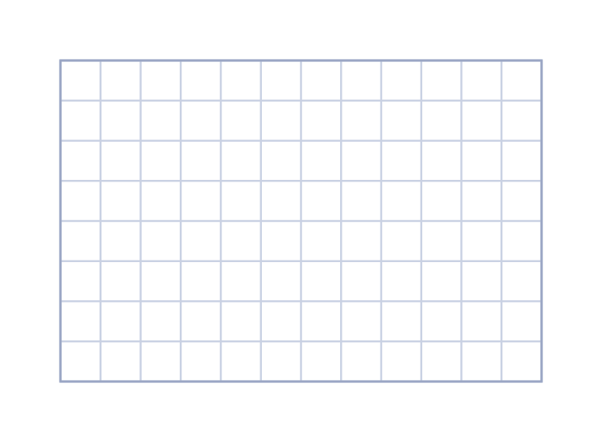  a) Length of one side (cm)
  1 | Draw a square with a perimeter of 20 cm on squared paper (1 square is 1 cm). Draw it accurately in your book. Use a ruler and a protractor.  a) Length of one side (cm)
  2 | Draw a rectangle with a perimeter of 22 cm. One side is 7 cm long. Draw it accurately in your book. Use a ruler and a protractor.  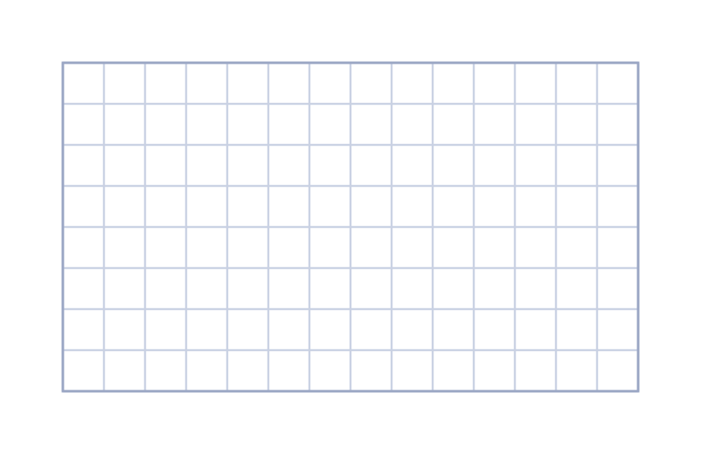  a) Length of the other side (cm)
  2 | Draw a rectangle with a perimeter of 22 cm. One side is 7 cm long. Draw it accurately in your book. Use a ruler and a protractor.  a) Length of the other side (cm)
  3 | Draw a right-angled triangle. The two short sides are 6 cm and 8 cm. Draw it accurately in your book. Use a ruler and a protractor.  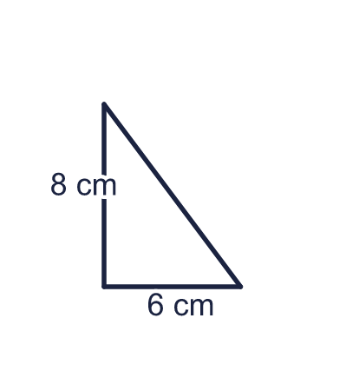  a) Length of the longest side (cm)
  3 | Draw a right-angled triangle. The two short sides are 6 cm and 8 cm. Draw it accurately in your book. Use a ruler and a protractor.  a) Length of the longest side (cm)
  4 | Draw a right-angled triangle. The two short sides are 8 cm and 15 cm. Draw it accurately in your book. Use a ruler and a protractor.  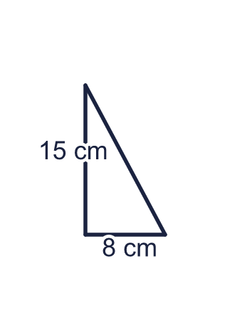  a) Length of the longest side (cm)
  4 | Draw a right-angled triangle. The two short sides are 8 cm and 15 cm. Draw it accurately in your book. Use a ruler and a protractor.  a) Length of the longest side (cm)
  5 | Draw a triangle. One side is 5 cm long. The angles at the two ends of this side are 55° and 60°. Draw it accurately in your book. Use a ruler and a protractor.  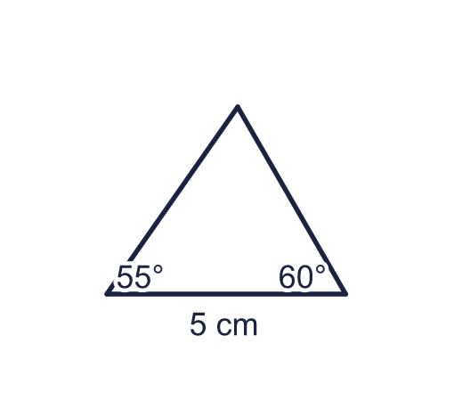  a) The third angle is (degrees)
  5 | Draw a triangle. One side is 5 cm long. The angles at the two ends of this side are 55° and 60°. Draw it accurately in your book. Use a ruler and a protractor.  a) The third angle is (degrees)
  6 | Draw an isosceles triangle with sides of 5 cm, 5 cm and 8 cm. Draw it accurately in your book. Use a ruler and a protractor.  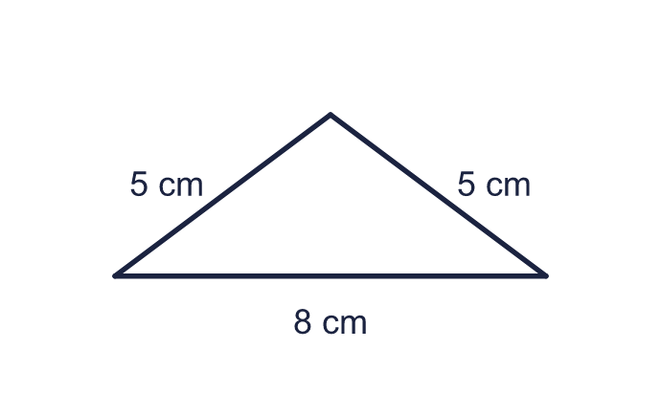  a) Height of the triangle (from the top corner to the base) (cm)  b) Area of the triangle (cm²)
  6 | Draw an isosceles triangle with sides of 5 cm, 5 cm and 8 cm. Draw it accurately in your book. Use a ruler and a protractor.  a) Height of the triangle (from the top corner to the base) (cm)  b) Area of the triangle (cm²)
  7 | Draw an angle of 110°. The arms are 38 mm and 44 mm long. Draw it accurately in your book. Use a ruler and a protractor.  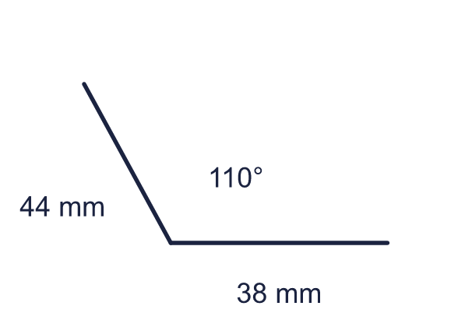  a) The reflex angle on the other side is (degrees)
  7 | Draw an angle of 110°. The arms are 38 mm and 44 mm long. Draw it accurately in your book. Use a ruler and a protractor.  a) The reflex angle on the other side is (degrees)
  8 | Draw a rectangle 4.5 cm long and 2.5 cm wide. Draw it accurately in your book. Use a ruler and a protractor.  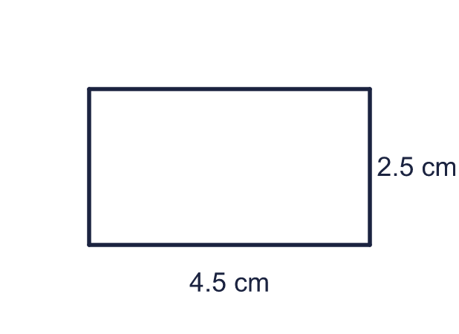  a) Area of the rectangle (cm²)
  8 | Draw a rectangle 4.5 cm long and 2.5 cm wide. Draw it accurately in your book. Use a ruler and a protractor.  a) Area of the rectangle (cm²)

  9 | Tommy says: “I have drawn a right-angled triangle. The two shorter sides are 6 cm and 8 cm.” Draw it accurately in your book. Use a ruler and a protractor.  a) Length of the longest side (cm)
  9 | Tommy says: “I have drawn a right-angled triangle. The two shorter sides are 6 cm and 8 cm.” Draw it accurately in your book. Use a ruler and a protractor.  a) Length of the longest side (cm)
  10 | Aisha draws a triangle. Its base is 6 cm. The angles at the ends of the base are 35° and 50°. Draw it accurately in your book. Use a ruler and a protractor.  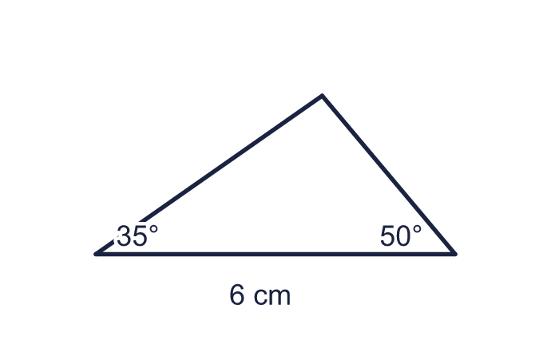  a) The third angle is (degrees)  b) Is the triangle acute-angled, right-angled or obtuse-angled?
  10 | Aisha draws a triangle. Its base is 6 cm. The angles at the ends of the base are 35° and 50°. Draw it accurately in your book. Use a ruler and a protractor.  a) The third angle is (degrees)  b) Is the triangle acute-angled, right-angled or obtuse-angled?
  11 | Draw an equilateral triangle with sides of 6 cm. Draw it accurately in your book. Use a ruler and a protractor.  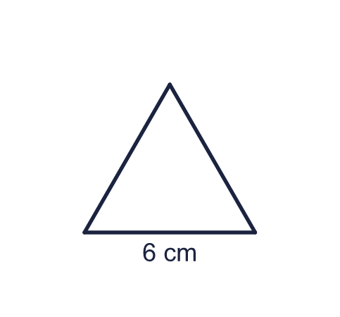  a) Size of each angle (degrees)  b) Perimeter (cm)
  11 | Draw an equilateral triangle with sides of 6 cm. Draw it accurately in your book. Use a ruler and a protractor.  a) Size of each angle (degrees)  b) Perimeter (cm)
  12 | Draw a rhombus with sides of 5 cm and one angle of 60°. Draw it accurately in your book. Use a ruler and a protractor.  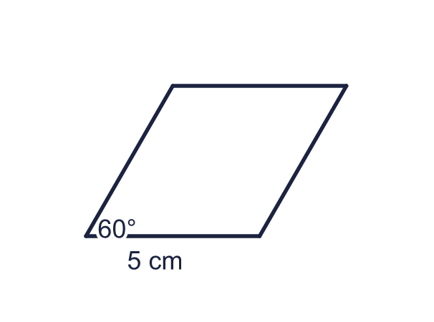  a) The shorter diagonal is (cm)  b) The other angle at the base is (degrees)
  12 | Draw a rhombus with sides of 5 cm and one angle of 60°. Draw it accurately in your book. Use a ruler and a protractor.  a) The shorter diagonal is (cm)  b) The other angle at the base is (degrees)
  13 | Draw a rectangle 9 cm long and 12 cm wide, then draw one diagonal. Draw it accurately in your book. Use a ruler and a protractor.  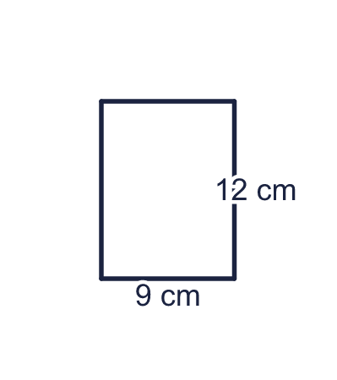  a) Length of the diagonal (cm)
  13 | Draw a rectangle 9 cm long and 12 cm wide, then draw one diagonal. Draw it accurately in your book. Use a ruler and a protractor.  a) Length of the diagonal (cm)
  14 | Draw a house. The wall is a rectangle 6 cm wide and 5 cm tall. The roof is an isosceles triangle on top with two sloping sides of 5 cm. Draw it accurately in your book. Use a ruler and a protractor.  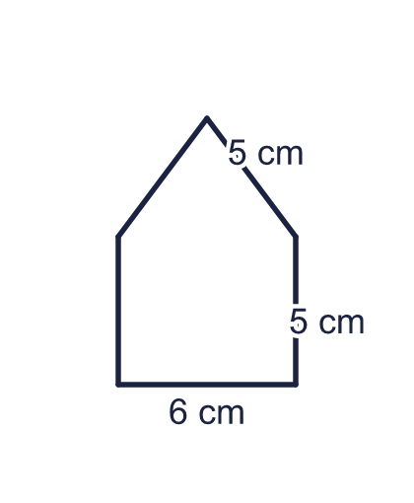  a) Total height of the house (cm)  b) Total area of the house (cm²)
  14 | Draw a house. The wall is a rectangle 6 cm wide and 5 cm tall. The roof is an isosceles triangle on top with two sloping sides of 5 cm. Draw it accurately in your book. Use a ruler and a protractor.  a) Total height of the house (cm)  b) Total area of the house (cm²)

Year 6 · Shape · Step 10
Drawing shapes accurately
Answers (teacher copy)

  1 | Draw a square with a perimeter of 20 cm on squared paper (1 square is 1 cm). Draw it accurately in your book. Use a ruler and a protractor.  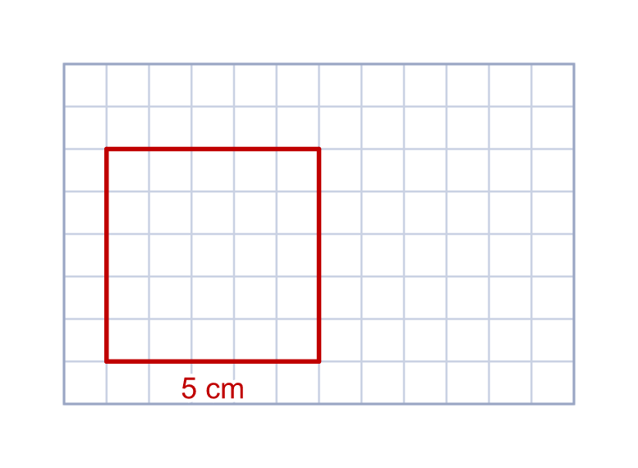  a) Length of one side (cm) 5
  2 | Draw a rectangle with a perimeter of 22 cm. One side is 7 cm long. Draw it accurately in your book. Use a ruler and a protractor.  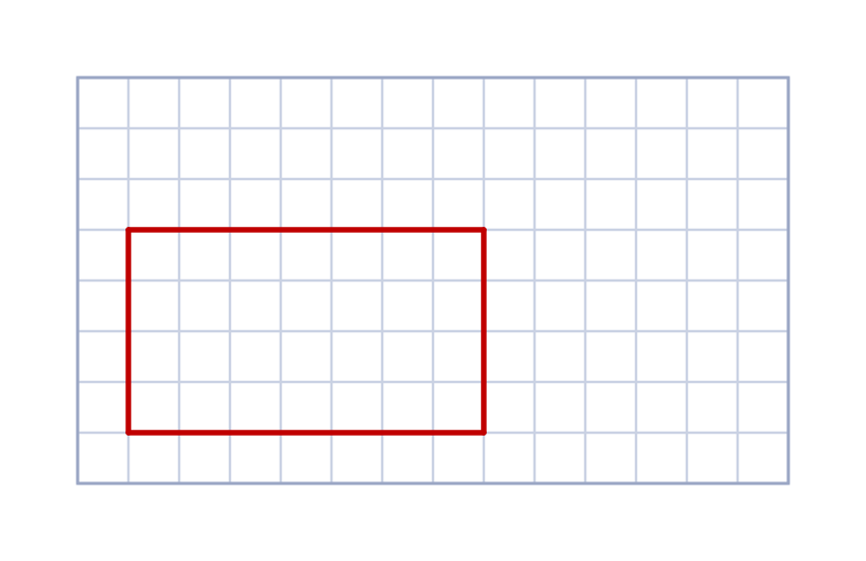  a) Length of the other side (cm) 4
  3 | Draw a right-angled triangle. The two short sides are 6 cm and 8 cm. Draw it accurately in your book. Use a ruler and a protractor.  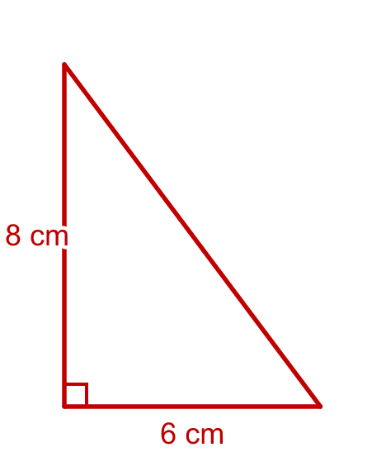  a) Length of the longest side (cm) 10
  4 | Draw a right-angled triangle. The two short sides are 8 cm and 15 cm. Draw it accurately in your book. Use a ruler and a protractor.  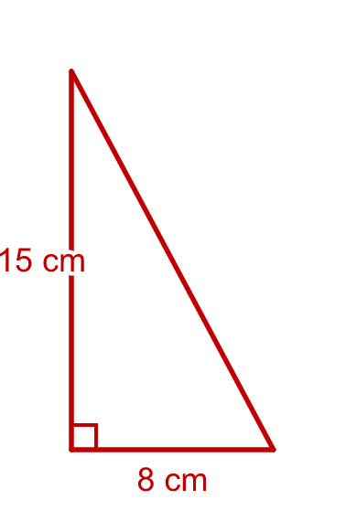  a) Length of the longest side (cm) 17
  5 | Draw a triangle. One side is 5 cm long. The angles at the two ends of this side are 55° and 60°. Draw it accurately in your book. Use a ruler and a protractor.  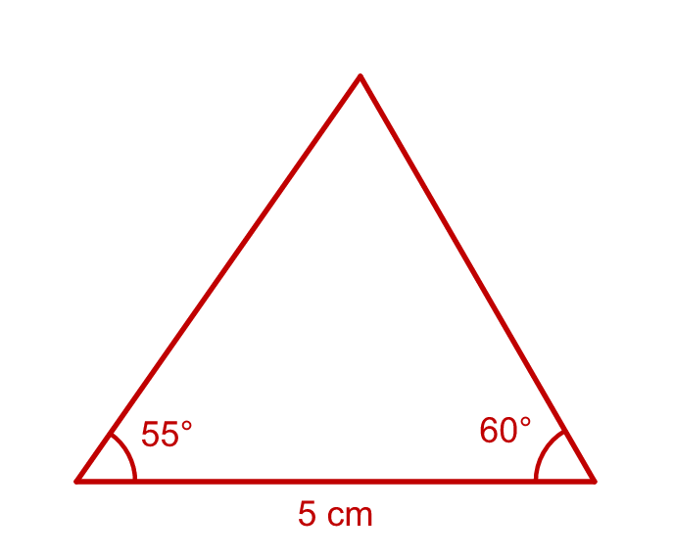  a) The third angle is (degrees) 65
  6 | Draw an isosceles triangle with sides of 5 cm, 5 cm and 8 cm. Draw it accurately in your book. Use a ruler and a protractor.  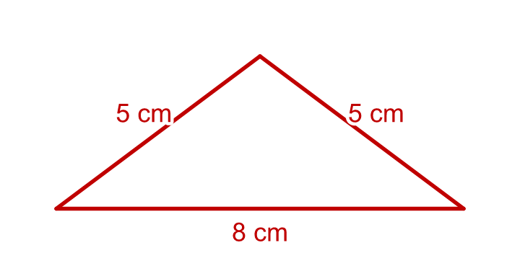  a) Height of the triangle (from the top corner to the base) (cm) 3  b) Area of the triangle (cm²) 12
  7 | Draw an angle of 110°. The arms are 38 mm and 44 mm long. Draw it accurately in your book. Use a ruler and a protractor.  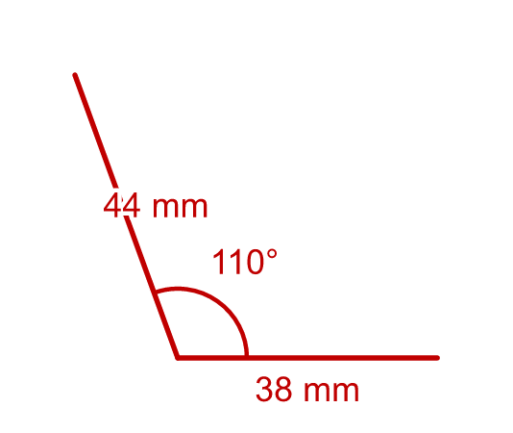  a) The reflex angle on the other side is (degrees) 250
  8 | Draw a rectangle 4.5 cm long and 2.5 cm wide. Draw it accurately in your book. Use a ruler and a protractor.  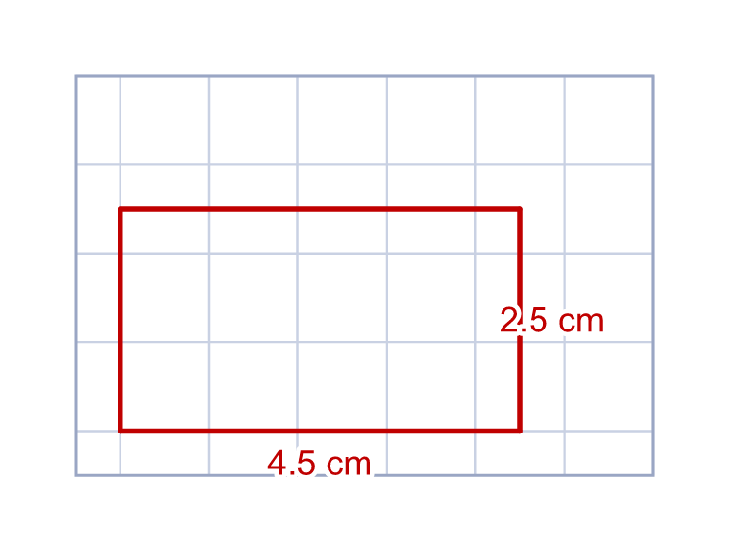  a) Area of the rectangle (cm²) 11.25
  9 | Tommy says: “I have drawn a right-angled triangle. The two shorter sides are 6 cm and 8 cm.” Draw it accurately in your book. Use a ruler and a protractor.  a) Length of the longest side (cm) 10
  10 | Aisha draws a triangle. Its base is 6 cm. The angles at the ends of the base are 35° and 50°. Draw it accurately in your book. Use a ruler and a protractor.  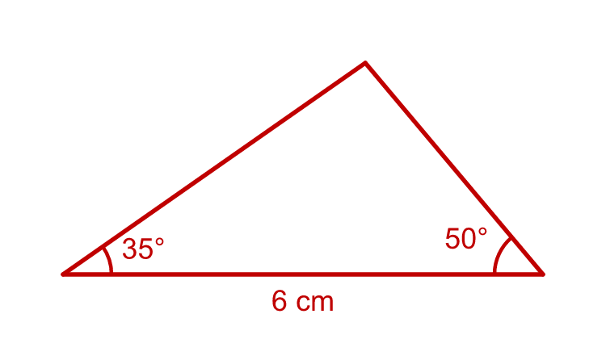  a) The third angle is (degrees) 95  b) Is the triangle acute-angled, right-angled or obtuse-angled? obtuse-angled
  11 | Draw an equilateral triangle with sides of 6 cm. Draw it accurately in your book. Use a ruler and a protractor.  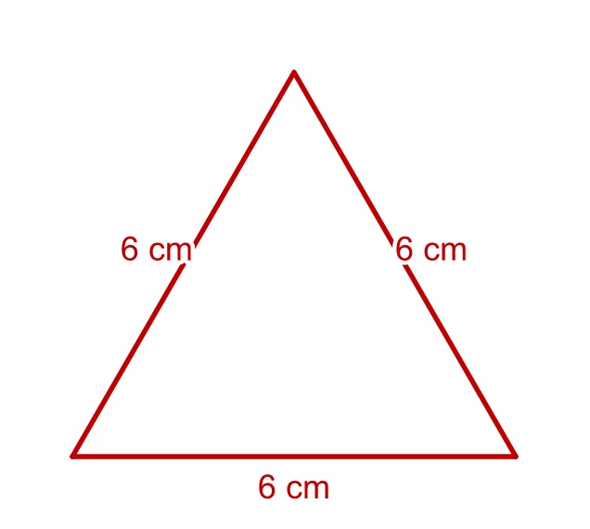  a) Size of each angle (degrees) 60  b) Perimeter (cm) 18
  12 | Draw a rhombus with sides of 5 cm and one angle of 60°. Draw it accurately in your book. Use a ruler and a protractor.  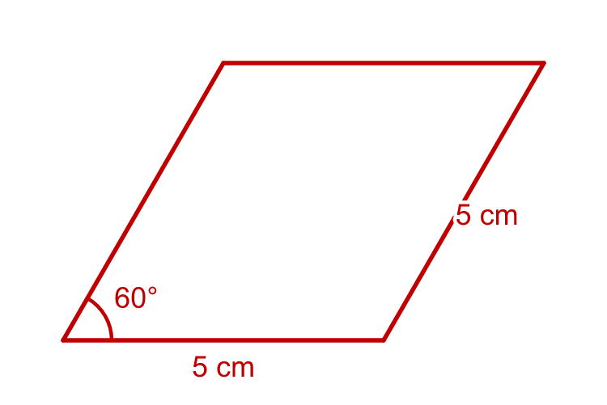  a) The shorter diagonal is (cm) 5  b) The other angle at the base is (degrees) 120
  13 | Draw a rectangle 9 cm long and 12 cm wide, then draw one diagonal. Draw it accurately in your book. Use a ruler and a protractor.  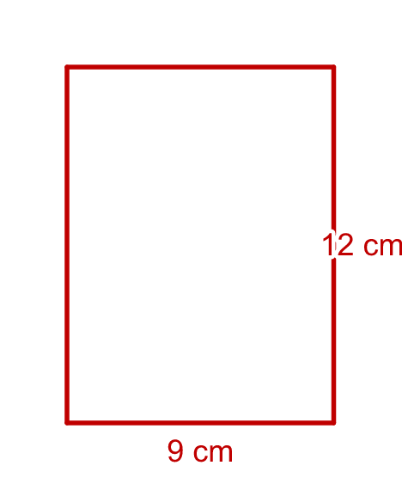  a) Length of the diagonal (cm) 15
  14 | Draw a house. The wall is a rectangle 6 cm wide and 5 cm tall. The roof is an isosceles triangle on top with two sloping sides of 5 cm. Draw it accurately in your book. Use a ruler and a protractor.  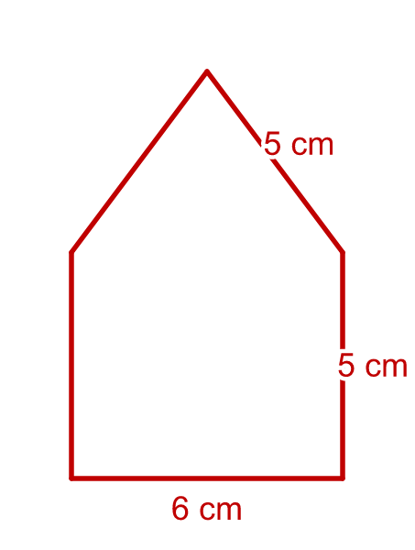  a) Total height of the house (cm) 9  b) Total area of the house (cm²) 42

