  Year 6 · Shape · Step 11  Nets of 3-D shapes | 
  Year 6 · Shape · Step 11
  Nets of 3-D shapes
  1 | A face is a flat surface of a solid. An edge is where two faces meet. A vertex is a corner.  a) Number of faces of a cube  b) Number of edges of a cube  c) Number of vertices (corners) of a cube
  1 | A face is a flat surface of a solid. An edge is where two faces meet. A vertex is a corner.  a) Number of faces of a cube  b) Number of edges of a cube  c) Number of vertices (corners) of a cube
  2 | Write the number of faces, edges and vertices of a triangular prism.  a) Number of faces of a triangular prism  b) Number of edges of a triangular prism  c) Number of vertices (corners) of a triangular prism
  2 | Write the number of faces, edges and vertices of a triangular prism.  a) Number of faces of a triangular prism  b) Number of edges of a triangular prism  c) Number of vertices (corners) of a triangular prism
  3 | Write the number of faces, edges and vertices of a pentagonal pyramid.  a) Number of faces of a pentagonal pyramid  b) Number of edges of a pentagonal pyramid  c) Number of vertices (corners) of a pentagonal pyramid
  3 | Write the number of faces, edges and vertices of a pentagonal pyramid.  a) Number of faces of a pentagonal pyramid  b) Number of edges of a pentagonal pyramid  c) Number of vertices (corners) of a pentagonal pyramid
  4 | Here are three nets. Each folds to make a different solid.  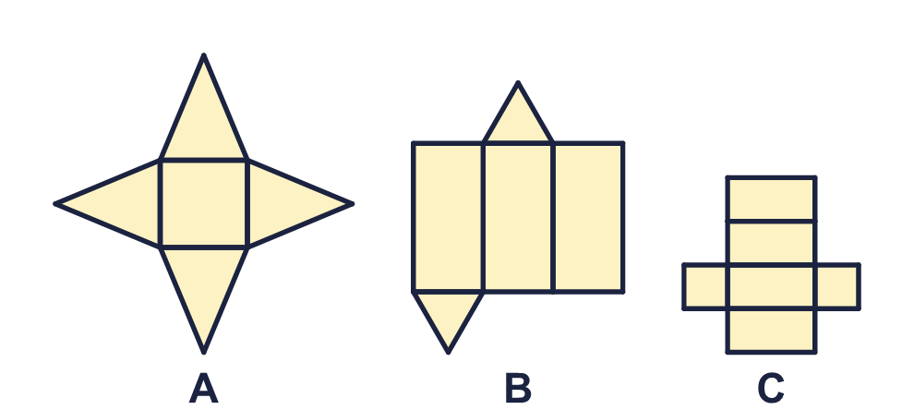  a) Which net makes a square-based pyramid? Write the letter.  b) Which net makes a triangular prism? Write the letter.
  4 | Here are three nets. Each folds to make a different solid.  a) Which net makes a square-based pyramid? Write the letter.  b) Which net makes a triangular prism? Write the letter.
  5 | Which of these nets fold to make a cube? Write the letters, in order, with a comma between them.  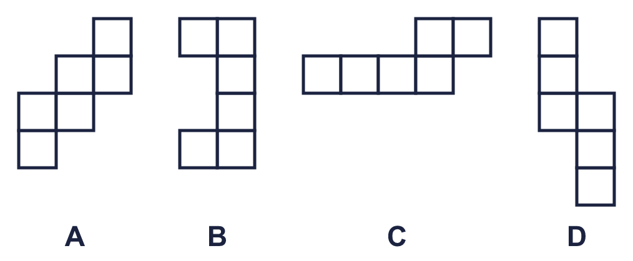
  5 | Which of these nets fold to make a cube? Write the letters, in order, with a comma between them.
  6 | A cuboid is 7 cm long, 4 cm wide and 5 cm tall. Each face is a rectangle.  a) Area of the top face (cm²)  b) Area of the front face (cm²)  c) Area of the side face (cm²)
  6 | A cuboid is 7 cm long, 4 cm wide and 5 cm tall. Each face is a rectangle.  a) Area of the top face (cm²)  b) Area of the front face (cm²)  c) Area of the side face (cm²)
  7 | Four squares of the net of a cube are shaded. Draw two more squares (in your book, on squared paper) so that the net folds to make a cube.  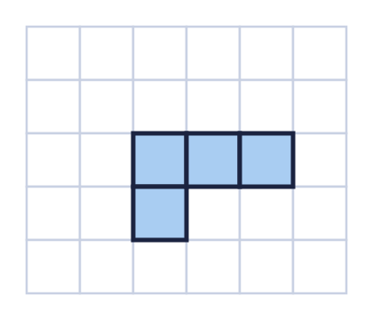  How many squares are in the finished net?
  7 | Four squares of the net of a cube are shaded. Draw two more squares (in your book, on squared paper) so that the net folds to make a cube.  How many squares are in the finished net?
  8 | The cuboid is 4 cm long, 2 cm wide and 2 cm tall. Part of its net is shown on squared paper (1 square is 1 cm). Complete the net in your book.  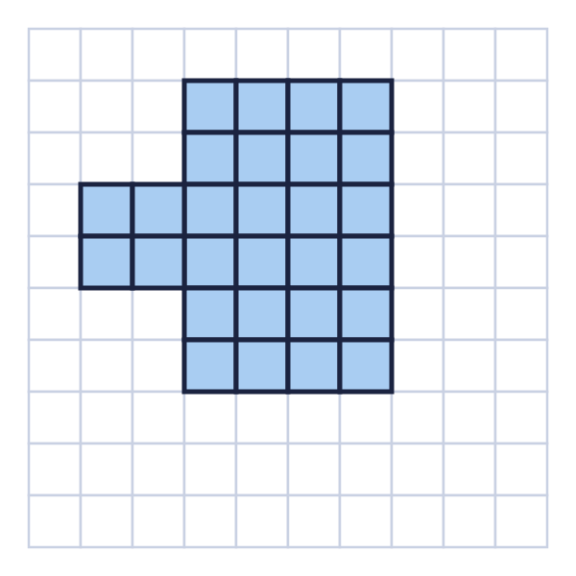  How many squares are in the finished net?
  8 | The cuboid is 4 cm long, 2 cm wide and 2 cm tall. Part of its net is shown on squared paper (1 square is 1 cm). Complete the net in your book.  How many squares are in the finished net?

  9 | The net is folded to make a cube. Each square has a letter.  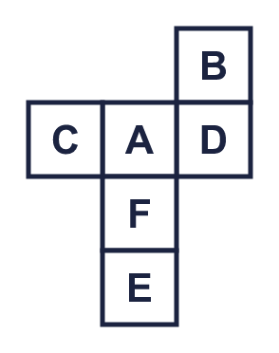  a) Which face is opposite face A? Write the letter.  b) Which face is opposite face D? Write the letter.
  9 | The net is folded to make a cube. Each square has a letter.  a) Which face is opposite face A? Write the letter.  b) Which face is opposite face D? Write the letter.
  10 | Here are three nets.  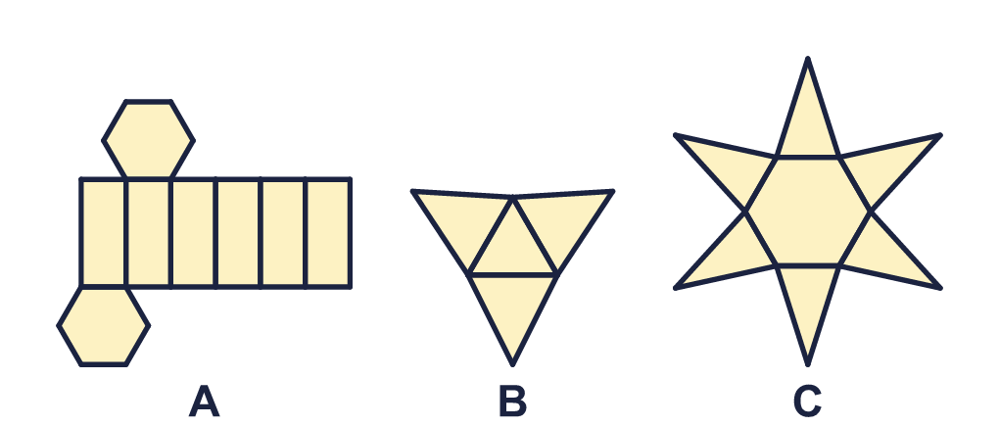  a) Which net is the net of a prism? Write the letter.  b) How many faces does that prism have?
  10 | Here are three nets.  a) Which net is the net of a prism? Write the letter.  b) How many faces does that prism have?
  11 | There are 35 different shapes that can be made by joining six squares edge to edge (turning or flipping a shape does not make a new one). Some of them fold to make a cube.  How many of the shapes are nets of a cube?
  11 | There are 35 different shapes that can be made by joining six squares edge to edge (turning or flipping a shape does not make a new one). Some of them fold to make a cube.  How many of the shapes are nets of a cube?
  12 | A prism has 8 faces.  a) What shape is each end (base) of the prism? Write the name.  b) How many edges does the prism have?
  12 | A prism has 8 faces.  a) What shape is each end (base) of the prism? Write the name.  b) How many edges does the prism have?
  13 | This is the net of a square-based pyramid. All four triangles are the same. The side of the square and the height of one triangle are marked.  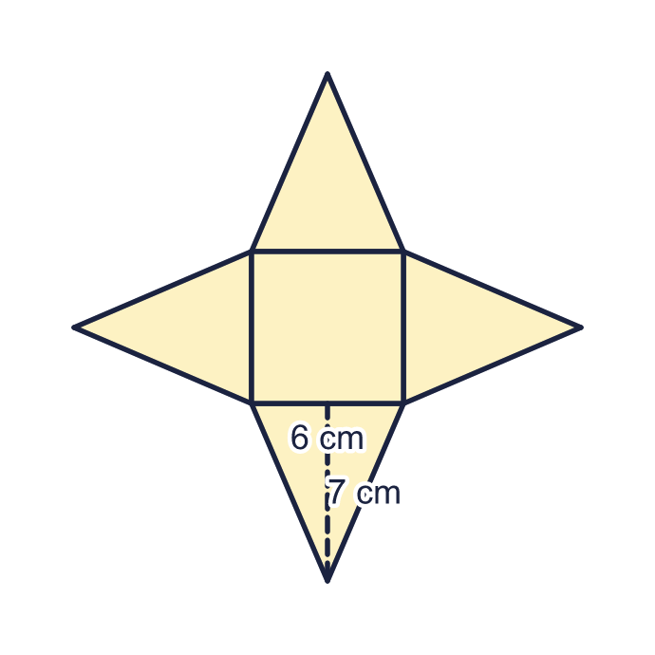  a) Area of one triangle (cm²)  b) Area of the whole net (cm²)
  13 | This is the net of a square-based pyramid. All four triangles are the same. The side of the square and the height of one triangle are marked.  a) Area of one triangle (cm²)  b) Area of the whole net (cm²)
  14 | This is the net of a triangular prism. The triangles have sides of 3 cm, 4 cm and 5 cm. The prism is 8 cm long.  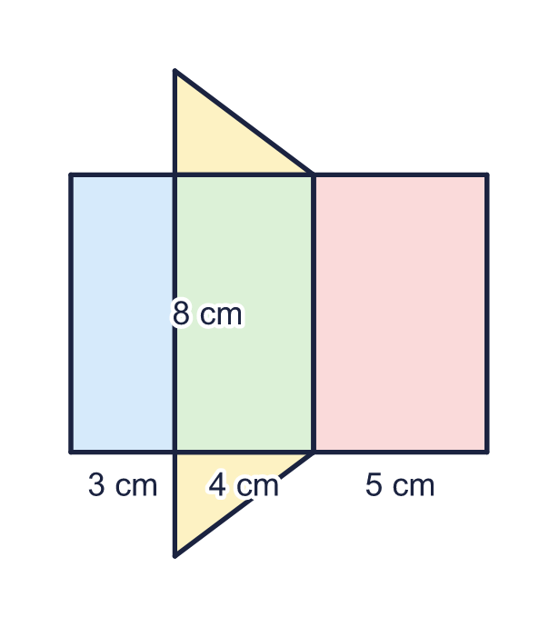  a) Area of the largest rectangle (cm²)  b) Area of the whole net (cm²)
  14 | This is the net of a triangular prism. The triangles have sides of 3 cm, 4 cm and 5 cm. The prism is 8 cm long.  a) Area of the largest rectangle (cm²)  b) Area of the whole net (cm²)

Year 6 · Shape · Step 11
Nets of 3-D shapes
Answers (teacher copy)

  1 | A face is a flat surface of a solid. An edge is where two faces meet. A vertex is a corner.  a) Number of faces of a cube 6  b) Number of edges of a cube 12  c) Number of vertices (corners) of a cube 8
  2 | Write the number of faces, edges and vertices of a triangular prism.  a) Number of faces of a triangular prism 5  b) Number of edges of a triangular prism 9  c) Number of vertices (corners) of a triangular prism 6
  3 | Write the number of faces, edges and vertices of a pentagonal pyramid.  a) Number of faces of a pentagonal pyramid 6  b) Number of edges of a pentagonal pyramid 10  c) Number of vertices (corners) of a pentagonal pyramid 6
  4 | Here are three nets. Each folds to make a different solid.  a) Which net makes a square-based pyramid? Write the letter. A  b) Which net makes a triangular prism? Write the letter. B
  5 | Which of these nets fold to make a cube? Write the letters, in order, with a comma between them.  A, D
  6 | A cuboid is 7 cm long, 4 cm wide and 5 cm tall. Each face is a rectangle.  a) Area of the top face (cm²) 28  b) Area of the front face (cm²) 35  c) Area of the side face (cm²) 20
  7 | Four squares of the net of a cube are shaded. Draw two more squares (in your book, on squared paper) so that the net folds to make a cube.  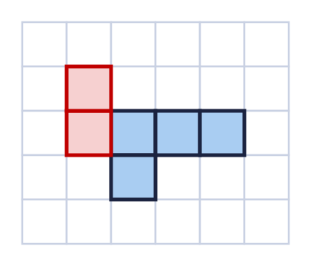  How many squares are in the finished net? 6
  8 | The cuboid is 4 cm long, 2 cm wide and 2 cm tall. Part of its net is shown on squared paper (1 square is 1 cm). Complete the net in your book.  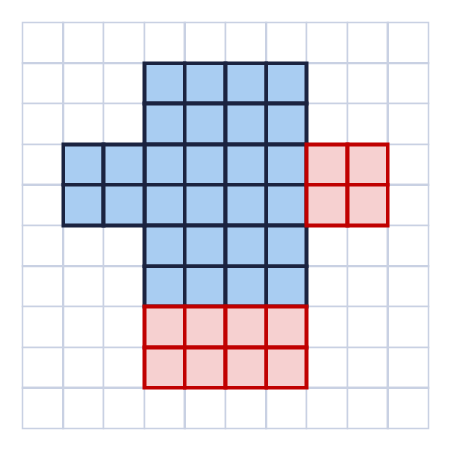  How many squares are in the finished net? 40
  9 | The net is folded to make a cube. Each square has a letter.  a) Which face is opposite face A? Write the letter. E  b) Which face is opposite face D? Write the letter. C
  10 | Here are three nets.  a) Which net is the net of a prism? Write the letter. A  b) How many faces does that prism have? 8
  11 | There are 35 different shapes that can be made by joining six squares edge to edge (turning or flipping a shape does not make a new one). Some of them fold to make a cube.  How many of the shapes are nets of a cube? 11
  12 | A prism has 8 faces.  a) What shape is each end (base) of the prism? Write the name. hexagon  b) How many edges does the prism have? 18
  13 | This is the net of a square-based pyramid. All four triangles are the same. The side of the square and the height of one triangle are marked.  a) Area of one triangle (cm²) 21  b) Area of the whole net (cm²) 120
  14 | This is the net of a triangular prism. The triangles have sides of 3 cm, 4 cm and 5 cm. The prism is 8 cm long.  a) Area of the largest rectangle (cm²) 40  b) Area of the whole net (cm²) 108

