  Year 6 · Shape · Step 3  Vertically opposite angles | 
  Year 6 · Shape · Step 3
  Vertically opposite angles
  1 | Two straight lines cross. Work out the three missing angles.  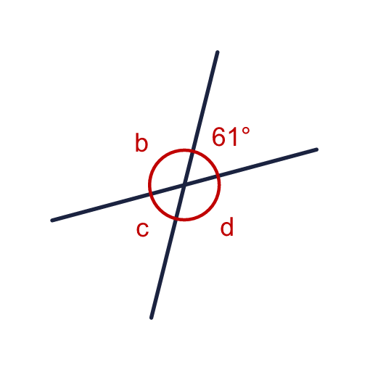
    b = |  | °
    c = |  | °
    d = |  | °
  1 | Two straight lines cross. Work out the three missing angles.
    b = |  | °
    c = |  | °
    d = |  | °
  2 | Two straight lines cross. The angle marked x is vertically opposite the angle shown.  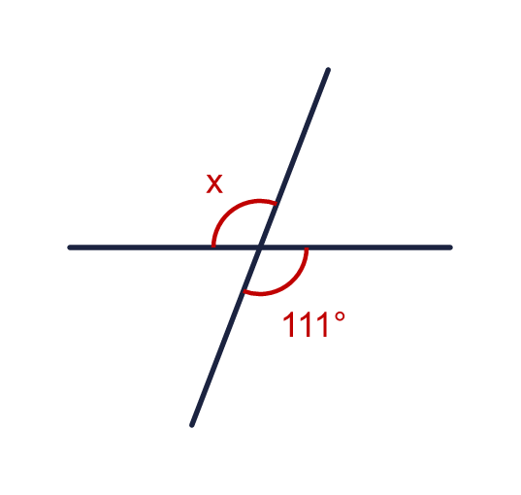
    x = |  | °
  2 | Two straight lines cross. The angle marked x is vertically opposite the angle shown.
    x = |  | °
  3 | Two straight lines cross. Angle a is 57°.  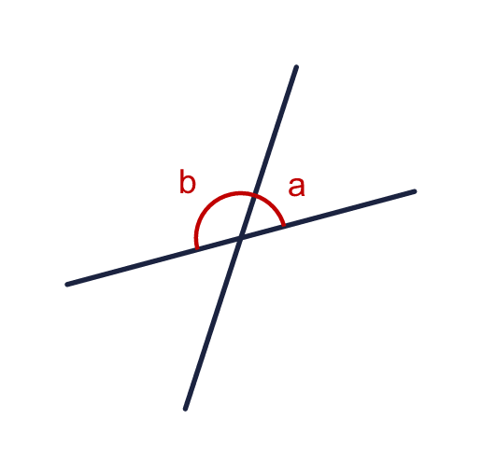  a) What is the size of angle b?  b) What is a + b?
  3 | Two straight lines cross. Angle a is 57°.  a) What is the size of angle b?  b) What is a + b?
  4 | Two straight lines cross. Angle c is vertically opposite which angle? Write the letter.  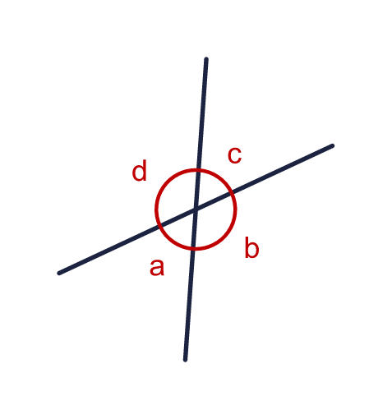  a) Vertically opposite angle c
  4 | Two straight lines cross. Angle c is vertically opposite which angle? Write the letter.  a) Vertically opposite angle c
  5 | Two straight lines cross. Work out the angles marked b and d.  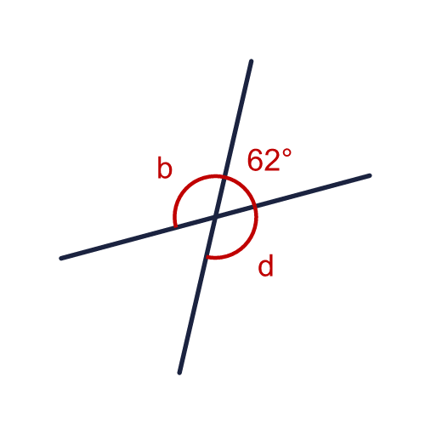
    b = |  | °
    d = |  | °
  5 | Two straight lines cross. Work out the angles marked b and d.
    b = |  | °
    d = |  | °
  6 | Two straight lines cross. Work out angle y.  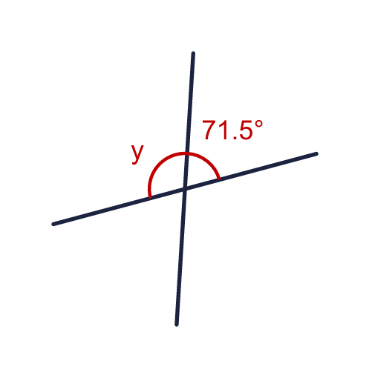
    y = |  | °
  6 | Two straight lines cross. Work out angle y.
    y = |  | °
  7 | Two straight lines cross. Work out the three missing angles.  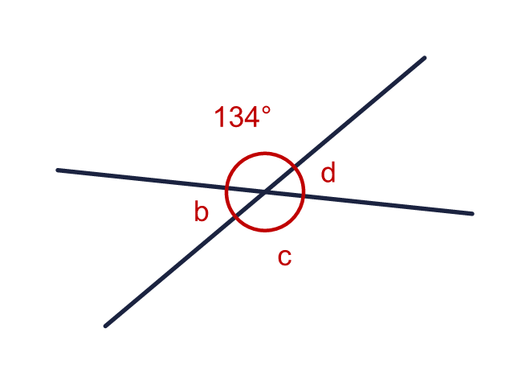
    b = |  | °
    c = |  | °
    d = |  | °
  7 | Two straight lines cross. Work out the three missing angles.
    b = |  | °
    c = |  | °
    d = |  | °
  8 | Two straight lines cross. One of the angles is 73°. Write the sizes of the other three angles.  a) The angle vertically opposite it  b) The other two angles (they are equal)
  8 | Two straight lines cross. One of the angles is 73°. Write the sizes of the other three angles.  a) The angle vertically opposite it  b) The other two angles (they are equal)

  9 | Look at the three angles on the straight line.  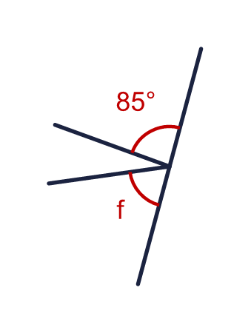  Is Boba correct? Circle yes or no.  Yes / No  Explain how you know.
     | 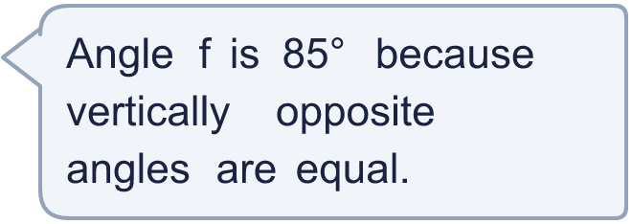
  9 | Look at the three angles on the straight line.  Is Boba correct? Circle yes or no.  Yes / No  Explain how you know.
  10 | Two straight lines cross. Angle b is three times the size of angle a.  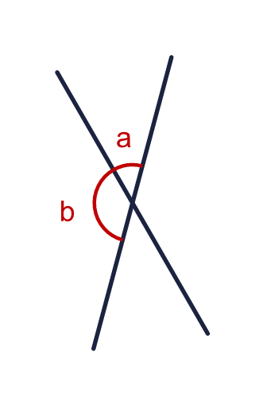
    a = |  | °
    b = |  | °
  10 | Two straight lines cross. Angle b is three times the size of angle a.
    a = |  | °
    b = |  | °
  11 | Two straight lines cross. The angles next to each other are marked x and 4x.  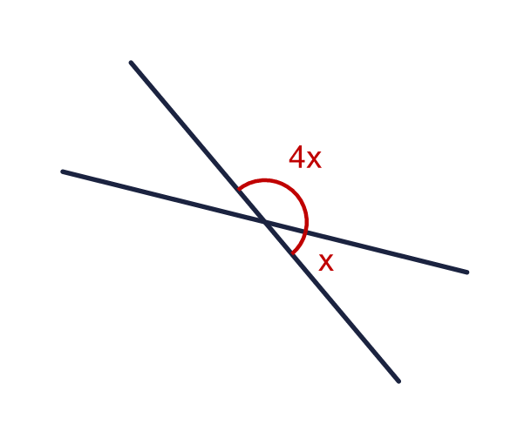
    x = |  | °
    4x = |  | °
  11 | Two straight lines cross. The angles next to each other are marked x and 4x.
    x = |  | °
    4x = |  | °
  12 | The two lines cross at the corner of a triangle. Work out the angle x.  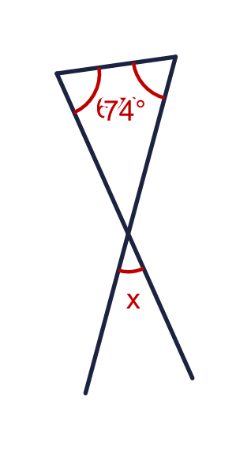
    x = |  | °
  12 | The two lines cross at the corner of a triangle. Work out the angle x.
    x = |  | °
  13 | Two straight lines cross. Two vertically opposite angles are marked 3x and x + 86.  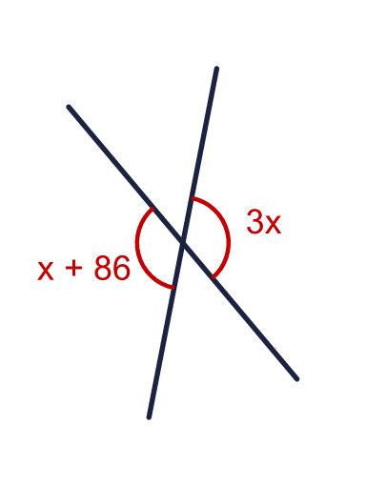  a) Work out the value of x.  b) What is the size of each of these two angles?
  13 | Two straight lines cross. Two vertically opposite angles are marked 3x and x + 86.  a) Work out the value of x.  b) What is the size of each of these two angles?
  14 | Three straight lines cross at one point. The angles x and y are marked.  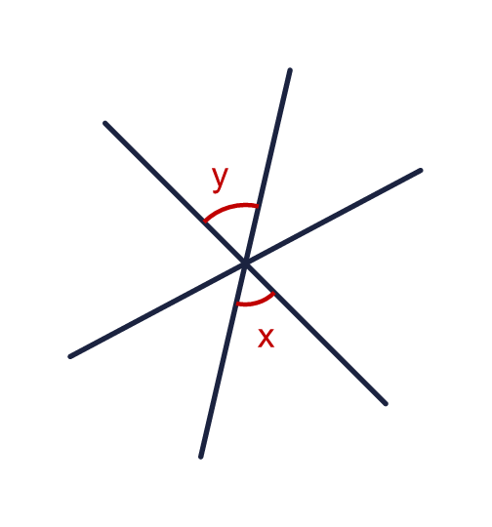  Are angles x and y vertically opposite? Circle yes or no.  Yes / No  Explain how you know.
  14 | Three straight lines cross at one point. The angles x and y are marked.  Are angles x and y vertically opposite? Circle yes or no.  Yes / No  Explain how you know.

Year 6 · Shape · Step 3
Vertically opposite angles
Answers (teacher copy)

  1 | Two straight lines cross. Work out the three missing angles.  b = 119 °  c = 61 °  d = 119 °
  2 | Two straight lines cross. The angle marked x is vertically opposite the angle shown.  x = 111 °
  3 | Two straight lines cross. Angle a is 57°.  a) What is the size of angle b? 123  b) What is a + b? 180
  4 | Two straight lines cross. Angle c is vertically opposite which angle? Write the letter.  a) Vertically opposite angle c a
  5 | Two straight lines cross. Work out the angles marked b and d.  b = 118 °  d = 118 °
  6 | Two straight lines cross. Work out angle y.  y = 108.5 °
  7 | Two straight lines cross. Work out the three missing angles.  b = 46 °  c = 134 °  d = 46 °
  8 | Two straight lines cross. One of the angles is 73°. Write the sizes of the other three angles.  a) The angle vertically opposite it 73  b) The other two angles (they are equal) 107
  9 | Look at the three angles on the straight line.  Is Boba correct? Circle yes or no.  Yes / No  Explain how you know.  The 85° angle and f are not vertically opposite. The angles on a straight line add up to 180°, so f = 180 − 85 − 28 = 67°, not 85°.
  10 | Two straight lines cross. Angle b is three times the size of angle a.  a = 45 °  b = 135 °
  11 | Two straight lines cross. The angles next to each other are marked x and 4x.  x = 36 °  4x = 144 °
  12 | The two lines cross at the corner of a triangle. Work out the angle x.  x = 39 °
  13 | Two straight lines cross. Two vertically opposite angles are marked 3x and x + 86.  a) Work out the value of x. 43  b) What is the size of each of these two angles? 129
  14 | Three straight lines cross at one point. The angles x and y are marked.  Are angles x and y vertically opposite? Circle yes or no.  Yes / No  Explain how you know.  x and y are on opposite sides of the point, made by the same two lines. They are both 58°.

